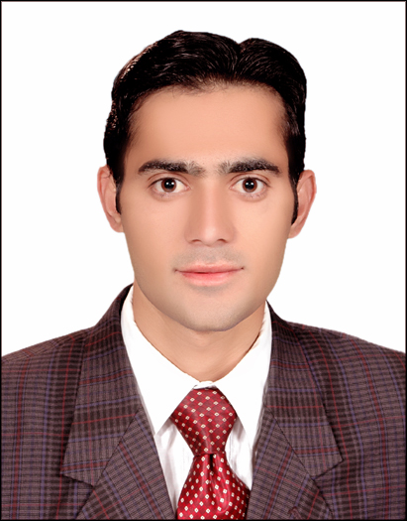
Muahmmad Waqas Other Contact: +923459360633 Email: eng.waqas@live.com
CAREER OBJECTIVE:
To ensure challenging position in a growing organization where I would be able to utilize my capabilities to the best extend and, in the process, add value to the organization and my career.
PROFESSIONAL WORK EXPERENCE:

Organization: 220 KV grid station Peshawar Electric Supply Company (PESCO)


Tenure: April 2014- march 2015

Designations: Trainee Engineer

Responsibilities:

- Testing of Circuit Breaker
- Installation of Circuit Breakers.
- Testing of transformers
- Testing and commissioning of CT & PT.
- Preparing reports of the regular operations.

ACADEMIC EDUCTION:

DISCIPLINE EXAMINING BODY YEAR
- Post-graduation Power & Energy COMSATS University Islamabad Course work done
- Graduation: Engineering COMSATS University Abbottabad 2010-2014
- Graduation: Applied science Govt. Post graduate College Mardan 2007-2011
- Intermediate: pre-engineering Govt. Post graduate College Mardan 2007

COMMUNICATION AND INTERPERSONAL SKILLS:
- Network configuration, Auto cad, MATLAB, MS Office(Word, Excel & PowerPoint), Database.
- Excellent typing speed
- Ability to Work in Teams plus excellent management skills (task oriented)
- Effective Writing and Communication Skills (Excellent Presentation Skills)
- Have a good level command over English and Urdu Languages.

PROJECT SKILLS:
Final Year Project:
- Dual control single phase matrix converter fed DC Drive.
- Voltage control strategy in distributed power system

Academic Projects:
- Water level indicator
- Low pass, High pass filters through control systems
- Touch Electronic LED Dice
- Infrared Rays based Home security Headlights and Alarm via microcontroller system

CERTIFICATION:

- Certificate of competency from Govt. of KPK, Pakistan.
- Control automation using PLC from advance automation & electronics Peshawar KPK, Pakistan.
- Electrical AUTO-CAD from Haris institute mardan.

PERSONAL INFORMATION:

Date of Birth: March 8th ,1988
Religion : Islam (Muslim)

DECLARATION:
I hereby declare that the information provided above is correct to the best of my knowledge.

