PERSONAL INFORMATION | Usman Ali Khan
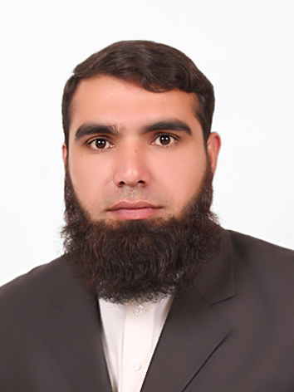 |   P.O Box Chuprial Bazar Tehsil Matta District Swat, 19040 Gharai (Pakistan)

+923468005690

engr.usman023@gmail.com

Skype usman.khan4243

NIC: 42401-9648982-1
 | Sex Male | Date of birth 12 Aug 1992 | Nationality Pakistani

JOB APPLIED FOR | ASSISSTANT DIRECTOR VIGILANCE

WORK EXPERIENCE

6th Jul 2015–6th Oct 2015 | Training Internee
6th Jul 2015–6th Oct 2015 | Pakistan WAPDA Peshawar Electric Supply Company LTD 132KV Grid Station, Saidu Sharif Amankot Swat (Pakistan)

EDUCATION AND TRAINING

5th Sep. 2016=Present  Aug 2011–26 Jan 2016 | Master of Science in Electrical Engineering MS(EE)  COMSATS Institute of Information Technology, Abbottabad (Pakistan)  Main subjects  Electric Machine Design, Advanced Power Electronics, High Voltage Design  Bachelor of Science in Electrical Engineering BS(EE) | ICT R&D Scholarship Scholar
5th Sep. 2016=Present  Aug 2011–26 Jan 2016 | COMSATS Institute of Information Technology, Attock (Pakistan)  CGPA 2.55/4.00  70% Marks  Main Subjects
5th Sep. 2016=Present  Aug 2011–26 Jan 2016 | Electric Power, Electric Electronics, Control System​

Apr 2009–Apr 2011 | Higher Secondary School Certificate
Apr 2009–Apr 2011 | Government Farooq Shaheed Degree College, Mingora Swat (Pakistan)  71.8% Marks  Main Subjects
Apr 2009–Apr 2011 | Pre-Engineering​

Apr 2007–Apr 2009 | Secondary School Certificate
Apr 2007–Apr 2009 | Abdali Public School, Matta Swat (Pakistan)  81.52 Marks
Apr 2007–Apr 2009 | Science​

PERSONAL SKILLS

Mother tongue(s) | Pashto
Other language(s) | UNDERSTANDING |  | SPEAKING |  | WRITING
Other language(s) | Listening | Reading | Spoken interaction | Spoken production
Urdu | C1 | C1 | C1 | B2 | B1
English | A2 | A1 | B1 | A2 | A1
Levels: A1 and A2: Basic user - B1 and B2: Independent user - C1 and C2: Proficient user
Common European Framework of Reference for Languages

Communication skills | Good Communication skills gained during my four year Bachelor education ​

Organisational / managerial skills | -Good team leading skills  -Good command ​of group working

ADDITIONAL INFORMATION

Academics Projects | “THREE PHASE LOAD BALANCING” as a title of Final year Project  “AIR FLOW DETECTOR” as a title of Semester Project

Achievements | Availed Fee Reimbursement Scheme Scholarship for Master Education (MSEE)  Got ICT R&D Full Funded Merit Based Scholarship for four year Bachelor Education​ (BSEE)

