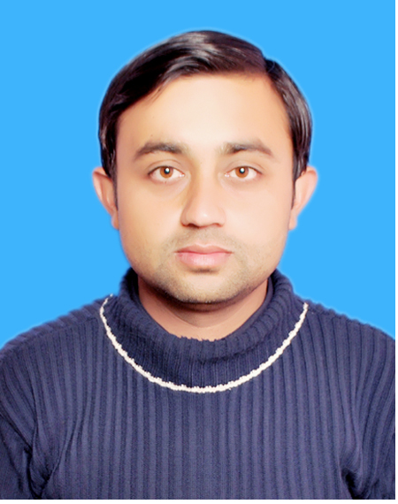
Engineer Muhammad Suleman
Email: engr.suleman@yahoo.com
Skype id: engrsuleman1
PEC# CHEM-12024

CAREER OBJECTIVE:
A Bright, Talented, Ambitious and Self-motivated Engineer with a strong technical background who possesses self-discipline and the ability to work with the minimum supervision. Using initiative to develop effective solutions to problems with an active and dynamic approach to work and getting things done efficiently. Having following skills, which I am sure, will make me a good competent.
- Chemical Engineering Operation
- New Process Development & Implementation
- Highly motivated and smart worker
- Customer Relations & Interpersonal Skills
- Organizational & Time Management Skills
- Prioritize & Execute Tasks In High Pressure Environment
- Work Effectively In Team Oriented, Collaborative Environment
- Leadership Experience, Technical And Analytical Skill
- Microsoft Office, AutoCAD Proficiency
- Heat Exchanger, Separation Column And Plant Economics
Keen to find a suitable position within a successful and determined company.

PROFESSIONAL WORK EXPERIENCE:
Organization: Arabesque Laboratory For Soil Testing (Abudhabi, UAE)
Tenure: October 2015 Till Date
Designations: Chemical Engineer

Responsibilities:
- Performs Proficiency Test Program samples assigned by QCC Abu Dhabi
- Performs Internal Quality Check samples assigned by the Quality Department
- Coordinates and reports with the Chemical Department Manager for the daily activities
- Deputy to Quality Manager
- Performs the chemical analysis of samples adequately as per the standards ( witnessing of the clients as requested)

Chemical Tests:
- Soil
- Ground Water
- Hardened Concrete
- Aggregate
- Cement (OPC, SRC, MSRC

Responsibilities as Quality Controller:
- Deputy to Quality Manager
- Control of documents as per ISO 17025 Standards
- Ensuring the laboratory’s equipment calibrations are kept up to date and regular preventive maintenance is performed on schedule. Withdrawing any items of equipment out of calibration or found to be defective.
- Assisting QA Manager to conduct the Internal Quality Control & calculation of measurement of uncertainty
- Prepare method statement, worksheet for Laboratory test.
- Prepare LPO and correspondence and coordinate purchase of equipment and laboratory consumables.
- Revise and update all Quality forms and ensure all Laboratory procedures and forms in use are updated.
- Perform regular internal audits of laboratory procedures including tests, and all other aspects of the quality system as and when required.

Organization: Pakistan Atomic Energy (PINSTECH), Islamabad
Tenure: June 2012 –August 2012
Designations/Job Type: Internee (R&D)

Responsibilities:
- Internship Project : Formation of metal aluminates and their analysis
- Experimental work under the Senior Scientist Dr. Shahid khan Dorrani
- Drying of materials and palates formation
- XRD analyses
- Worked on above project in a team, and achieved result in the form of successfully forming Metal aluminates crystals

Organization: ATTABAK Pharmaceuticals, Islamabad
Tenure: July 2011 –August 2011
Designations/Job Type: Internee (QC Analyst)

Responsibilities:
- QC Chemist
- Calculations of amount of chemicals to be processed, from chemical reactions
- Observation of process of mixing chemicals
- Monitoring the process parameters
- Drying of final desired products
- Reporting to manger

ACADEMIC QUALIFICATION:
BE (Chemical Engg.) UET, Peshawar (3.02 / 1st Division) 2013
F.Sc (Pre-Engg.) BISE, Kohat (A₁ / 1st Division) 2009
Matriculation (Science) BISE, Kohat (A₁ / 1st Division) 2007

PROJECTS:
- Production of Ultra low sulfur diesel (ULSD) by HDS method (main project).
- Production of Metal Aluminates by Hydrothermal method (mini project).
- Preparation of Stair Circuit (mini project).

COMMUNICATION AND INTERPERSONAL SKILLS:
- Outstanding command over verbal and non-verbal communicative & interpersonal skills.
- Strong organizational, managerial, problem solving, interpersonal and negotiation skills.
- Confidently able to work independently or in a team to deal effectively with educators & employees.
- Flair to organize & prioritize tasks to meet deadlines.
- Ability to manage multiple projects with minimal supervision.
- Have a good level command over English and Urdu Languages.

INTERESTSANDHOBBIES:
- Student Counselor by organizing Seminars, competitions, Lectures and workshops.
- Playing Football, Cricket and Badminton
- Reading Books/Magazines/Newspapers,
- Watching movies/Listening Music,
- Working with computer/Net Surfing.

PERSONAL INFORMATION:

Father’s Name : Rab Nawaz
Date of Birth : Feb 10, 1991
NIC # : 14101-5948071-5
Marital Status : Single
Religion : Islam
Nationality : Pakistani
COVER LETTER

Dear Sir/Ma’am,

It is with great interest that I am forwarding my resume for consideration for the open position of within your organization. Combining my previous experience with strong interpersonal and communication abilities, I am confident that you will quickly realize my abilities to make major contributions to your organization. I never let any opportunity of improvement. Therefore, I ask you to consider my enclosed resume for the position.

My resume provides you with details of my skills and accomplishments, but I am certain that a personal interview would more fully reveal my desire ability to contribute to your organization.

Thank you for your time and consideration and don’t hesitate to contact me if you have any questions. I look forward to speaking with you soon.

Sincerely,
Muhammad Suleman

