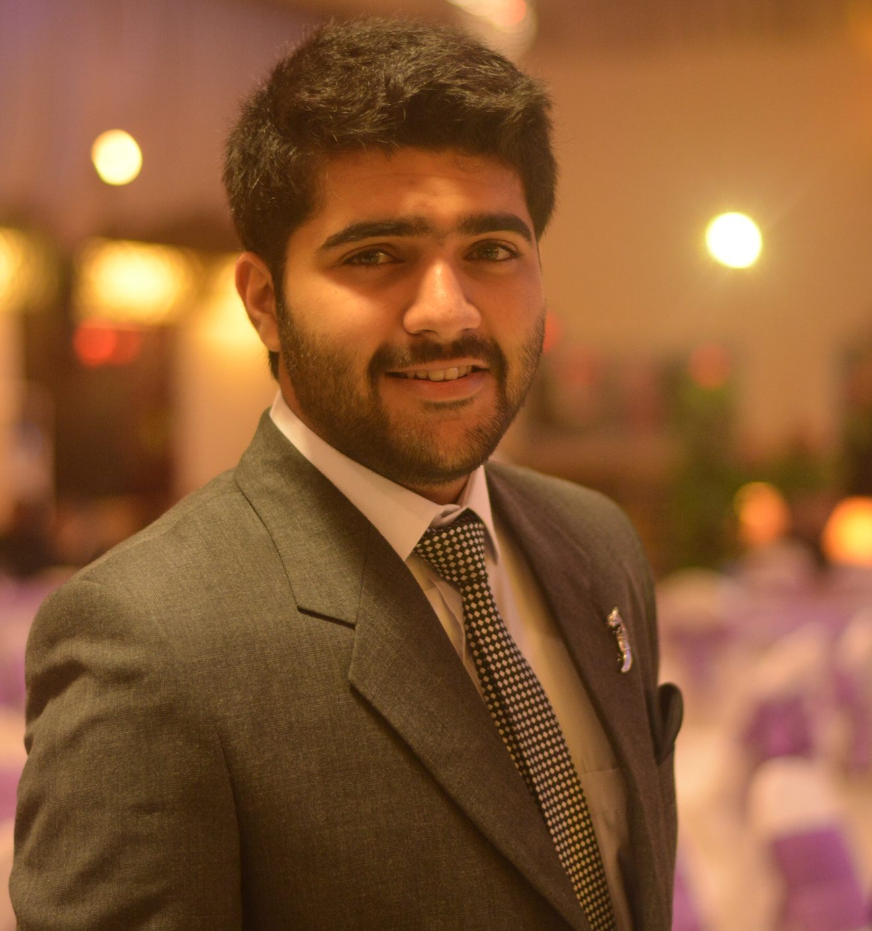

Muhammad Mohsin Khan
DOB:29/06/1996
House No. 127, Street No. 12, Gulbahar No. 2, Peshawar, KPK, Pakistan
Phone: 0092-91-2264076, 0092-336-9596459
Email: m.mohsin127@yahoo.com

Profile

With Bachelors in Electrical Engineering. I am looking for an opportunity in a reputed organization which will help me deliver my best and upgrade my skills in Engineering and meet the demand of the organization.

Education & Credentials

B.Sc Electrical Engineering
UET Peshawar – Sept 2018
(Obtained 2.86/4 CGPA from UET Peshawar)
F.Sc (Pre-Engineering)
Edwards College Peshawar – 2014
(Obtained 72.3% Marks from BISE Peshawar)

S.S.C (Science)
Peshawar Model School – 2012
(Obtained 82.6% Marks from BISE Peshawar)


Experience

Project through Fiver & Co
- Working online as a freelancer with people around the World.
- Assisting people with their Electrical Engineering Tasks.
- Designed circuit for Dentaball for a USA company (Pet Innovation). Product ready for launch in USA in September 2018.
- Designed a screen that creates a dynamic electro-static field on skin as relief map of that moving image. “US Company project”
- Designed Electromagnetic engine for flying suit. “Canadian Company project”

Peshawar Development Authority (Intern)
- Working as Intern in PDA as Electrical Engineer in Bus Rapid Transit (BRT) Peshawar project

Computer and Language Skills
- Highly skilled in applications and programming language C and C++.
- Expert user of Matlab.
- Worked on software for Electrical Engineering Keil and Proteus.
- Proficient user of Microsoft Tools, including word, excel, power point and Access.
- Have worked with various versions Windows Operating Systems.

Final Year Project

“Wheelchair controlled through eye ball movements” received “A”

Personal Competencies

- Excellent oral and written correspondence with an exceptional attention to detail.
- Highly organised with a creative Player for project work.
- Enthusiastic self-starter who contributes well to the team.
- Efficient management and organizational abilities.
- Excellent written and communication skills in English.
- Have good problem solving with analytic thinking.
- Open minded to work in complex environment and projects.

Achievement in Co-Curricular Activity
Worked as Director Web and Networks for IEEE UET Peshawar. Helped department in making website for IEEE and an online library .

Trainings and Certifications
- Certified Member of Institute of Electrical and Electronics Engineering.
- 11th IEEE Pakistan student/young professional congress ( 3 Day Congress in Superior University, Lahore).
- PLC and SCADA training by Lambda( 1 Day Training held in UET Peshawar.
- Organizing IEEE Technophilia ( 3 Day Technology Function Held in UET Peshawar ).
- Organizing Final Year Project guide ( 1 Day Training UET Peshawar ) .

