Khalid Rasheed  Mechanical Engineer |  | 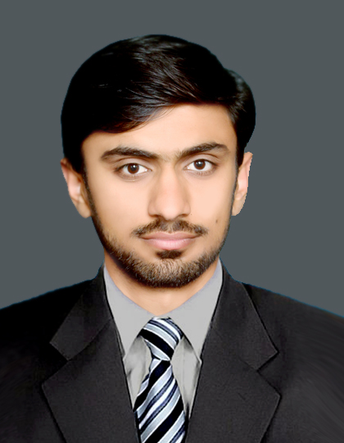
CAREER OBJECTIVE:
I want to obtain a challenging and dynamic position in an industrial organization that promotes leadership, diversity, integrity, commitment and provides opportunities for applying engineering knowledge towards the innovation and development of new products and processes.
EDUCATION: |  | Address:  Mohalla Durhatta Gali Janaza Gah Qadir Pur Ran, Multan  Phone Number:  +923047874466  Email: khalid48261@gmail.com  Passport No:  DZ9840061  EXTRA CURRICULAR ACTIVITIES:   Travelling   Photography   Socializing   Video Games  LANGUAGES:   English  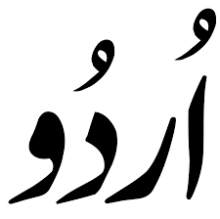 Urdu
2014 – 2018  2011 – 2014  2009 – 2011  WORK EXPERIENCE: | B.sc Mechanical Engineering | NFC Institute of Engineering and Technology, Multan | 3.64/4.00 CGPA  HSSC | 840/1100 (76.36%)  BISE Multan  SSC | 811/1050 (77.24%)  BISE Multan  Kot Addu Power Company Limited (KAPCO)  During the internship I was assigned in Mechanical Maintenance Block in which my key duty was to see the process and to gain knowledge about the turbines and give feedback about the work process.  Pakistan Railways Locomotives Workshops, Mughal Pura Lahore Pakistan  During my internship I was assigned in (Spring Shop, Bearing Shop and Locomotive Industry) departments. My key duty was to learn about the basics of all departments working and suggest improvements in every section where needed.
DEVELOPMENT & TECHNICAL SKILLS:
MS Office: Word, PowerPoint, Excel.
Operating Systems: Windows xp, 7,8,10, Good at trouble shooting.
Software’s: ANSYS, Solid works, AutoCAD, MATLAB, C++

ACADEMIC PROJECTS:
- Enhancing heat transfer rate of condenser by optimizing its design and material for Fins [Research will Published soon]
Design adaptation is done by replacing wire Fins through plate like arrangement in which tubes are running through that arrangement. Condenser is a cross flow heat exchanger so area exposed to environment increase and ultimately rate of heat transfer.
Investigate different aluminum alloys series to enhance the rate of heat transfer, condenser efficiency and ultimately diminishing energy losses.

- Working Model of Lathe Machine:
The aim of this project was to make use of technical skills learned in mechanical workshop in developing the working model of lathe machine. The model was the replica of original lathe machine consisting of all the necessary parts and equipment’s.
- Portable Water Distillation System.
A solar still was constructed and studied under actual environmental conditions of Multan. It is an economical means to provide portable water for remote areas and small communities in arid zones.
The experimental results obtained show that it this technology prove an economical and easier way to get pure water everywhere where solar energy is abundant source.
HONOURS & ACHIEVEMENTS:
Prime Minister Government Laptop award on merit
Awarded the membership of SMEP Pakistan.
Awarded Certificate of Proficiency in English Language Communication from University Department.
Awarded with Recommendation letter from Head of Department for further studies.
REFERENCES
References can be made available on demand.
Key Skills:
Pro Hardworking, Self-motivated and Dedicated
Ample experience of meeting Deadlines
Good Communication and Management skills
Possessing good numeric and analytical and research skills

