CURRICULUM VITAE

HASSAN - E - SAQLAIN
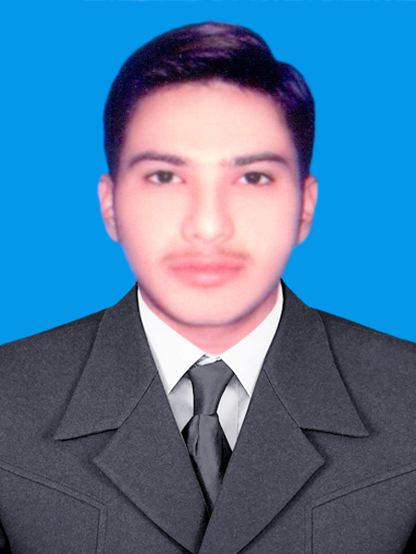

(Chemical Technology)

Address:- House No. 430/41/4c Street No. 03 Medina Abad
Behind Wallytabad N0 .01 Multan.Pakistan.

PERSONAL PROFILE

Father Name: Muhammad Mushtaq Ahmed Nationality : Pakistani

Phone No.: 0092 - 302 - 5802711 Domicile: Punjab
NIC No. : 36302 - 4889107- 3 D.O.B: 15-01-1993

Passport No. JC 6801071 Languages: English,Urdu,Punjabi

E-mail: ch.saqlain15@yahoo.com

CAREER OBJECTIVE

To seek a challenging opportunity by which I enable to utilize my additional potential, interpersonal skills and share my enthusiasm in the better interest of any renowned organization.

EDUCATION

B.S. Chemical Technology I.S.P. Multan. (3.25/4.0 ) 2016

D.A.E P.B.T.E.L. (2st Division) 2011

Matriculation Multan. (1st Division) 2008

B.S Thesis: Effluent Treatment Of Pulp & Paper Industry (17000m³ /day)

PROFESSIONAL EXPERIENCE / TRAINING/ INTERNSHIP

COMPANY LOCATION DURATION

Supervisor , Patron Chemical Industry (P.V.T.L) Multan, Pakistan. May. 08, 2017 - Till Date

Cashier, & Waiter Restaurants Oregano Pizza Multan, Pakistan. Marach, 01,2017- May. 07, 2017

CONFERENCES:

Oral presentation of thesis data in -Conference at Applied Technology Department

“Institute Of Southern Punjan Multan” on April 4, 2016.

COMPUTER SKILLS:-

MS. Office, Internet Browsing, searching, E-mails, C & C++,Visual basic, GoogleSketchUp, Adobe Photoshop ets.

