CURRICULUM VITAE

Muhammad Junaid Shah
Email Address: javedshah275@gmail.com
Mailing address: Sector 20HC, House No.998 POFs,Wah Cantt,
Thesil : Taxila, Distt : Rawalpindi
Cell #.0092-333-5104611
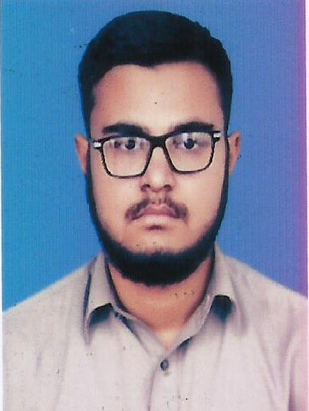
OBJECTIVE

- Looking for a rewarding career in a progressive and dynamic organization with a competitive/congenial/ challenging environment that gives me to exhibit and enhances my knowledge and skills and thus to reach better position & to attain more achievements in my career life.
- Contribute to repeat and referral business through strong problems solving skills and commitment to top quality workmanship.
- Participate in continuous training and professional development activities to maintain current knowledge of rapid advancing mechanical technologies.

PERSONEL DETAIL

• Father’s Name : Javed Shah.
• Date of Birth : 23-07-1999.
• CNIC # : 37406-0342172-7
• Marital Status : Unmarried
• Religion : Islam
• Nationality : Pakistani
- Domicle : K.P.K
- Height : 5’-9”

EDUCATIONAL INFORMATION

Degree | Intuition | Year | Marks Obtained | Total Marks | Div | %
Matric (Science) | F.G. Boys High School No.09  Wah Cantt | 2015 | 728 | 1050 | Ist | 69.33
D.A.E (Mech) | POF Institute of Technology  Wah Cantt | 2016 - 2018 | 2767 | 3450 | Ist | 80.20

TECHNICAL & PROFESSIONAL SKILLS

Course attended | Period |  | Name of Institution
Course attended | From | To | Name of Institution
Office Automation | 20-05-2015 | 20-08-2015 | POF Welfare Computer Centre-Wah Cantt
Auto CAD | 04-07-2017 | 04-10-2017 | POF Welfare Computer Centre-Wah Cantt
CNC Operator/  Programming | is under completion

COMMUNICATION & LANGUAGE SKILLS

- English = Speak, Write, Understand.
- Urdu = Speak, Write, Understand
- Punjabi = Speak, Understand
- Pushto = Speak, Understand.

REFRENCE:-

Reference will be available if desired.

