PERSONAL INFORMATION | Sheeraz Ali Bhutto
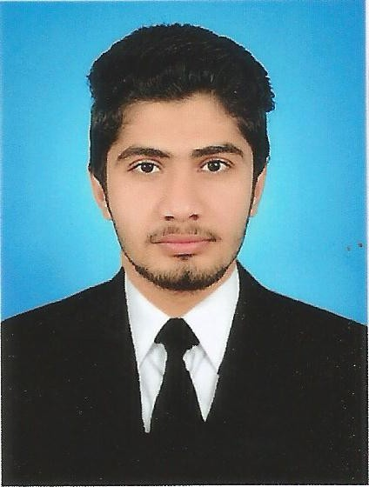 |   Flat No# 22, Block B9, Johar Square, Gulistan-i-Johar, Karachi, Sindh, Pakistan
 |  0300-3736795, 0333-7572129

Sheerazbhutto86@gmail.com

LinkedIn engineersheeraz@gmail.com
 | Sex Male | Date of birth 05/03/1995 | Nationality Pakistani | CNIC 43205-4671898-9

personal statement | To be a part of an organization where I can fully utilize my skills and make a significant contribution to the success of the employer and at the same time my individual growth

WORK EXPERIENCE

Jan 2018 to Date Lab Engineer
Indus University (ST-2D, Block-17, Adjacent to National Stadium Gulshan-e-Iqbal, Karachi)

2nd Jan 2018 to June 2018 Site Engineer
Rising Developers Construction Company as Site Supervisor

04th Jan 2017 to 10th Aug 2017  Feb 2017 to Jan 2018  Jun 2015 to Jul 2015 | Visiting Lecturer Mechanical
 | Leading Institute of Science and Technology (House #63 opp: SDM house peoples colony larkana)
 | - Instructor of DAE mechanical technology, Conduct workshop practical
Business or sector Educational Institute, Private

Internee PMYTS
Prime Minister Youth Development Program (National Internship Program)

Internee GENCO-I JPCL
Monitor and understand various processes of thermal power plant

EDUCATION AND TRAINING

08th Jan 2013 to 29th Dec 2016 | Bachelor’s of Engineering Mechanical ( 3.28 CGPA out of 4.0)  (PEC Registered Engineer)
08th Jan 2013 to 29th Dec 2016 | Mehran University of Engineering and Technology Jamshoro (Shaheed Zulfiqar Ali Bhutto Campus Khairpur Mir’s, Sindh, Pakistan)
August 2010 to Sept 2012 | Intermediate ( A1 Grade, 879/1100 )
August 2010 to Sept 2012 | Government Degree College Larkana
Sept 2008 to March 2010 | Matriculation ( B Grade, 586/850 )  Government Saint Joseph High School Larkana

PERSONAL SKILLS

Languages | Sindhi, Urdu and English

Communication skills | Good communication skills gained through my experience as lecturer at Leading institute of science and technology larkana and at Indus University

Organisational / managerial skills | Leadership (The leadership skills I gained during my final year project as I was group leader )
Job-related skills | Good command in Mechanical Technology Subject and Workshop Practices (Lathe Machine, Welding, CNC Lathe and other related operations)
Computer Skills | 4 Months Course of Office Automation
- Good command of Microsoft office (MS word, MS PowerPoint and Publisher)
- Good command of Computer Hardware and Software
- Proficiency in internet surfing

Other Skills | - Pro Engineers Wildfire 5.0  - AutoCAD  - Health and Safety Knowledge  SolidWorks

ADDITIONAL INFORMATION

Awards  Projects  Conferences  Seminars | Awarded PM Laptop, Remained Top 10th Student and got Merit Scholarship every year.  Balance of components of solar photovoltaic system for catering power needs at APS shikarpur  - IMSES’2016, IMSES’2017 and Mehran Techno Wizard Convention 2013.  One day seminar on health and safety and one day seminar on thesis writing and research
REFERENCE

Mr. Faheem Raza Sandhano
AVP, IT Officer National Bank of Pakistan
Add: Old Tank Chowk Larkana
Cell:03337540618

Mr. Muhammad Safar Korai
Assistant Professor, Mehran University of Engineering and Technology
Add: Society Phase 1 Jamshoro
Cell:03332703277

ANNEXES

- Copies of degrees and qualifications;

