

Muthair Ibrahim PAEC Flat No.2,Second Floor Block-C, G-8/4 Islamabad.
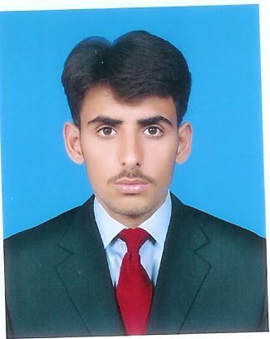
Mobile: 03235492215
Mobile:03457087369
Email: muthairkhan11@yahoo.com

SUMMARY
To work for an organization which provides me the opportunity to improve my skills and knowledge to growth along with the organization objective.
• Expert in implementation of each step of project.
• Eager to learn new technologies and methodologies.
• Always willing to innovate the new things which can improve the existing technology.

PERSONAL INFORMATION
Father’s Name: Muhammad Ibrahim Khan
NIC No. 37405-4230527-3
Domicile: Azad Kashmir (Bagh)
Date of Birth: 08-08-1995
Postal address: PAEC Flat No.2,Second Floor Block-C,G-8/4 Islamabad.
Permanent Address: Village Gulistan, Chatter No.1 Tehsil & District Bagh Azad Kashmir.

KEY SKILLS
- Machining Processes
- Forging Processes
- Mechanical Processes
- Industrial Safety & First Aid
- Industrial Materials
- Software(Ms-Office , Excel , Power Point)
- Internet Suffering
- Technical Report Preperation
- Quality Control Techniques & Management
- Fire Safety
- Furanance Working
- Technical Drawing

COURSES

November, 2016 – March, 2017 Technical Supervisor SMME (NUST ISLAMABAD)

EDUCATION / QUALIFICATIONS
B.Tech(Mechanical) | Continued | SARHAD UNIVERSITY PESHAWAR
DAE (Mechanical Technology (Production) With Specialization in Metallurgy and Welding Technology. | 1st Division | PBTE Lahore
Matriculation | 1st Division | FBISE Islamabad

LANGUAGES
Urdu: Reading, Writing and Understanding Excellent
Listening and Speaking Excellent
English: Reading, Writing and Understanding Excellent
Listening and Speaking Good

HOBBIES / INTERESTS
Reading, Writing, Traveling, Playing Cricket, Football.

PROJECTS.

Installation Of New Rerolling Steel Mills

Supervised By : Engr. Naweed Hassan
Deputy Director (DMRC NUST)

Date Of Started: 16 March 2017
Date Of Completed: 29 March 2017

Remarks:------------------------

