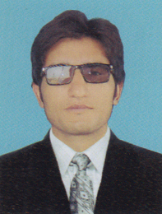

Tahir Iqbal
S/O
Muhammad Iqbal

NIC #: 14203-5191247-5

D.O.B: 15-04-1995

Religion : Islam

Nationality: Pakistani

Marital Status: Single

Current Address:
Vill&P/O Surati kala Teh Takht-e-nasrati Distt karak KPK

Permanent Add:
Vill&P/O Surati kala Teh Takht-e-nasrati Distt karak Kpk

Contact Number:
Cell # 03365605683
Cell # 03139944237

E-mail address:

Engr1275@gmail.com

Curriculum vitae

JOB OBJECTIVE:

To work with an aim to gain valuable hands on experience and professional skills in an organization, which provides a challenging, learning and developing atmosphere?

ACADEMIC QUALIFICATION:
CGPA/ GPA/
Degree/Certificate Session Obtained Marks Total Marks %age Board University

Bs (Mining 2017 2.38 4 60% BUITEMS Quetta
Engineering)

F.Sc. 2013 740 1100 67% B.I.S.E, Kohat

SSC (Science) 2011 742 1050 70% B.I.S.E, Kohat

OTHER QUALIFICATIONS:
Safety OfFicer from OSHA
Mine Rescue and Safety Training
First Aid Training Certificate
INTERNSHIP:
Mr ASHFAQ & AFZAL Minerals Nakband Kohat(6 months)
FINAL YEAR PROJECT:
Evaluation and Recommendation of Safety and Support System Of Coal Mine
LANGUAGES:
English, Urdu, Pashto.

REFERENCES
References will be furnished on demand

