Adnan Shafi (Electrical Engineer) 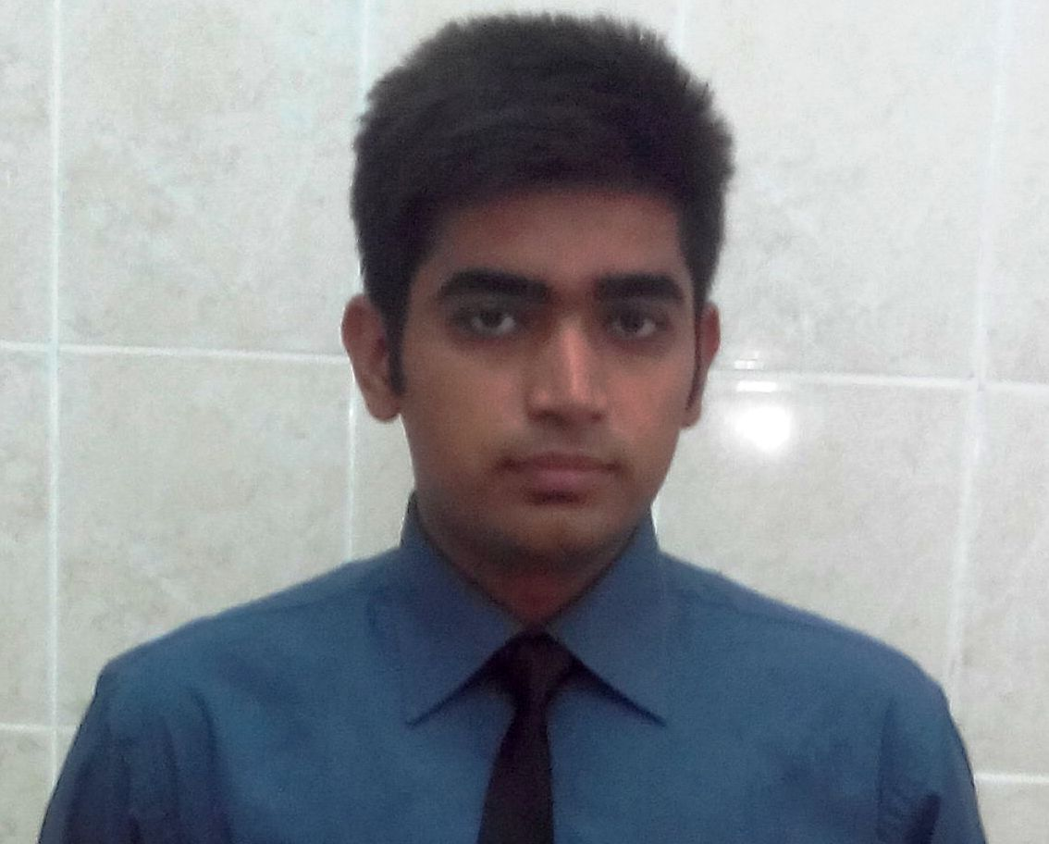

Address: : Advocate Muhammad Shafiullah, Near Baba garay wala, Muhammadi town near paf colony, Mianwali, Pakistan
Mob: +92-306-0849976 Email: adnanshafi123@gmail.com
NIC #: 38302-8858845-3 Alternate No. : +92-335-6032390

Introduction

I am a Electrical Engineer with a passion to thrive in the Power Industry of the Country. I have strong analytical as well as practical skills with an aptitude to work independently with minimum supervision.

Education

Degree | Institution/Board | Marks/GPA,Div
BS( Electrical Engineering)  (2012-2016) | COMSATS university of sciences and technology | 2.85/4.00
HSSC (2010-2012) | FBISE Islamabad | 845/1100 ,1st
SSC (2008-2010) | FBISE Islamabad | 878/1050,1st

Experience:

DESCON Engineering
Employee ID(3453)
  - Worked as trainee engineer in DESCON from 21 DECEMBER 2016- 25 DECEMBER 2017.
  - Experience of COAL fired power plant erection and commissioning.
  - Experience of Cement plant erection and commissioning.
  - CFPP And Cement Plant design,erection.troublesooting.
  - Expertise in Power and control circuits,instruments,route declaration,installation,working.
  - Experience of installation of Electrical system.
  - Cable Laying, Panel installation, Cable terminations.

Maple Leaf Cement Factory Mianwali
  - Worked As Internee Engineer at MLCF Mianwali from 05 SEP 2016 till 05 DEC 2016.
  - Have Know about
  - Operation/Maintenance of “NIIGATA” and “ WARTSILA” Engines
  - Star/stop of Wartsila/Niigata Engines.
  - Operation and handling of engine/Generator auxiliaries.
  - Trouble shooting of Wartsila/Niigata engines/Generator faults.
  - Engine Load management, monitoring of staff and machinery.
  - Administration and office work of power plant.
Internship at Pak American fertilizer factory Mianwali.(24 july 2015 till 24 Aug 2015).

Major Courses

- Power Generation
- Power Distribution
- Power Utilization
- Power System Analysis
- Electric Circuit Analysis

- Digital Signal Processing
- Digital Logic Design
- Analogue Electronics 1,2&3
- C++
- Signal and Systems

Final Year Project

Automatic Voltage Regulator(AVR) and Power Factor Improvement

Major Projects

- Designing and Implementation of a 25 Watt DC Electrical motor.
- Designed a Four Way Traffic signal circuit with the help of BJTs.
- Designed automated parking system using Logic gates.
- Designing and Implementation of a Line following robot.
- Designing and Implementation of temperature controlled cooling fan.
- Designing and Implementation of a power supply.
- Designing and Implementation of a Transformer.

Skills

- Microcontroller Programing.
- Ms Office.
- Engineering Software include C++, Matlab, PSpice, Proteus.
- Good sense of troubleshooting.
- Good problem solving skills in complex situations.
- Competency in digital and analog circuit design and simulation software.

Training & Seminars attended

- British council seminar.
- Kangaroo mathematics seminar.
- Placement seminars.

