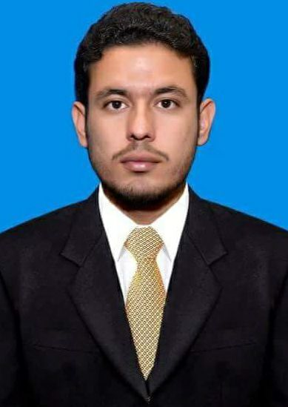
SHAH AHLULLAH ZAKORI
Cont:0314-9088997
Email:shahahlullahzakori@gmail.com
Personal Information

Father’s Name: Khurshid Anwar Zakori
Date of Birth: 30-Mar-1997
Martial Status: Single
Religion: Islam
Domicile: Lakki Marwat (KPK)
CNIC NO: 11201-5170195-7
Nationality: Pakistani
Mailing Address: Vill & P/O Gandi khan khel, Tel: Serai naurang Distt: Lakki Marwat(kpk)
Objective

Desire a challenging position to meet my competencies, capabilities, skills, education and experience; and be an active part of qualified professionals; and to apply my talent, energy and enthusiasm for the mutual growth. An exciting and creative position where there is an opportunity to work with people in an environment of excellence, competition and passion. Make positive contribution towards the given position the organization and enhance the knowledge abilities and skill through organization by contribution.
Internships

- POF(Pakistan Ordinance Factory)Wah cantt
Academic Qualification

Qualification | Passing Year | Subject | Board/University
Graduation | 2018 | Bachlor of  Chemical Engineering | University of Wah, wah cantt
Intermediate/ ‘A’ Level | 2014 | Pre Engg | BISE Banuu
Matriculation/ ‘O’ Level | 2012 | Science | BISE Kohat

Assignment & Projects

Skills

- Typing gross Speed more then 35 words per min.
- Proficient user of MS Office & Internet.
- Excellent communication and presentation skills.
- Hands on the use of all hardware in composing, scanning & printing.
- Hands on the installation of all kinds of Software and Hardware.

Study Tours

- Hazara Phosphates, Haripur
- Dakni OGDCL Gas Processing Plant

Languages

 | READ | WRITE | SPEAK
English | - . | - . | - .
Urdu | - . | - . | - .
Pashto | - . | - . | - .

References

