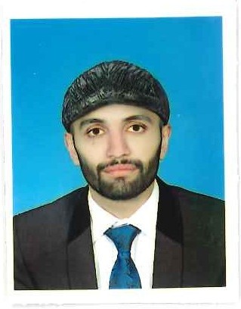
Imran Awalbaz
Address: Gohar ayub town,Abbottabad,Pakistan.
Mobile No. +92 3459759991 / +92 3121866699
E-mail Address: imranawalbaz93@gmail.com

Objective

To work in a dynamic and international organization with challenging responsibilities which would assist in my development and would contribute to the growth of the company.

Technical Expertise

- Free-Cad
- Raspberry Pi
- Proteus
- Altium Design.
- Arduino.
- MP-Lab.
- Mat Lab.
- Simulink
- Proficiency in English and good verbal and written communication skills.
- C++ programming language.
- Excellent Interpersonal relationship, motivational and team building skills.
- Good IT skills.

Professional Experience

- COMPANY : National Radio and Telecommunication Corporation (NRTC).
Haripur, Pakistan

POSITION : Internee Engineer (Research and Development)
09th Feb 2016 to 28th Feb 2016.

Key strength

- Analytical mind to identify problems and implement effective solutions.
- Flexible by nature.
- Positive attitude.
- Hard working & self-confident.
- Team management.

Educational Background

University : Bachelor of Science in Electrical and Electronics Engineering
Comsat Institute of information technology, Abbottabad, Pakistan

COLLEGE : H.S.S.C (majored in pre engineering)
Peace College, Pakistan

School : S.S.C (majored in Science)
The Message school & College, Pakistan

Final Year Project

Project Title : Design and Implementation of Low Resource Humanoid Robot
Description : Self Balancing of Humanoid Robot and Detection of obstacles with laser pointing.
No OF Team members : Three

Semester Projects

- Control System : Automatic Water Level detector with Auto start Motor
- Electronics : Home Automation Using Arduino (Single Room)
- Digital Signal Processing : Noise Removal using Notch Filter
- Digital System Design : Digital Clock using Spartan-3E
- Industrial Electronics : Control of Speed OF Servo Motor
- Electric Circuit Analysis : Automatic Street Light Using LDR
- Electric Machines : Speed Control OF DC motor on Proteus

Field of Interest

- Industry
- Power generation and Control
- Communication Side
- RF Receivers and Transmitters
- Project Management
- Event Management

Personal Information

Date of Birth : 07th Mar 1995
Religion : Islam
Civil Status : Single
Nationality : Pakistani
Gender : Male
Language : Fluent in English, Urdu, Pashto & Hindko
CNIC : 21303-1928584-3
Father Name : Awalbaz

Awards and achievements

- Black Belt 2nd Dan (Taekwondo).
- District Medalist (Taekwondo).
- Provincial Medalist (Taekwondo).
- National Medalist (Taekwondo).

Hobbies

- Taekwondo
- Cricket.
- Travelling and interacting with people from different culture.
- Reading.

Reference

- Reference will be provided on demand.

I hereby declare that the above information is true and correct and I bear the responsibility for the correctness of the above mentioned particulars.

Applicant

Sign:-

