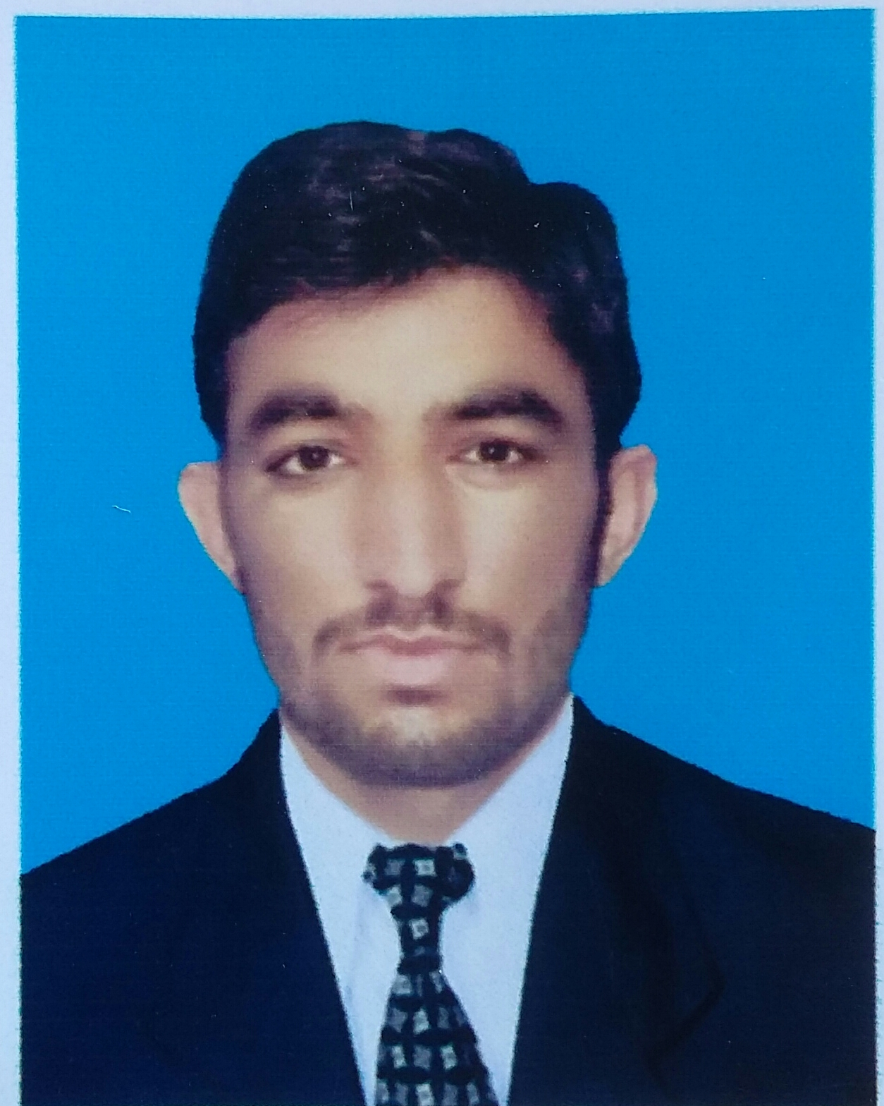
Amjad iqbal
Vill: shagi lawagher P/O karak Tehsil and District Karak.
Cell# :03318897848
E-mail:amjadktk305@gmail.com

OBJECTIVE:
- To work in an organization as an integral part of it and accomplish the job assigned in a better way. I am looking for a highly challenging and dynamic work environment in which I will be able to enhance my Professional skills and would be able to get valuable work experience.
- I believe in honesty, simplicity, teamwork, and commitment.

EDUCATION:

Class | Passing Year | Marks/CGPA | % Age | School/Collage/University
SSC | 2011 | 765/1050 | 72.85% | Karak model high school karak
F.Sc | 2013 | 778/1100 | 70.72% | Chokara science school and college chokara karak
B.S Electrical power Engineering | 2017 | 3.0/4.00 | 75.25% | University of engineering and technology taxila

current status:
Working at different project
COMPUTER SKILLS:
- MS Office, C++ programming, PLC Programming, and MATLAB.

ENGINEERING Projects
- design and develop power factor correction using static var compensator (svr)
- Digital thermometer
- ampare meter
- digital clock

Personal Qualities
- Strong analytical and people management skills
- Excellent verbal and personal communication skills
- Passion for constant improvement
- Ability to take sound decisions
- Excellent organization and prioritization skills
LANGUAGES:
- English, Urdu, Pashto (Read, Write & Speak)
Interest:
- Reading books, writing and sports.

PERSONAL DATA:
Father’s Name : Aziz ur rehman
Date of Birth : 11/09/1995
Domicile : karak KPK (Pakistan)
N.I.C : 14202-2688339-7
Marital Status : Single

POSTAL ADRESS:
- Present Address
Village shagi lawagher P/O karak tehsil and district karak.
- Permanent Address:
Village shagi lawagher post office shagi lawagher Tehsil and district karak.

ReferenCES:
Reference will be provided on demand

