FAYAZ ALI FAYAZ
Master of Science in Engineering Management
& Bachelor of Technology in (Mechanical)
Contact No: - 00923152121246
Nic No: - 14101-7486545-5
Passport No: - AX8115451
E-mail:- fayaz486.suit@gmail.com
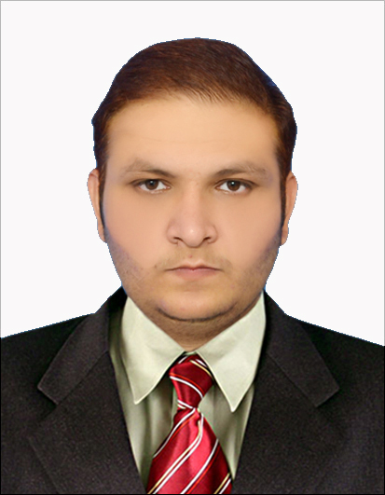

Present Address: Five Star General Store near Al-Faisal Street Bara Gate Peshawar Pakistan

CAREER OBJECTIVE

To work in a firm with a professional work driven environment where I can utilize and apply my knowledge, skills which would enable me as a fresh graduate to grow while fulfilling organizational goals.

ACHIEVEMENTS

- Gold Medalist in Bachelor of Technology Mechanical Engineering from Sarhad University of Science and Information Technology Peshawar Pakistan

EXPERIENTIAL LEARNING ( INTERNSHIP PROGRAM)


    - Company Name :- Heavy Mechanical complex Taxila Pakistan
- Project Title :- Over all fabrication and casting process
- Duration :- One and half Month from 25/9/2015 to 6/11/2015

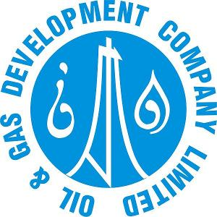
    - Company Name :- Oil and Gas Development company limited Pakistan
    - Project :- Maintenance and overhauling of rig
    - Duration :- One month from 5/11/2015 to 2/12/ 2015

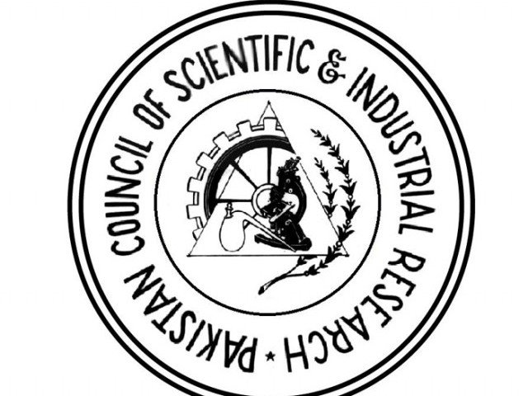
    - Company Name :-Pakistan Council of Scientific And Industrial
Research (PCSIR)
    - Project :- AUTO CAD/AUTO CAM
    - Duration :- Two month 14/02/2012 to 14/04/2012

SAFETY COURSES

- IOSH
- OSHA
- One Year Diploma of Safety Officer from Trade Testing Board Pakistan

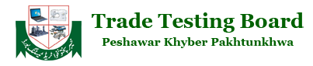

BASIC ACADEMIC CREDENTIALS

Qualification | Board/College/University | Year | Percentage
Intermediate (Science) | Board of Intermediate Secondary Education Peshawar Pakistan | 2007 | 60%
Diploma of Associate  Engineer Mechanical  (3Years) | Government College of Technology  Peshawar Pakistan | 2008/2011 | 70%
Diploma in Information  Technology (1Year) | Government College of Technology  Peshawar Pakistan | 2015 | 79%
Diploma of Safety Officer (1Year) | Harris Institute of Safety and Information Technology Peshawar Pakistan | 2017 | 84%
Bachelor Of Technology Mechanical (Hons) | Sarhad University Of Science And Information Technology Peshawar Pakistan | 2015 | 83%  3.72 CGPA  Gold Medalist
MS Engineering  Management | Abasyn University Peshawar Pakistan | 2015/2017 | CGPA 3.90  Nominate for Gold medal

THESIS REPORT

- Impact of Intrapreneurship on Value Addition Process with Mediating role of Process Innovation

PROJECTS REPORT

- Solar power Wheel chair With Automated Steering (On Bachelor’s Level)
- Adjustable Inclined conveyer belt (On Diploma Level)

IT PROFICIENCY

- Auto CAD
- Auto CAM
- Microsoft Office Word, Microsoft Office Excel, Microsoft Office Power Point
PROFESSIONAL EXPERIENCE

- Served few months in private industrial sector as multiple Machine Operator in Mechanical workshop in 2011 in MKB group of industries
- Served about 4 years and 4 months from 2011 to 2015 as a Maintenance Supervisor in different mechanical parts fabrication and casting in a private industrial sector (Raheem engineering works)

INTERPERSONAL SKILL

  - Ability to rapidly build relationship and set up trust
  - Confident and Determined
  - Ability to cope up with different situations

PERSONAL DETAILS

- Father’s Name :- Sarfaraz Khan
- Permanent Address :- Peshawar KPK Pakistan
- Date of Birth :- 24th March 1990
- Language Known :- English & Urdu
- Marital Status :- Single
- Nationality/Religion :- Pakistani/Muslim
- Interest & Hobbies :- Internet browsing , badminton

DECLARATION

I do hereby declare that the above information is true to the best of my knowledge.

Place: Fayaz Ali Fayaz
Date: (Signature)

