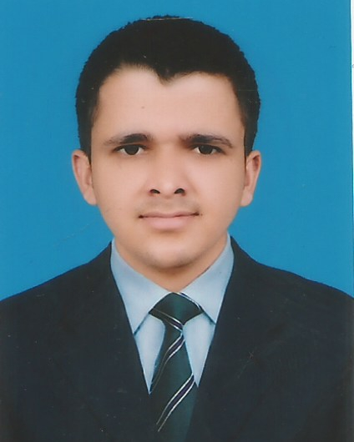
MUHAMMAD REHAN MUMTAZ

Address: Colony No. 1 Street No. 3 House No. 977 Khanewal.
Mob # 0340-3132425/0331-7996410
Objective

- To achieve excellence in commitment and dedication and in my career and prove services with utmost commitment and dedication in a professional and career oriented organization, which will offer me challenging and motivated environments.
Personal Data

- Father’s Name : MUMTAZ ALI
- Date of Birth : 21-09-1996
- CNIC No. : 36103-5601176-1
- Marital Status : Single
- Religion : Islam
Qualification

Degree | Year | Marks | Division | Board/University
Matric | 2012 | 836/1050 | 1st | B.I.S.E Multan
F.sc (pre.eng) | 2014 | 668/1100 | 1st | B.I.S.E Multan
B.sc(ph,chm,g.math) | 2017 | 376/800 | 2nd | BZU Multan
Hobbies

- Book reading
- Newspaper reading
- Playing cricket

Language

- English
- Urdu
- Punjabi
Reference

- Will be furnished on demand.

