3o
 | Ésumé

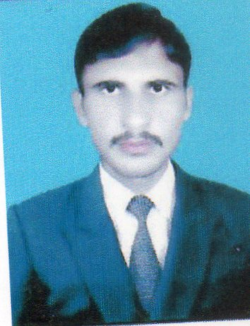

Name: Zia ur rehman

F.Name: Abdur rehman

CNIC: 11201-6420297-7

Birth: 31-03-1995

Gender: Male

Nationality: Pakistani

Religion: Islam

Domicile: Lakki Marwat

Address: Bachkan Ahmadzai P/O Tajori Dist Lakki Marwat.

Contact :

+92313 9893693

+92304 9400114



Zia7194@gmail.com

Personal Statement:

To become an active member of a dynamic team of any organization, accept challenges and further to improve my professional skills. I will not make the institution feel sorry for hiring me.

Academic Profile:

Degree | Passing Year | Marks | Division | University / Board
Matric  ( Science) | 2011 | 838/1050 | 1st | B.I.S.E BANNU
F. Sc  (Pre.Med) | 2013 | 777/1100 | 1st | B.I.S.E BANNU
B.Sc  Supper chemistry | 2016 | 397/550 | 1st | University of Science and Technology Bannu
M.Sc  Chemistry | 2018 | 3.05/4.00 | 1st | Kohat University of Science & Technology Kohat
C.T | 2016 | 631/900 | 1st | Alama Iqbal Open University, Islamabad
DIT Computer | 2016 | 1180/1400 | 1st | KPK Board OF Technical Education
Others:

- Six month computer Special training Course organized by the S.D.C Peshawer in the institute of Matrix PPC College Bannu

Computer Skills:

- Office Automation (Word, Excel, Power Point)
- Software and Hardware Installation.
- Operating System (Windows XP, 7 and 8)
- Internet Surfing.

Languages:

- Urdu.
- Pashto.
- English.

Hobbies:

- Reading Books.
- Internet Browsing.
- Driving Cars and Bikes.

