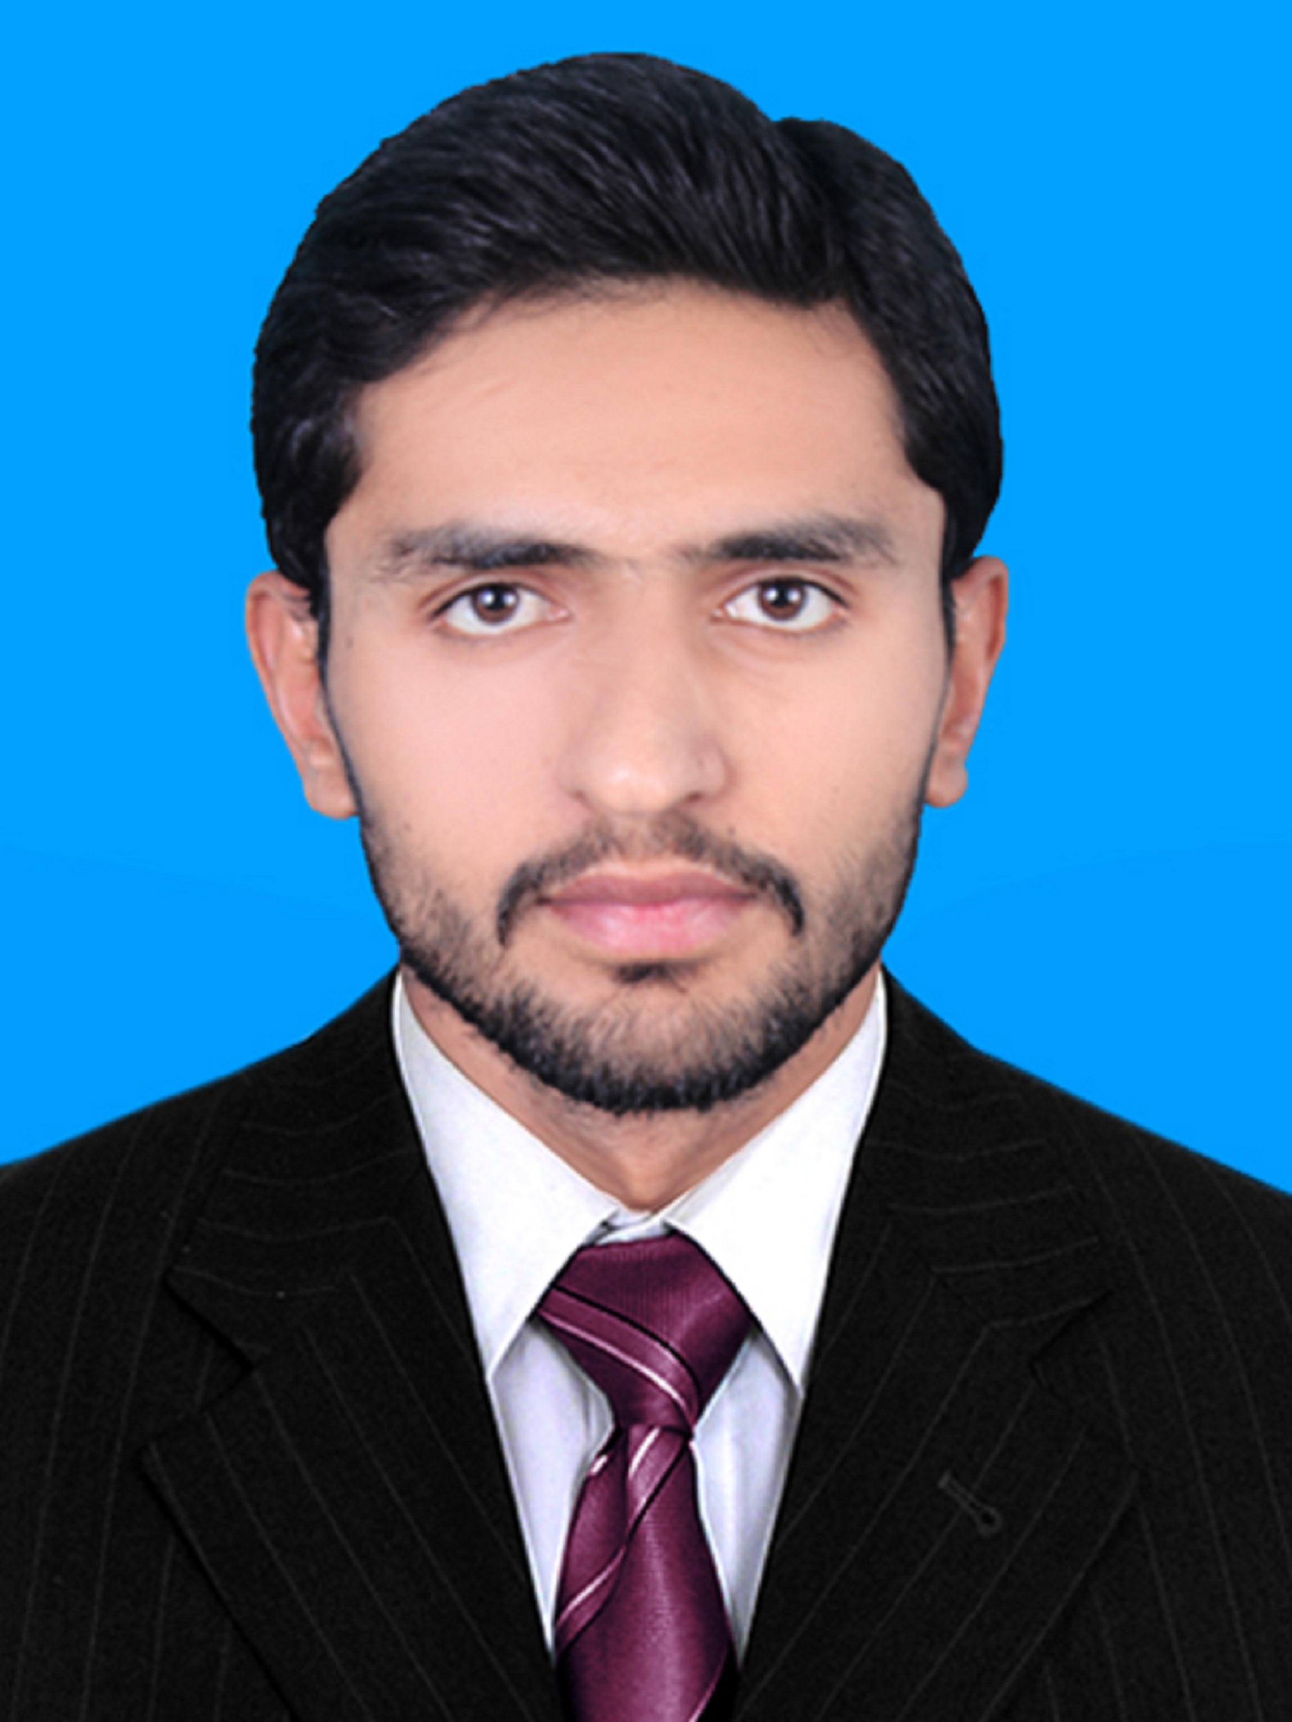
Muhammad Arslan Rasheed
PEC No.: Chemical/15332
marslan9559@gmail.com
+92 331 2772800, +92 304 7283393
House # 35, Street # 02, Ilyas Colony, Block # C, Sadiq Abad, distt. Rahim Yar Khan, Punjab

Objective
To find a position within a workplace that challenges me to perform and improve my skills, an environment that offers me to help others as much as learn from them and an opportunity for growth and career advancements.
Experience
- Combined Fabrics Ltd.
(3 July 2017 - Present)
I am working as a Management Trainee Officer (MTO) at combined fabrics. My responsibilities are
as follows:
- Maintaining MSDS (Material Safety Data Sheet), RSL (Restricted Substances List), TDS (Technical Data Sheet) & CIL (Chemical Information Log).
- Maintaining Printing Chemicals Stock like Pigments, Sprays, Starter Sprays and cotton tapes etc. and making sure enough chemicals are available in stock
- Making Purchase Orders for different required chemicals.
- Contacting to different vendors for ordering chemicals.
- Making color recipes for sampling & production color kitchen.
- Making sure that all items such as stationery, masks, safety gloves etc. are available all the times in printing department.
- In leisure time, to work on machines according to the instructions given by manager.
Education
2016 | B.Sc. Chemical Engineering |  | 2.83 CGPA |  | University of Gujrat, UOG, Pakistan
2012 | F.Sc. Pre-Engineering |  | 66.72 % |  | Bismillah Higher Secondary School, Sadiq Abad
2010 | S.S.C. Science Group |  | 76% |  | Bismillah Higher Secondary School, Sadiq Abad
Achievements
- Received laptop in “Shahbaz Sharif Youth Initiative Program”, 01st March 2013
- Won 3rd Prize in All Pakistan Project and Poster Competition 2015 held at University of Gujrat Hafiz Hayat Campus, Gujrat.
- Organized Chemical Engineering Cricket Championship 2015 in University of Gujrat Hafiz Hayat Campus.
- Completed all the assigned projects with remarkable distinction, during engineering studies
- Remained Class Representative for one year during engineering studies
- Member of the Extra Curricular Activities Group at the school
Plant Design Project
Oct 2015 – Oct 2016 |  | Conversion of 3000 TPD of sugarcane bagasse to fermentable sugars using concentrated acid hydrolysis
Memberships & Participations
- Participated in seminar on “Emerging Technologies in Process Industries & Entrepreneurship 2015”, 25th May 2015, held at University of Gujrat Hafiz Hayat Campus, Gujrat
- Participated in “2nd International Conference on Engineering Sciences”, 02-03rd December 2015, held at Institute of Chemical Engineering & Technology, University of the Punjab, Quaid-i-Azam Campus, Lahore,
- Participated in “APPPC’15”, 10th December 2015, held at University of Gujrat Hafiz Hayat Campus, Gujrat
- Participated in “I NEED A JOB” Savvy!, 21st January 2016, held at University of Gujrat Hafiz Hayat Campus, Gujrat
- Participated in “4 Days Training Workshop on Software and Tools of Chemical Engineering”, 19-22nd April 2016, held at University of Gujrat Hafiz Hayat Campus, Gujrat
- Participated in “APPPC’16”, 01-02nd June 2016, held at University of Gujrat Hafiz Hayat Campus, Gujrat
- Participated in “1st International Conference on Emerging Technologies for Waste Water Processes and Alternative Energy Resources”, 01st June 2016, held at University of Gujrat Hafiz Hayat Campus, Gujrat
Technical Skills
Basic knowledge of : | - Math Works MATLAB  - Microsoft Office including Visio | - Coco
Interests
- Reading  - Surfing on Internet | - Travelling and Exploration
References
References will be furnished on demand.

