UMER ALTAF

PERSONAL INFORMATION
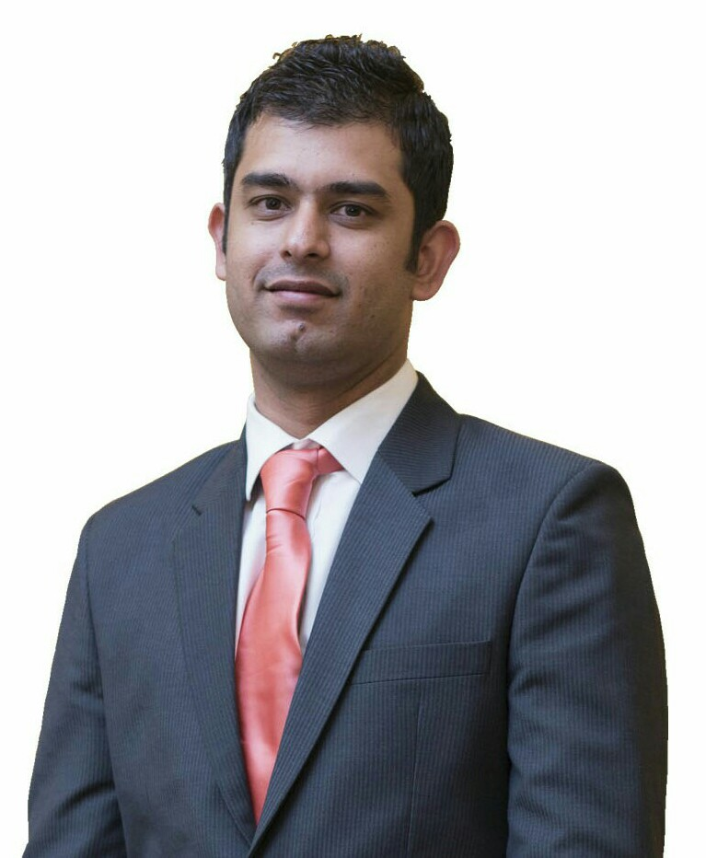
Permanent Address:
House No 48, Street No10
Qutbal Town Khana East
Islamabad
Mobile:+923465318778
E-mail: umer.altaf1@gmail.com
Skype: umer_altaf
Languages: English, Urdu

OBJECTIVE

To work in an environment that promotes my professional growth and gives me the opportunities to
utilize my abilities to the fullest.

EDUCATIONAL HISTORY

B.Sc. Electrical Engineering (Electronics) (2004-2008) from Air University Islamabad
CGPA: 3.16/4.00

Work Experience

Company: Turno Tech
Duration: Feb 2018 – Present
Designation: IT Support Engineer

- Install and configure computer hardware operating systems and applications.
- Monitor and maintain computer systems and networks.
- Talk staff through a series of actions, either face-to-face or over the phone, to help set up systems or resolve issues.
- Troubleshoot system and network problems, diagnosing and solving hardware or software faults.
- Replace parts as required.
- Set up new users' accounts and profiles and deal with password issues.
- Respond within agreed time limits to call-outs.
- Conduct electrical safety checks on computer equipment.

Company: Al Marwa Rayhaan By Rotana
Duration: Oct 2012 – Jan 2018
Designation: Engineering Coordinator

- Maintain all mechanical, electrical and electronic equipment including heating and ventilation, as well the general maintenance of the Hotel complex.
- Distribute the work to subordinates accordingly to capabilities to get the best result
- Organize and set up preventive maintenance programmers for all electrical and mechanical equipment including general building works
- Schedule planned and preventive maintenance programs on all electrical ,mechanical and kitchen equipment throughout the Hotel premises
- Supervise maintenance Employees and contract Employees who are carrying out minor building work, electrical and mechanical installations
- Oversee the general maintenance of all life safety systems throughout the Hotel and reports any major defects to the Assistant Director of Engineering/Director of Engineering
- Maintain the cleanliness of all electrical panels, motors, electrical appliances etc
- Follow the preventive maintenance chart strictly and maintain records for future reference
- Coordinate with other departments counterparts and ensure their satisfaction on quality and progress and create healthy inter-department relationships
- Maintain all kitchen equipment in good working order
- Maintain the performance of pumps and motors
- Ordering, filing requisitions and obtain the relevant departmental approval for the
purchase of items
- Coordinate with the vendors/ suppliers & Purchasing department for the timely delivery of
items to the hotel
- Prepare the 6-month departmental Learning & development plan based on identified needs and in line with the standard of the Managing Employee Development program
- Ensure that all departmental Learning & Development activities are recorded on the respective Learning & Development records and that those are kept up to date at all times in line with the Learning & Development review standards
- Maintain the department’s Standards Of Performance manual in line with the agreed format, updating the SOPs or adding new ones and to ensure the adherence to the departmental SOPs by all the departments
- Maintain and update Departmental Orientation Manual
- Conduct departmental orientation for new employees, using the department orientation checklist
- Prepare, organize and review initial job training plans for new employees.
- To organize and review as applicable the new employee cross exposure as applicable to selected positions within the first three months of employment
- Monitor and, when required, review any individual employee personal development plans (PDP.
- Carry out any administration / development requirements relating to trainees allocated to the department
- Submit monthly departmental Learning & development report to the Learning & Development Department by the end of each month, using the agreed format.
- Prepare for and participate in the organized departmental Learning & development standards reviews
- Operate in a safe and environmentally friendly way to protect guests’ and employees’ health and safety, as well as protect and conserve the environment
- Comply with the hotel environmental, health and safety policies and procedures

Company: Speedy Automation
Duration: Dec 2010 – June 2012
Designation: Sales Engineer

- Managed inquiries, developed quotations and created sales orders with references to quotations
- Developed business plans for sales and marketing for commercial clients
- Prepared sales proposals, estimated price, and credit terms
- Maintaining strong and good business relationships with the customers as well as with the principals.
- Providing Instrumentation & Automation solutions to the Industry
- Sizing and selection of proper instruments (Level, Pressure, Flow and Temperature) to meet customer requirements
- Calibration and re-parameterization of Ultrasonic Flow Meter at WASA.
- Installation and Commissioning of Dust Analyzer / Stack Analyzer in different Steel Mills.
- Identified new clients regularly by using resources such as business directories, followed up leads for existing clients

Company: Al Ghurair Foods L.L.C (Dubai)
Duration: Dec 2009 – Mar 2010
Designation: Trainee Engineer

- Worked in three different Food Industries to analyze the process of the Plant.
- Daily Inspection of the Plant
- Take readings of the machinery and ensure that all equipment’s are running in working condition.
- Testing and troubleshooting of 3 phase Ac motors in machineries
- Learned about different types of sensor used in Oil Plant e.g. Flow sensor, Temperature sensor, Speed sensor, Pressure sensor, Level sensor, Proximity sensor, Pneumatic Valve, Variable frequency drive.

Company: Pakistan Telecommunication Company Limited
Duration: July 2007 – August 2007
Designation: Trainee Engineer

Working in the international gateway transmission and maintenance center of the PTCL. Understanding the principles of data compression of the incoming and outgoing traffic, E1, T1 and PCM.

ACHIEVEMENTS

- Selected for achieving the highest score in Departmental Learning & Development Standard Reviews for the Year 2016.
- Selected for achieving the highest score in Departmental Learning & Development Standard Reviews for the Year 2015.

TRAININGS
- On Job Training (OJT)
- Managing Colleague Development (MCD)
- Destination Leadership
- Fire Training
- Evacuation Drill With Saudi Service and Al Borj International

SKILLS

SOFTWARES: Opera , FBM, QMS, Microsoft office, Outlook, Adobe Photoshop, Windows XP, Windows vista and 7.

