ahsan ali 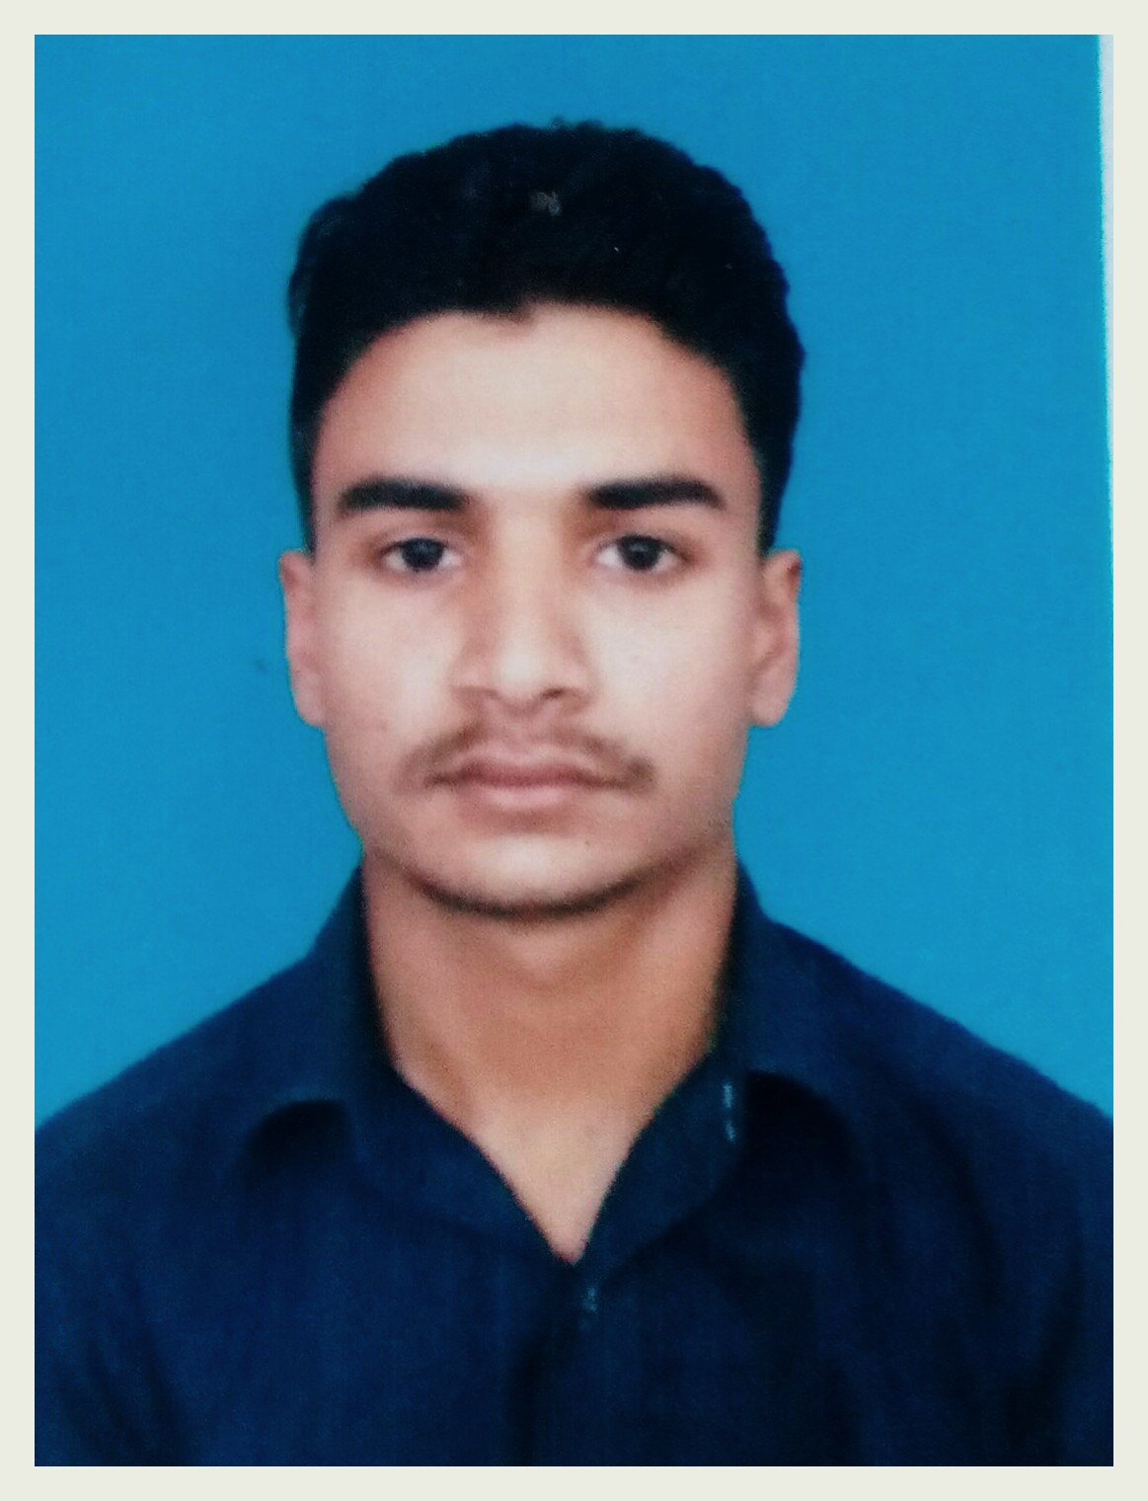
Address: Mohallah Khandiq Vill & P.O Kot-Najibullah Dist. Harpiur.
Email: gahsan1250@gmail.com
Mobile: +92-307-5897964.

Objective:
To begin my career life with hard working, technical skills ,which improve my knowledge and ways of working.
Education:
Duration | Degree & Institution | obtain marks/total marks
 | .
2016 – 2017 | S.S.C  Board of Intermediate & Secondary Education Abbottabad. | 619/1100
SKILLS:______________________________________________________________________________
Electrical single phase wiring.
Home appliances installation and Maintenance
Computer knowledge
MS-OFFICE
Mobile repairing Hardware and software knowledge.

experience:
One year working of out source home wiring .
6 month working as mobile repairing center
Interests & Activities:

Playing Cricket, Gaming, Reading books, Web surfing, Movies and Music.
Personal Profile:
- Father’s Name: Safdar Nawaz
- NIC No. : 13302-9495527-5
- D.O.B. : 16-July -2000.
- Marital Status: Single.
- Domicile: Haripur, (K..P.K).
- Nationality: Pakistani.
- Language: English, Urdu, Hindko.
References
References will be furnished upon request.

