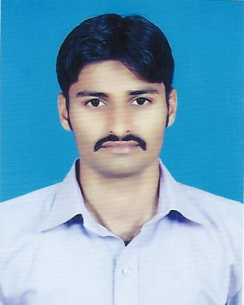
SHAHID MURTAZA  Shahid.murtaza.96@gmail.com | ADDRESS:  Quaid E Azam International Hospital ICU Department Golra Moar  Rawalpindi.
Cell: 0300-2948351 | 0334-5315680 | 0308-4996772

OBJECTIVE:

“A position in a results-oriented organization that seeks an ambitious and career conscious person where acquired skills and education will be utilized towards continued growth and advancement.”

PERSONAL INFORMATION:

Father’s Name Ex-6682586 Retd NK/CIK Ghulam Murtaza, ASC
Date of Birth 21-02-1992
CNIC No 38201-6104472-1
Domicile Punjab (Khushab)
Religion Islam
Marital Status Single

EDUCATION:

- MATRICULATION (SCIENCE)

BOARD OF INTERMEDIATE & SECONDRY EDUCATION SARGODHA
(B.I.S.E SARGODHA)

- D.A.E ELECTRONICS

PUNJAB BOARD OF TECHNICAL EDUCATION LAHORE (P.B.T.E LAHORE)

COMPUTER SKILLS:

- (D.I.T) Diploma in Information Technology from Institute of Computer & Management Sciences (1 year).

EXPERIENCE:

- Work as a Computer Operator & Sales Manager in Singer Pakistan Limited Rawalpindi Saddar Haider Road Branch from 15/09/2012 to
30-11-15.
- Working as Computer Operator (UR) in QUAID_E_AZAM INTERNATIONAL HOSPITAL in ICU Department from 07-12-15 to till.
- Two year working Experience with WHO as a Polio worker.

LANGUAGES:

- English
- Urdu
- Punjabi

STRENGTHS:

- Excellent leadership, analytical, problem solving / decision making skills.
- Excellent track record of meeting the targets on time using time management skills.
- Excellent Documentation, written, oral, interpersonal communication and presentation skills.
- Pleasant manners with a high sense of commitment, loyalty, integrity and patience.
- Highly adaptable to work in dynamic environment.

OTHER SKILLS & HABITS:

- Reading Islamic Books.
- Having the habit of Self-Service, Self-Direction & Self-Motivator (as well as for others).
- Energetic & Good Player of Cricket.
- Study extra knowledge.

REFERENCE:

- Will be furnished on demand.

CONCLUSION:

- I believe in making a difference no matters how small is it? Hope to get a positive response from you. Anxiously forward to hear from you as soon as possible.

