Jahanzaib Malik

Personal Information
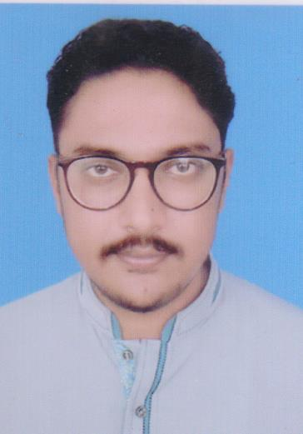
Date of Birth 23-03-1992
Address Mohallah rasheed pura street malik sarwar Shakargarh, Narowal
Mobile No. +92 334 8004571
Email jazzi143@outlook.com

Key Competencies
- Ambient air quality monitoring
- Solid waste management
- Occupational health and safety
- Preparation and implementation of environmental management plan (EMP)
Work Experience
03/2017 – Present Executive Officer at Green Crescent Environmental Consultants, Pakistan
- Environmental monitoring of different projects funded by ADB and World Bank
- Prepared initial environmental examination (IEE) and environmental impact assessment (EIA) reports
- Visited to different industries in order to check their indoor air quality and health and safety measurements
- Preparation and implementation of EMP
- Conducted environmental baseline survey of Turkmenistan, Afghanistan, India and Pakistan pipeline (TAPI)
11/2016 – 03/2017 Environmentalist at Solution Environmental and Analytical Laboratory, Lahore
- Prepared IEE report of Umar Hospital, Lahore
- Environmental audit report of Metro Cash and Carry, Islamabad
- Arranged stockholder meetings
- Designed waste water treatment plant for Noon Sugar Mill
- Conducted environmental baseline survey of jalalpur irrigation project
08/2013 – 10/2013 Internship at Municipal Services Department, city district government, Rawalpindi
- Reviewed environmental assessment studies
- Participated in building up plans and solid waste management in Rawalpindi
- Developed route map plan to transfer solid waste to the landfill site
- Reviewed audit reports for occupational health and safety in SWM department, CDGR
- Participated in capacity building and public awareness
07/2013 – 08/2013 Internship at Blessed Textile LTD, Shiekhupra Faisalabad Road, Ferozewattoan
- Compliance and enforcement of health, safety and environmental systems
- Carried out risk assessment initiatives and their control
- Identified job hazards, analyses and proposed mitigation plans

07/2012 – 10/2012 Internship at Robica Enterprises, Wazirabad, Pakistan
- Conducted safety risk assessment and characterization of the whole plant
- Prepared preventive and corrective action plans
- Implementation of the preventive and corrective action plans
- Inspection and supervision of health safety and environment (HSE) plans and systems
- Revised plans and systems for continual improvement

Education
2014 – 2016 M.Sc. (Hons) Environmental Sciences
University of Agriculture Faisalabad, Pakistan
2010 – 2014 BS (Hons) Environmental Sciences
University of Gujrat, Pakistan
Key Skills
Professional Marketing, project management, team management, communication and presentation
Language Skills
English good Urdu Mother tongue
References
Available upon request

