TURMO
www.turmo.org
How to use the FPS function?
- Click the link
https://tw.msi.com/Landing/afterburner/graphics-cards to download and install
https://tw.msi.com/Landing/afterburner/graphics-cards
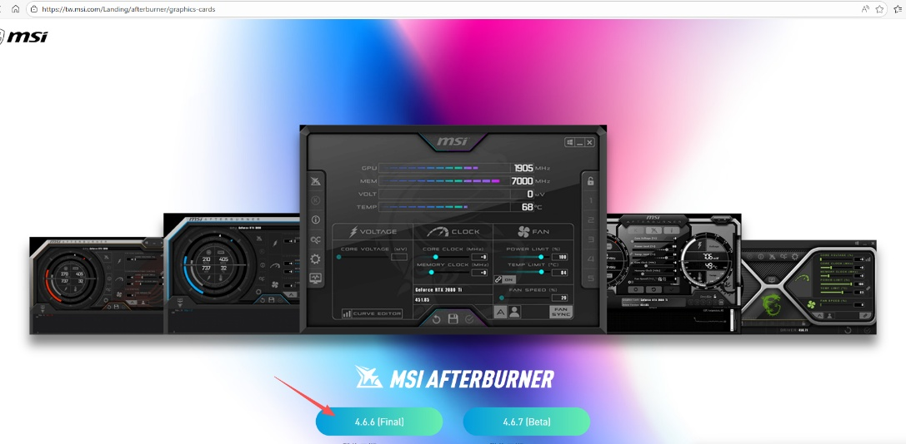
2. Extract and run the program
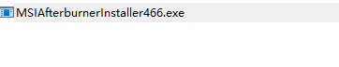
3. Select the MSI Afterburner
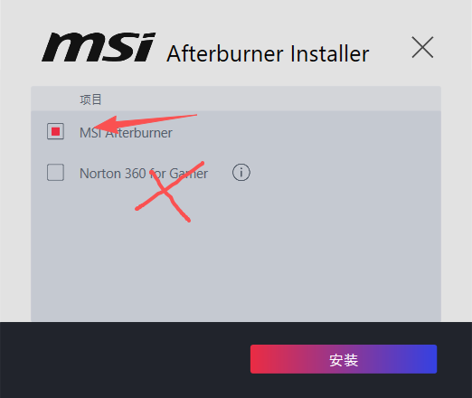
4. Select language
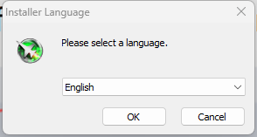
5. Must Select RivaTuner statistics server
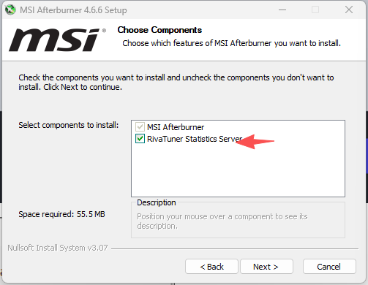
6. Select language
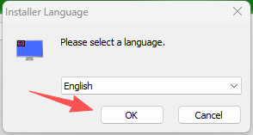
7. Remember the RTSS installation folder, locate the Rtss directory (the default folder is shown in the picture)! Run it by clicking rtss.exe. 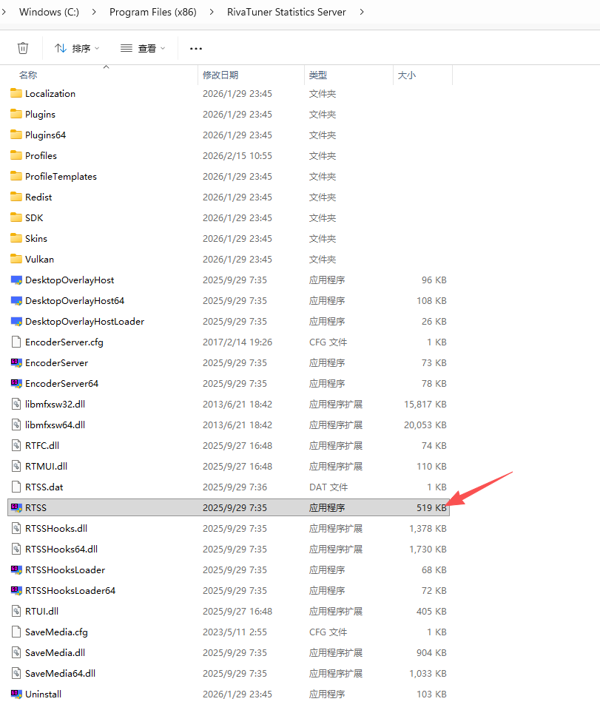
8. After running, you can see RTSS in the system tray. Click to open it. 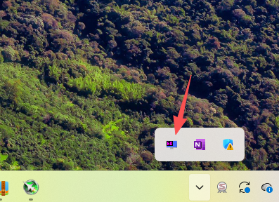
8. Set RTSS to launch automatically on system startup. 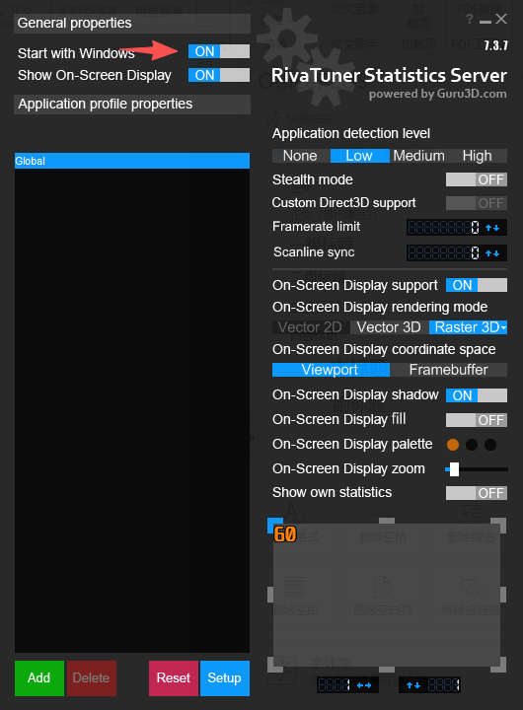
9. After you restart your computer and launch the game, the FPS function will work normally.

