Performance Measures

# Body

* [What body does a performance SUP racer need](2_body.md)
* Training Fundamentals
  + [The fundamentals you need to build upon](training_fundamentals)
  + Self Evaluation
  + Year Planning
  + Planning Blocks
  + Planning Sessions
  + Executing Sessions
  + Tracking performance
  + [Journaling](jornaling)
  + [Pathways](training_pathways)
  + [Performance Measures](training_measures.md)
  + [Polarised Training](training_polarised)
  + [Rate of Perceived Effort](training_rpe)
  + [Cross Training](training_crosstraining)
* Changing what your body is capable of
  + [Physical Transformation](transformation)
  + Strength
  + Speed
  + Endurance
  + Balance
  + Fuelling

# Journaling

We have already mentioned journaling in the Mind Section but it is equally important here

!!! Info “Journalling”

- Record your training session  
- Record stats, conditions, fuelling, kit, company and feelings  
- Use these to work out what helps you and what hinders your progress

Some journal examples are in the Resources Appendix

# Fundamentals

## Strength

* If you are not strong then you will never reach your speed potential
* Lack of strength will mean that going fast during an endurance race will tire you out quickly

## Power

* Strength is largely a static thing. Power is Using that Strength
* Power = Work Done/Time. This means that more Power allows you to use your Strength quicker.
* A Strong person can pull the paddle really hard.
* A Powerful person can pull it hard AND fast.

Why does this matter?

* Lots of strength training will make you strong but potentially unable to use it at speed.
* Think of the stereotype of a musclebound bodybuilder who is quite stiff. Stronger than I will ever be BUT might struggle to maintain 45 strokes per minute.
* This also suggest that flexibility also impacts ability to deliver Power.

## Aerobic Fitness

* Long and Slow

## Anaerobic Fitness

Sp

## Balance

## Paddle Skills

## Mindset

## Performance Measures

As we train throughout the year we will use mostly Quantitive measures (how much, how fast, how long etc…):

* Distance
  + 200m time
  + 1km time
  + 5km time
* Courses
  + 250m technical course time
* Endurance
  + Average moving speed on endurance races

!!! note “Journalling” BUT it is also important to listen to your body:

- Know when you are feeling drained vs lazy  
- Keep a journal. Note what improves or damages your times. Learn from this over time.

## What makes a good time

The answer is it depends.

* Age
* Fitness
* Hydration
* Board,Paddle,Kit…
* Conditions
* Temperature
* Did you rush here straight from work and skipped eating etc…

Ballpark figures might be

| Distance | Beginner | Club Racer | Elite |
| --- | --- | --- | --- |
| 200m time | 2.5 mins | 1.8 mins | 1.25 min |
| 1km time | 12 mins | 9.5 mins | 7 mins |
| 5km time | 60 mins | 45 mins | 35 mins |

!!! danger “Beware” - These times are only an vague guide. - What matters is how you improve over time. - For the first year, you are racing yourself most of all. - Don’t obsess about how you compare with other people. - More experienced racers probably have faster kit or at least have their kit tuned to work better for them. Don’t worry about them being much faster (for now)

# Pathways

There are lots of ways to start improving.

## Improve general Fitness

How to do this:

* Aerobic Endurance.
  + Lots of long slow paddles.
  + Learn where your initial lactate threshold is, and sit just bellow it
* Basic Interval/Strength Training
  + Intervals will improve your speed and strength but can damage your Aerobic fitness. Start easy with this and only do a couple of hours a week, max.

## Get Ready to Race

* Base Distance
  + Aerobic training but with potential micro sprints and some slightly higher threshold training
  + You will be doing more strength training anyway which will not be great for your Aerobic system. Make sure you Periodise and take breaks from strength training to revamp your Aerobic system with long slow paddles.
* Interval Speed Training
  + 1 session a week of serious Interval Training
* Strength Training
  + Hitting the Gym and ensuring that you are training Anatgonistic muscle groups. i.e Balance the muscles you use most on a SUP by training the opposite muscle groups. Otherwise you will get lop-sided and then injured.
  + Working on functional strength rather than isolating muscles.
    - This looks like Kettle Bells, Free Weights, Bodyweight exercises rather than machines that work just one muscle.

## Elite Race Fitness

Get a coach. Your training will look at:

* Periodised training
* Nutrition
* Mental Training
* Recovery paddles (These matter. You get stronger AFTER the hard sessions)
* Interval Speed Training
* Strength Training (Hitting the Gym)
* Power (This is how you can apply your Strength in the real world)

!!! danger “Beware” - Strength training will sabotage your Aerobic fitness and vice versa. - It is not always a good idea to mix them evenly.  
- A periodised plan will emphasise one or the other in each block. - Over winter you are probably putting down base miles and improving Aerobic Fitness - In Race Prep mode, you will be improving strength/speed more and just trying to maintain Aerobic fitness levels. - During the race season you will learn to balance racing and maintenance to stop you getting exhausted - If a coach tells you something else, then listen to them. They will have a more nuanced knowledge of where you are at.

# Polarised Training

This involves:

* training 80% of your time at a relatively slow rate (to improve Aerobic endurance).
* training 20% of your time at high intensity to increase speed and strength.
* The mid ground is not trained as it does not improve either endurance or speed at all well.
* Overdoing strength/speed training is quite common and it can destroy your Aerobic stamina. You need time to recover.
* Increasing your strength makes going faster easier. In turn this means your average speed goes up even in endurance races.

!!! note “Key Point” - Quality of Strength training is the key to improvements - Long and Slow paddles feel wrong but stick with it and put in the miles

# Rate of Perceived Effort

Heart rate zone training is great, but can take a lot of fine tuning to: - work out your own zones - know what factors will vary those zones and by how much

A simpler (but blunter) technique is to use **Rate of Perceived Effort (RPE)**.  
This is basically **How hard it feels**

We simplify this further by using the analogy of effort feeling the same as:

## Rate of Perceived Effort (RPE)

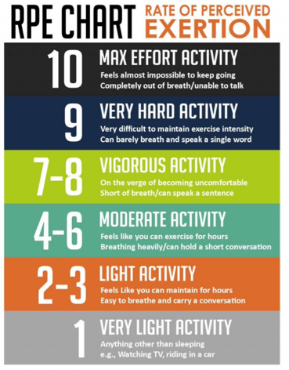

Rate of Perceived Effort Graph

So you can compare these by using running terms as a sort of Short Hand

Training Effort Levels

* Walk (Level 3: Recovery in between Sprints)
* Jog (Level 5: Endurance pace but well within limits)
* Race (Level 8: Race pace for shorter races
* Sprint (Level 10: Flat out sprinting)

We are avoiding that 6 to 7 zone that most people will fall into when trying to train.

## Why train in different zones?

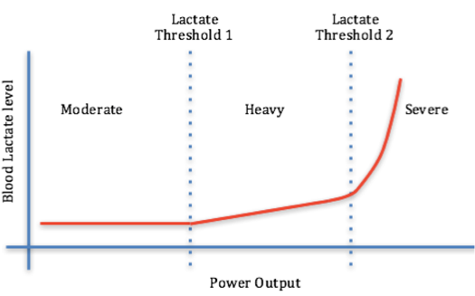

Lactate Thresholds Graph

!!! info “Lactate and training zones”

- Lactate builds up when we exercise beyond certain effort levels.   
- It is the Burn that you start to feel when you push hard or hit weights at the gym  
- After the first threshold, our bodies can't clear all the lactate out of our muscles and it slowlly starts to build up.   
- In an endurance race this is the area that you are balancing to keep your performance going whilst still being fast  
- After the 2nd threshold the lactate goes through the roof and you have very little time before you are exhausted  
 - This is pretty much sprinting  
- There are a huge number of complications and variables but in the simplest possible terms  
 - **Moderate** = Aerobic Training and is good for endurance  
 - **Heavy** = Threshold Training and is good for getting used to the pain of racing and having your body adapt  
 - **Severe** = Strength Training and is good for developing Speed and Power over short distances  
- Don't neglect speed training even though you only ever do endurance races.

**For Endurance:**

* To get optimal results, we want to Train Aerobic without any Lactate Buildup in our bodies.
* To do this we keep below the Lactate Threshold:
* This is the **Moderate** section on the graph

**For Speed:**

* We want to train anaerobically and this means operating above the 2nd Lactate Threshold.
* This is the **Severe** section on the graph

**Threshold training:** (the middle zone of 6 and 7 ):

* Has it’s place but not when we are trying to rapidly improve speed and endurance.
* It is not good at raising either of these characteristics
* It is useful once speed and endurance targets have been reached.
* We are avoiding threshold training until we have built up our base fitness
* We also avoid it when Tapering before a race because Threshold Training is exhausts the body and nervous system.
* This is the pace you probably think you should be training at.
* This is the **Heavy** section on the graph

!!! warning “Real world use” - At Clyde we found that shouting 1, 5, 9 makes zero sense to people half way through an Interval training session. - We use equivalent percentages instead or say walk, jog, run, sprint. Everyone gets this - This is going to be a 30% effort (jogging) - This is going to be a 90% effort (short distance race pace)

| RPE | RPE as a % | Name | Usage | Why |
| --- | --- | --- | --- | --- |
| 1 | 10% | Walk | Recovery between Intervals | Good for gaining your breath between Intervals |
| 2 | 20% | Fast Walk |  |  |
| 3 | 30% | Jog |  |  |
| 4 | 40% | Fast Jog |  |  |
| 5 | 50% | Lazy Run | Most Distance Work | Below the Lactate Generating threshold |
| 6 | 60% | Run | Getting used to race conditions | Less impact on speed and more about toughening up for races |
| 7 | 70% | Long Distance Race Pace | Getting used to race conditions | Less impact on speed and more about toughening up for races |
| 8 | 80% | Mid Distance Race Pace | Some mid distance speed training | Longer sessions trying to improve long distance speed |
| 9 | 90% | Short Distance Race Pace | Intervals | High Lactate strength training |
| 10 | 100% | Sprint | Intervals | High Lactate strength training |

# Physically transforming your body

!!! Info

- You have to change your body if you want to get stronger, more flexible and have amazing endurance  
- Your body will only let you improve one thing at a time  
- Whilst you are doing this you try to maintain previous improvements in other areas  
- For SUP Racing this means that you will be working on improving Endurance or Speed but not both at the same time