|  |  |  |
| --- | --- | --- |
| D:\Canoeing\ClubMark\Logos\Logo04.gif | Copeland Canoe Club | C:\Users\John Hatton\Downloads\QM_Logo (1).jpg |

# 18th Ravenglass Seaquest

# Sunday 13th July 2025

# Start 12:15 registration from 10:00 Briefing 11.45 HW 13:53

**A navigation event on the 3 beautiful estuaries at Ravenglass**

**Competitors, in kayaks, canoes or SUPs, (no engines or sails!) visit as many controls as they can, in a time limit of 3 hours.**

An event for everyone, take your time and enjoy lunch alongside the Esk, or set yourself a challenge and join the competitive racers.

A wonderful day out on the water however you choose to join us.

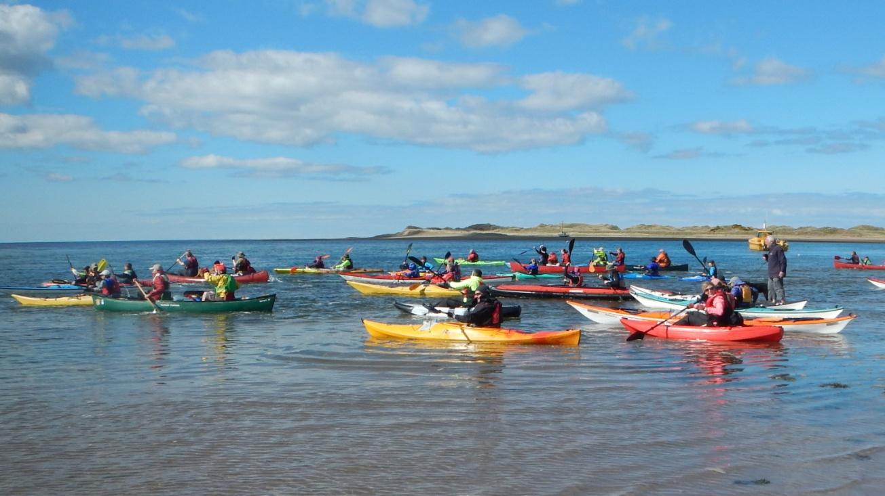

**Entry donations for 2025 are £10 single: £5 U18: £15 per family.**

**Registration 10:00-11:00, Compulsory Briefing 11:45. Start 12:15.**

**Return by 15:15 latest. Hopefully presentations in the Ratty Arms 16.00!**

**Charity: 2025 Cumbria First Responders.**

**For entry forms and more information, please visit the Copeland Canoe Club website:** [**www.copelandcanoe.org.uk**](http://www.copelandcanoe.org.uk)