CIA TECHNOLOGY · WELLS FARGO
WorkCycleAI
An AI-Driven Workforce Capability & Skill Intelligence Platform
Why Skill Depth — Not Just Prompting — Is the Real Differentiator at Scale

Stakeholder Review Document
Team: CIA (Consumer & Investment Advice) Technology · Built In-House
Project Initiated July 2025 · Prepared July 2026

1. Problem Statement
Everyone is prompting. Very few are building skill. AI licenses are now common, but a good prompt only produces good output when the person behind it already understands the domain well enough to judge what comes back. Without that depth, teams get plausible answers that fail quietly — and the failure surfaces mid-delivery, not before it.
At scale, this is what actually separates one team from another: not who has access to AI — everyone will — but who has real domain depth, clear skill ownership, and structured visibility into their own capability gaps. The industry data backs this up sharply:
- Nearly all companies use AI somewhere in the business, yet only ~1% consider themselves AI-mature. (McKinsey, 2025)
- Insufficient worker skill — not budget or technology — is now the top barrier to real AI integration. (Deloitte, 2026)
- Formal AI training drives ~2.3x faster adoption and ~67% higher AI ROI. (BCG)
- Talent-strategy gaps are costing companies up to 40% of potential AI productivity gains. (EY, 2025)
- 94% of employees say they'd stay longer if their company invested in their learning. (LinkedIn Workplace Learning Report)
Inside CIA Technology this shows up concretely: skill data lives in scattered spreadsheets, learning plans are built from scratch for every new project, and managers have no reliable answer to where the team is strong or where it needs to grow. That gap — not a lack of AI access — drives saturated delivery and disengaged teams.

2. Proposed Solution
WorkCycleAI
A single AI-powered platform that reads project documentation, extracts the technologies it actually requires, compares them against each employee's real skill matrix, and turns the gap into a personalized, trackable learning plan — replacing manual assessment and spreadsheets with one continuously updated source of truth for team capability.

3. System Architecture
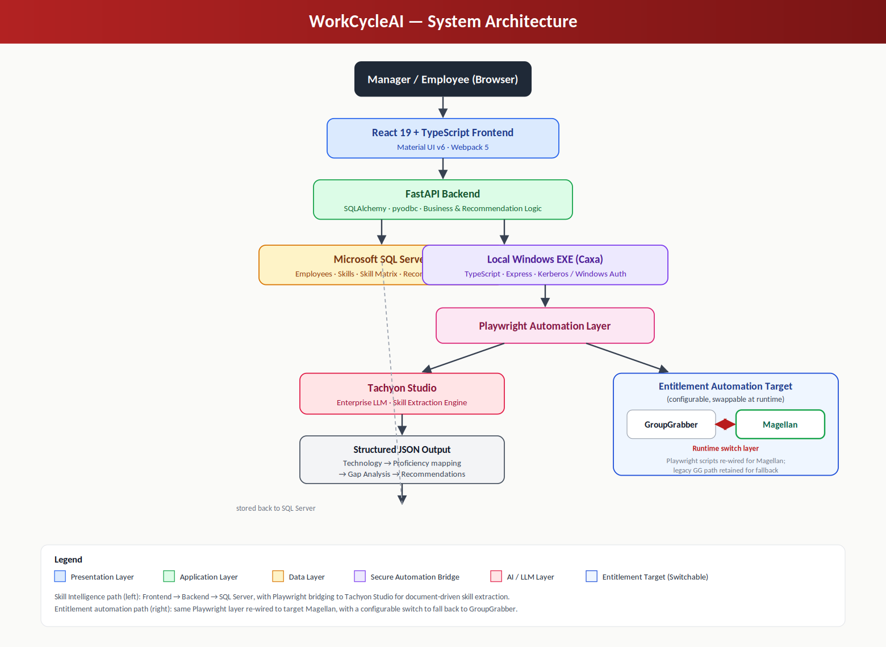
Figure 1 — Presentation, application, and data layers, bridged by a secure local automation layer into Tachyon Studio (AI) and a switchable entitlement target (GroupGrabber / Magellan).

4. Technical Implementation
Frontend & Backend
React 19 + TypeScript + Material UI on the frontend; Python FastAPI with SQLAlchemy/pyodbc on the backend, connected to SQL Server under Windows Authentication and Kerberos.
Data Layer
SQL Server holds employees, a ~34-technology skill taxonomy across four categories, per-employee proficiency levels, and full recommendation history with source-document traceability.
AI Skill Extraction Pipeline
Uploaded documents (Confluence, PDF, DOCX, TXT, images) are parsed, combined with the skill taxonomy into a structured prompt, and sent through a local, Kerberos-authenticated automation bridge into Tachyon Studio, Wells Fargo's enterprise LLM — which returns technology-to-proficiency mappings that drive gap analysis and recommendations.
Entitlement Automation — GroupGrabber to Magellan
The Playwright automation layer has been fully re-wired to target Magellan, the system replacing legacy GroupGrabber. This was built as a configurable, target-agnostic bridge — the same workflow can switch back to GroupGrabber, and this pattern is what will power the upcoming team-member-list-driven recommendation feature.
Skill Recommendation Engine
The delivered, working core: it compares each employee's stored skills against project-derived requirements, computes gaps, and produces a personalized — not generic — learning recommendation for manager review.

5. Built to Scale
Nothing here is hard-coded to one document type, one team, or one external system — the skill taxonomy is data-driven, the extraction pipeline is format-agnostic, and the automation bridge is target-agnostic by design, as proven by the Magellan migration.
This is a scalable foundation, not a one-off tool — any team facing a similar problem can extend this architecture rather than build from zero.

6. Roadmap
- Team-member-list-driven recommendations at the team level (next milestone).
- Closed feedback loop: completed training auto-updates the skill matrix.
- Predictive staffing based on real-time skill coverage.
- Cross-team benchmarking dashboards for leadership.
- Extending the switchable-target automation pattern to additional internal systems.

7. Closing Note
AI tooling is becoming table stakes — the differentiator is the domain and skill depth underneath it. WorkCycleAI measures and closes that gap for CIA Technology, while proving out a reusable, scalable automation pattern along the way.

