Tagging

* Tagging is the task of labelling each word in a sentence with its appropriate part of the speech.

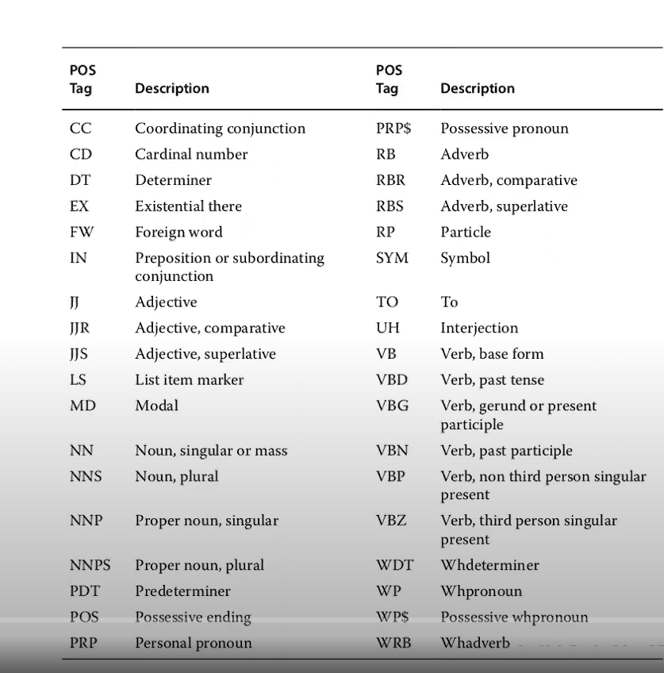

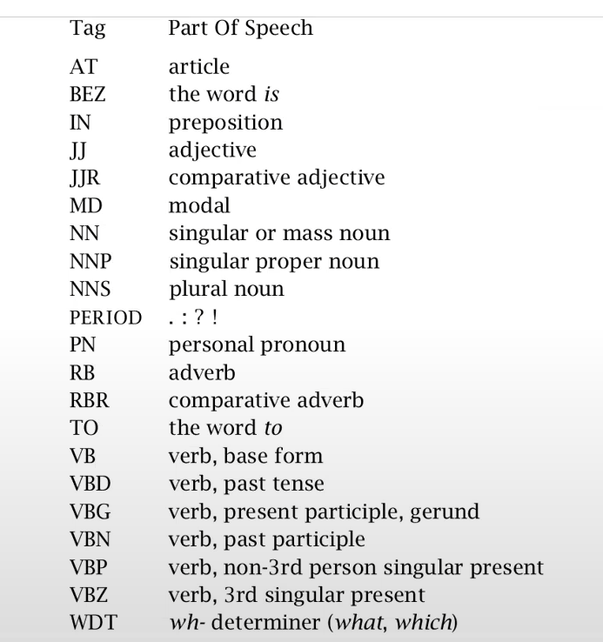

Problem with Tagging is that : The same word could be a part of multiple part of speech tags. When that particular word is tagged in different sentences or texts, it may a noun, adjective or verb at different places.

Hence the problem is to determine a particular POS tag for a particular word in a sentence.

**Generative models** are a wide class of machine learning algorithms which make predictions by modelling joint probability P(y, x).

**Discriminative models** are a class of supervised machine learning models which make predictions by estimating conditional probability P(y|x).

In order to use a generative model, more unknowns should be solved: one has to estimate probability of each class and probability of observation given class. These probabilities are used to compute joint probability, and finally, joint probability can be used as a substitute for conditional probability to make predictions.

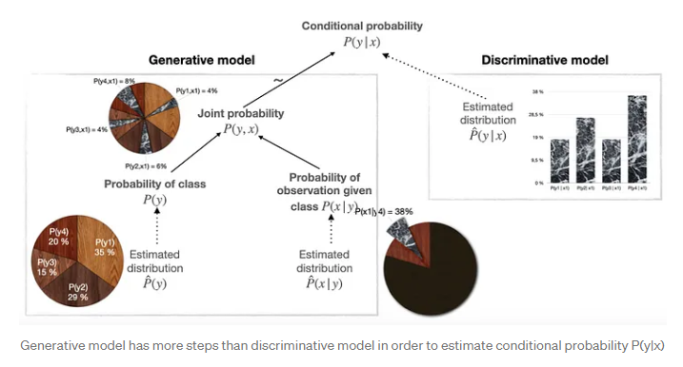

The discriminative model takes a shorter way: it simply estimates conditional probability directly.