Report for simple web server

1. Development Environment  
   - version of operating system : Window10  
   - programming language : python  
   - interpreter versions : python 3.6
2. How to test  
   1) run ‘server.py’ by python 3.6.  
   2) send message to server in browser.
3. Screen capture  
   1) file system  
   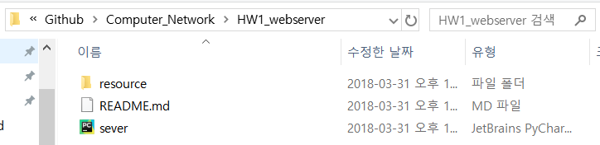  
   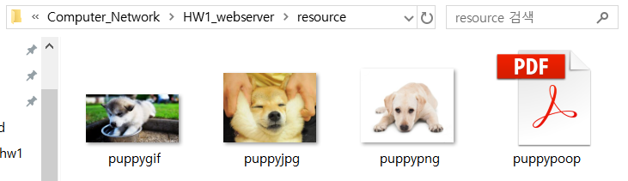  
   2) run ‘server.py’  
   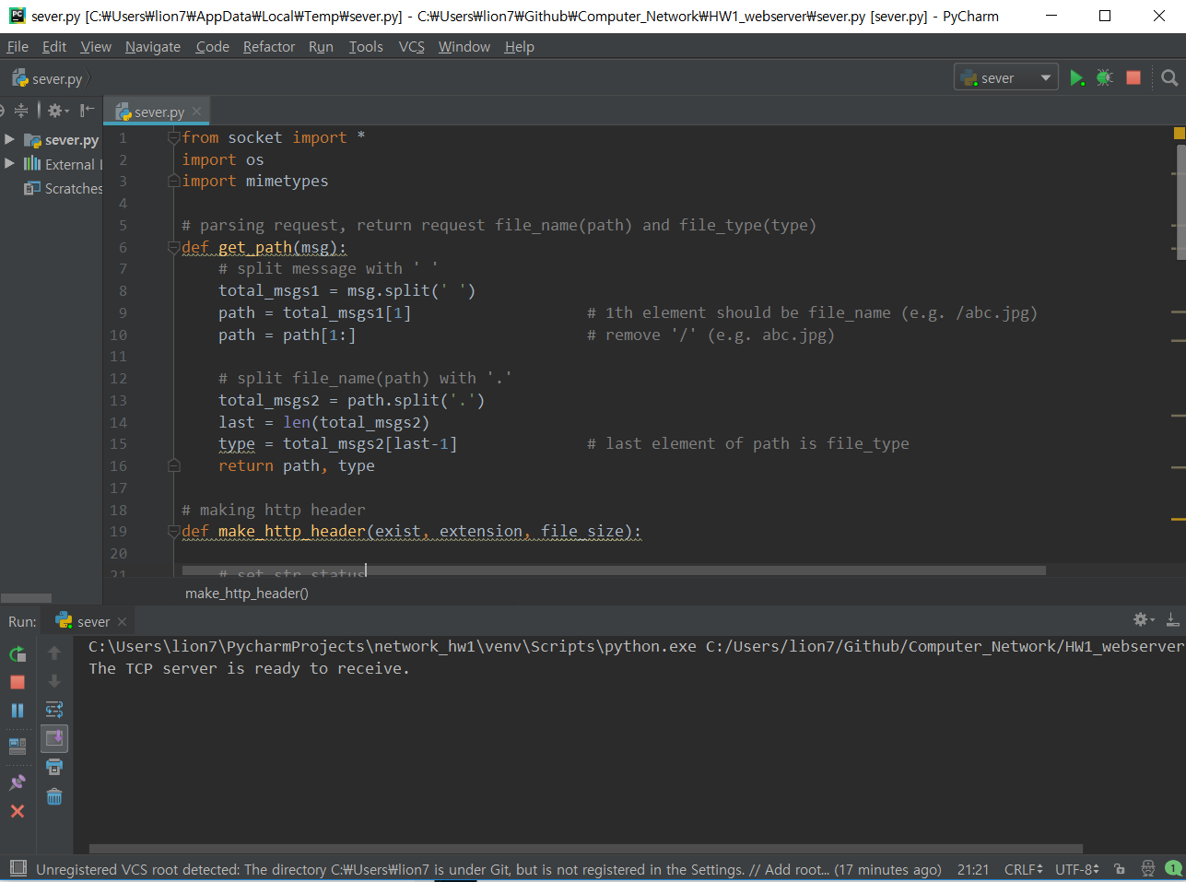  
   3) send message to server in browser  
    (1) not exist   
   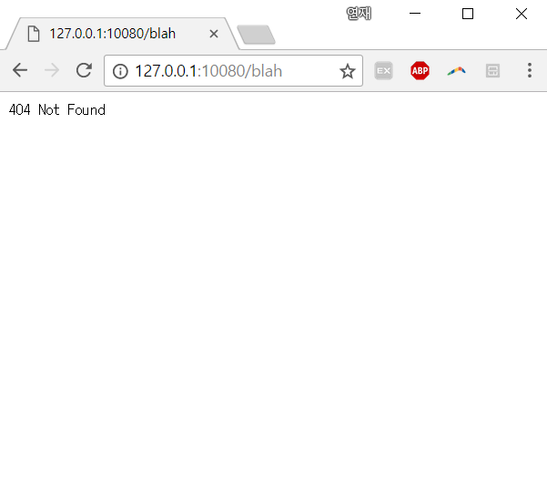  
    (2) exist  
   