Sinus function Error Orders

# Purpose

We wish to illustrate by a simple example the concrete effect of a choice of an approximation scheme. This document reproduces the main steps of the example by [1].

Three main schemes are chosen and the approximation of the derivative of the function (i.e.) is calculated together with the error. The precision of the approximation is demonstrated by showing the predicted error precision and the error we calculate in practice. The definitions of the different kinds of errors are proposed. Eventually, a graph is proposed that allow a direct appreciation of the error.

# Protocol

1. A set of step is declared with graduated degree of precision.
2. The derivative of the function, is approximate around the value 1 by:
   1. A backward approximation scheme: ,
   2. A forward approximation scheme: ,
   3. A central approximation scheme:
   4. A central approximation scheme:
3. The truncation error is obtained by subtracting the derivative from the calculated value scheme.
4. A log-log scale graph is shown with the error against the value of the step.

# Result

## Numerical results

Once the procedure is written and ran we obtain these results.

|  |  |  |  |  |  |  |  |  |  |  |  |  |  |  |  |  |  |  |  |  |  |  |  |  |  |  |  |  |  |  |
| --- | --- | --- | --- | --- | --- | --- | --- | --- | --- | --- | --- | --- | --- | --- | --- | --- | --- | --- | --- | --- | --- | --- | --- | --- | --- | --- | --- | --- | --- | --- |
| |  |  |  |  |  | | --- | --- | --- | --- | --- | | *h* | *Backward* | *Forward* | *Central* | *Du3* | | 1.00E-01 | -4.11E-02 | 4.29E-02 | 9.00E-04 | -6.8207e-05 | | 5.00E-02 | -2.08E-02 | 2.13E-02 | 2.25E-04 | -8.6491e-06 | | 1.00E-02 | -4.20E-03 | 4.22E-03 | 9.00E-06 | -6.9941e-08 | | 5.00E-03 | -2.10E-03 | 2.11E-03 | 2.25E-06 | -8.7540e-09 | | 1.00E-03 | -4.21E-04 | 4.21E-04 | 9.01E-08 | -6.9979e-11 | |

The columns two and three show the equivalence of the order of the error for the forward and backward approximation. The fourth column shows clearly that the central approximation has a squared order of the preceding error. All the results show that this behaviour is proportional to the step chosen.

Even more convincing is the graphical result that is shown below.

## Graphical results

We have here a clear illustration of the nature of the law followed by the error:

|  |  |  |
| --- | --- | --- |
|  |  | (1) |

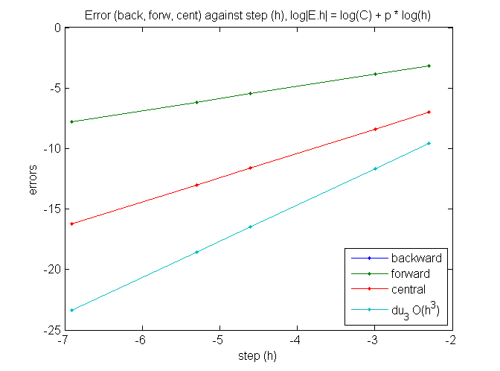

# Bibliography

x

|  |  |
| --- | --- |
| [1] | LeVeque R J., *Finite Difference Methods for Ordinary and Partial Differential Equations*. Philadelphia: Society for Industrial and Applied Mathematics (SIAM), 2007. |

x