NumFOCUS Project Funding Ledger (PFL)

Functional Specification

1 Introduction

1.1 Executive Summary
The Project Funding Ledger (PFL) is a project funding visibility and governance application that provides NumFOCUS staff and authorized Fiscally Sponsored Project stakeholders with a centralized view of project funding, financial activity, funding authority, agreements, reporting obligations, supporting documents, and related project information.
Today, project funding information is `distributed across multiple operational systems, spreadsheets, documents, and institutional knowledge, making it difficult for project stakeholders to understand available funding, funding restrictions, reporting commitments, and the agreements that govern project resources. The PFL consolidates this information into a single application that improves transparency, supports informed decision-making, and strengthens project governance.
The PFL imports selected financial activity from QuickBooks Online (QBO) and combines that information with project-specific operational metadata maintained within the application. Together, these records provide a comprehensive view of project funding without duplicating the accounting responsibilities of existing financial systems.
The PFL is not an accounting system and does not replace QuickBooks Online. QBO remains the authoritative system of record for accounting transactions, financial reporting, accounts payable, accounts receivable, payment processing, and other accounting functions. The PFL supplements these operational systems by organizing project funding information in a manner that is meaningful and accessible to project stakeholders.
The application supports NumFOCUS's broader objectives of improving financial transparency, strengthening project governance, reducing reliance on manual reporting processes, and providing project leaders with self-service access to the information needed to manage their projects effectively.

1.2 PFL in the Financial Systems Architecture
The Project Funding Ledger is one of three core financial management systems used by NumFOCUS. Each system serves a distinct business purpose and complements, rather than replaces, the others.
The Expense Entry System captures and approves spending requests, including employee reimbursements, credit card expenses, and vendor invoices. Approved expenses are recorded in the Accounting System, which serves as the authoritative system of record for all economic activity, including the general ledger, financial statements, assets, liabilities, revenues, and expenses.
The Project Funding Ledger imports selected accounting activity together with Project governance, funding, agreement, reporting, and supporting document information to provide a point-in-time operational view of available Project funding. The PFL is not an accounting system and does not replace the organization's financial or operational systems of record.

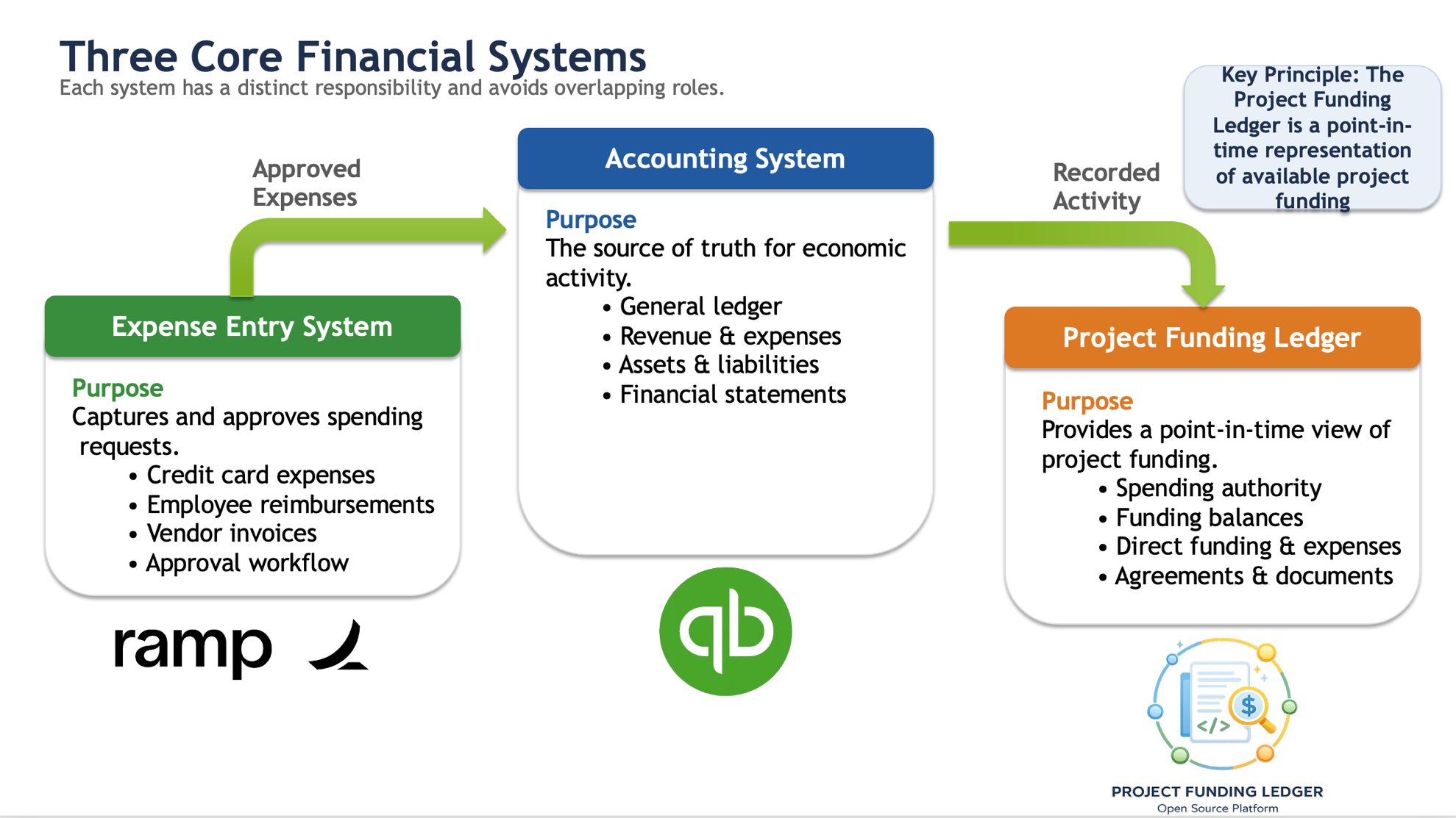

1.3 Purpose
This Functional Specification defines the business capabilities, functional requirements, and business rules for the PFL.
The document describes the business problems the application addresses, the users it serves, and the functional capabilities required to support project funding management and visibility. It defines what the system must do from a business perspective without prescribing the technical implementation.
The intended audience includes business stakeholders, project sponsors, product owners, business analysts, architects, software developers, quality assurance personnel, and others involved in the planning, design, development, testing, and support of the PFL.

1.4 Relationship to Other Project Documentation
The PFL documentation is organized into complementary documents, each serving a distinct purpose.
This Functional Specification defines the business capabilities, user requirements, business rules, and functional behavior of the PFL. It focuses on what the application must do to meet business objectives.
The Design Specification translates those business requirements into the logical system design, including the application architecture, business entity model, database design, integration strategy, security model, and other technical design decisions.
The Development Standards define the engineering practices used during implementation, including coding standards, testing strategy, deployment processes, security requirements, and documentation standards.
Together, these documents provide a complete description of the PFL while maintaining a clear separation between business requirements, system design, and software implementation.
Document Definition
Document | Purpose
NumFOCUS PFL - 1 Functional Specification | Defines the business requirements, functional capabilities, user workflows, and reporting requirements.
NumFOCUS PFL - 2 Development Roadmap and Implementation Strategy | Defines the overall implementation strategy, development phases, milestones, and project sequencing. (This document.)
NumFOCUS PFL – 3 Architecture Design | Defines the system architecture, database design, security model, data model, integrations, and technical design decisions.
NumFOCUS PFL - 4 Development Plan | Defines the detailed implementation tasks, coding standards, repository structure, development environment, testing procedures, deployment process, and other developer guidance.

1.5 Business Objectives
The primary business objectives of the PFL are to:
- Provide a centralized source of project funding information for NumFOCUS staff and authorized project stakeholders.
- Improve transparency into project funding, financial activity, and available funding authority.
- Provide authorized users with self-service access to project funding information without requiring access to QuickBooks Online.
- Consolidate project governance records, agreements, reporting obligations, and supporting documents into a single application.
- Improve consistency, traceability, and accountability of project funding information.
- Reduce the manual effort required to answer project funding questions and prepare operational reports.
- Support the retirement of Open Collective as the primary project funding visibility platform.
- Provide a scalable foundation for future enhancements to project funding management and reporting.

1.6 Business Scope
The PFL supports the operational management and visibility of project funding throughout its lifecycle.
The application provides capabilities for:
- Maintaining Project information.
- Maintaining Funding Source information.
- Importing and viewing financial activity.
- Managing Project Governance records.
- Managing Agreement records.
- Managing Reporting Obligation records.
- Managing Supporting Document records.
- Reviewing project funding activity and funding availability.
- Searching, filtering, and exporting project funding information.
- Maintaining an auditable history of significant operational activity.
The PFL supplements existing operational systems by organizing project funding information for operational visibility and governance. It is not intended to replace accounting, payment processing, expense management, document management, or other operational systems that remain the authoritative source for those business functions.

1.7 Guiding Principles
The PFL is guided by the following business principles:
- QuickBooks Online remains the authoritative financial system of record.
- The PFL provides operational visibility into project funding rather than performing accounting functions.
- Information should be entered once whenever practical and reused throughout the application.
- Authorized users should be able to answer routine project funding questions without requiring assistance from Finance.
- Project funding information should remain traceable to its authoritative source.
- The application should support future organizational growth while minimizing disruption to established business processes.

2. Functional Requirements

2.1 Overview
The Project Funding Ledger provides business capabilities that support the management, visibility, governance, and reporting of project funding throughout its lifecycle. The functional requirements described in this section define the business capabilities the application must provide to support NumFOCUS staff and authorized Fiscally Sponsored Project stakeholders.
The requirements are organized by major functional area and describe what the system must do from a business perspective. Technical implementation details, application architecture, database design, and development standards are documented separately within the Design Specification and Development Standards.

2.2 Project Management
The system shall provide functionality for maintaining and managing Project information throughout the Project lifecycle. Users shall be able to create, maintain, search, view, and archive Project records, together with associated governance information, funding sources, and supporting documentation.
Primary capabilities include:
- Create and maintain Project information.
- View Project details and current status.
- Associate Funding Sources with a Project.
- Associate Project Governance records.
- Associate Supporting Documents.
- Search and filter Projects.
- View Project funding summary information.

2.3 Funding Source Management
The system shall provide functionality for maintaining Funding Sources and the operational information associated with each source of project funding.
Primary capabilities include:
- Create and maintain Funding Source information.
- Record funding authority and related operational metadata.
- Associate Funding Sources with Projects.
- Associate Governing Agreements.
- Associate Reporting Obligations.
- Associate Supporting Documents.
- Monitor funding availability.
- Close or archive Funding Sources.

2.4 Financial Activity
The system shall provide visibility into financial activity associated with Projects and Funding Sources by importing accounting activity from the financial system of record.
Primary capabilities include:
- Import financial activity.
- View financial activity.
- Search and filter financial activity.
- Associate financial activity with Projects and Funding Sources.
- Export financial activity.
- Preserve traceability to source accounting records.

2.5 Funding Adjustment Management
The system shall provide functionality for recording operational funding adjustments that affect the availability or presentation of Project funding without modifying the underlying accounting records.
Primary capabilities include:
- Record Funding Adjustments.
- Associate Funding Adjustments with Funding Sources.
- Maintain adjustment history.
- Include Funding Adjustments in operational funding views.
- Preserve an audit history of adjustments.

2.6 Project Governance Management
The system shall provide functionality for maintaining Project Governance information that defines the relationship between NumFOCUS and each Project.
Primary capabilities include:
- Create and maintain Project Governance records.
- Associate governance records with Projects.
- Associate Supporting Documents.
- View governance history.
- Search Project Governance information.

2.7 Agreement Management
The system shall provide functionality for maintaining Governing Agreements that establish funding authority, contractual obligations, or other relationships affecting Project funding.
Primary capabilities include:
- Create and maintain Agreement records.
- Associate Agreements with Projects and Funding Sources.
- Track Agreement status and effective periods.
- Associate Supporting Documents.
- Search and review Agreements.

2.8 Reporting Obligation Management
The system shall provide functionality for maintaining Reporting Obligations associated with Projects, Funding Sources, and Governing Agreements.
Primary capabilities include:
- Create and maintain Reporting Obligations.
- Record reporting schedules and due dates.
- Track reporting status.
- Associate Reporting Obligations with Funding Sources and Agreements.
- View reporting calendars and schedules.

2.9 Supporting Document Management
The system shall provide centralized management of Supporting Documents associated with Projects, Funding Sources, Governing Agreements, Project Governance records, and Reporting Obligations.
Primary capabilities include:
- Upload Supporting Documents.
- Maintain document metadata.
- Associate Supporting Documents with business records.
- Maintain document versions.
- Search and retrieve Supporting Documents.
- Download Supporting Documents.

2.10 User Access and Security
The system shall provide user authentication, authorization, and permission management appropriate to each user's assigned responsibilities.
Primary capabilities include:
- Maintain User Profiles.
- Assign Project Permissions.
- Authenticate users.
- Authorize access to Project information.
- Restrict access to authorized information.
- Maintain user session security.

2.11 Search, Inquiry, and Reporting
The system shall provide inquiry, search, dashboard, and reporting capabilities that enable users to locate and analyze Project funding information.
Primary capabilities include:
- Search across Project funding information.
- Filter business information.
- Display Project dashboards.
- Display Funding Source dashboards.
- Export selected information.
- Support operational reporting.

2.12 Administration
The system shall provide administrative capabilities necessary to support ongoing operation of the Project Funding Ledger.
Primary capabilities include:
- Maintain Supporting Reference Data.
- Configure application settings.
- Manage Mapping Rules.
- Review and resolve Mapping Exceptions.
- Monitor Import Batches.
- Manage application configuration.

2.13 Audit and Traceability
The system shall maintain a complete history of significant operational activity to support accountability, transparency, and historical review.
Primary capabilities include:
- Record Audit Log entries.
- Maintain historical record changes.
- Preserve traceability to originating records.
- Review system activity.
- Support operational and compliance audits.

