1.

a.impossible

b.impossible

c.

2.a.

Kept the bigest item, because it determins the complexity class.

b. all the lower (more slowly growing) terms and the

constant in front of the most frequently executed statement (the fastest

growing term). Because they are not dominant, and comapred to the bigest item ,they are not important

c.Because cpu schedule or cache , and other factors may affect the running time.

3.

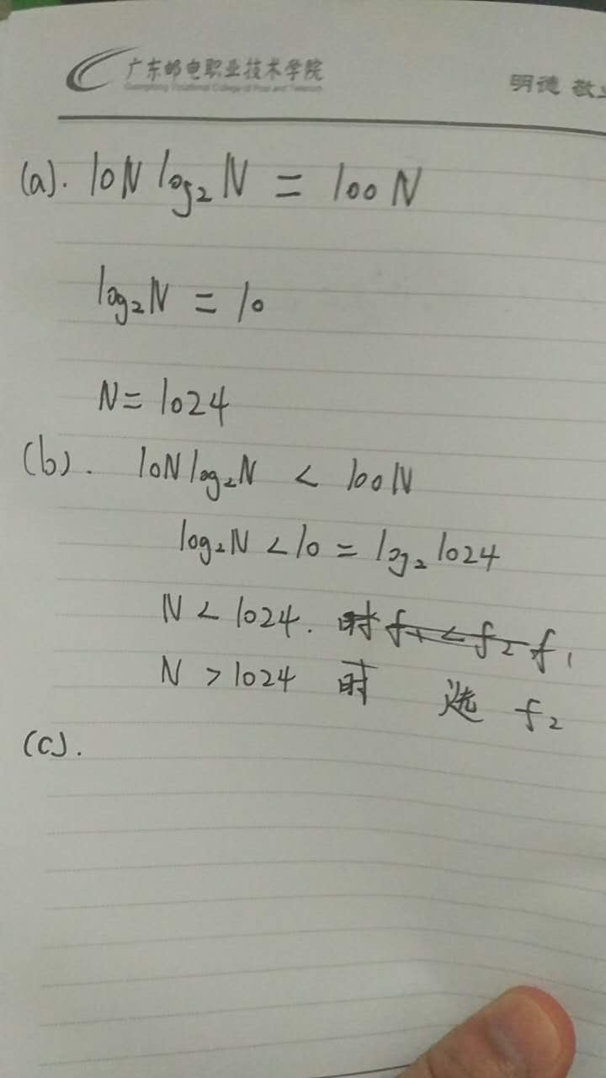

a.N=1024,

b. f1 is faster for N<2014

f2 is faster for N>1024

c.

d.

565,341