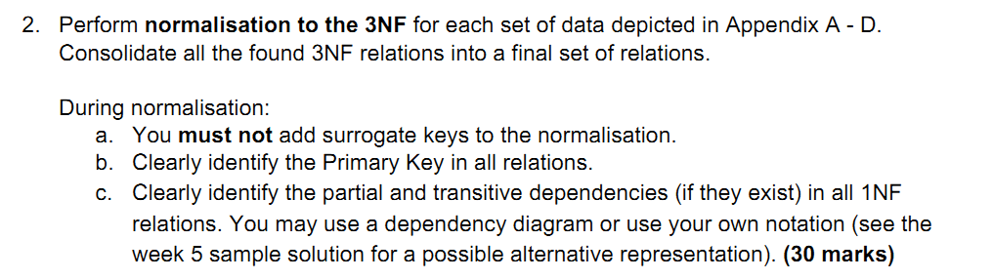

**Appendix A**

**UNF**

**Carnival(date, director, location(The Tan, Botanic Gardens...), event(10km run, 5km run, 3km run), sponsors(sponsor1(vegout), sponsor2(Dept..)))**

**1NF**

**Carnival(date, diirector)**

**Location(carnival_date, location_name)**

**Event(carnival_date, event_name)**

**Sponsor(carnival_date, sponsor_name, isNaming, amount, contact, contact)**

**2NF**

**Carnival(date, diirector)**

**Location(carnival_date, location_name)**

**Event(carnival_date, event_name)**

**Sponsor(carnival_date, sponsor_name, isNaming, amount, contact, contact)**

**3NF**

**Carnival(date, diirector)**

**Location(carnival_date, location_name)**

**Event(carnival_date, event_name)**

**Sponsor(carnival_date, sponsor_name, isNaming, amount, contact, contact)**

**Appendix B**

**UNF**

**Competitor(number, firstname, lastname, gender, birthday, email, isStudent, mobile, Medicial(condition, area(breathing, hearing, heart...), Emergency(firstname, lastname, phone, relationship,Guardian(firstname, lastname, phone))**

**1NF**

**Competitor(number, firstname, lastname, gender, birthday, email, isStudent, mobile)**

**Medical(competitor_number, condition, areas)**

**EmergencyContact(competitor_number, firstname, lastname, phone, relationship)**

**Guardian(competitor_number, firstname, lastname, phone)**

**2NF**

**Competitor(number, firstname, lastname, gender, birthday, email, isStudent, mobile)**

**Medical(competitor_number, condition, areas)**

**EmergencyContact(competitor_number, firstname, lastname, phone, relationship)**

**Guardian(competitor_number, firstname, lastname, phone)**

**3NF**

**Competitor(number, firstname, lastname, gender, birthday, email, isStudent, mobile)**

**Medical(competitor_number, condition, areas)**

**EmergencyContact(competitor_number, firstname, lastname, phone, relationship)**

**Guardian(competitor_number, firstname, lastname, phone)**

**Appendix C**

**UNF**

**Entry(competitor_number, firstname, lastname, event, teamname)**

**1NF**

**Entry(competitor_number, firstname, lastname, event_name, teamname)**

**2NF**

**Competitor_number -> firstname partial**

**Competitor_number -> lastname partial**

**Entry(competitor_number, event, teamname)**

**3NF**

**Entry(competitor_number, event, teamname)**

**Appendix D**

**UNF**

**Order(order_number, order_date, carnival_date, carnival_location, competitor(number, name), merchandise(good1, good2), total_cost)**

**1NF**

**Order(order_number, order_date, carnival_date, carnival_location, competitor_number, competitor_name, total_cost, delivery)**

**Merchandise(order_number, item_code, item_description, cost, qty,line_cost)**

**2NF**

**Carnival_date -> carnival_location partial**

**Competitior_number -> competitior_name partial**

**Order(order_number, order_date, carnival_date, competitor_number)**

**Merchandise(order_number, item_code, item_description, cost, qty,line_cost)**

**3NF**

**Order(order_number, order_date, carnival_date, competitor_number)**

**Merchandise(order_number, item_code, item_description, cost, qty,line_cost)**

**Appendix E**

**UNF**

**Order(order_number, order_date, carnival_date, carnival_location, Volunteerr(number, name), merchandise(good1, good2), total_cost)**

**1NF**

**Order(order_number, order_date, carnival_date, carnival_location, volunteer_number, volunteer_name, total_cost, delivery)**

**Volunteer(volunteer_number, volunteer_name)**

**Merchandise(order_number, item_code, item_description, cost, qty,line_cost)**

**2NF**

**Carnival_date -> carnival_location partial**

**volunteer_number -> volunteer_name partial**

**Volunteer(volunteer_number, volunteer_name)**

**Order(order_number, order_date, carnival_date, volunteer_number)**

**Merchandise(order_number, item_code, item_description, cost, qty,line_cost)**

**3NF**

**Volunteer(volunteer_number, volunteer_name)**

**Order(order_number, order_date, carnival_date, volunteer_number)**

**Merchandise(order_number, item_code, item_description, cost, qty,line_cost)**

**Final Relations:**

**Carnival(date, diirector)**

**Location(carnival_date, location_name)**

**Event(carnival_date, event_name)**

**Sponsor(carnival_date, sponsor_name, isNaming, amount, contact, phone)**

**Competitor(number, firstname, lastname, gender, birthday, email, isStudent, mobile)**

**Medical(competitor_number, condition, areas)**

**EmergencyContact(competitor_number, firstname, lastname, phone, relationship)**

**Guardian(competitor_number, firstname, lastname, phone)**

**Entry(competitor_number, event_name, teamname)**

**Volunteer(volunteer_number, volunteer_name)**

**Order(order_number, order_date, carnival_date, volunteer_number)**

**Merchandise(order_number, item_code, item_description, cost, qty,line_cost)**