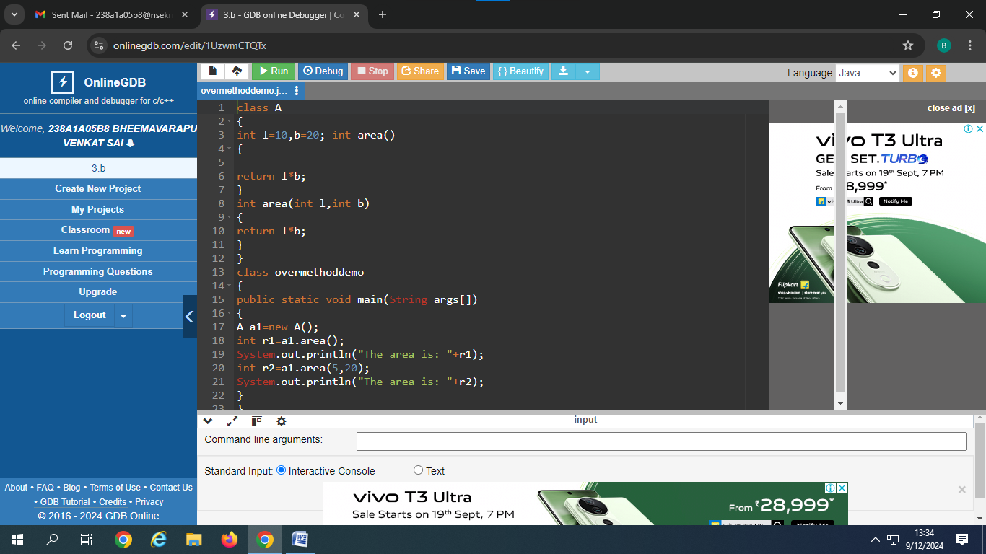

Output:

The area is: 200

The area is: 100