# 2019 -CS352 - Assignment 1: SelfieLessActs on AWS

| Member Name | USN | Section |
| --- | --- | --- |
| Maanvi Nunna | 01FB16ECS187 | D |
| Meghana Ganesh | 01FB16ECS205 | D |
| Nandagopal NV | 01FB16ECS221 | D |
| P Abhishikta Sai | 01FB16ECS242 | D |

**Date of Evaluation** : 25/1/2019  **Evaluator : Srinivas Shekar** 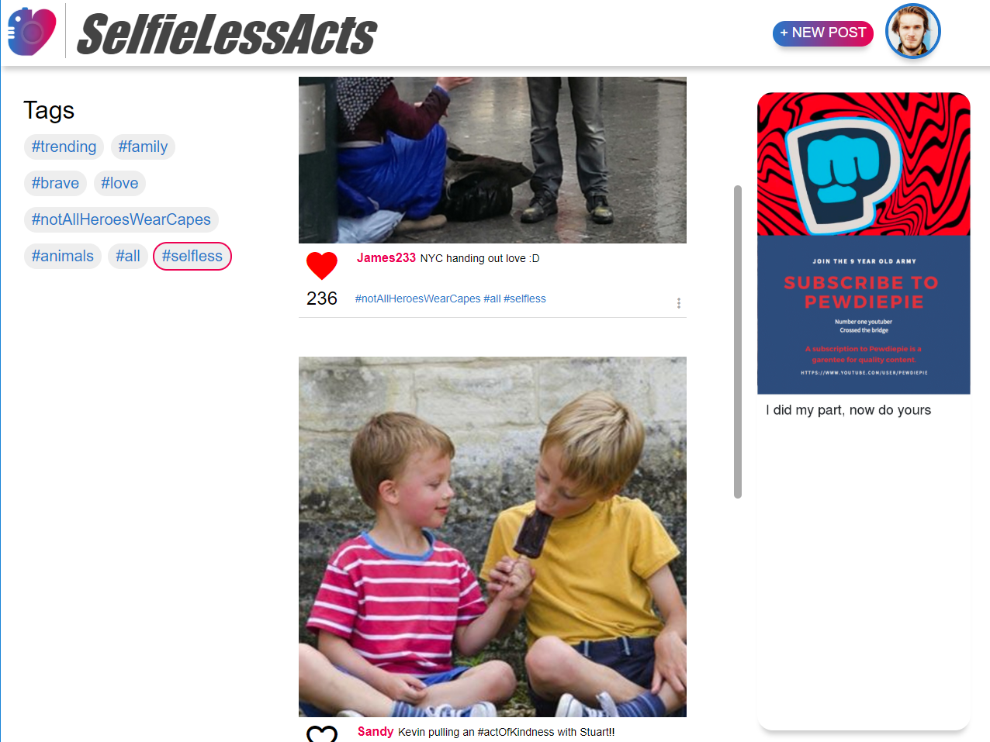

1. AWS username on which demo was shown :

gopi.nv6@gmail.com

1. Public IP address of web server :

http://52.70.124.134/a1/

1. Put a screenshot of your home page GUI :

**Summarize your learning as part of this assignment**

We learnt how to use AWS, set up a VM, pick an OS to our requirements and install a web server on it. The mock webpage we created uses HTML, CSS and JavaScript. After launching the instance and storing the webpage resource files in the /var/www/html/ folder, we were able to access the web pages using the public IP provided with the VM. We also learnt to use ‘scp’ to transfer files between local and virtual machines.

Connecting to the VM using an SSH client was perhaps the biggest learning. We also used a client to make file transfer simple. We had to deal with permissions of the VM’s OS, and we developed an appreciation for the virtualisation process. We also realized the security concerns of using a VM, where it was enforced by making us create a cryptographic key pair and using that to securely connect to the VM through SSH.

**Any other observations/challenges/comments**

We observed that after launching the instance, installing the Apache server and storing the required docs to host a website, despite shutting down the instance, the data remains persistent. It got us wondering where these files are being stored without us having to explicitly mount any storage on the VM.