
Post Graduate Program in Artificial Intelligence and Machine Learning
Online Batch Oct’24
Capstone Project

Fly-Kite Airline Q&A BOT using
Retrieval Augmented Generation
Group -04
Submission Date: 02-November-2025
Version 1.0

Project Members | Email ID
Karthikeyan Palani | jpkarthikk@outlook.com
Muppaneni Naveen Kumar
Niraj Kumar
Nikhil Ranjan
Bhagat Singh
Ippili Jagadeesh

Table of Contents
No table of contents entries found.

- Business Context:
Modern organizations operate in an environment where internal policies have grown increasingly complex, covering areas such as leaves, reimbursements, travel, hybrid work norms, performance management, compliance, and more. These policies are commonly documented in static, lengthy HR handbooks or PDFs, which employees often find difficult to understand, search, or apply in their daily work scenarios.
As a result:
- HR teams are burdened with repetitive queries about standard policies, diverting their focus from strategic initiatives.
- Employees struggle with confusion or non-compliance, as the dense and static format of policy documents obscures the necessary guidance.
- Both sides suffer from reduced productivity, HR spends excessive time addressing routine questions, while employees experience delays in obtaining the information they need to perform efficiently.
Addressing these challenges requires modern HR systems that centralize policy information, simplify access, and deliver clear, actionable insights. By leveraging technology to streamline policy communication and automate routine queries, organizations can enhance clarity, boost compliance, and ultimately improve overall operational efficiency.

- Objective:
The goal is to develop a prototype that demonstrates how Natural Language Processing (NLP), powered by Retrieval-Augmented Generation (RAG), can help employees efficiently query company HR policies and receive accurate, context-aware, and easily understandable answers. Specifically, the system aims to:
- Answer employee questions by retrieving relevant content from official HR handbooks and policy documents.
- Handle ambiguous queries and follow-up questions by clarifying intent and distinguishing between similar policy categories (e.g., sick leave versus casual leave).
- Personalize responses based on role, location, or department, acknowledging that policies may differ (e.g., field staff versus HQ).
- Increase trust and compliance by citing sources (document name, section, and clause) for each response

- Data Description:
The employee handbook is an internal reference published by Flykite Airlines that outlines a wide range of workplace policies, guidelines, and procedures for staff. The handbook is provided in PDF format and serves as a comprehensive resource for employees across different roles within the airline.
- Introduction To Retrieval Augmented Generation (RAG)
The Concept of RAG originated from a journal on 2020 titled “Retrieval-Augmented Generation for Knowledge intensive NLP Tasks” by researchers at Meta
Retrieval Augmented Generation (RAG) Generative AI architecture which enhances the capabilities of the Large Language Model (LLM) by integrating with external knowledge sources for which the LLM were not trained. In RAG system the LLM is no longer depend on its parametric memory. RAG combines the strength of two powerful component Retrieval & Generative Models
Retrieval Models: these fetch relevant documents or knowledge snippets from an external Corpus database.
Generative Models: These use the retrieved information to generate coherent, context-aware responses.
Traditional LLM like GPT or BERT are trained on static datasets and it cannot access the private confidential documents which is not exposed to public domain this leads to
- Hallucination – Generates response with incorrect answer,
- Stale knowledge: No access to new or updated information
- Opaque reasoning: user couldn’t trace the source of generated content
RAG addresses these LLM limitation by grounding generation in retrieved documents enabling Factual accuracy, Domain adaptability and explainability where user can get the source of the information retrieved

- How RAG differ from Traditional QA system
Feature | LLM Q&A | RAG
Source of Knowledge | Pre trained model | External document + LLM
Frequency of update | Requires retraining | Real Time corpus updating
Explainability | Low | High in retrieving the source information
Domain Adaptability | Limited & costly | Tailored to specific domain without retraining the LLM
Model | GPT, BERT QA | Lang Chain RAG

- RAG system Components
- Document Store: Collection of domain specific private document not exposed to public domain.
- Chunking: Splits the document into manageable, semantically meaningful pieces.
- Embedder: Converts the chunks into vector representation using sentence transformers.
- Vector Database: stores and indexed embedding for fast similarity search.
- Retriever: finds the most relevant chunks bases on the user queries.
- LLM system: Generated the final response using the retrieved chunk as context.

- RAG Evolution
- Standard RAG (2020 – 2023)
  - Standard RAG: Simple, Linear model Embed Query Vector Search Fetch Top-K chunks for user query LLM summarize the RAG response.
  - Limitations: Retrieval accuracy issues – fetching irrelevant chunks and the LLM still struggled to stitch desperate facts together coherently.
- Advanced RAG (2023 – 2024)
  - Focused to improve the Indexing, Retrieval and Post – Retrieval (Generation).
  - Re-ranking, HyDE (Hypothetical Document Embedding), Query Expansion and parent Document retrieval. The goal is to ensuring the most relevant high quality context feed to LLM to summarize the document content.
- Agentic RAG (Current – Future)
  - This is the most advanced form, where LLM act as orchestrator, deciding when to retrieve, what query to use (e.g., breaking a complex question int sub-queries) , which tools to call like database, an API call, or the vector store and how to synthesize the information. The retrieval is an iterative process.

- Different Types Of RAG
- Simple RAG:
  - Linear process Query Retrieval Generation.
  - Simple, face-based Q&A system and quick prototype.

- RAG with Memory:
  - This includes storage component to retain the past chat history and use it context in the current query.
  - Best suited for conversational chatbots and multi turn user session.

- Branched RAG:
  - This evaluates the query and route to the most specific data source; here multiple documents were used.
  - This work fine for system with diverse, Silo knowledge source.

- Corrective RAG:
  - This adds evaluating step to the retrieved documents to verify its accuracy of retrieval.
  - This type of RAG used when scenario demanding factual accuracy such as finance or legal documents used as source for creating RAG Chat BOT.

- Agentic RAG:
  - Utilizes an LLM to act as an agent that reasons, plans and use the RAG system as tool, breaking down complex tasks into sequential steps.
  - Sophisticated workflows, data management and dynamic problem-solving use cases.

- RAG Architecture
- Indexing Phase:
  - Data source: The Raw document which is source of truth
  - Document Loaded: Loading the data source, extracting text, meta data like Page number, section, clause, sub topics, file name
  - Chunking: The raw data source is splitting into contextual coherent segments which is called chunks
  - Embedding: Each chunk is converted into a high-dimensional vector embedding using a sentence transformer model
  - Vector Store: The Embedding along with the original text chunk and its metadata are stored in the vector database (chroma/FAISS/Pinecone). This searchable index is the knowledge base for the RAG application

- Retrieval & Generation Phase:
  - User query: The user inputs a question
  - Query Embedding: The user query is converted into vector using the same embedding model that was used during the indexing phase
  - Vector search (Retrieval): This query vector is used to perform a similarity search which is cosine similarity against all the stored vectors in vector database. The system retrieves the top k most similar document chunks, which are deemed to the most relevant context.
  - Prompt Augmentation: A final prompt is dynamically constructed. This prompt includes,
    - The user original query
    - A set of instruction for the LLM (Prompt engineering to get the most relevant answer from the raw retrieved response

  - Generation (LLM): The Augmented prompt is sent to the LLM which synthesize the retrieved information and the user’s question to generate final, grounded and relevant answer
  - Response: The final answer is returned to the user.

- Implementation of RAG
- Loading Data source:
  - PyMuPDF (fitz): Known for its speed and precision in extracting text and layout information, including co-ordinated, making it effective for structured extraction.

- Pre-Chunking.
  - Cleaning the data is performed in this stage to maximize the quality of the embedding and improve the search accuracy
  - Removing Noise: Removing differences that do not affect the meaning of the text.
    - Whitespace standardization: converting multiple spaces/tabs into single space
    - Header/Footer Removal: Eliminating the repetitive content (page numbers, headers, footers0 that can pollute the context
    - Special characters cleanup: Removing Non-ASCII or problematic characters.
    - OCR Correction: Image based PDFs need to undergo this process to avoid OCR related errors.

  - Chunk Enrichment: Adding relevant metadata to each chunk such as document Section/Chapter name, Page number, this will helps for contextual understanding during retrieval

- Chunking:
  - The process of splitting a large document into smaller, manageable, semantically coherent text segments known as chunks
  - This step is pivotal as the LLMs and embedding models have limited context windows.
  - Smaller, high-quality chunks improve the retrieval accuracy and computational efficiency
  - Dense In information: Each chunk must contain enough surrounding context to be fully comprehensible on its own
  - Small in Size: Must fit comfortably within the LLMs context window, allowing room for the query, instruction and other restricted chunks
  - Chunk Size:
    - The chunk size dictates the maximum length of a text segment, often measured in tokens or characters.
    - Too Large:
        - Risk exceeding the LLMs tokens limit
        - Harmonized information to the context
        - Can cause hallucination
        - Reduce the precision of the response

    - Too Small:
        - More fragmented
        - Chances of losing the required context to answer a question
        - Lead to incoherent or incomplete answers

    - Best practice:
        - Fine tuning with multiple chunk size will help to decide the best chunk size preferable to start with 512, 1024 or 2048

  - Chunk Overlap:
    - Specifies the number of tokens or characters that are repeated at the end of one chunk and the beginning of the next
    - Role: used to preserve the contextual continuity at the boundaries between chunks also it prevents a critical piece of information that spans two chunks from being missed during retrieval
    - A typical overlap is 10-20% of the chunk size

- Sentence Transformer Embedding
  - Role of the Embedding Model:
    - The Core of RAG’s retrieval mechanism is semantic search, which is powered by an embedding model.
    - This block transfers text into numerical, high dimensional vector format called an embedding
    - Mechanism: Texts with similar meanings will be mapped to vectors that are numerically close to each other in the vector space
    - Function: When a user query is embedded, the system can search for document chunks whose vectors are nearest to the query vector, effectively searching by meaning rather than by exact keywords

  - Comparison of Sentence Transformer Embedding Models:
Model Name | Key Features | Pros | Cons
All-MiniLM-L6-v2  (MiniLM-Distilled BERT) | Speed & Efficiency | Very Fast inference  (5x than MPNet).  Extremely small model size (80 MB).  Ideal for throughput or resource-constrained environments | Lower overall semantic search quality compared to larger models.
All-mpnet-base-v2  MPNet- Hybrid BERT/XLNet | Highest Quality | Provides the best general-purpose embedding quality and highest accuracy on semantic search.  Robust at capturing complex context and word order | Slower inference speed and larger model size (420 MB) compared to MiniLM Models
Paraphrase-MiniLM-L3-v2 | Paraphrase Focus | Specifically trained on paraphrase data, making it good for finding passages that convey the same meaning even with different wording.  Highly efficient (very fast, smallest model at 61MB) | Lower accuracy for general purpose semantic search compared to all-mpnet-base-v2
Multi-qa-mpnet-base-dot-v1  (MPNet) | Question/Answer focus | Optimized for question-Answering and retrieval tasks, offering very good quality specifically for query-document matching | Slower inference time due to the larger MPNet base

- Vector Database:
  - The vector database is non-parametric memory of the RAG system
  - Storage: It is specialized in storing and managing high-dimensional vector embedding and their associated metadata
  - Retrieval: It uses a advanced indexing techniques
  - Approximate nearest neighbour searches efficiently allowing the system to quickly find the k most semantically similar chunks to the user’s query vector even among the billions of vectors

Database | Key strength | Pros | Cons
Chroma DB  Open source Embeddable | Local development & prototyping | Extremely easy to setup and excellent for research and small-scale application | Limited scalability for massive production workloads, self-managed infrastructure for non-local development
FAISS (Facebook AI Similarity Search)  Open-source library | Maximum performance & Control | Highly Optimized C++ Library with python bindings,  Offering the fastest possible search speeds for high-throughput large-scale systems maximum control over indexing algorithms | It is a library, not a managed database.  Requires significant engineering and operational overhead to deploy and scale in production environment
Pinecone  Cloud service | Production Scale & Low latency | Serverless, fully managed platform, offering enterprise-grade reliability, low-latency retrieval and instant scalability for billions of vectors. | Managed services incur a cost, less control over the underlying indexing infrastructure  Compared to FAISS

- Retrieval Mechanism: Query to chunk Fetching
In this phase the user query is transformed into the best possible set of context chunks.
Retrieval Pipeline:
- Query Vectorisation: The user’s query is converted into a vector embedding using the embedding model.

- Vector Search: The query vector is passed to the vector DB (chroma DB, FAISS or Pinecone) to perform a Nearest Neighbour search.

- Similarity Calculation: The distance between the query vector and every document chunk vector is calculated using distance metric, most commonly Cosine Similarity.

- Top-K Selection: The system ranks the chunks based on their similarity score and retrieves the top k chunks. These chunks are then passed as context to the LLM.

Metrices
- Cosine Similarity:
- It measures the cosine of the angle between two vectors in multi-dimensional space.
- Cosine Similarity Score 1.0 means the vector are pointing in the exact same direction which is perfect semantic match.
- Cosine Similarity score 0 means the vector are orthogonal – no relation
- Cosine Similarity score -1.0 means vectors are diametrically opposite.
- Higher cosine similarity scores a higher relevance between the query and the document chunk

- Relevance Score:
- A metric that measures how relevant the retrieved context is to the original user query.
- Often calculated based on the maximum cosine similarity score between the query embedding and the retrieved chunk embedding.
- A high score close to 1.0 on the retrieved document confirm the retrieval mechanism worked well.

- Groundedness Score:
- The degree to which the LLMs generated answer is supported and factually consistent with the retrieved context.

- This is direct measure of how successful RAG is at reducing the hallucination.

- LLM to synthesize and summarize the Retrieved document:
- LLM does not retrieve the chunks from vector DB
- Its function is to synthesize and summarize the retrieved information into single, coherent and user-friendly answer.
- Generative Task: The LLM receives augmented prompt and using its core generative capabilities, performs as in context summarization and synthesis task.it reads the instruction, analyse the context, identifies the specific facts that the answer the user query and formats them into fluent, conversational response.
- Output Grounding: The LLM’s output is grounded in the retrieved documents, meaning the LLM uses the contextual information to generate the final response, ensuring the accuracy and factual. In advanced RAG, LLM is often instructed to include citations to prove the answer’s source

- Code Implementation
  - Project Folder structure
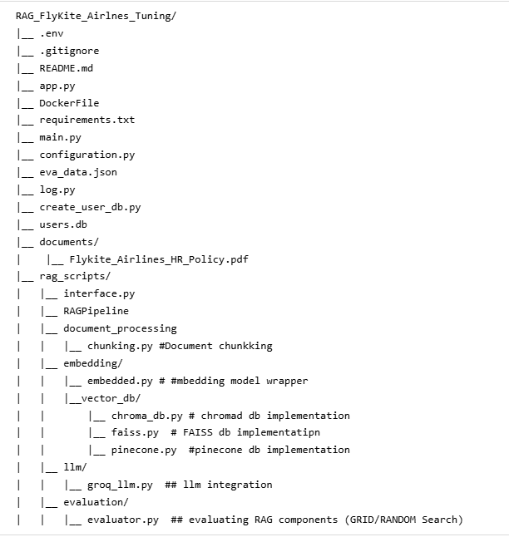
  - Requirement.txt
The following packages need to installed in the system
- langchain-text-splitters # Package for splitting the document into chunks
- sentence-transformers # Transforms the chunks to vector embedding
- chromadb # Package for chroma DB
- pymupdf # PDF package for loading
- regex # regex package for clearing the clutters in data
- groq # Groq LLM
- streamlit # front end creation
- huggingface_hub # HF package for hosting it in HF space
- faiss-cpu # FAISS vector DB package
- pinecone # Pinecone vector DB package
- bert-score # calculating the BERT score
- python-dotenv # to load the env variable
  - Environment Variable (.env file)
This file store the configurable variables like the LLM API keys, default chunk size, chunk overlap, embedding models, vector database, re-ranker models, Pinecone API key, hugging face API key, Data source path, executables folder path.
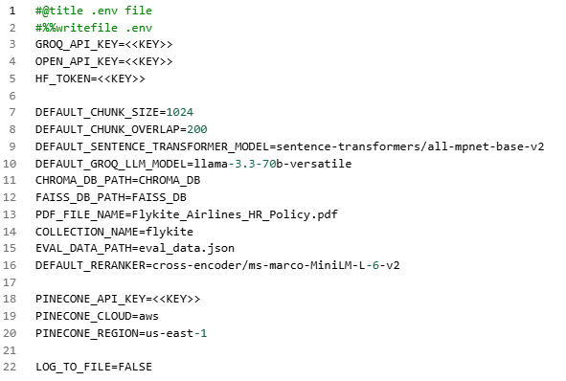

  - Configuration.py
This class loads the .env files and store it in global variable

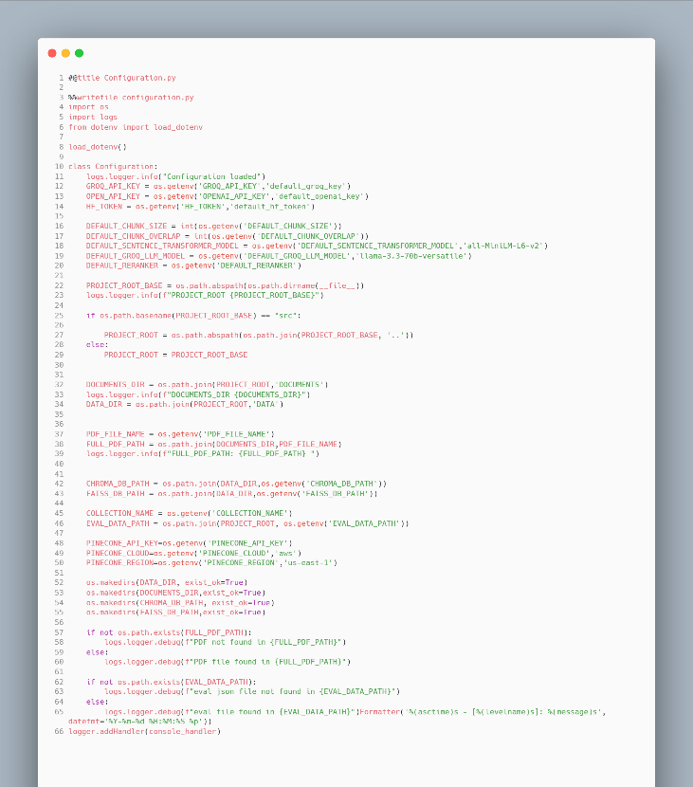

  - Logs.py
This class create a logs Initialization which can be used across the project
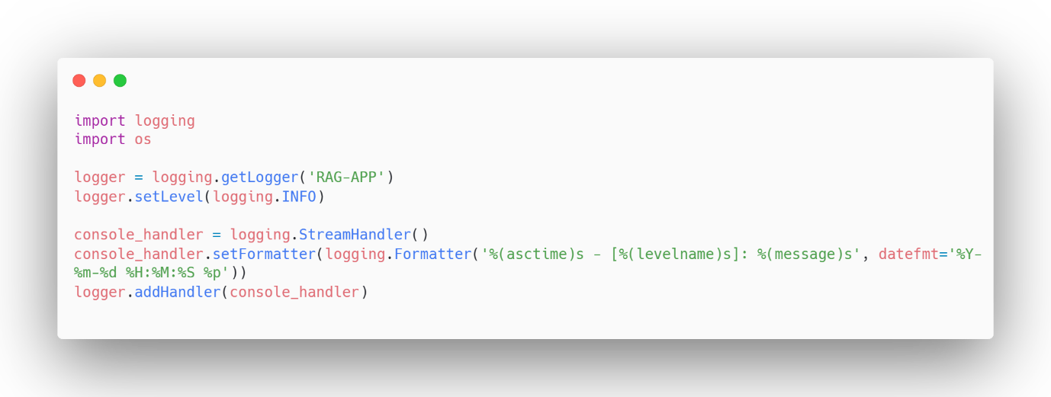

  - Interface.py
  - Chunkking.py
This class PyMuPDFChunker (IDocumentChunker) is used for the loading the Data source, cleaning the data source, and chunking the data source.
Function Name | Function Description | Input Parameters | Output Parameters
__init__ | Constructor | PDF path, chunk size, chunk overlap | Values of PDF path, chunk size and overlap
_clean_text | Removes the non-ASCII characters from the data source | Data source pages | removes the non-ASCII characters from the page
hash_document | creating a hash key for the input data source | Data source file | Hashed value of the pages
chunk_documents | Breaking the data source into multiple chunks | Data source pages | Data chunks with overlap
_extract_section | To get the topics from the data source | Data source pages | Topics from the page
_extract_clause | To get the sub-topics from the data source | Data source pages | Sub Topic from the page
Functions:

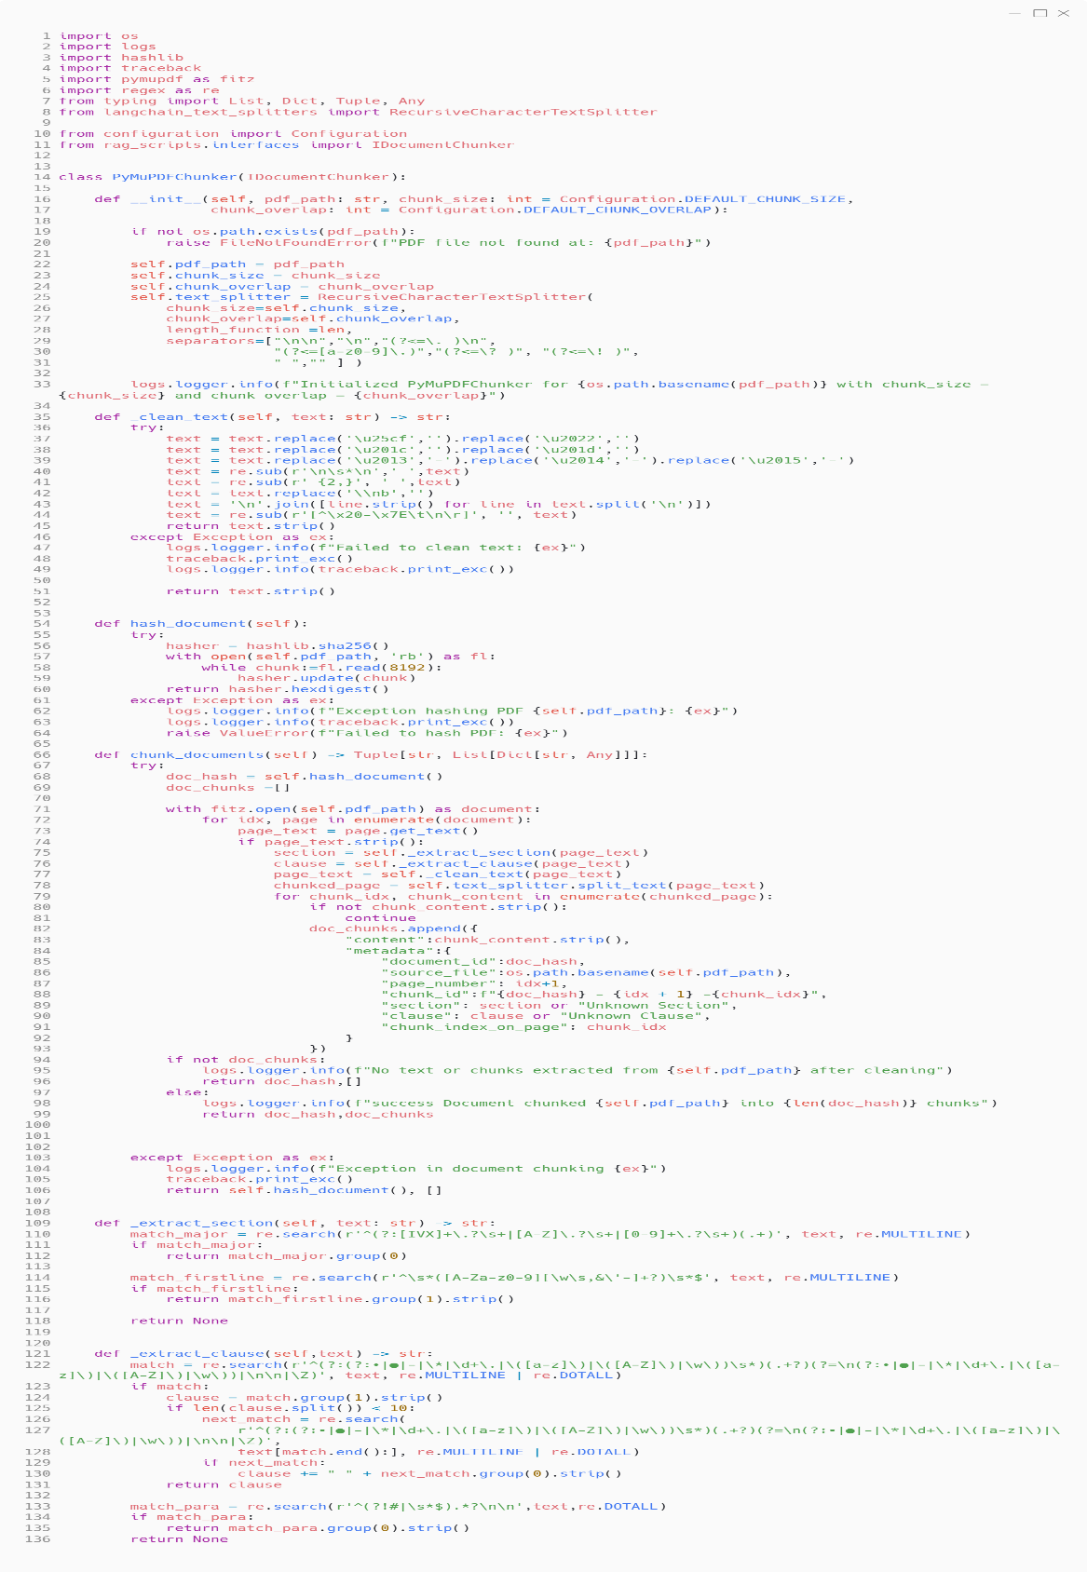

  - Embedding.py
Embedding class SentenceTransformerEmbedder(IEmbedder) created for converting the text into vector embedding and the user query into the vector embedding and re-ranking the retrieved documents based on the cosine similarity
Function Name | Function Description | Input Parameters | Output Parameters
__init__ | Constructor | Sentence transformer embedding model
embed_texts | The chunked document converts into the vector embeddings | Document page as list of string | Vector embedding as List of List float
embed_query | The user query will be converted into the vector embedding | user query as string | Vector embedding as List float
rank | Re Rank the retrieved document based on the relevance answer using re ranker model | User query as string & Retrieved document | re ranker score as list of float value

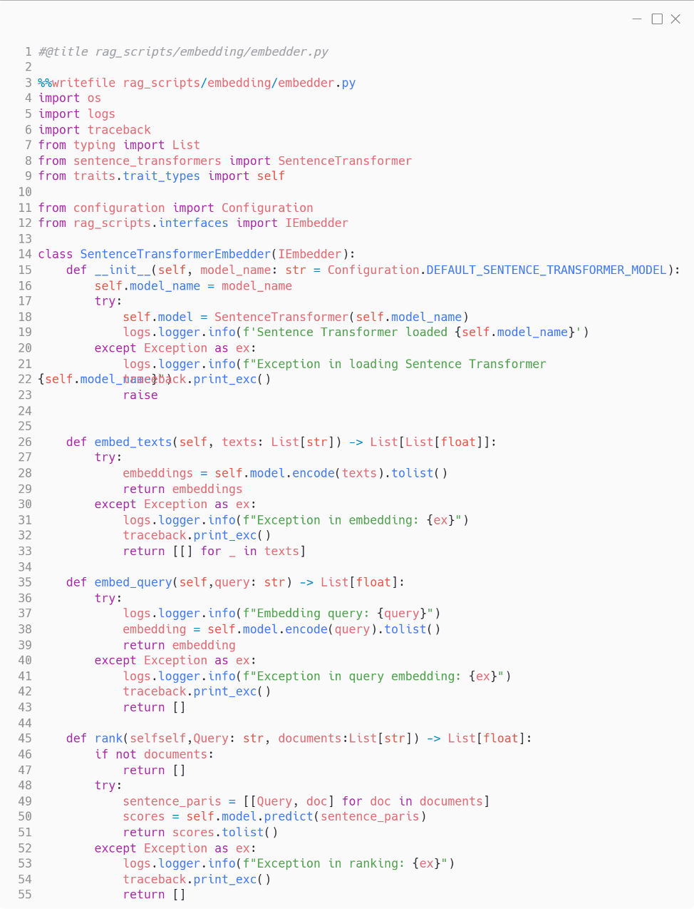

  - VectorDB (chroma_db.py, faiss_db.py, pinecone_db.py)
- chromaDBEmbeddingFunction (EmbeddingFunction):
- FAISSVectorDB (IVector):
- PineconeVectorDB (IVector):
This class help to embed the chunk vectors into vector database when the hyper-tuning the different RAG parameters like chunk size, overlap, embedding models and re-ranker models and different vector DB
Function Name | Function Description | Input Parameters | Output Parameters
__init__ | Constructor | Collection name and DB path
_get_or_create_collection | creating the collection and embedding function object | Collection name and DB path | Collection object
add_chunks | Adding the chunks into vector DB | Chunked documents List of dictionaries | chunked pages embedded into vector DB
get_document_hash_ids | getting the hash id of the chunks | chunked documents as string | hash value of the chunk
search | function to retrieve the chunks based on the user query from vector DB | user query and k value | response as List of dict contains response and metadata
delete_collection | delete the collection in vector DB post the hype tuning iteration | collection name | string message about delete
count_documents | to get the number of documents stored in vector DB | collection name | number of docs as int

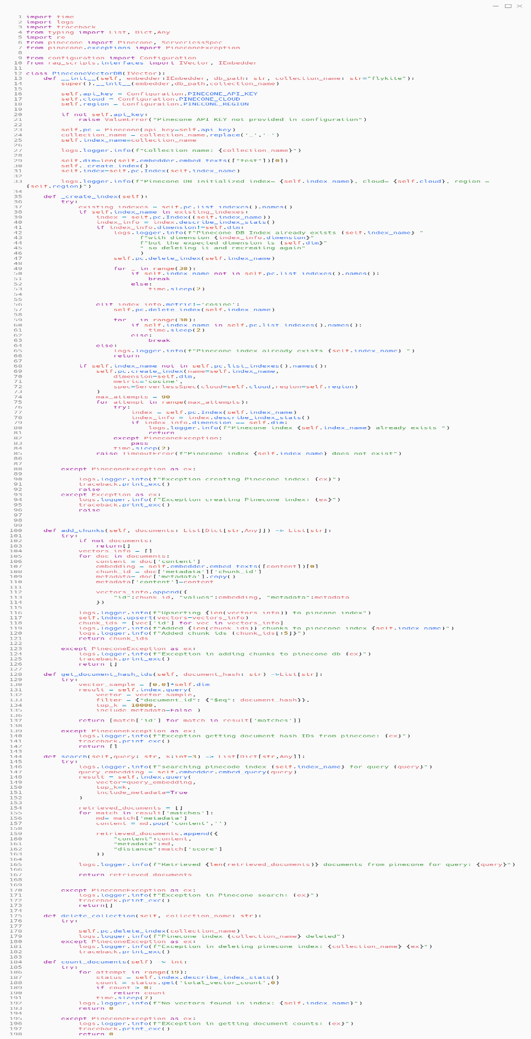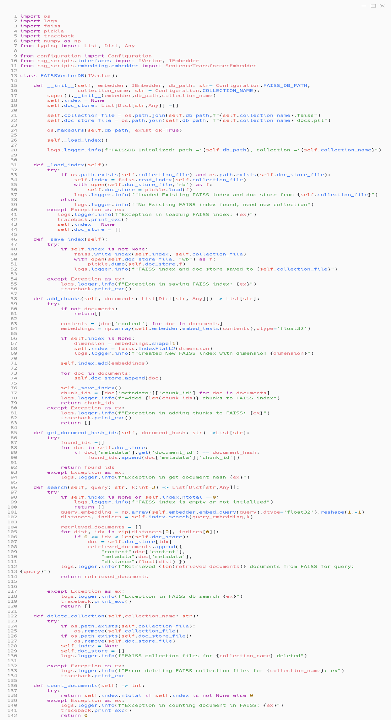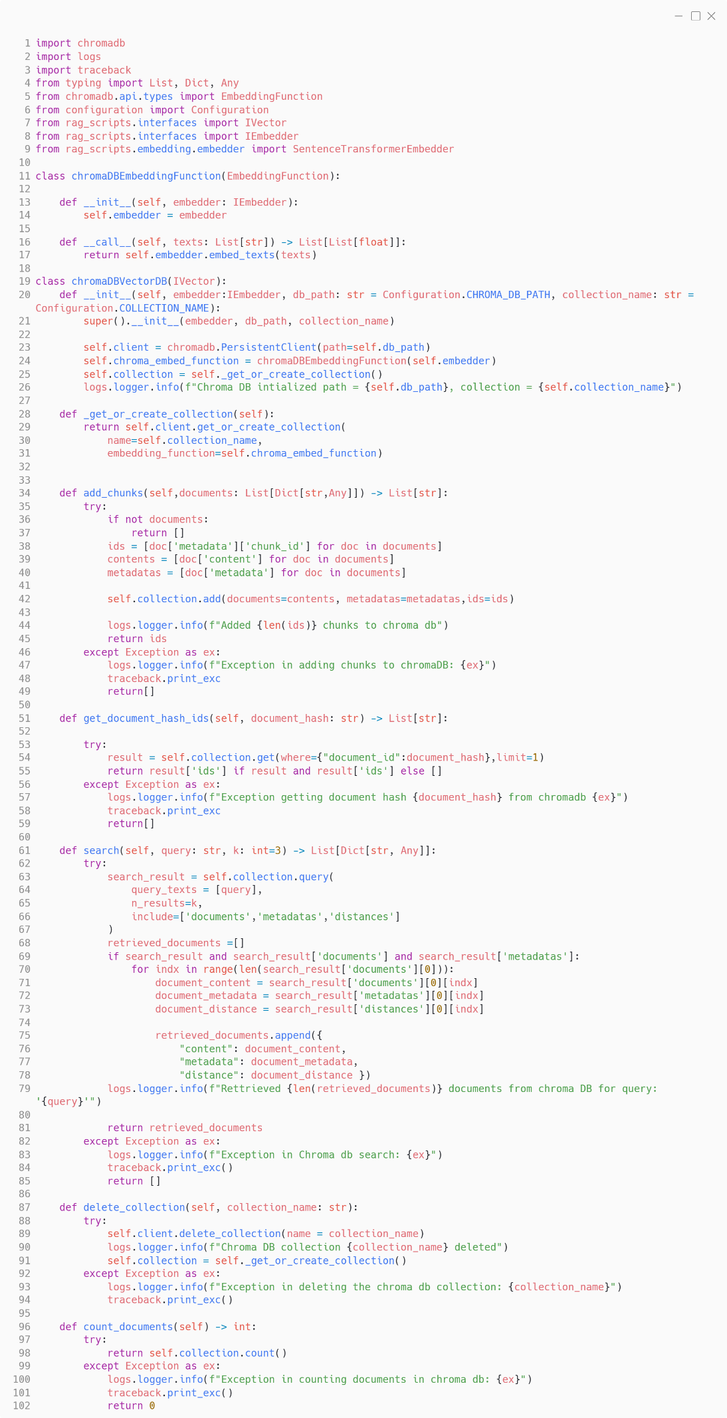
Pinecone.py
FAISS_DB.py
ChromaDB.py
  - Evaluator.py
This class used to evaluate the RAG responses in terms of Groundedness, Relevance score
Also, it is creating the hyper-tuned model (Grid search or Randomised search) based on the user requirements.

Function Name | Function Description | Input Parameters | Output Parameters
__init__ | Constructor | eva_data_json path, data source pdf path, sentence transformer model
_sanitize_collection_name | removes the numeric and underscore, cap letter from the collection name | collection name as string | sanitized collection name
_calculate_retrieval_relevance | To find the Cosine similarity score for the retrieved documents | Query: User input query  retrieved docs: List of retrieved documents  expected answer as string from the eval_Data_json | Cosine score as float
_calculate_response_groundedness | To find the groundedness score for the retreived documents | retreived document as list  response answer for the query | Groundedness score as float
_calculate_response_relevance | To find the relevance score for the retrieved document | Query: User input query  retrieved docs: List of retreived document  expected answer as string from the eval_Data_json | Relevance score as float
_calculate_bert_score | To find the Bert score | retreived document as list  response answer for the query | Bert score as float
evaluate_response | Invoking the above function to find the average score (cosine score, groundedness, relevance and bert score) | Query: User input query  retrieved docs: List of retreived document  expected answer as string from the eval_Data_json | Along with other score best score with observation as out dict output
_evaluate_with_llm | feeding the raw retrieved document into LLM and synthesise the response and passing to another LLM to evaluate the response for groundedness and relevance | Query: User input query  retrieved docs: List of retreived document  response from LLM | Score with explanation as dict
_syntesize_raw_reference | structuring the retrieved response | retreived document as list | cleaned retrieved doc as string

RAGEvaluator.py
Contructors
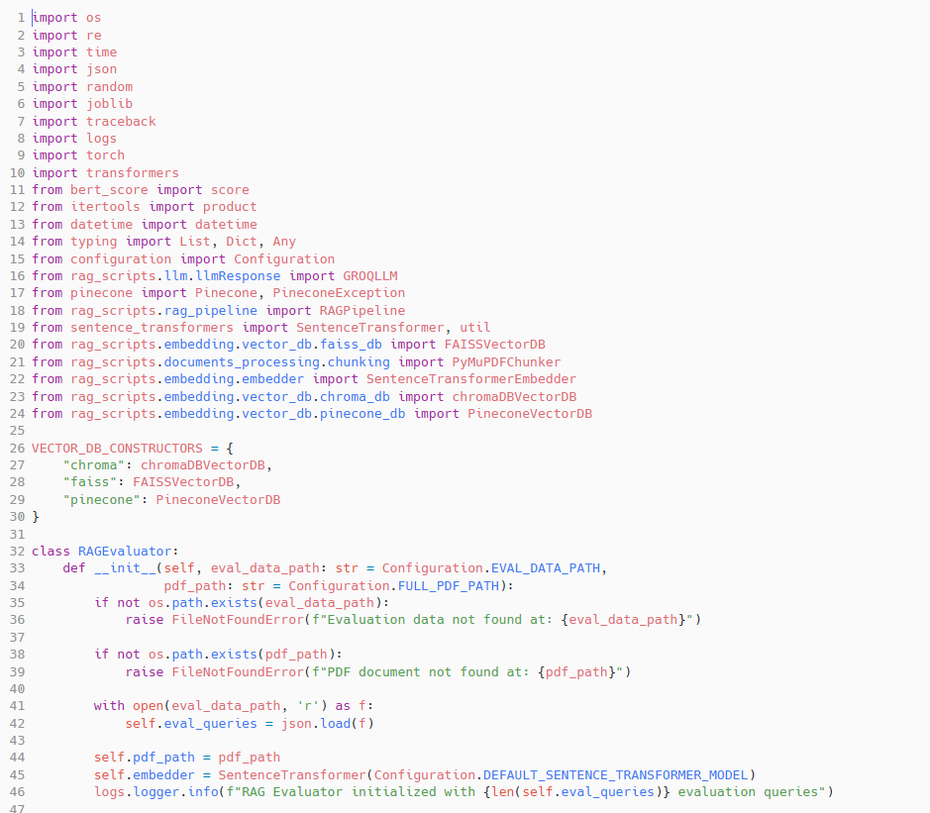

Sanitize & Relevance score(cosine score)
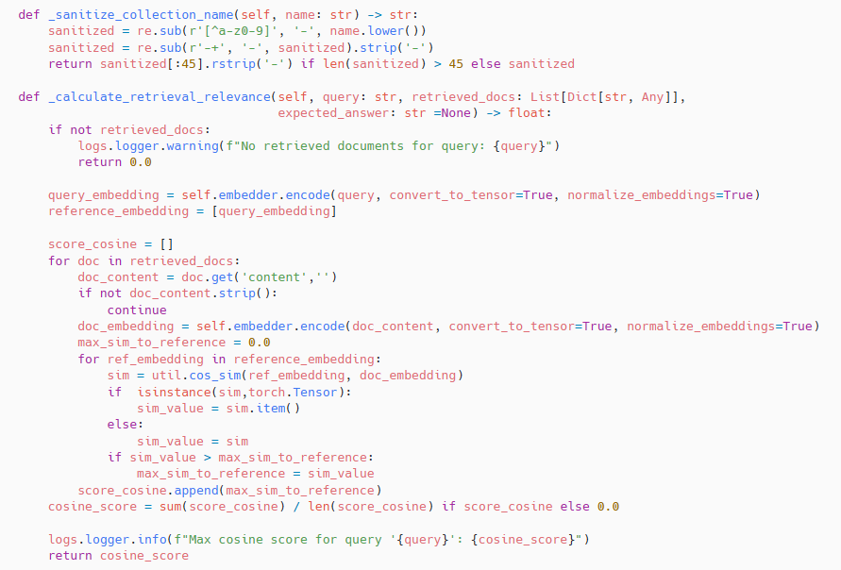

Groundedness score
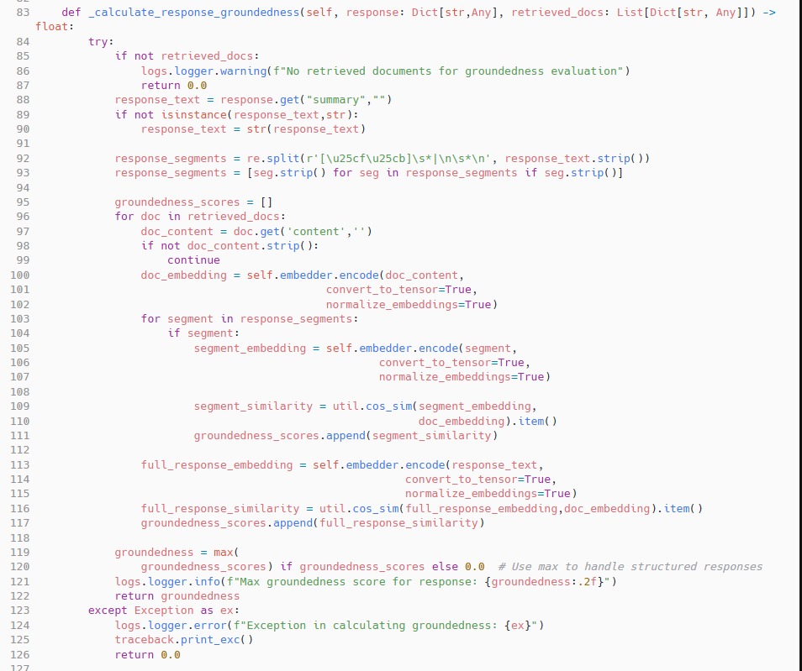

Response Score:
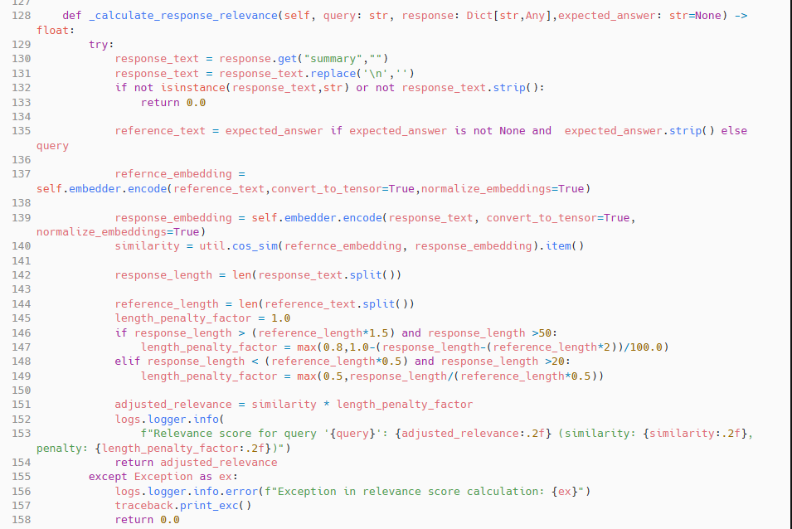

BERT Score
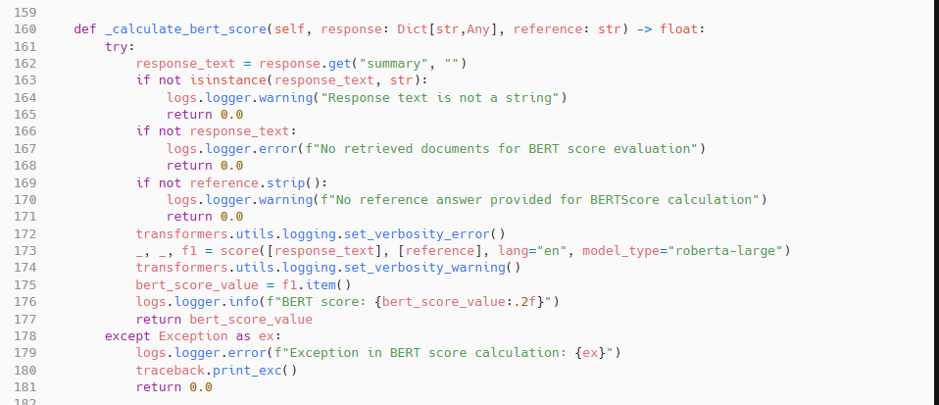

Evaluate Response function:
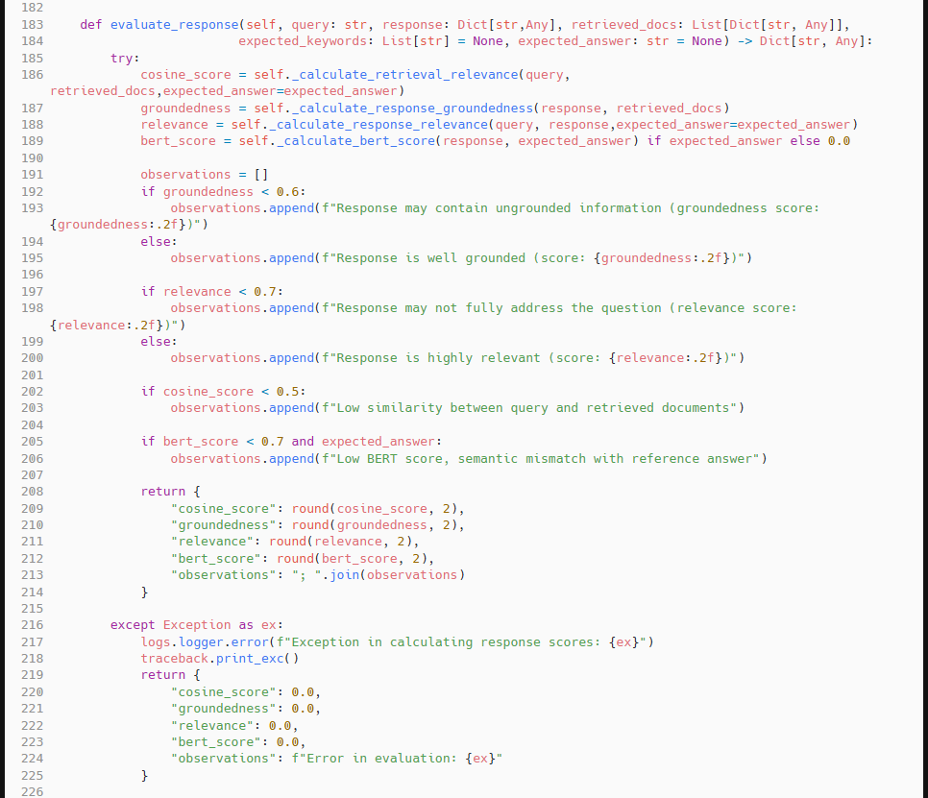

LLM Evaluator
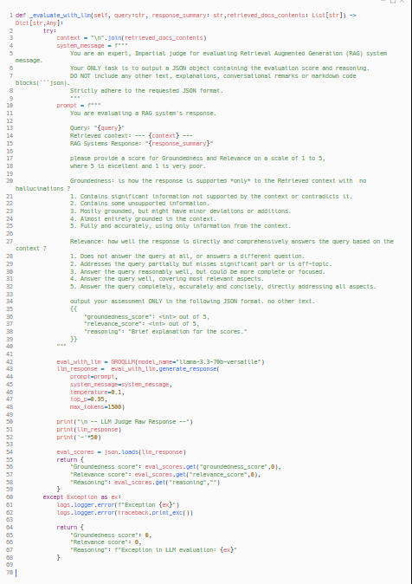

  - RAG_Pipeline.py
  - Main.py
  - App.py
  - DockerFile
  - README.md

