TFMINI
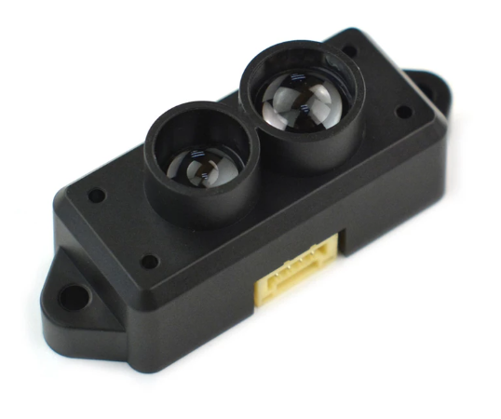 | Physical stimulus to be measured
 | Working Principle
Type of sensor
Active/Passive; Analog/Digital; Internal/External; Hybrid/Direct
 | Transfer Function (or related characteristics, e.g. sensitivity, range, linear/nonlinear)
Comment: (e.g. Qualitative or quantitative purpose? Possible applications)

CNY 70
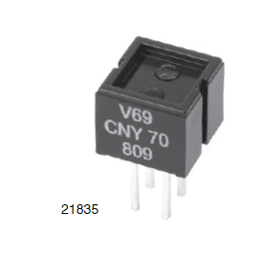 | Physical stimulus to be measured
 | Working Principle
Type of sensor
Active/Passive; Analog/Digital; Internal/External; Hybrid/Direct
 | Transfer Function (or related characteristics, e.g. sensitivity, range, linear/nonlinear)
Comment: (e.g. Qualitative or quantitative purpose? Possible applications)

Ultrasound sensor
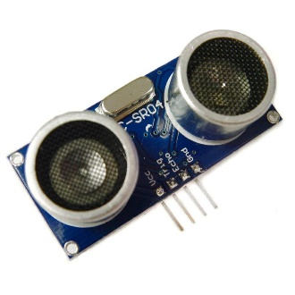 | Physical stimulus to be measured
 | Working Principle
Type of sensor
Active/Passive; Analog/Digital; Internal/External; Hybrid/Direct
 | Transfer Function (or related characteristics, e.g. sensitivity, range, linear/nonlinear)
Comment: (e.g. Qualitative or quantitative purpose? Possible applications)

PDF10A/M
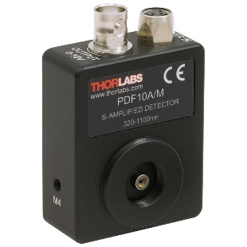 | Physical stimulus to be measured
 | Working Principle
Type of sensor
Active/Passive; Analog/Digital; Internal/External; Hybrid/Direct
 | Transfer Function (or related characteristics, e.g. sensitivity, range, linear/nonlinear)
Comment: (e.g. Qualitative or quantitative purpose? Possible applications)

TEMT6000
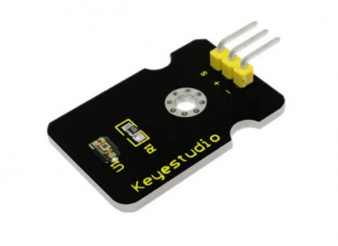 | Physical stimulus to be measured
 | Working Principle
Type of sensor
Active/Passive; Analog/Digital; Internal/External; Hybrid/Direct
 | Transfer Function (or related characteristics, e.g. sensitivity, range, linear/nonlinear)
Comment: (e.g. Qualitative or quantitative purpose? Possible applications)

DHT11
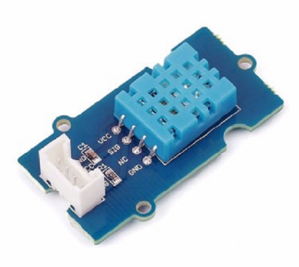 | Physical stimulus to be measured
 | Working Principle
Type of sensor
Active/Passive; Analog/Digital; Internal/External; Hybrid/Direct
 | Transfer Function (or related characteristics, e.g. sensitivity, range, linear/nonlinear)
Comment: (e.g. Qualitative or quantitative purpose? Possible applications)

LM35
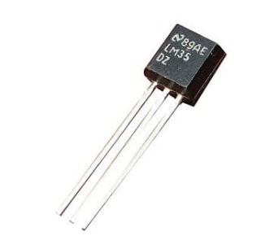 | Physical stimulus to be measured
 | Working Principle
Type of sensor
Active/Passive; Analog/Digital; Internal/External; Hybrid/Direct
 | Transfer Function (or related characteristics, e.g. sensitivity, range, linear/nonlinear)
Comment: (e.g. Qualitative or quantitative purpose? Possible applications)

SKU:SEN0114
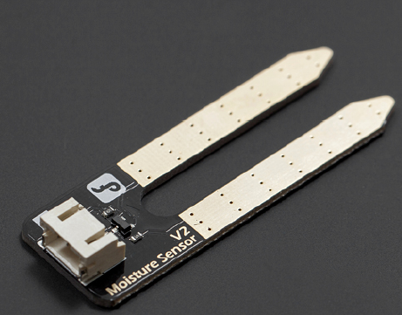 | Physical stimulus to be measured
 | Working Principle
Type of sensor
Active/Passive; Analog/Digital; Internal/External; Hybrid/Direct
 | Transfer Function (or related characteristics, e.g. sensitivity, range, linear/nonlinear)
Comment: (e.g. Qualitative or quantitative purpose? Possible applications)

Lab prototype
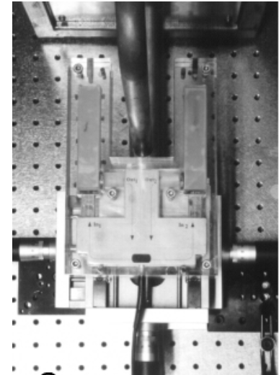 | Physical stimulus to be measured
 | Working Principle
Type of sensor
Active/Passive; Analog/Digital; Internal/External; Hybrid/Direct
 | Transfer Function (or related characteristics, e.g. sensitivity, range, linear/nonlinear)
Comment: (e.g. Qualitative or quantitative purpose? Possible applications)

