Datasheet
Overview:
This IP provides multiplication capabilities with variable bit width

Symbol:
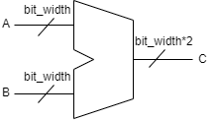

Table of parameters:
bit_width = number of bits of each input, the output will always have double the bits as to not overflow
Table of Signals:
  - A and B: input, these are the numbers to be multiplied
  - C : output, this is the result of the multiplication

