WORKDEY
Match Agent
Product Requirements Document, Hackathon Edition (v2.0)
An AI agent, built as an Apify Actor, that watches job boards for a job seeker, picks the jobs that truly fit her profile, and drafts her reply, cover letter and CV tips.

Field | Detail
Product | WorkDey Match Agent (Apify Actor)
Event | Apify x She Code Africa BuildHer Hackathon 2026, theme: Ship and Earn Africa
Track | Jobs Board (career tools and opportunity matching)
Version | 2.0, reworked from PRD v1.0 (21 September 2026) for the hackathon
Date | 23 September 2026
Build window | Thursday 24 September, 1:20 PM to Friday 25 September, 11:55 AM
Demo | Friday 25 September 2026, in person, The Zone, Gbagada, Lagos
Monetization | Pay Per Event (PPE)
Team | 3 members

1. Summary
WorkDey Match Agent takes a job seeker's profile (skills, education, experience and CV), and on a schedule she picks, like every 5 hours, it checks public Nigerian and remote job boards for new posts. It scores each post against her real profile, picks the 2 or 3 best fits, and emails her a short alert that opens a results page with a ready reply, a cover letter and CV update tips for each job. Other job tools on the Apify Store only collect job posts, but this agent does the hard part for her: it finds the jobs that actually fit and writes her application using only facts from her own CV.
Why it matters for She Code Africa: the community exists to get more African women into tech jobs. This Actor turns job hunting from hours of scrolling into a few minutes of reviewing and sending.

2. Hackathon rules and how we meet them
These are the rules from Saurav Jain's Slack note and the official Program Brief. Every item has a clear answer in this plan.
Rule | How we meet it
Build a new Apify Actor | We build WorkDey Match Agent from scratch on the Apify TypeScript template used in the workshop repo (kazadoiyul/sca2026-demo).
Do not just use an existing Actor | Our Actor does its own scraping, filtering, scoring and AI drafting. We may call Apify's send-mail Actor only to deliver the email. That is one small helper step, not the product.
Pay per event or pay per usage | PPE with two events: match-found and application-pack-drafted (Section 9).
Demo is a live run, no slides | Demo script in Section 12. We run the Actor live in front of judges and show the email and results page.
New use case not on the Store gets priority | Store has many job scrapers. None take a profile, score fit, and draft an application pack. Section 10 explains the gap.
AI Agent Actors get extra points | The Actor is an agent: it reads a goal (the profile), plans steps, uses tools (scrapers, LLM), makes decisions (real job or not, fits or not) and produces finished work.
Solve a real African problem | Built for Nigerian job seekers first. Understands NYSC, HND or BSc, Lagos, Abuja, remote-Nigeria and informal hiring language.
Publicly published Actor | Published on the Apify Store with README, input schema and example output.
Submit Store link, GitHub repo, demo link | Public GitHub repo with README. Store link and demo run link ready before 12:30 PM on Friday.

3. The problem
Job seekers in Nigeria check many sites every day, copy job details by hand, rewrite their CV for each role and struggle to write a good reply or cover letter. Most people give up after a few days, and good jobs expire. Users also want very short updates, not another long feed to scroll.
Job scrapers on the Apify Store solve only the first part: they dump a list of posts. The seeker still has to read all of them, decide which ones fit and write the application herself. That is where time is lost.

4. What we are building for the hackathon
The original PRD (v1.0) describes a full app with login, accounts, a Match Inbox and LinkedIn, X and Instagram sources. That is weeks of work. We have about 22 hours. So we keep the full idea but build it the Apify way: the Actor is the product, and Apify gives us the scheduling, storage and hosting.

4.1 How the original idea maps to Apify
Original PRD idea | Hackathon version on Apify
Log in and create a profile | The Actor input form (built from input_schema.json)
Pick 3, 5 or 24 hours | Apify Schedules, built into the platform
Email when a match is found | Short email at the end of each run with the top matches
Click the email to open the app | The email links to an HTML results page saved by the Actor
AI reply, cover letter, CV revamp | LLM step that runs only on the top matches
Match Inbox and history | Apify dataset (one row per match), viewable and exportable
Do not alert the same job twice | A saved list of seen job links in a named key-value store

4.2 In scope
- Actor input form for the profile.
- Scraping 2 or 3 public job sources that work without a login.
- Removing duplicates and posts already sent in earlier runs.
- AI check that drops non-jobs and likely scams.
- Fit score with 1 or 2 short, human reasons.
- AI application pack for the top matches: reply, cover letter and CV tips.
- HTML results page, dataset output and a short email.
- PPE monetization, public Store listing, README and GitHub repo.

4.3 Out of scope for the hackathon
- LinkedIn, X and Instagram scraping. These need logins, block bots and their terms forbid scraping. They move to the roadmap (Section 14).
- User accounts, passwords and a separate web app.
- Applying on behalf of the user. She always reviews and sends herself.
- PDF export of the CV. We give CV tips and a rewritten summary instead.

5. How it works

5.1 User journey
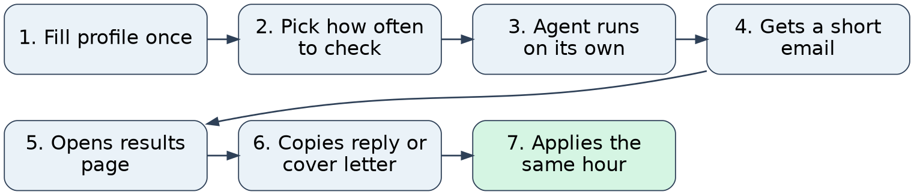
Figure 1. What the job seeker does, from setup to applying.

5.2 System flow inside the Actor
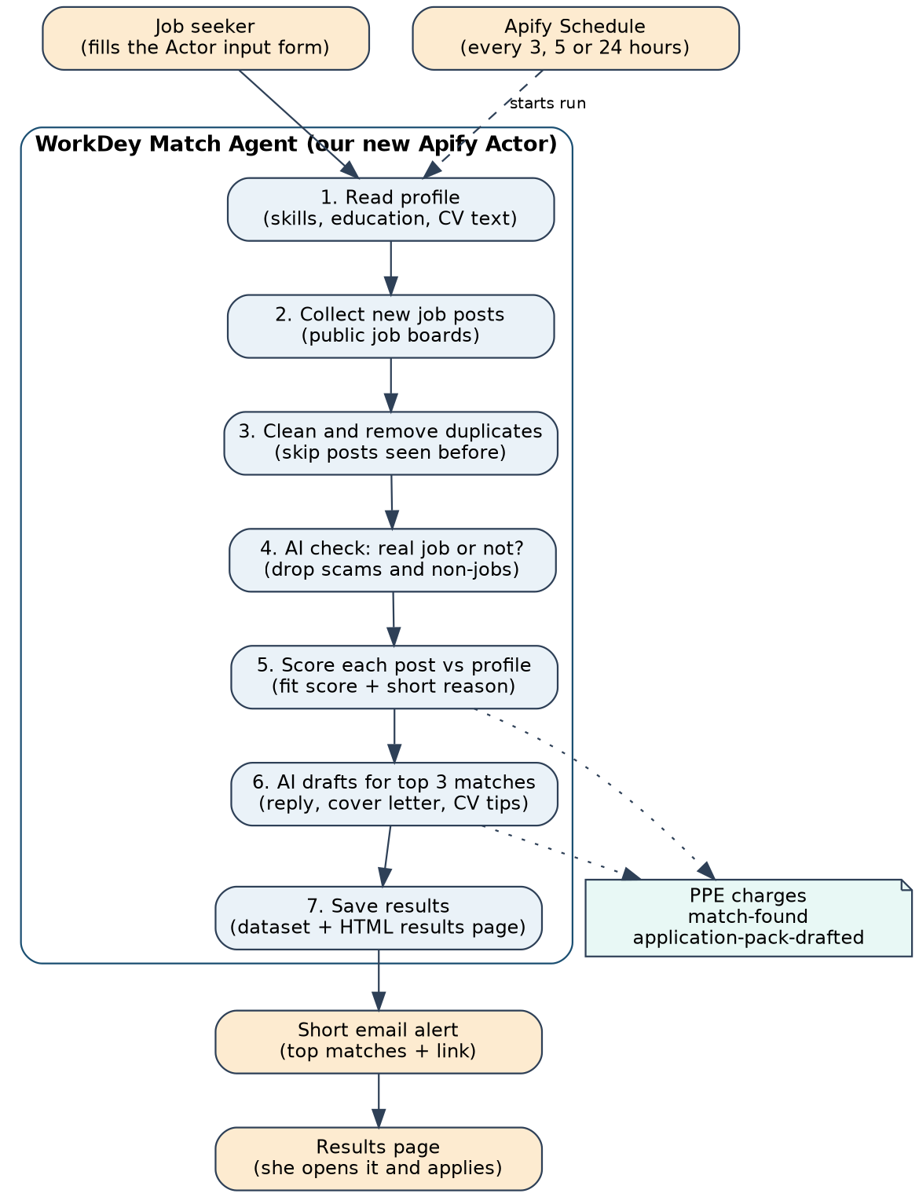
Figure 2. The steps the Actor runs every time it starts.

5.3 Step by step
- Read profile. The Actor reads the input: skills, education, experience, target roles, location, work type and CV text.
- Collect posts. It scrapes new posts from the selected public job sources. Each post is turned into one standard shape (title, company, location, text, link, date, source).
- Clean and dedupe. It removes the same job seen on two sources and skips any job link already sent to this user in an earlier run.
- Real job check. A cheap AI call marks each post as Job, Gig, Not a job or Likely scam. Only Job and Gig move on. Posts asking for payment before an interview are dropped.
- Score. Each post gets a fit score from 0 to 100 and 1 or 2 short reasons, for example: "Matches your Excel and bookkeeping skills; based in Lagos." A match-found event is charged for each post above the minimum score.
- Draft. For the top 3 matches only, the AI writes a reply, a cover letter and CV tips. An application-pack-drafted event is charged for each pack.
- Deliver. Results go to the dataset, an HTML results page is saved, and a short email is sent with a link to that page.

6. Input (the profile form)
Field | Type | What it does
fullName | string | Used in the reply and cover letter.
email | string | Where the alert is sent. Optional, skip to turn email off.
skills | array | Main matching signal, for example Python, Excel, Figma.
targetRoles | array | 1 to 3 roles, for example Data Analyst, Virtual Assistant.
education | string | Degree, school, NYSC status.
experienceYears | integer | Helps skip roles that are too senior or too junior.
locations | array | Cities or Remote. Used as a filter.
workType | enum | full-time, gig or either.
cvText | textarea | Plain text of her CV. The AI may only use facts from here and the fields above.
sources | array | Which job sources to check. Default: all.
minScore | integer | Lowest fit score to count as a match. Default 60.
maxPacks | integer | How many top matches get a full application pack. Default 3.

To run it every few hours, the user saves this input as an Actor task and adds an Apify Schedule (for example every 5 hours). No extra code is needed.

7. Output

7.1 Dataset (one row per match)
Field | Example
title, company, location | Junior Data Analyst, Sample Company Ltd, Lagos
source, url, postedAt | Job board name, link to post, date
fitScore | 82
fitReasons | ["Matches your SQL and Excel skills", "Entry level role in Lagos"]
postType, scamRisk | Job, low
reply | Short message she can send to the poster (40 to 90 words)
coverLetter | Tailored cover letter (up to 280 words)
cvTips | 3 to 5 changes to make her CV fit this role, plus a rewritten summary

7.2 Results page
A clean, mobile friendly HTML page saved in the run's key-value store. Each match shows as a card with the job title, source, fit score, the reason it fits, a link to the original post and three sections: Reply, Cover letter and CV tips, each with a copy button.

7.3 Email alert
Short, as the users asked for:
- Subject under 50 characters, for example "2 new job matches for you".
- Body of 3 to 5 lines: the best job title, one line on why it fits, and one button to open the results page.
- No email is sent if nothing new was found.

8. Matching and AI rules

8.1 Scoring
- Hard filters first: location and work type, if the user set them.
- Skill overlap score: how many of her skills and target role words appear in the post.
- AI fit score: the model rates fit from 0 to 100 and gives 1 or 2 short reasons.
- Final score = 40% skill overlap + 60% AI fit score. Bonus for posts less than 48 hours old.

8.2 AI safety rules
- Use only facts from the profile, the CV text and the job post. Never invent employers, dates, degrees or certificates.
- If the post is not a real job, say so and do not draft anything.
- Formal boards get a cover letter first. Informal posts get a short reply first.
- Understand Nigerian context: NYSC, HND or BSc, Lagos, Abuja, Port Harcourt, remote-Nigeria.
- Every draft is marked "Draft only. Check before you send."

8.3 Cost control
The cheap real-job check runs on every post. The expensive drafting runs only on the top 3. This keeps the LLM cost per run low and makes the PPE prices below profitable.

9. Monetization (Pay Per Event)
We charge for the value the agent creates, not for raw scraping. Scraped posts are free because that is what existing scrapers already sell.
Event | Suggested price | When it is charged
match-found | $0.02 | Each job that passes the real-job check and scores above minScore.
application-pack-drafted | $0.05 | Each full pack (reply, cover letter, CV tips) written for a top match.

Example: a run with 5 matches and 3 packs costs the user $0.25. At every 5 hours, that is about $1.20 per day, less than a single printed CV. Final prices will be set after we measure real LLM cost on Thursday. Events are declared in the Actor's monetization settings and charged in code with Actor.charge().

10. How we stand out
 | Job scrapers on the Store | WorkDey Match Agent
Input | Keywords or a search URL | Her full profile and CV
Output | A long list of raw posts | 2 or 3 jobs that fit, with reasons
Decides what fits | No | Yes, with a score and plain reasons
Filters scams and non-jobs | No | Yes
Writes the application | No | Reply, cover letter and CV tips
Stays honest | Not relevant | Uses only facts from her CV
Runs by itself | User must set it up and read results | Schedule plus a short email
Built for | General use | African, mainly Nigerian, job seekers

Pitch line: "There are job scrapers on Apify already. WorkDey Match Agent is the layer nobody has built: it reads your real profile, finds the 2 or 3 jobs that actually fit, and hands you a ready reply and cover letter, using only facts from your CV."
Before the demo, we search the Store one more time for "job match", "cover letter" and "CV" and write what we found in the README, so we can answer the judges' question "does this already exist?" with facts.

11. Technical plan

11.1 Stack
- Apify SDK and Crawlee, TypeScript template (same as the workshop example).
- CheerioCrawler for job boards, or a public JSON API or RSS feed where one exists (faster and more stable, as shown in the workshop example).
- LLM through an API key stored as a secret environment variable in actor.json.
- Named key-value store for the list of already-sent job links.
- Apify send-mail Actor for the email step.

11.2 Project structure
File | Purpose
.actor/actor.json | Name, version, secret env vars
.actor/input_schema.json | The profile form (Section 6)
.actor/dataset_schema.json | Match fields and table view (Section 7.1)
.actor/output_schema.json | Links to dataset and results page
src/main.ts | Runs the 7 steps in order
src/sources/*.ts | One file per job source, all return the same shape
src/dedupe.ts | Removes duplicates and already-sent jobs
src/ai.ts | Real-job check, fit score, drafting prompts
src/report.ts | Builds the HTML results page
src/notify.ts | Sends the short email

11.3 Job sources
We pick 2 or 3 sources that are public, load without a login and allow access in their terms. Candidates: Nigerian job boards (such as MyJobMag or Jobberman) and a remote jobs board with a public API or RSS feed. We test each one on Wednesday night. Any source that blocks us is dropped. We keep request speed low, like the workshop example does.

12. Team plan and demo

12.1 Roles
Member | Owns
Member A | Job sources: scrapers, standard post shape, dedupe and seen-jobs store
Member B | AI: real-job check, scoring and drafting prompts. Tests with fake posts so she does not wait for Member A
Member C | Input and output schemas, results page, email, PPE setup, publishing, README

12.2 Timeline
When | What
Wed 23 Sept (today) | All: Apify accounts and CLI set up ("Before you start" in workshop repo). Test job sources. Get LLM key. Agree on the post shape.
Thu 11:00 AM to 1:20 PM | Attend onboarding. Note judging criteria and submission rules.
Thu 1:20 PM to 7:00 PM | Each member builds her part separately.
Thu 7:00 PM to 11:00 PM | Join all parts. First full run on the Apify platform. Publish.
Thu 11:00 PM onward | PPE events, schedule, README, Store listing text.
Fri 9:25 AM to 11:55 AM | Fix bugs, final Store check, prepare demo profile, practice demo twice.
Fri 12:30 PM | Private demo round at judging desks.

12.3 Demo script (about 3 minutes)
- Problem, 20 seconds: "Job hunting in Nigeria means hours of scrolling and rewriting your CV. Most people give up."
- Show the input form with a real sample profile, 20 seconds.
- Start the run live and explain the 7 steps while it works, 60 seconds.
- Show the email that arrives, then open the results page, 40 seconds.
- Show one match: fit reason, reply, cover letter and CV tips. Point out that nothing was invented, 30 seconds.
- Show the schedule and PPE prices, then the pitch line, 10 seconds.
Backup: keep a finished run from Friday morning open in another tab in case the live run is slow or the internet drops.

13. Risks
Risk | Impact | What we do
A job source blocks us or changes | No posts to match | Use 2 or 3 sources. Keep a backup run to show.
AI invents facts in a cover letter | Loss of trust | Strict prompt rules, only CV facts, "draft only" label.
Scam job is sent to a user | Harm to user | Real-job check before scoring. Drop posts asking for payment.
LLM cost too high | PPE not profitable | Draft only top 3. Cheap model for the check step.
Not finished in time | Weak demo | Each part tested alone first. Email and page are last, can be simple.
Judges think it copies a scraper | Lower score | Lead with matching and drafting. Show Section 10 table in README.

14. After the hackathon
Phase | Plan
Next | More Nigerian and African job sources. Pidgin reply option. Feedback on matches to improve scoring.
WorkDey app | Connect the Actor to the WorkDey app so users get accounts, a Match Inbox and PDF CV export, as in PRD v1.0.
Social sources | X, LinkedIn and Instagram only through official APIs, partners or user-shared posts, after a terms review.
Growth | Share with She Code Africa chapters as a free trial. Earn through PPE on the Apify Store.

15. Submission checklist
- New Actor built by the team, published publicly on the Apify Store
- PPE events set up: match-found and application-pack-drafted
- README with what it does, how it differs from Store job scrapers, input, output and pricing
- Input schema, dataset schema and output schema complete
- At least one successful run on the Apify platform with real output
- Schedule example set up (every 5 hours)
- Public GitHub repository
- Store link, GitHub link and demo run link submitted
- Demo practiced twice, backup run open

