**Personal Details**

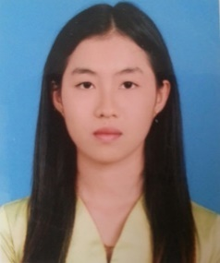

Name : Nu Nu Aung

Date of Birth : Feb 25, 1995

Nationality : Mon / Buddhist

Marital Status : Single

Email : jellywelly1500@gmail.com

Mobile : 09765069600

Yangon Address : Train Building(2)Room(8), Ngu War Street, Ahlone Township, Yangon.

Current address : No.(19), Aung Thitsar Street, Aung Chan Thar Qtr, Thanbyuzayat Tsp.

**Personal Skill**

A passionate developer who likes to learn new technologies and develop any kinds of projects. Able to communicate with team members and work under pressure.

**Key Points**

* Quick Learning
* Passionate
* Willingness to learn new things
* Can work under pressure
* HTML, CSS, SCSS, Bootstrap, Javascript, Jquery, React, Wordpress

**Education**

- Bachelor of Computer Science 2011 – 2015 (University of Computer Studies Thaton)

- Thesis(coursework) 2015 – 2016 (University of Computer Studies Yangon)

- Web Design and PHP Web Development Course at Information and Communication Technology Training Institute(ICTTI) in December 11,2017.

**Professional Experience**

**Seattle Consulting Myanmar Co., Ltd.**

**Position -** Web Developer(Wordpress) (March 2019 to October 2020)

**Project link** - <https://www.sparkling-lights.jp/ec/>

<https://www.sunnyside-international.jp>