1. When u first open the app, there are menu List Machine Data.   
   you can add new machine data with tap Add New in Top Right Corner.

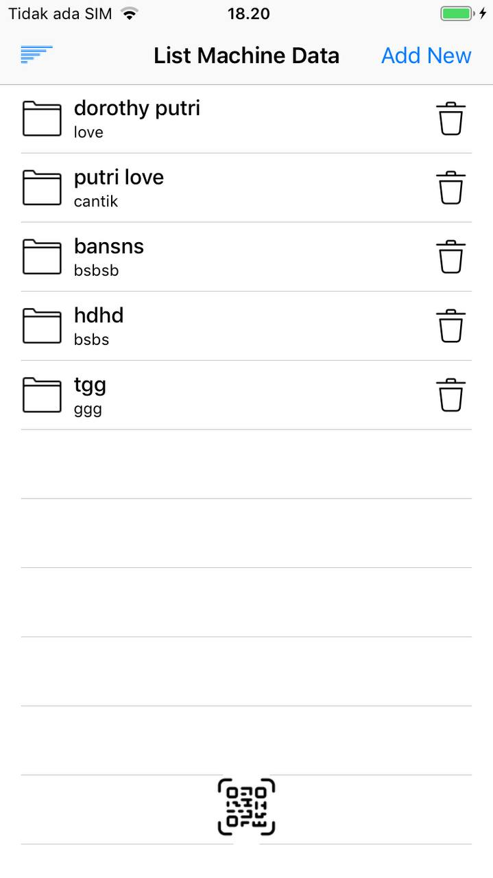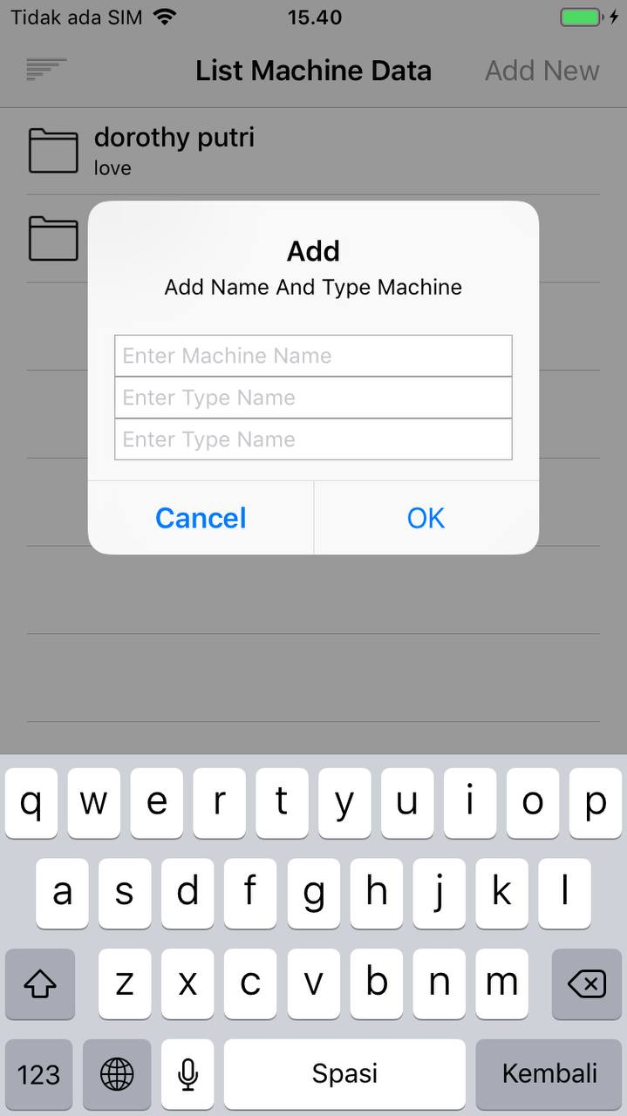

1. You can sort by machine name and machine type with icon sort in Top Left Corner.
2. You cand delete data by tap icon trash.
3. You can find machine data detail by scan qrcode number you have (I use qode generator, for testing, I insert qrcode number from my machine data there, then I scan. Then the app will go to detail machine data that have that machine data number.

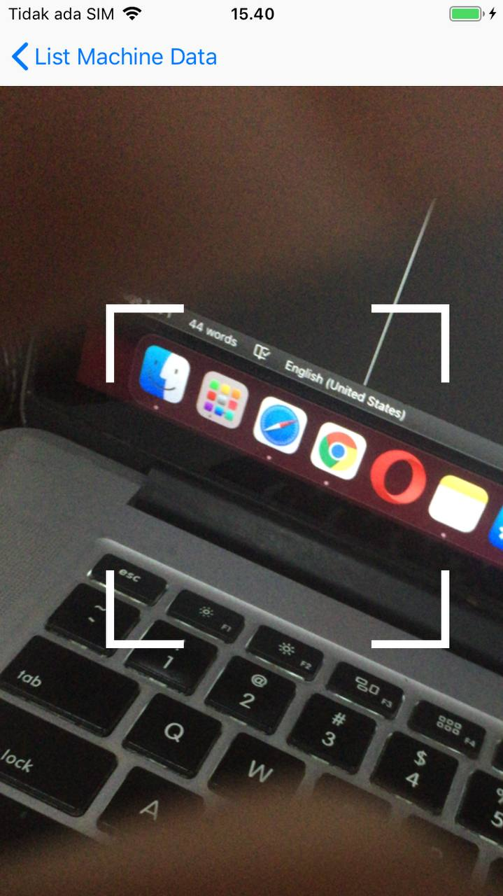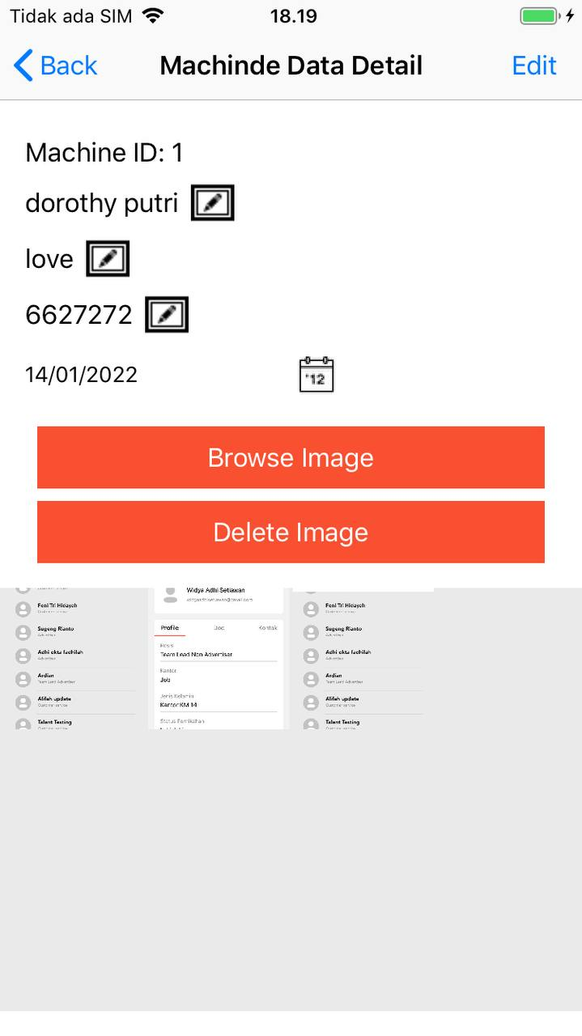

1. If you cliked list machine data detail, it will go to machine data detail.



* You can change machine name, machine type and qrcode by click icon edit on right.
* If you want to pick multiple image, you can click browse image. Max multiple image is 10.
* If you want to set date maintenance, click icon calender. And set your date.
* If you want to see full image from the gallery, please click the image.
* But if you want to delete image, please first click edit in top right corner. And select (multiple image) that you want to delete, (click button delete after your selected the image you want to delete.