Technical Requirements Document (TRD)
AI Company Detection Agent berbasis OpenClaw
Versi: 1.0 | Status: Draft Teknis | Bahasa: Indonesia
Disusun untuk kebutuhan implementasi perusahaan berdasarkan PRD Deteksi Perusahaan v6
Tujuan teknis: membangun sistem yang dapat menginvestigasi data register, mengidentifikasi apakah akun punya/mewakili/terafiliasi perusahaan, menyimpan bukti, menghitung confidence, dan mengirim laporan naratif ke Slack.

Daftar Isi
- 1. Ringkasan Teknis
- 2. Scope dan Non-Scope
- 3. Prinsip Arsitektur
- 4. Target Architecture
- 5. Komponen Sistem
- 6. OpenClaw Tools & Provider Plan
- 7. Multi-Agent Design
- 8. Data Model dan Evidence Store
- 9. API Contract dan Job Lifecycle
- 10. Deployment Docker
- 11. Security, Privacy, dan Compliance Guardrails
- 12. Observability dan Operasional
- 13. Roadmap Implementasi
- 14. Risiko Teknis dan Mitigasi
- 15. Referensi Teknis

1. Ringkasan Teknis
Dokumen ini menerjemahkan PRD Deteksi Perusahaan menjadi kebutuhan teknis implementasi. Sistem yang dibangun adalah AI Company Detection Agent: sebuah agent berbasis OpenClaw yang menerima data register, membentuk hipotesis awal, memilih tools investigasi secara fleksibel, mengumpulkan bukti, menghitung confidence, lalu mengirim laporan ke Slack dalam gaya naratif asisten kerja.
OpenClaw digunakan sebagai orchestration layer karena tools di OpenClaw memang berfungsi sebagai typed functions yang dapat dipanggil agent, misalnya exec, browser, web_search, web_fetch, x_search, message, code_execution, dan subagents. Skill boleh dipakai sebagai instruksi, tetapi TRD ini fokus pada tools, runtime, data model, deployment, dan integration contract.
Area | Keputusan Teknis
Primary runtime | OpenClaw Gateway + custom investigation worker
Execution model | Bounded agentic investigation loop, bukan pipeline kaku
Deployment awal | Docker Compose di VPS atau cloud VM
Queue | Redis + BullMQ/Celery, atau Temporal untuk versi lebih serius
Database | Postgres sebagai evidence store dan result store
Search/scrape | OpenClaw web_search, x_search, web_fetch, browser, Firecrawl, Tavily/Brave/Exa jika tersedia
Slack report | OpenClaw message tool atau Slack Web API melalui custom tool
Fallback budget | Tool yang belum ada API key/budget ditandai disabled/skipped, bukan menghambat sistem

2. Scope dan Non-Scope

2.1 Scope
- Menerima job investigasi dari backend platform saat user register.
- Melakukan normalisasi identitas: email, domain, name, username, signup source, dan metadata lain.
- Memberikan AI goal, aturan, batas tools, retry budget, dan stop condition.
- Menggunakan tools OpenClaw dan custom tools untuk mencari evidence publik.
- Menyimpan semua evidence, tool run, confidence update, dan alasan keputusan.
- Menghasilkan internal JSON dan Slack narrative report.
- Mendukung tools yang belum aktif dengan status disabled/waiting_budget tanpa merusak flow.

2.2 Non-Scope Awal
- Tidak membangun dashboard CRM penuh di fase MVP.
- Tidak melakukan bypass login, CAPTCHA, paywall, atau anti-bot system.
- Tidak menjadikan scraping LinkedIn langsung sebagai dependency utama.
- Tidak membuat klaim “owner/founder” tanpa evidence kuat dan traceable.
- Tidak memakai semua tools secara wajib; tools dipilih berdasarkan suspicion dan expected value.

3. Prinsip Arsitektur
Prinsip | Implikasi Teknis
Goal-first agent | Agent selalu menerima tujuan eksplisit sebelum tools: deteksi apakah akun merupakan individu biasa, terafiliasi perusahaan, mewakili perusahaan, founder/owner, suspicious, atau unknown.
Suspicion-based routing | Agent memilih tools berdasarkan kecurigaan, evidence sementara, source reliability, biaya, dan risiko; bukan alur fixed A lalu B lalu C.
Early stop with proof | Agent boleh berhenti setelah 2 tools jika klaim sudah aman, confidence tinggi, dan evidence cukup.
Evidence over guess | Setiap conclusion wajib punya evidence item, source, timestamp, dan confidence contribution.
Tool availability aware | Jika API key belum ada atau budget belum tersedia, tool diberi status disabled/waiting_budget dan dilewati dengan alasan.
Human-readable + machine-readable | Slack report dibuat naratif, sementara JSON internal disimpan untuk audit dan automation.

4. Target Architecture
Arsitektur target memisahkan platform backend, queue, OpenClaw gateway, custom worker, evidence store, external tools, dan Slack delivery. OpenClaw menjadi tool orchestration surface, sedangkan custom worker menangani kontrak job, persistence, dan integrasi business logic yang spesifik ke perusahaan.
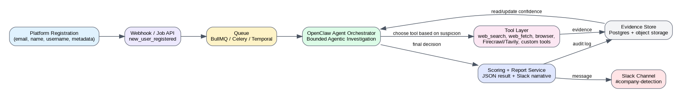
Gambar 1. Arsitektur logis AI Company Detection Agent.

5. Komponen Sistem
Komponen | Fungsi | Teknologi
Registration Event Producer | Backend platform mengirim event user_registered ke queue/webhook. | App backend
Investigation Job API | Menerima payload register dan membuat job_id/idempotency_key. | FastAPI/Express/NestJS
Queue | Menjamin job async, retry, rate limit, dan backpressure. | Redis BullMQ / Celery / Temporal
OpenClaw Gateway | Runtime agent, channel Slack, tool access, web/browser/message. | OpenClaw Docker/Gateway
Investigation Worker | Mengatur lifecycle job, memanggil OpenClaw, custom tools, DB writes. | Node.js/Python service
Tool Catalog | Registry tools yang available/disabled/cost/risk. | YAML/DB config
Evidence Store | Menyimpan evidence graph, source URL, raw snippet, screenshot metadata. | Postgres + object storage
Scoring Engine | Menghitung classification dan confidence. | Rules + LLM structured output
Slack Reporter | Membentuk laporan naratif dan mengirim ke Slack. | OpenClaw message / Slack API

6. OpenClaw Tools & Provider Plan
Tools di bawah dipetakan berdasarkan kebutuhan produk. Tidak semua harus aktif di MVP. Agent harus membaca availability matrix sebelum memilih tool.
Tool | Type | Dipakai untuk | Prioritas | Catatan
web_search | Built-in | Cari kandidat company/person/profile lewat web dan SERP-like result. | MVP: wajib | Low-medium cost
x_search | Built-in | Cari sinyal dari X/Twitter, terutama signup dari X campaign. | MVP: optional | Gunakan jika data username/handle kuat
web_fetch | Built-in | Fetch konten URL spesifik untuk halaman ringan/static. | MVP: wajib | Tidak untuk JS-heavy
browser | Built-in UI | Render halaman JS-heavy, klik, screenshot, validasi visual. | Phase 2 | Lebih mahal dan lebih lambat
code_execution | Built-in runtime | Normalisasi data, scoring, dedup, validation script. | MVP: wajib | Sandboxed
message | Built-in messaging | Kirim report ke Slack/channel lain. | MVP: wajib | Butuh Slack channel configured
sessions_spawn/subagents | Built-in sessions | Investigasi paralel: website, public profiles, enrichment. | Phase 2 | Gunakan untuk job kompleks
read/write/edit | Built-in FS | Simpan draft report, configs, temporary evidence. | MVP: optional | Jangan jadi DB utama
cron/gateway | Built-in automation | Scheduled re-check, gateway config, operational tasks. | Phase 2 | Owner-only untuk config sensitif
Firecrawl | Provider/plugin | Search/scrape/crawl web page menjadi markdown/structured data. | MVP/Phase 2 | Butuh API key/budget
Tavily | Provider/plugin | AI-friendly search/extract dengan filters/domain control. | Phase 2 | Butuh API key
Brave/Exa/Perplexity | Search providers | Alternatif provider web_search sesuai budget dan kualitas. | Phase 2 | Provider selection by config
llm-task | Plugin tool | JSON-only structured scoring/report fields. | Phase 2 | Bagus untuk schema validation

6.1 Custom Tools yang Perlu Dibuat
Custom Tool | Contract Ringkas | Fase
email_intelligence | Input: email. Output: domain, free_provider, disposable, mx_valid, role_email, risk flags. | MVP
domain_checker | Input: domain. Output: website_active, redirects, title, meta, detected_company_name. | MVP
serp_query_builder | Input: identity. Output: query variants + target sources. | MVP
evidence_store.write | Input: evidence item. Output: evidence_id. | MVP
scoring_engine.score | Input: evidence graph. Output: classification, confidence, reasons. | MVP
slack_report_formatter | Input: internal JSON. Output: human narrative Slack text. | MVP
enrichment_api.lookup_person/company | Input: email/name/domain. Output: vendor signals. | Phase 2/paid
github_public_checker | Input: username/name. Output: profile/company/blog/org evidence. | Phase 2
producthunt_checker | Input: username/name/company. Output: maker/product evidence. | Phase 2

7. Multi-Agent Design
MVP dapat berjalan dengan single orchestrator agent. Multi-agent digunakan saat volume, latensi, atau kompleksitas evidence meningkat. Multi-agent tidak wajib dari awal, tetapi desainnya perlu disiapkan.
Agent | Tanggung Jawab | Kapan Dipakai
Orchestrator Agent | Menetapkan goal, suspicion, tool selection, stop/continue decision. | Selalu
Web Research Agent | Search SERP, LinkedIn via SERP signal, source discovery. | Jika email tidak cukup atau butuh cross-check
Company Website Agent | Scrape company domain, about/team/contact/pricing/legal pages. | Jika ada domain kandidat
Public Profile Agent | Cek X/GitHub/Product Hunt/Crunchbase/Wellfound signal. | Jika username/handle kuat
Scoring Agent | Membaca evidence graph dan menghasilkan classification + confidence. | Setiap job
Report Agent | Membuat Slack report naratif dan internal JSON final. | Setiap job

7.1 Agent Loop
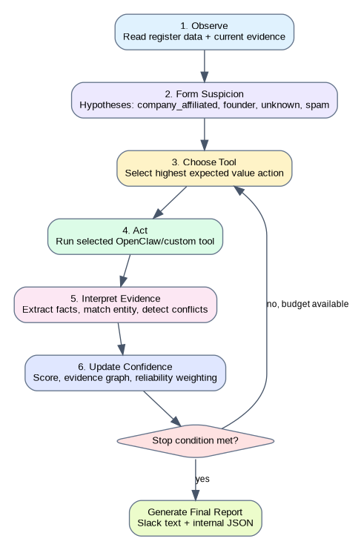
Gambar 2. Bounded agentic investigation loop.

8. Data Model dan Evidence Store
Evidence store adalah pusat audit. Semua tool run harus menghasilkan record yang bisa ditelusuri ulang. Jangan hanya menyimpan final conclusion.
Tabel | Fungsi | Kolom Kunci
investigation_jobs | Menyimpan status job per user register. | job_id, user_id, status, started_at, finished_at, final_classification, confidence
register_snapshots | Menyimpan snapshot data register saat investigasi. | job_id, email, name, username, signup_source, metadata_json
tool_runs | Log setiap tool call. | tool_run_id, job_id, tool_name, status, started_at, latency_ms, cost_estimate, error
evidence_items | Unit bukti yang sudah diekstrak. | evidence_id, job_id, source_type, source_url, claim, value, reliability, confidence_delta
entity_candidates | Kandidat company/person yang ditemukan. | candidate_id, job_id, entity_type, name, domain, match_score
confidence_updates | Riwayat perubahan confidence. | job_id, prior_score, delta, posterior_score, reason
final_reports | Report internal dan Slack report. | job_id, json_result, slack_text, sent_at, slack_ts

{
"job_id": "job_123",
"classification": "founder_verified",
"company_detected": true,
"company_name": "Acme AI",
"company_domain": "acme.ai",
"confidence": 91,
"tools_used": ["email_intelligence", "firecrawl_scrape", "scoring_engine"],
"tools_skipped": [
{"tool": "tavily_search", "reason": "stop_condition_met"},
{"tool": "enrichment_api", "reason": "not_needed_to_save_cost"}
],
"evidence": [
{
"source_type": "email_domain",
"claim": "Corporate email domain detected",
"value": "alex@acme.ai",
"confidence_delta": 25
},
{
"source_type": "company_website",
"source_url": "https://acme.ai/about",
"claim": "User appears as Founder",
"value": "Alex Rivera - Founder",
"confidence_delta": 45
}
],
"recommendation": "Route to B2B Founder / High Intent Lead segment"
}

9. API Contract dan Job Lifecycle

9.1 Job Input Contract
POST /internal/company-detection/jobs
{
"user_id": "u_123",
"email": "alex@acme.ai",
"name": "Alex Rivera",
"username": "alexbuilds",
"signup_source": "x_campaign",
"country": "US",
"metadata": {
"plan": "free",
"utm_campaign": "x_launch"
}
}

9.2 Job State Machine
State | Arti | Next
queued | Job masuk antrean. | running / failed
running | Agent sedang investigasi. | waiting_tool / scoring / failed
waiting_tool | Menunggu tool eksternal/API. | running / skipped / failed
scoring | Evidence sudah cukup untuk scoring. | reporting / running
reporting | Slack report sedang dibentuk/dikirim. | completed / failed
completed | Report berhasil dibuat dan disimpan. | -
inconclusive | Tidak cukup evidence setelah batas percobaan. | completed
failed | Error teknis. | retry / dead_letter

10. Deployment Docker
Deployment awal disarankan memakai Docker Compose di VPS/cloud VM. Komponen minimum: openclaw-gateway, investigation-worker, postgres, redis. Provider API keys disimpan sebagai environment variables atau secret manager.
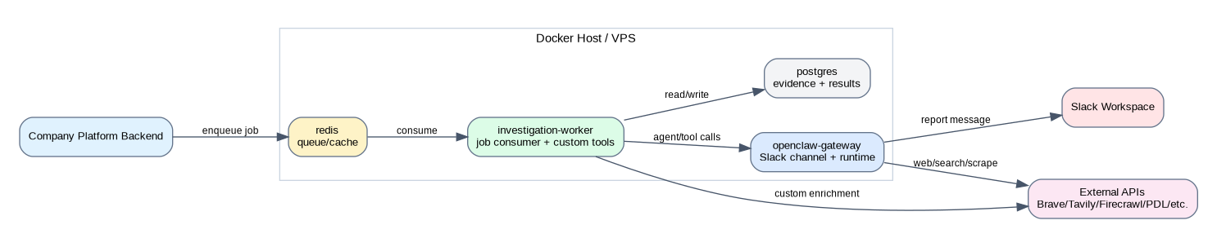
Gambar 3. Deployment topology Docker/VPS.
services:
openclaw-gateway:
image: openclaw/openclaw:latest
restart: unless-stopped
env_file: .env
volumes:
- ./openclaw:/workspace
ports:
- "3000:3000"
investigation-worker:
build: ./worker
restart: unless-stopped
env_file: .env
depends_on:
- redis
- postgres
- openclaw-gateway
postgres:
image: postgres:16
restart: unless-stopped
environment:
POSTGRES_DB: company_detection
POSTGRES_USER: company_detection
POSTGRES_PASSWORD: ${POSTGRES_PASSWORD}
volumes:
- pgdata:/var/lib/postgresql/data
redis:
image: redis:7-alpine
restart: unless-stopped
volumes:
pgdata:

10.1 Environment Variables
Variable | Fungsi | Status
OPENCLAW_BASE_URL | Endpoint gateway OpenClaw. | Required
SLACK_BOT_TOKEN | Kirim report ke Slack jika memakai Slack API langsung. | Required jika tidak via OpenClaw channel
SLACK_REPORT_CHANNEL | Channel report seperti #company-detection. | Required
DATABASE_URL | Koneksi Postgres. | Required
REDIS_URL | Koneksi queue/cache. | Required
BRAVE_API_KEY | Search provider. | Optional
FIRECRAWL_API_KEY | Scrape/crawl provider. | Optional/paid
TAVILY_API_KEY | AI search/extract provider. | Optional/paid
EXA_API_KEY | Neural search provider. | Optional/paid
PDL_API_KEY | People/company enrichment. | Optional/paid

11. Security, Privacy, dan Compliance Guardrails
- Tool allowlist harus eksplisit. Deny exec/process untuk agent yang tidak perlu shell access.
- Browser dan scraping tidak boleh digunakan untuk bypass login, CAPTCHA, paywall, atau anti-bot.
- Evidence yang disimpan harus relevan dengan tujuan company detection, bukan profiling bebas.
- Raw scraped content sebaiknya dibatasi, direduksi menjadi evidence claim, dan diberi TTL jika tidak diperlukan.
- API keys harus disimpan di secret manager/.env server, bukan di prompt, Slack, atau repo.
- Slack report tidak boleh memuat data sensitif yang tidak relevan.
- Setiap classification harus punya source dan timestamp agar bisa diaudit/diperbaiki.
- Tool marketplace/community plugin perlu security review sebelum diinstall di production.
Risk | Mitigasi
AI overclaiming | Gunakan classification levels: company_affiliated, business_owner_candidate, founder_verified, unknown; require evidence threshold.
Cost blow-up | Tool budget per job, max attempts, provider priority, caching.
Bad/ambiguous identity match | Entity matching score, conflicting evidence penalty, manual review status.
Tool abuse | OpenClaw allow/deny tools, restricted exec, no untrusted plugins.
Rate limits | Queue backoff, provider rotation, graceful skip/waiting_budget.

12. Observability dan Operasional
Metric/Log | Tujuan
jobs_completed_total | Jumlah investigasi selesai.
jobs_inconclusive_rate | Mengukur kualitas data/register dan tool coverage.
avg_tools_used_per_job | Kontrol cost dan efisiensi early stop.
avg_confidence_by_source | Menilai source mana yang paling berguna.
tool_error_rate | Deteksi provider down/API limit.
slack_delivery_success_rate | Memastikan report terkirim.
manual_review_rate | Mengukur kasus ambigu.

13. Roadmap Implementasi
Fase | Deliverables | Tools Aktif
Phase 0 - Design | Finalisasi PRD/TRD, schema DB, tool catalog, Slack report format. | Tidak perlu
Phase 1 - MVP | Queue, Postgres, email_intelligence, web_search, web_fetch, scoring, Slack report. | web_search, web_fetch, code_execution/message, custom tools
Phase 2 - Scraping+ | Firecrawl/Tavily, browser fallback, GitHub/X/Product Hunt checks. | Firecrawl, Tavily, x_search, browser
Phase 3 - Multi-agent | Subagents untuk parallel investigation dan advanced scoring. | sessions_spawn/subagents
Phase 4 - Paid enrichment | People/company enrichment vendor, cost-based routing. | PDL/Apollo/Clearbit-like custom tools
Phase 5 - Ops Dashboard | Review dashboard, evidence viewer, feedback loop, metrics. | Internal admin app

14. Risiko Teknis dan Mitigasi
Risiko | Dampak | Mitigasi
Provider belum bisa diakses/belum ada dana | Coverage rendah | Tool availability matrix; skipped reason; start dengan free/built-in tools.
Data register minim | Banyak inconclusive | Gunakan search based on username/name; tambahkan metadata signup source.
False positive company owner | Salah segmentasi lead | Pisahkan affiliation vs ownership; require founder evidence.
Scrape gagal karena JS-heavy | Evidence tidak terbaca | Fallback dari web_fetch ke browser/Firecrawl.
Report terlalu panjang di Slack | Sulit dibaca | Gunakan summary + evidence bullets + link ke full JSON/internal report.
LLM membuat alasan yang tidak sesuai evidence | Audit gagal | Report generator hanya boleh memakai evidence_items yang tersimpan.

15. Referensi Teknis
- OpenClaw Tools and Plugins
- OpenClaw Web Search / Web Tools
- OpenClaw Firecrawl Tool
- OpenClaw Tavily Tool
- OpenClaw Slack Channel
- OpenClaw Sub-Agents
- OpenClaw LLM Task
- Bounded Rationality - Herbert Simon Nobel Lecture
- ReAct: Synergizing Reasoning and Acting in Language Models
- OODA Loop overview

