PRD - AI Native Compliance Automation
OpenClaw + Elastic + GitLab; Telegram MVP and MongoDB ideal mode
Version: 2.0 | Date: 2026-05-23

1. Product summary
This product helps Flutter developers keep Android and iOS native project configuration up to date with platform policy changes from Google, Apple, and Flutter. A developer submits GitLab repository URLs. The system checks indexed platform policy context in Elastic, then runs an AI Coding Agent through OpenClaw to update the affected repository and create a GitLab Merge Request. The final output is a GitLab Merge Request reviewed by a human.

2. Problem
Flutter teams often discover native platform changes late: target SDK changes, new permission behavior, App Store submission requirements, Gradle/Xcode compatibility requirements, and Flutter breaking changes. This can block publishing and create repetitive manual migration work.

3. Product goals
- Accept GitLab repo URLs through Telegram for hackathon MVP.
- Use Elastic as the context layer for Google / Apple / Flutter policy docs.
- Run AI Coding Agent through OpenClaw to inspect repo code and make changes.
- Create GitLab Merge Requests with explanation and human-review requirement.
- Keep private credentials out of public source code.

4. Non-goals
- No automatic merge to default branch.
- No broad crawl of entire web; use selected platform-policy seed URLs.
- No MongoDB in Telegram MVP flow.
- No raw code patch as the final user-facing deliverable.

5. Personas
User | Need
Flutter Developer | Submit repo list and receive MR when native policy changes require updates.
Tech Lead / Maintainer | Review generated MR before merge.
Hackathon evaluator | See clear agentic flow using OpenClaw, Elastic, Telegram, and GitLab.

6. Sequence diagrams

6.1 Ideal mode - account-based repository list with MongoDB
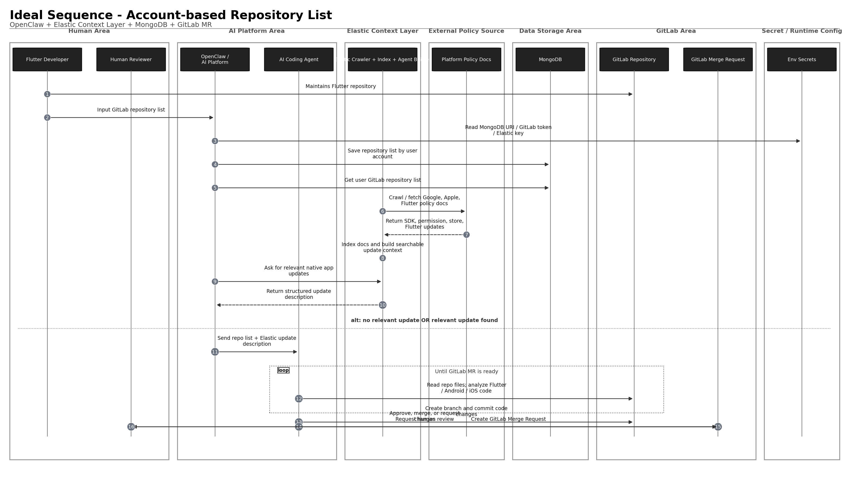

6.2 Hackathon MVP - Telegram runtime input, no MongoDB
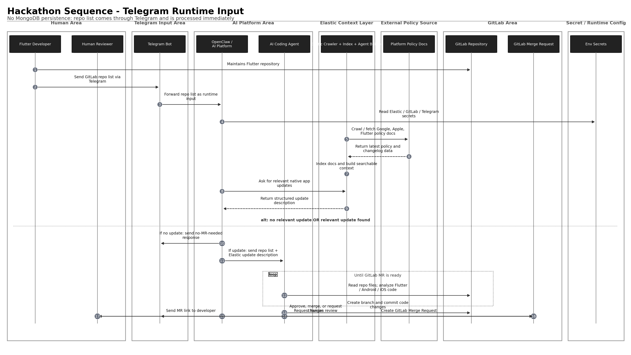

7. Core user flows

7.1 Telegram MVP flow
- Flutter Developer sends /check with GitLab repo URLs to Telegram Bot.
- OpenClaw receives Telegram input and extracts repo URLs.
- OpenClaw asks Elastic for relevant native platform updates.
- Elastic searches indexed Google / Apple / Flutter docs and returns structured update description.
- If no relevant update exists, OpenClaw replies in Telegram: No Merge Request needed.
- If update is relevant, OpenClaw sends repo list and update description to AI Coding Agent.
- AI Coding Agent reads GitLab repository files, modifies code, creates branch, commits, and opens GitLab MR.
- OpenClaw sends MR link back to developer in Telegram.
- Human Reviewer approves, merges, or requests changes in GitLab.

8. Functional requirements
ID | Requirement | Priority
FR-01 | Accept one or more GitLab repo URLs from Telegram message. | Must
FR-02 | Query Elastic for latest relevant Google / Apple / Flutter policy updates. | Must
FR-03 | Return no-MR-needed response when no relevant update is found. | Must
FR-04 | Pass repo list and Elastic update description to AI Coding Agent. | Must
FR-05 | AI Coding Agent reads repository files and identifies affected Flutter / Android / iOS files. | Must
FR-06 | AI Coding Agent creates branch, commits changes, and creates GitLab MR. | Must
FR-07 | MR description includes policy summary, affected files, code change summary, and human review note. | Must
FR-08 | Telegram Bot sends final MR link to developer. | Must
FR-09 | Store account-based repo list in MongoDB in ideal mode. | Should
FR-10 | Do not expose Elastic API key, GitLab token, Telegram token, or MongoDB URI in public repo. | Must

9. Expected MR content
- Policy update summary from Elastic.
- Affected files.
- Code changes made.
- Risk notes.
- Manual reviewer checklist.
- Statement: Generated by AI Native Compliance Agent. Human review required.

10. Success metrics
Metric | Target
Telegram command to MR creation | Under 5 minutes for small sample repo
MR contains useful explanation | 100% of generated MRs
Human merge required | 100%
Secrets leaked in repo | 0
Elastic used for platform-policy context | Yes

11. Security requirements
- Store ELASTIC_API_KEY, GITLAB_TOKEN, TELEGRAM_BOT_TOKEN, and MONGODB_URI as environment secrets.
- Never commit .env with real values.
- Use .env.example for documentation.
- GitLab token should use minimum required scope.
- Telegram Bot should use allowlist or restricted group configuration.
- MR generation must be branch-based and human-reviewed.

12. Risks and mitigations
Risk | Mitigation
Elastic index has stale policy docs | Add crawl timestamp and source URLs in MR.
AI modifies wrong files | Restrict task to native Flutter/Android/iOS config scope.
GitLab token leaks | Use environment secrets and never log token values.
Generated MR fails CI | Mark MR as draft or include validation status.
Telegram command abused | Use Telegram allowlist / group allowlist.

13. Acceptance criteria
- Developer can send repo list via Telegram.
- OpenClaw receives and processes repo list.
- Elastic returns structured policy update context from indexed docs.
- AI Coding Agent creates code changes in GitLab branch.
- GitLab Merge Request is created.
- Developer receives MR link in Telegram.
- Human Reviewer is the final decision-maker.

References
- OpenClaw Tools - https://docs.openclaw.ai/tools
- OpenClaw Skills - https://docs.openclaw.ai/tools/skills
- OpenClaw Telegram channel - https://docs.openclaw.ai/channels/telegram
- OpenClaw channels overview - https://docs.openclaw.ai/channels
- OpenClaw plugin bundles - https://docs.openclaw.ai/plugins/bundles
- Elastic Agent Builder - https://www.elastic.co/docs/explore-analyze/ai-features/elastic-agent-builder
- Elastic Web Crawler - https://www.elastic.co/guide/en/enterprise-search/current/crawler.html
- Elastic Open Crawler - https://github.com/elastic/crawler
- GitLab Merge Requests API - https://docs.gitlab.com/api/merge_requests/
- GitLab Branches API - https://docs.gitlab.com/api/branches/
- GitLab Commits API - https://docs.gitlab.com/api/commits/
- MongoDB databases and collections - https://www.mongodb.com/docs/manual/core/databases-and-collections/
- MongoDB connection strings - https://www.mongodb.com/docs/manual/reference/connection-string/
- Telegram Bot API - https://core.telegram.org/bots/api

