TRD - AI Native Compliance Automation
OpenClaw + Elastic + GitLab; Telegram MVP and MongoDB ideal mode
Version: 2.0 | Date: 2026-05-23

1. Technical summary
The system uses OpenClaw as AI platform and Telegram interface, Elastic as the platform-policy context layer, and GitLab as source-code and Merge Request system. The hackathon MVP avoids MongoDB by receiving repo URLs directly through Telegram and processing them as runtime input. The ideal mode adds MongoDB to persist repository lists by user account.

2. Architecture principles
- Elastic owns policy context.
- OpenClaw orchestrates the agent flow.
- AI Coding Agent owns code changes.
- GitLab owns source control and review.
- Secrets stay outside source code.

3. Sequence diagrams

3.1 Ideal mode - with MongoDB repository persistence
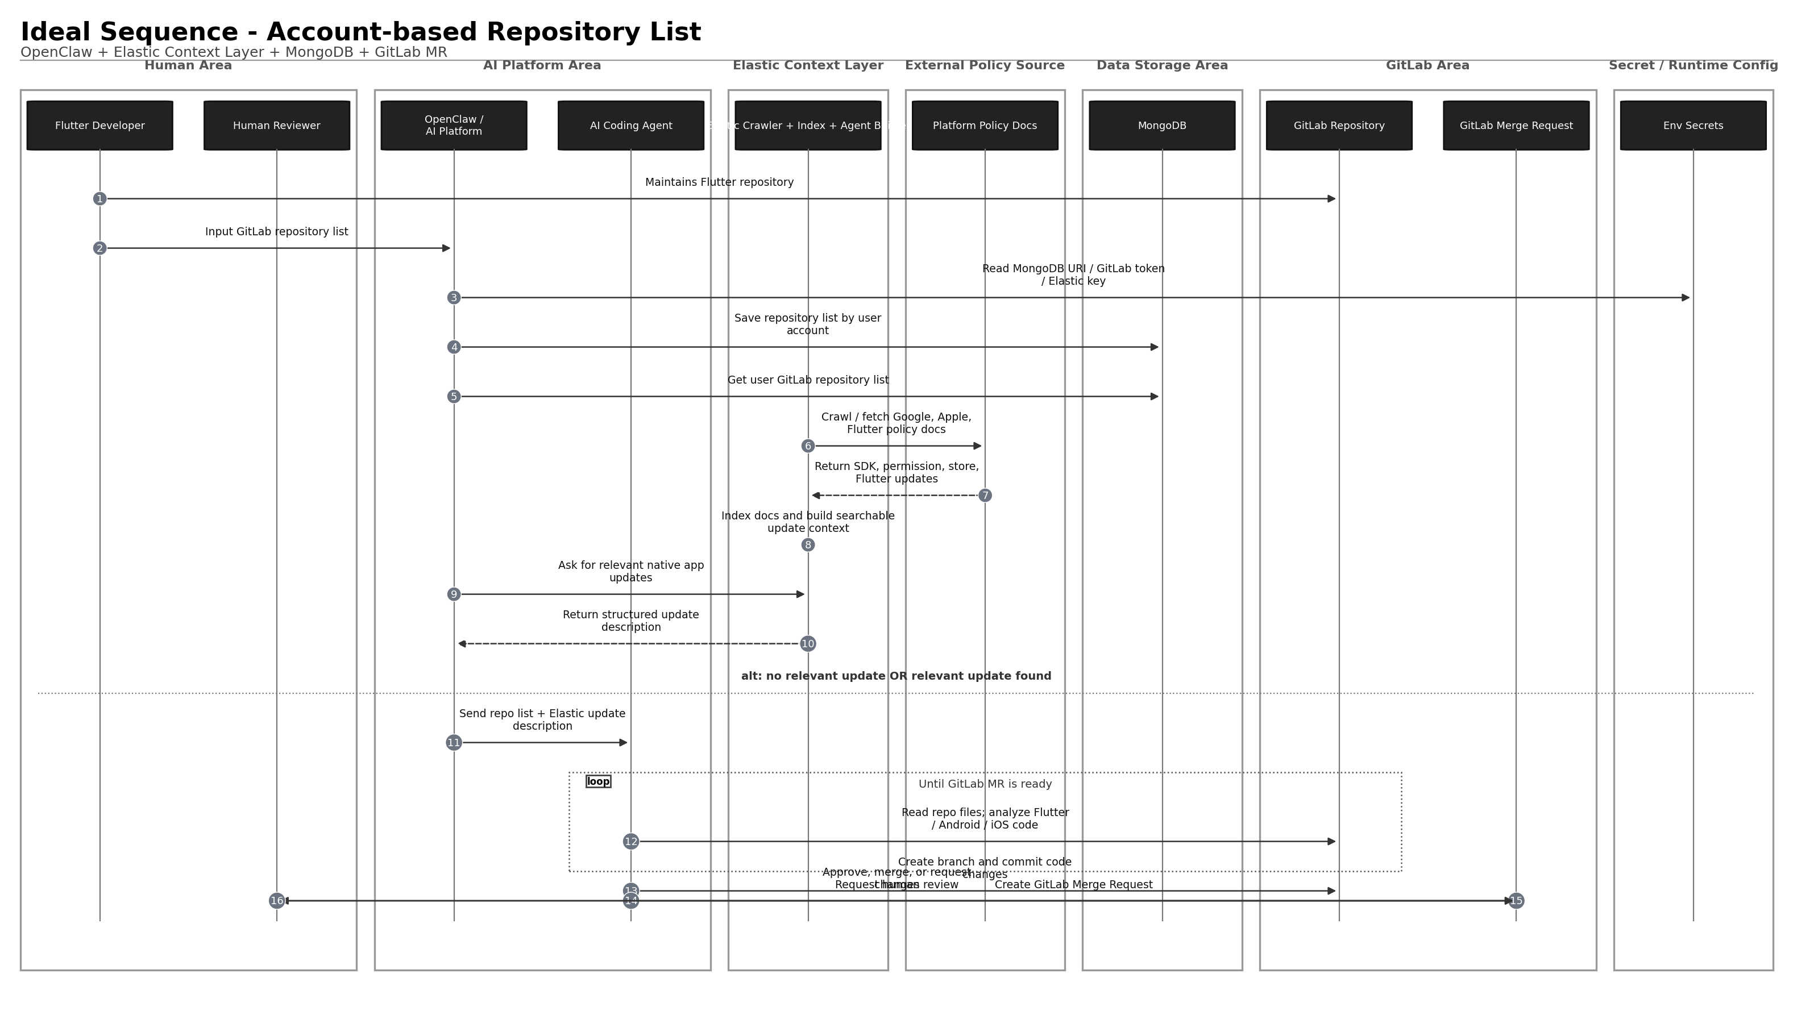

3.2 Hackathon MVP - Telegram input, no MongoDB
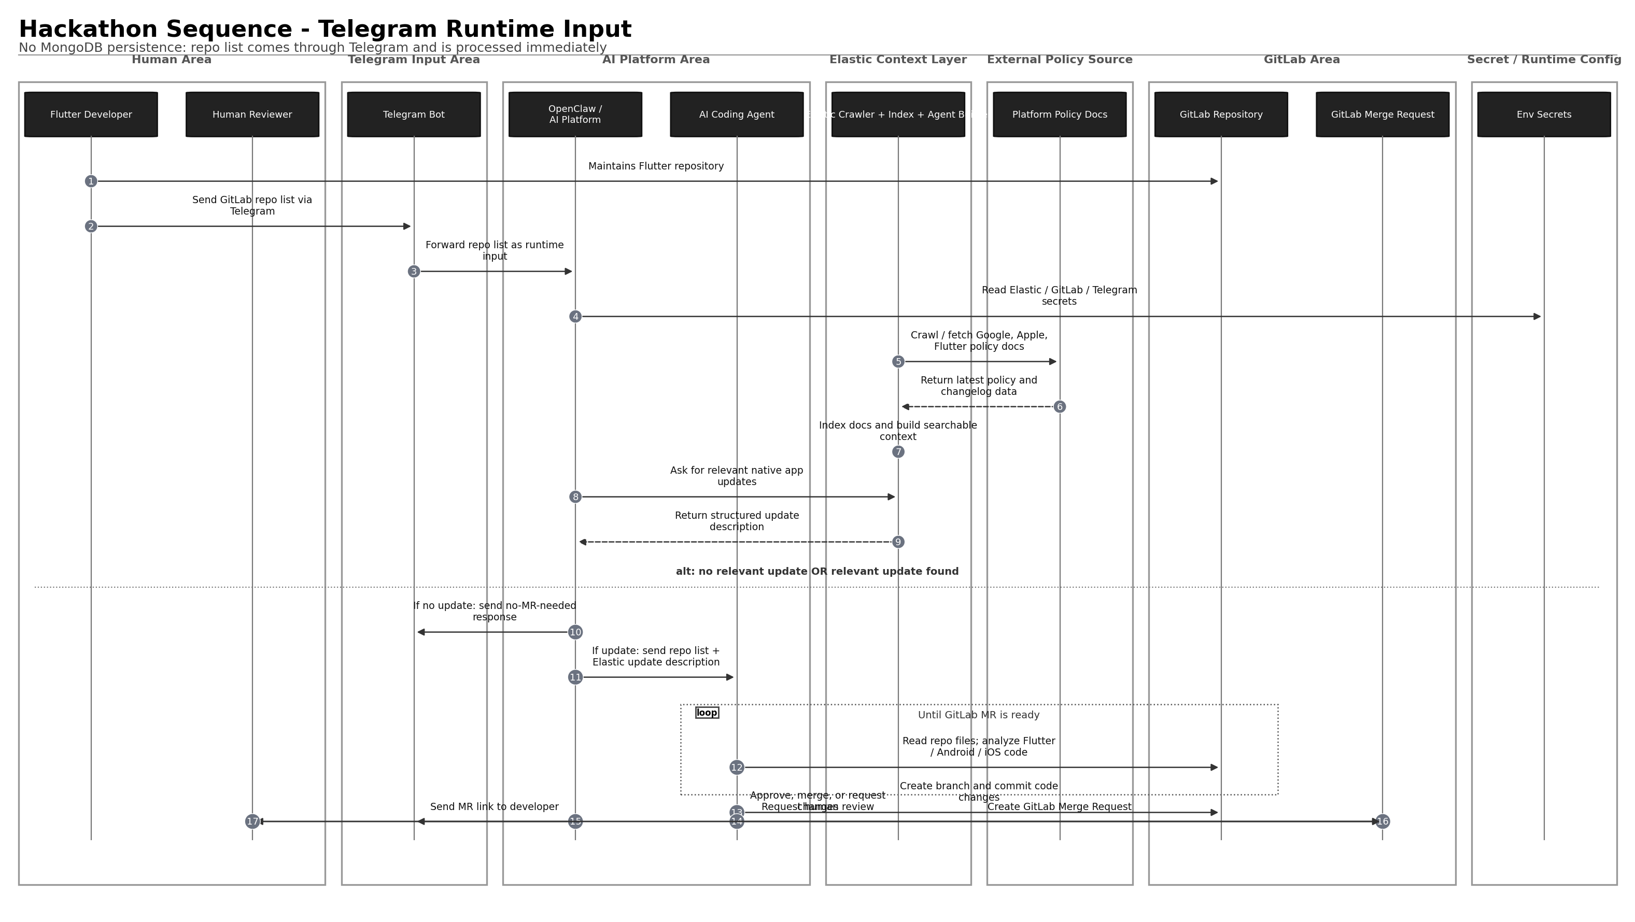

4. Technology inventory and responsibilities

4.1 OpenClaw
Capability / tool | Function in this project | Notes
Telegram channel | Receives /check messages and sends MR link back to developer. | Telegram is fastest setup path with bot token.
Tools layer | Agent invokes typed functions such as exec, browser, web_search, message. | Used for shell commands, outbound messaging, search/fetch if enabled.
Skills | Define how agent performs native-compliance remediation. | Create workspace skill: flutter-native-compliance-agent.
Plugins / bundles | Package channel integrations, providers, tools, hooks, or skills. | Useful if GitLab/Elastic integrations are packaged as plugins.
Gateway | Runs OpenClaw message and agent runtime. | Required for Telegram bot routing.
Message tool | Sends progress, no-action result, or MR link to Telegram. | Developer notification.
Exec / terminal tool | Runs git, flutter, shell, or helper scripts if enabled. | Should be gated/sandboxed.
File read/edit/apply_patch pattern | Reads and modifies cloned repo files in workspace. | May be built-in or custom wrapper.
Agent workspace | Temporary working directory for cloned repos. | Clean up after MR creation.
Access control | Telegram allowlist, group allowlist, activation/mention policy. | Prevents random users triggering code changes.

4.2 Elastic
Component / tool | Function in this project | Notes
Elastic Web Crawler or Open Crawler | Crawls/fetches platform policy docs from Google / Apple / Flutter. | Discover, extract, and index searchable content.
Elasticsearch Index | Stores cleaned platform policy documents and summaries. | Suggested index: platform_policy_updates.
Elastic Agent Builder | Searches indexed docs and returns structured update descriptions. | Agents/tools can query Elasticsearch indices.
Custom search / ES query tool | Finds latest relevant policy update by platform/date. | Semantic, keyword, or hybrid query.
Enrichment pipeline | Normalizes crawled docs into platform, requirement, affected_files, severity, source_url. | Can be simple script for MVP.
Elastic API key | Programmatic access to Elastic APIs / Agent Builder. | Keep in env secrets.

4.3 GitLab
GitLab capability / API | Function in this project | Notes
GitLab Repository | Source of Flutter project code. | Repos are maintained by Flutter Developer.
Personal/Project Access Token | Authenticates read/write operations. | Use minimum required scope; keep secret.
Repository clone / file read | Lets agent inspect pubspec.yaml, android/, ios/, CI config. | Use git clone or GitLab APIs.
Branches API / git branch | Creates feature branch for remediation. | ai/native-compliance-<date>.
Commits API / git commit | Commits generated code changes. | Message should mention AI native compliance update.
Merge Requests API | Creates MR with title, description, source and target branches. | Final output of the system.
Merge Request approvals | Human reviewer approves or requests changes. | Automation must not self-approve.
CI pipeline optional | Validates flutter analyze/test/build. | Can be included in MR if available.

4.4 Telegram
Telegram capability | Function in this project | Notes
Telegram Bot | Main hackathon input channel. | Developer sends repo list.
Bot token | Authenticates bot access. | Store as TELEGRAM_BOT_TOKEN.
DM or group chat | Input surface for /check command. | Use allowlist.
Message send | Sends no-action result or MR link. | Via OpenClaw Telegram channel.
Allowed sender IDs | Restricts who can trigger code automation. | Use OpenClaw Telegram allowlist/group config.

4.5 MongoDB - ideal mode only
MongoDB component | Function in this project | Notes
repositories collection | Stores GitLab repo URLs by user account. | Used only in ideal account-based mode.
users collection optional | Maps Telegram/OpenClaw user to account. | Not required in Telegram MVP.
Connection string | Connects helper/runtime to database. | Store as MONGODB_URI.
Query by user account | Loads registered repos for a specific user. | Replaces Telegram runtime repo list.

4.6 AI Coding Agent
Capability | Function
Understand structured update context | Receives Elastic policy description and repo list.
Inspect repo | Reads project files and identifies native config impact.
Generate changes | Updates Android/iOS/Flutter config files if relevant.
Git operations | Creates branch, commits, and pushes changes.
MR creation | Opens GitLab Merge Request with explanation.
Self-loop | Iterates until MR-ready branch exists.

5. Data models

5.1 Elastic index: platform_policy_updates
{
"source": "google_android | apple_ios | flutter_docs",
"platform": "android | ios | flutter",
"title": "Target API level requirements for Google Play apps",
"url": "https://developer.android.com/...",
"content": "Cleaned text from policy document",
"summary": "Short normalized update description",
"detected_requirement": "targetSdk update required",
"affected_files": ["android/app/build.gradle", "ios/Info.plist"],
"severity": "info | warning | publishing_blocker",
"last_crawled_at": "2026-05-23T00:00:00Z"
}

5.2 MongoDB ideal-mode collection: repositories
{
"user_id": "telegram:123456789",
"provider": "gitlab",
"repo_url": "https://gitlab.com/company/flutter-app",
"default_branch": "main",
"platforms": ["android", "ios"],
"created_at": "2026-05-23T00:00:00Z"
}

6. Telegram command design
/check
https://gitlab.com/company/flutter-app-1
https://gitlab.com/company/flutter-app-2

7. GitLab MR template
# Native Compliance Update

Generated by AI Native Compliance Agent. Human review required.

## Policy Context
- Source: Elastic indexed Google / Apple / Flutter docs
- Requirement: <requirement summary>
- Severity: <severity>

## Changes
- <file>: <change summary>

## Review Checklist
- [ ] Confirm platform requirement is relevant
- [ ] Review native Android/iOS changes
- [ ] Run CI or local build
- [ ] Merge only after human approval

8. Security and secret management
TELEGRAM_BOT_TOKEN=
GITLAB_TOKEN=
ELASTICSEARCH_URL=
ELASTIC_API_KEY=
MONGODB_URI= # ideal mode only
- Never commit real .env values.
- Provide only .env.example in public repo.
- Mask GitLab CI variables if used.
- Log only token names, never token values.
- Use least-privilege GitLab token.
- Restrict Telegram input via allowlist.

9. Implementation plan

Phase 1 - Telegram MVP
- Configure OpenClaw Telegram channel.
- Create /check command parsing skill.
- Configure Elastic crawler/fetcher for selected platform docs.
- Build Elastic index and Agent Builder query/tool.
- Implement AI Coding Agent skill for Flutter native compliance.
- Implement GitLab read/branch/commit/MR operations.
- Send final MR link to Telegram.

Phase 2 - Ideal account-based mode
- Add MongoDB repository storage.
- Add user account mapping.
- Add get repositories by user account flow.
- Add scheduled or manual scans for stored repos.
- Add scan history if useful.

10. Testing strategy
Test | Expected result
Telegram unauthorized user | Bot rejects or ignores request.
Valid repo list, no relevant Elastic update | Bot returns no-MR-needed.
Valid repo list, relevant Android update | AI creates branch and GitLab MR.
Invalid repo URL | Bot reports invalid input.
Missing GitLab token | Tool fails safely without exposing secret.
Elastic unavailable | Bot reports context provider unavailable.
Generated MR | Contains policy summary, affected files, human review note.

11. Failure handling
Failure | Handling
Elastic index empty | Return policy context unavailable and do not modify repo.
GitLab repo inaccessible | Return error to Telegram.
AI cannot determine safe fix | Create no MR; return explanation.
Commit fails | Stop and report failure.
MR creation fails | Keep branch and report branch link if available.

12. Open questions
- Should MVP run CI before MR creation or after MR creation?
- Should Telegram command allow platform filter, such as Android-only?
- Should generated MR be marked Draft by default?
- Should Elastic crawler run scheduled or manually before each demo?
- Should AI Coding Agent commit directly through Git CLI or GitLab API?

References
- OpenClaw Tools - https://docs.openclaw.ai/tools
- OpenClaw Skills - https://docs.openclaw.ai/tools/skills
- OpenClaw Telegram channel - https://docs.openclaw.ai/channels/telegram
- OpenClaw channels overview - https://docs.openclaw.ai/channels
- OpenClaw plugin bundles - https://docs.openclaw.ai/plugins/bundles
- Elastic Agent Builder - https://www.elastic.co/docs/explore-analyze/ai-features/elastic-agent-builder
- Elastic Web Crawler - https://www.elastic.co/guide/en/enterprise-search/current/crawler.html
- Elastic Open Crawler - https://github.com/elastic/crawler
- GitLab Merge Requests API - https://docs.gitlab.com/api/merge_requests/
- GitLab Branches API - https://docs.gitlab.com/api/branches/
- GitLab Commits API - https://docs.gitlab.com/api/commits/
- MongoDB databases and collections - https://www.mongodb.com/docs/manual/core/databases-and-collections/
- MongoDB connection strings - https://www.mongodb.com/docs/manual/reference/connection-string/
- Telegram Bot API - https://core.telegram.org/bots/api

