Admin / Back Office Design Document
Personal Brand Platform — Standard Admin UI, CRUD, CMS, and Post Editor
Version: 1.0 | Scope: Admin/BE UI only | Public website design remains separate.

1. Decision Summary
The public website can keep the old-web / HTML-jadul aesthetic, but the admin/back office should not use that design. The admin area should be a standard, boring, efficient CMS interface: sidebar navigation, tables, filters, forms, status badges, and a reliable editor for posts.
Area | Recommendation | Reason
Admin CRUD shell | Backpex | Best fit for Phoenix LiveView admin CRUD with configurable LiveResources, filters, custom fields, and existing Ecto schemas.
Generated admin alternative | Lit | Useful if the project wants generated LiveView code instead of a framework-like admin layer.
UI components | Backpex + daisyUI + Tailwind | Backpex is already styled with Tailwind/daisyUI, so use that as the admin visual standard.
Post editor MVP | Markdown editor with preview | Best for technical writing, easy storage, versioning, SEO rendering, and AI-generated drafts.
Post editor upgrade | Tiptap or CKEditor 5 | Use when richer WYSIWYG authoring, image embedding, and structured content become important.

2. Why Admin Design Must Be Separate from Public Theme
- Public design is for branding and visitor attention.
- Admin design is for speed, clarity, and safe content management.
- Changing the public theme must not change admin workflows.
- Admin should follow standard SaaS/CMS patterns so any AI agent or developer can implement it quickly.
- The old-web theme is good for the public site, but bad for repetitive CRUD operations.

3. Admin Architecture Direction
Recommended architecture for MVP: Phoenix LiveView admin area using Backpex resources on top of existing Elixir contexts and Ecto schemas.
Browser
↓
/admin Phoenix LiveView
↓
Backpex LiveResources / Custom LiveViews
↓
Elixir Contexts
↓
Supabase Postgres + Supabase Storage

4. Recommended Admin Library Stack
Library | Use For | Use Now? | Notes
Backpex | Admin CRUD resources | Yes | Primary choice for Projects, Posts, Products, Media, Site Settings, Themes, and future Orders.
daisyUI | Admin component styling | Yes | Required by Backpex; use a clean light theme.
Tailwind CSS | Layout/custom admin screens | Yes | Phoenix ships well with Tailwind; keep custom screens consistent.
Petal Components | Custom LiveView components | Optional | Use only if custom admin screens need polished HEEX components beyond Backpex.
Lit | Generated LiveView admin code | Alternative | Consider if avoiding a Backpex dependency or needing full control over generated code.

5. Admin Information Architecture
Admin sidebar should be stable and predictable:
/admin
/admin/projects
/admin/posts
/admin/products
/admin/media
/admin/site-settings
/admin/themes
/admin/orders # future Midtrans proper
/admin/customers # future
/admin/payments # future
/admin/shipments # future

6. Required Admin Screens
Screen | Main Purpose
Dashboard | Summary cards, active theme, latest posts/projects/products, draft list, quick actions.
Projects | CRUD list, filters by status/tag, featured toggle, cover image, case study fields.
Posts | CRUD list, search, draft/published filters, editor, SEO fields, preview.
Products | CRUD list, price, product type, checkout_url for Midtrans Payment Link, status, images.
Media | Upload, list, copy URL, attach to posts/projects/products.
Site Settings | Profile, headline, social links, featured IDs, homepage settings.
Themes | Active public theme, preview, data contract validation.
Orders — Future | Order list, payment status, Midtrans reference, customer, fulfillment status.

7. Post Editor Requirement
For MVP, use a Markdown-first editor because this website is developer/content heavy. It is easier for AI-generated drafts, easier to diff/version, and easy to render safely to HTML. The admin should still feel comfortable for writing by adding toolbar buttons and live preview.
- Title input
- Slug input with auto-generate option
- Excerpt field
- Cover image picker
- Markdown editor area
- Preview tab or split preview
- Category/tag selector
- Status: draft / published / archived
- Published date
- SEO title and meta description
- OG image picker
- Save draft, preview, publish actions

8. Editor Library Options
Option | Type | Best For | Pros | Concern
EasyMDE | Markdown editor | MVP technical blog | Simple, embeddable, beginner-friendly, autosave/spellcheck support. | Needs JS hook integration with LiveView.
Tiptap | Headless rich text editor | Future advanced editor | Powerful, extensible, framework-agnostic, can support Markdown workflows. | More setup and JS complexity.
CKEditor 5 Phoenix | WYSIWYG integration | Non-technical admin writing | Phoenix integration package exists, supports editor variants. | May be heavier than needed for developer notes.
Trix | Simple WYSIWYG | Everyday writing | Stable simple editor for articles/messages/lists. | Stores HTML; less ideal if you prefer Markdown source.

9. Recommended Editor Decision
MVP: Markdown source stored in posts.content_markdown + rendered HTML generated at read/render time or cached in posts.content_html. Use EasyMDE or a simple textarea + custom preview first. Upgrade later to Tiptap if the writing workflow needs Notion-like editing.
posts
- content_markdown text
- content_html text nullable/cache
- editor_type enum: markdown | tiptap | ckeditor
- editor_json jsonb nullable

10. Admin Visual Direction
- Light theme by default, dark mode optional.
- Left sidebar navigation.
- Topbar with breadcrumbs, search, preview, save/publish actions.
- Tables for list pages, not card-heavy public layouts.
- Form pages with main content left and settings panel right.
- Use standard status badges: Draft, Published, Archived, Featured.
- Use predictable CTA hierarchy: Save Draft, Preview, Publish.
- No old-web aesthetic in admin; keep it standard and efficient.

11. Admin Design Mockup
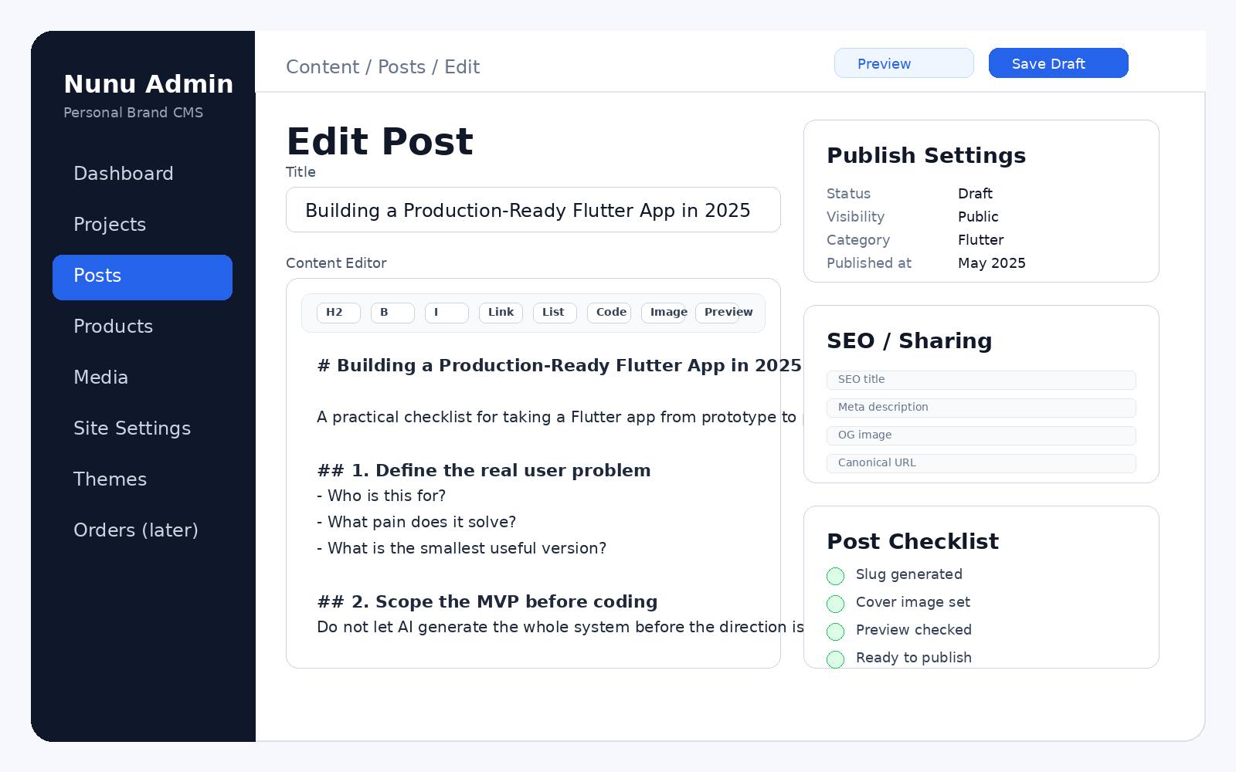

12. Implementation Plan
- Install Backpex, Tailwind 4, daisyUI 5, and Backpex hooks.
- Create /admin scope and admin layout using Backpex app shell.
- Create Backpex LiveResources for Projects, Posts, Products, Media, Site Settings, and Themes.
- Add custom Post Editor LiveView if Backpex default form is not comfortable enough for long-form writing.
- Add markdown preview using a JS hook or server-rendered preview action.
- Add validation for slug uniqueness, status transitions, featured content, and checkout_url.
- Add future /admin/orders route as disabled/placeholder so commerce expansion is clear.

13. Acceptance Criteria
- Admin is visually standard, not old-web themed.
- Admin can CRUD projects, posts, products, media, settings, and themes.
- Post editor supports draft writing, preview, SEO fields, and publish status.
- Product editor supports checkout_url for Midtrans Payment Link.
- Future commerce pages have reserved route/design direction.
- Public theme switching remains separate from admin theme.

14. Sources / References
- Backpex documentation: highly customizable admin panel for Phoenix LiveView applications; LiveResources and /admin routing.
- Backpex installation docs: Tailwind CSS 4 and daisyUI 5 requirements; Backpex app shell and sidebar components.
- Lit GitHub repository: admin generator for Phoenix LiveView and Tailwind apps.
- Petal Components docs: HEEX component library for Phoenix projects.
- Tiptap docs: open-source, extensible, framework-agnostic rich text editor; Markdown extension can parse/serialize Markdown.
- CKEditor5 Phoenix docs: Phoenix integration package for CKEditor 5.
- EasyMDE GitHub: simple embeddable Markdown editor with autosave and spellcheck features.
- Trix docs: WYSIWYG editor for messages, comments, articles, and lists.

