1 NuRo: the dynamic Binomial Model of NGS data that uses the Geometric Mean as Reference Frame for Absolute and Relative Differentials.
Running title: NuRo: the dynamic Binomial Model of NGS data that uses the Geometric Mean as Reference Frame for Absolute and Relative Differentials.
Emilia Nunzi$​^{†}$, Luigina Romani
$†$ To whom correspondence should be addressed:

Department of Medicine and Surgery
University of Perugia, Perugia, Italy
P.le Gambuli, 1, 06132, Perugia
Research article

2 Abstract
In the context of microbiological analyses, data often have an intrinsic multiplicative structure as in the case of relative abundances, compositional data or fold changes and thus the geometric mean (GM) is of particular interest because it is the only averaging tool that respects this multiplicative framework, unlike the arithmetic mean which instead assumes additive relationships. Therefore, GM is the most suitable tool to assess the average abundance of features in samples described by NGS data that have quantitative relevance only with respect to that of other features detected in the same sample. This paper proves that the use of clr-based assays, which uses GM as abundance normalization factor, is not affected by bioburden and provide interpretations identical to those obtained from expensive and time-consuming as the flow cytometric measurements. The clr abundance evaluation is also placed in the context of the novel NuRo dynamic binomial model of NGS data which includes the sample richness dependence on sequencing depth and excludes the presence of zero-counted features in single-sample sequencing. It is shown that when observed features almost approaches the sample richness thus abundance expressed as clr can be applied to both rarefied and non-rarefied data depending on whether analyses aim to describe relative or absolute differential comparisons, respectively.

3 Introduction
NGS sequencing allows the detection of complex interactions between genes, between microbes and with their surrounding environment at a relatively low cost and is now an integral component of experimental biology. NGS data are inherently compositional, and although laboratories meticulously try to generate equimolar PCR products, it is necessary to carefully choose the data normalization and their possible transformation on which to subsequently apply the descriptive statistics. Indeed, it strongly influences the results of the final analyses and the composition of the sample in terms of both number of features and abundance (2). Scientific literature often refers to counts of NGS features as absolute abundance and this could generate confusion in the choice of analysis software which instead is important to limit exclusively to tools that take into consideration the compositional nature of high-throughput sequencers, both DNA and RNA based (4). In fact, even the counts as well as the proportions have quantitative relevance only with respect to that of other features detected in the same sample and are therefore called relative counts (5).Thus, comparing the counts of a feature between different samples is meaningless due to the different microbial load which, although in some conditions could be estimated from the sequencing depth of each sample, the latter in turn is linked to the sequencer and not to the quantity of DNA or RNA molecules present in the sample. It follows that also the use of feature counts is a relative abundance estimate and the corresponding normalization domain need to be explicitly indicated for a inferring changes in abundance that can be only relative to the chosen reference frame (7).
The ranking of features detected in the samples describing an experiment is often evaluated using the within-sample (WS) feature-ratios in order to compensate for distortions due to the different and often unknown microbial load of the samples (9). However, when summary statistics of groups of samples are of interest, the use of the arithmetic mean (AM) of ratios evaluated across–samples (AS), although widely used, could lead to inappropriate ranks without a suitable transform of data and thus to wrong conclusions if used for comparing composition of the groups (10).
In this paper it is recalled and shown through simple examples that among the possible sample averages, the geometric mean (GM) is the only one that respects the multiplicative property that allows the average of the WS ratios to be evaluated as the ratios of the averages (10). This fundamental property makes the AS-GM the only correct averaging operator for data presented as ratios to reference values and thus defines a feature ranking of the compositional abundance regardless of data normalization. Thus, AS–GM is the most suitable tool for determining NGS microbial and genetic signatures.
Further aspects of GM are also described that highlight the benefits of its use in the context of NGS data analysis. WS–GM is often used as reference frame to obtain centered log–ratio (clr) for evaluating differential abundance of feature between samples (11) as it takes into account sample composition also when rarefaction is applied. Since this summary statistic can be applied and adopted as normalization factor to any type of compositional data beyond that of NGS systems such as metabolomics, proteomics, etc., in which concentrations are log-transformed and reported as geometric means, it is therefore of great importance to contextualize its practice in NGS sequencing and relating it to process parameters. Within this context, the mathematical–statistical characterization of GM focused on approximations introduced by the finite sequencing depth is analyzed in this paper. It is used to evaluate conditions under which proportions estimate is affected by sample sequencing depth and to define criteria for compensating the corresponding estimate bias. Moreover, it is shown that when a large number of features are collected, then the WS-GMs of the sample proportions are similar to each other as they all converge towards zero and therefore all become negligible compared to the most abundant features of each sample. The WS-GMs are therefore approximated to a single value which becomes the common reference frame for the samples involved and against which differential abundance analyses can be performed using WS–clr. The statistical analysis is contextualized within the dynamic multinomial NuRo (by the authors) model proposed in this paper for sequenced data which, compared to the classic “static” model, includes the dependence of the NGS sample richness on the sequencing depth and excludes the presence of features counted as zero in the sequencing of a single sample (see Figure 1).

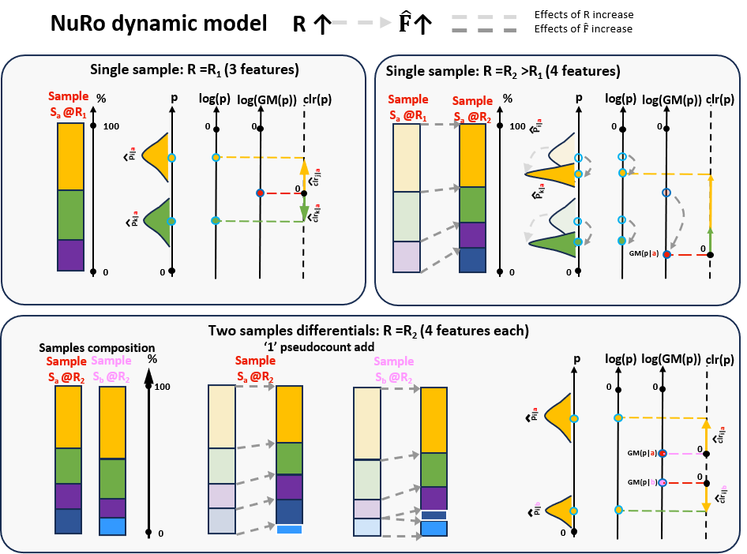
Figure 1. NuRo model for sequenced data. Composition of a single sample $S_{a}$ (red colored) is skectched in the upper panels with proportion bar plots at two sequencing depth $R_{1}$ and $R_{2}$, with $R_{2}>R_{1}$, revealing 3 and 4 features, respectively. The $i$-th (yellow) and the $k$–th (green) features ditributions and average proportions are represented on the a-priori probability axes, $p$ and $log\left(p\right)$, respectively. The sample GM value is represented on a logarithmic axis and it is used for drawing the taxon clr abundance according to vector notation that emphasizes its use as the sample reference frame. Dynamic effects of the $R$ and $\hat{F}$ increases are represented by light and dark gray dashed lines, respectively. The transition of colors from faded to bright emphasizes the effects of the dynamic model: as the sequencing depth increases, the richness of the sample increases with rares and the WS-GM decreases while at the same time the value of the a priori probabilities decreases while the precision and accuracy of the proportions increases. Lower panel describe the taxon differential between two samples, $S_{a}$ (red colored) and $S_{b}$ (pink colored), each with 4 taxa, of which 3 are in common and 1 is not. The feature set involved in the comparison consists of 5 features in total and the missing features in each sample are handled with pseudocount ‘1’ represented by a white outline in the composition bar chart of each sample. This scheme highlights the clr differential as the log-differetial but corrected by the WS-GM log-difference between the two samples.
The NuRo model is also exploited for some considerations on missing features that cause sparsity of NGS matrices and that should be treated carefully when comparing sample abundance (13). Indeed, the feature–set (microbiome or genes) of an experiment is given by the union of the feature set of each sample involved in the comparison and features missing in a sample are due to the presence of that feature in at least one of the other samples. Sparsity of NGS data is due to the choice of the pseudocount value used to manage missing features and which is generally set equal to 0 as it does not alter either the count or the proportions. However, the more zeros there are, the greater the impact on the mean statistics, and it is also not possible to use logarithm-based transformations instead, which often help to redistribute these data according to a normal distribution. On the other hand, the use of WS-clr, which is based on logarithmic transformation, forces the use of a non-null pseudocount, usually equal to 1. This value is more suitable for modeling a biological experiment as it represents the minimum count of a rare feature that was not detected in a sample due to technological limitations of sequencing or unlikely presences. The ‘1’ pseudocount affects marginal statistics of groups, but it is shown in this paper that if the sequencing depth is sufficiently large, the bias induced on the most abundant features is negligible, sample-clrs becomes unbiased and can be used for comparing also taxon abundance between samples even when information on microbial load lacks (experimental data from flow cytometric measurement are shown).
As a result, clr-based assays evaluated into the context of the NuRo model of NGS data are not affected by bioburden and provide interpretations identical to those obtained from flow cytometric measurements which are expensive and time-consuming. Therefore, they can be applied to rarefied or non-rarefied data depending on whether the interest is in relative or absolute differential comparisons, respectively.
All in all, guidelines for managing both precision and accuracy in differential analysis of compositional data based on clr is given and practical example is given by using also generative AI tools that implements the described algorithm with qiime2 pipelines, R and python.

4 Results

4.1 Geometric mean is the only appropriate average for ranking feature from NGS data
The choice of normalization factor to use as reference frame with the NGS data plays an important role in ensuring that the comparison between features is substantial and appropriate when averaging abundance across samples (14). In methods section 6.1 it is shown that the AS-GM is the most appropriate average metric for features ranking while the AS arithmetic mean is useless and often leads to completely incorrect considerations even if we consider ratios of taxa expressed as additive log-ratio (alr) since results are affected by the feature used for data normalization (see methods 6.1.1). Similar considerations apply to the AS total sum since it is proportional to the AS arithmetic mean.
Moreover, due to the scale invariant property of the geometric mean, ranking of features AS-GM averaged does not change with the chosen WS normalization factor as well as the ratio between AS-GM averaged features (see methods 6.1.2). It follows that AS-GM can be used to rank features based on the averaged relative abundance regardless of how and whether the data are presented as ratios to reference values since the geometric mean can be used even if the numbers are not normalized.
The AS-GM averaging feature ranking has been applied to data from salivary microbiota presented in (8) that ranks features before and after the brushing event using 16S rRNA gene amplicon sequencing and applying both the DR, aldex2 and CLR methods. The comparison among methods is reported plots (c)-(e) of Figure 1 and the (e) plot is the ranking obtained by applying the AS-GM averaging to data normalized to the WS-GM, i.e. the per-group average of the abundance expressed as clr. The most differentially abundant features are consistent with the DR and Aldex2 methods, which however do not provide significance to the features (Aldex2 does not detect them, DR only performs classification). Significant taxa obtained with the clr averaging are reported in Figure 1(f) and are in agreement with the scientific literature and with lowering of the total microbial load shown in panel (b): the brushing removes Haemophilus from the oral biofilm. PROF. PLEASE HELP, … ANCHE CON LA BIBLIO SE POSSIBILE.
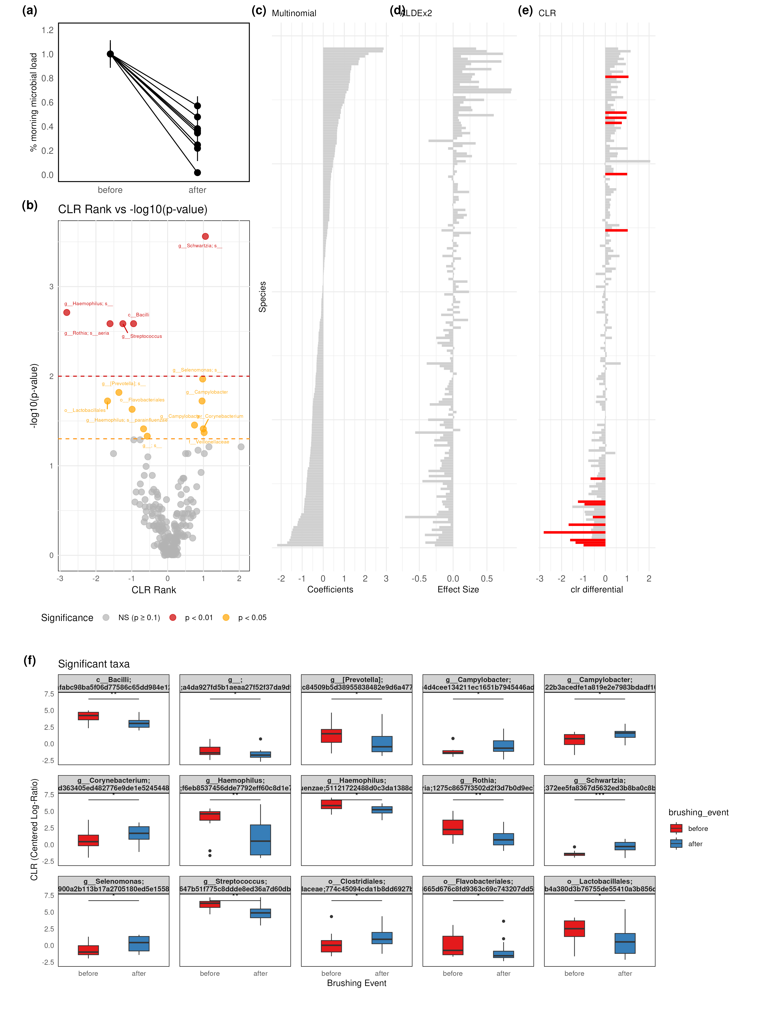
Figure 2 Saliva experiment: CLR differentials gets significance between the after and before brushing events according to the lower after brusing microbial load (flow cytometry measures). Data from . (a): Microbial load comparison of the after vs before brushing event as in (8). (b): Volcano plot emphasinzing significant clr differentials (c)-(e) Comparison of AS-GM averaging and DR, ALDEx2 and CLR differentias outputs. Features are sorted in the same order as the DR coefficients for comparison consistency purposes. Red bars highligths significant taxa. (f): Per group distribution of significant taxa obtained from CLR averaging are shown in (b) together to the wilcoxon t-test significance. *:p<0.05; **:p<0.01

4.2 The GM as reference frame within the NuRo dynamic binomial model of NGS data
In the context of NGS data, the WS-GM normalization factor is of particular interest since it uses the sample-GM as reference frame: the obtained abundances are relative to the WS averaged abundance of features and the log-transform gives the clr. The reference frame of this transform preserves knowledge about the composition of the sample even when the data are rarefied, information that is instead lost if proportions are used (15). Since this summary statistic is widely applied to compositional data types outside the context of NGS systems such as metabolomics, proteomics, serology, etc., it is therefore of great importance to customize it to NGS process parameters (16).
For this purpose, the sequencing procedure is modeled with the revised NuRo dynamic multinomial model described in the methods section 6.2 that includes, with respect to scientific literature (11) (12) (18), the dependency on the observed number of features, $\hat{F}$, with the sequencing depth, $R$. Indeed, the greater the value of $R$, the greater the coverage of less abundant features and therefore the greater the $\hat{F}$ which better approximates the actual richness, $F$, of the biological sample. Since the multinomial model assumes that all a-priori features probabilities sum to 1 for any value of the sample sequencing depth, when a new feature is revealed during the sequencing , thus the values of the proportional abundances are redistributed by lowering the probabilities of the previously recorded features according to the constraint.
Although arbitrary as it is limited by the total size of the library (19), after sequencing the number of reads per sample becomes a parameter of the process. The resulting $R$ value is finite and affects precision of proportions of detected features, with particular concern to the rares. The statistical characterization of proportions and log-abundance evaluated from binomial counts together to their relative error is described in methods 6.3. In particular, assuming to have moderate proportion values, $p$, larger sample size $R$ leads to more precise estimate since the corresponding relative standard deviation $RSD=\sqrt{\left(1-p\right)/\left(pR\right)}$, obtained from eq. (3) decreases. Being the sample proportion an unbiased estimator, accuracy improves as precision improves because proportion estimator becomes more consistently close to the parameter true value. The $RSD$ formula given above can be used for determining a-priori the maximum level of relative precision that can be obtained with a given sample size, $R$, or it can be reverted for arguing the minimum sequencing depth that guarantees a given proportion $p$ evaluated with a target relative error in terms of $RSD$, as reported in Figure 3. Some examples, also described in the generative AI section (see sec. 7), follow. If $10 000$ reads are available, the lowest proportion value that can be evaluated with a $RSD$ no larger than 0.10, that ensures that the first non-zero decimal digit is the most significant, is p=0.01. On the other hand, if the scope is to evaluate proportions about $0.001$ with the same precision, thus $100 000$ reads are needed.
Figure 3. Relative standard deviation of proportion estimate, $RSD$, and proportion values, $p$, evaluated using $RSD={\left(\left(1-p\right)/\left(pR\right)\right)}^{1/2}$ for different values of the number of sequenced reads, $R$, ($3 000$, $5 000$, $10 000$, $20 000$, $100 000$) in NGS data. Bold columns emphasize parameters for which $RSD=0.1$, a condition that guarantees that the first non-zero decimal digit of $p$ is the most significant.
In addition to the proportions, the log-abundance as well as the WS-clr of binomials are asymptotic unbiased estimator and thus they are good candidates to estimate sample abundance (see methods 6.5).
Clr uses WS-GM as the scaling factor and then applies logarithmic transformation to the resulting ratio. Thus the abundance of each taxon is relative to the sample GM which depends on the sample composition, i.e. on the features distribution. In particular, if a large sequencing depth is used, since a great number of rares are included in the sample, GM evaluated on proportions tends to a value close to zero thus slightly depending on $R$ while strongly depending on the sample composition. It follows that metrics that uses WS-GM as the abundance reference level, reduces the dependency from the number of reads if a sufficiently large sampling depth is used (see methods 6.4).

4.3 Infer changes in abundance among samples: the saliva experiment
When a single sample is analyzed, the corresponding feature table is composed by positive counts. On the other hand, when comparing abundance among samples, it is necessary to enter in the feature table an appropriate pseudo-count for those features that are missing because they are only observed in other samples (see methods 6.2). Features may be missing from the observed sample for two main reasons: they do not belong to the sample (the microbe may not be able to live in that environment or the gene is not expressed) or its proportion in the sample may be lower than the detection threshold imposed by the sequencing depth (14). A 0 pseudocunt does not alter WS-sum of relative counts and proportions, a ‘1’ pseudocount is the minimum value attributable to rares and that do not alter WS-sum of log-abundance. In any case WS– proportions and log-proportions are unbiased and asymptotic unbiased, respectively, estimators and thus when the sampling depth is large enough, the pseudocount can be compensated for (see methods 6.3).
The lack of knowledge regarding total microbial load introduces a bias when relative counts are used for comparing composition among samples. The use of within-sample ratios or log-ratios of taxa abundances instead of relative counts or proportions of each taxon remove this bias thus reducing both false-positives and false-negatives when microbial load quantification is not available (8). However, the choice of the reference feature is not always straightforward and the AS averaging of ratios in each group could lead to inappropriate conclusions as emphasized in methods 6.1.1. This issue can be overcome with the use of the WS-GM as reference frame and thus by considering the WS-clr as the relative abundance to be used for comparing samples log-ratios or compositions. Indeed, the WS-GM summarizes the knowledge on the average composition in each sample (see section 6.1.2) while simultaneously emphasizing importance of detected rare features, and thus is a reference frame peculiar to each sample even when rarefaction is applied: although samples present identical total sums, the same log-abundance value in different samples produces different clr values since WS-GM takes into account the specific composition of the sample. Thus, WS-clr can be used for inferring changes in abundance among samples. The comparison between two samples $a$ and $b$, described respectively by proportions vectors $p_{a}$ and $p_{b}$, of the abundance corresponding to the $i-th$ feature is described by:
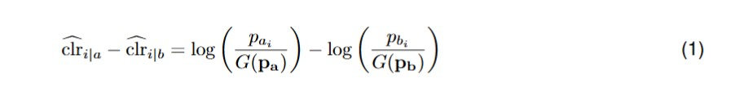

which states that the difference between clrs is the difference between the sample log-abundances but corrected by the differences between the corresponding log-GMs. It should be noticed that when a sufficiently large number of rares characterize each sample involved in the comparison process thus all WS geometric means converge to a small value (see e methods 6.4) since the average community structures become similar and thus contribution of GMs differences in eq. (1) reduces. As a consequence, log-abundance differential of samples with high richness well approximates clr differential.
Data from salivary microbiota before and after brushing teeth presented in (8) are used to evaluated clr sample differential since experimental setup provides for both microbial load quantification with flow cytometry and 16S rRNA gene amplicon sequencing. The analysis is here reproduced and extended to show that if a large number of features are used, difference between taxa clr can be alternatively used to log-ratio for comparing ratios of taxa between samples, that difference between samples of a taxon clr based on 16S data and on absolute differentials are identical if pseudocounts are properly managed and that results holds also when rarefaction is applied.
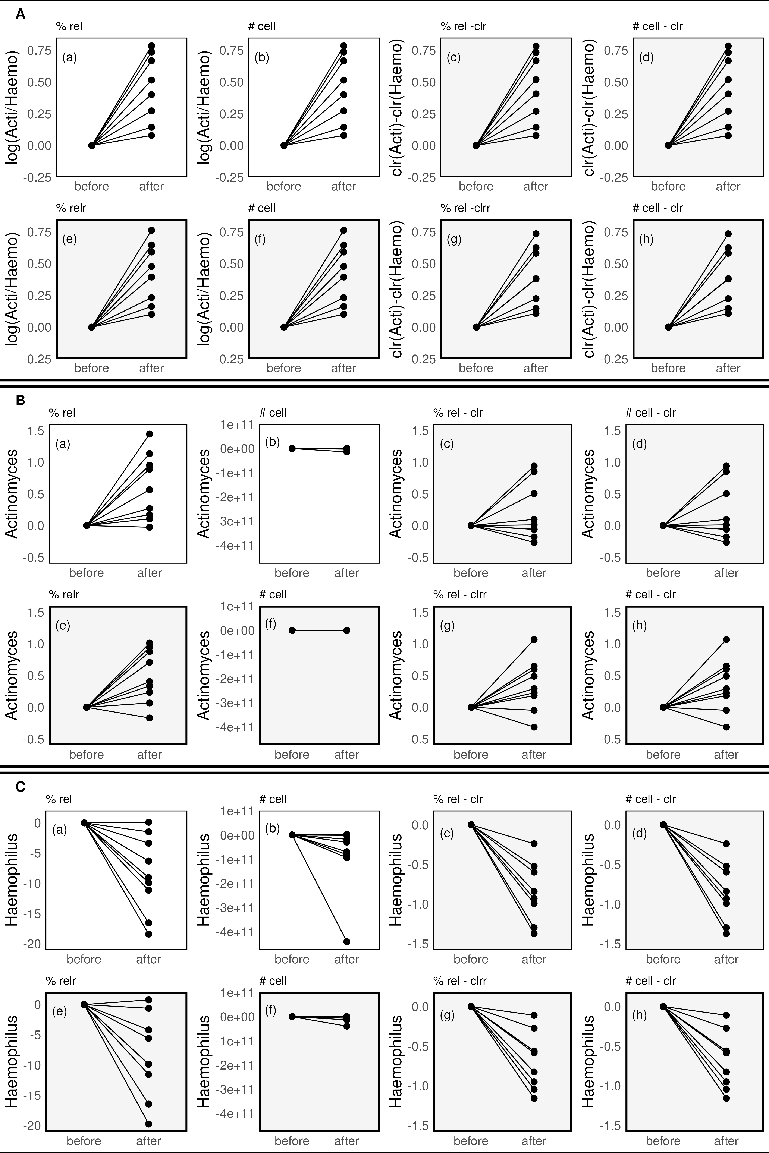
Figure 4. Within-sample differences between clr of the relative and absolute (from flow cytometry) counts result in the same average after/before ratio for both the log ratio of taxa and for individual taxa since the microbial load effect is taken into account by the WS-GM reference frame. Relative (a and e), absolute (b, f), clr of relative (c, g) and clr of absolute (d, h) abundances of log(Actinomyces/Haemophilus) (panel A), Actinomyces (panel B) and Haemophilus (panel C) before and after brushing teeth from https://github.com/knightlab-analyses/reference-frames. White sub-panels (a) and (b) refer to relative and absolute abundance data of taxa presented in (8), gray sub-panels (c) and (d) refer to WS differences between clrs of taxa evaluted on the same dataset of (a) and (b), respectively. Gray panels (e)-(h) shows the same metrics of panels (a)-(d) but of data rarefied to the lowest sample sequencing depth ($1 483$). Clr of the relative (g) and absolute (h) rarefied counts gives the same average after/before ratio.
Figure 4compares differential abundance after vs before brushing teeth of log(Actinomyces / Haemophilus), Actinomyces, and Haemophilus, respectivley, evaluated using many different WS normalizations (percentage, log-ratio, clr). These normalizations are applied to both 16S relative abundance and to absolute abundance from flow cytometry expressed as number of cells in order to highlight a direct comparison. White panels (a) and (b) of all the three figures refer to relative and absolute abundances data, respectively, presented in (8), gray panels (c) and (d) are evaluated in this paper and refer to the clr abundances evaluated on the same corresponding dataset. Gray panels (e)–(h) shows the same metrics of panels (a)–(d) but of data rarefied to the lowest sample sequencing depth ($1 483$).
Panel A of Figure 4 focuses on WS log-ratio and clr differences between Actinomyces and Haemophilus. WS differences between clrs of taxa shown in Figures (c)-(d) cancel out microbial load effect and thus gives the same average after/before ratio shown in Figures (a)-(b). This happens also when clr is applied to rarefied data figure e-h and therefore the difference between clrs can be used in the same way as the log ratio regardless of the number of readings in each sample although their interpretation is quite different when rarefaction is applied. Without rarefaction this log-ratio describes the interaction of the two taxa and states that after brushing Haemophilus counts are less than Actinomyces (8). However, it is not possible infer on proportions relationship due to the lower microbial load after brushing. When rarefying to the lowest sample sequencing depth ($1 483$ reads), microbial load cancels out and proportions becomes comparable between samples although less precise since some samples were up to $20 533$ reads. In this case one subject has negative log-ratio although the number of counts after brushing Haemophilus are larger than Actinomyces. Clrs gives result coherent with log-ratio, some differences are due to the low number of considered reads that affects the WS-GM of the before - after groups. In any case, clrs of relative and absolute counts gives identical results.
Panel B and C shows Actinomyces and Haemophilus abundances, respectively. In both cases relative and absolute clrs in (c) and (d) sub-panels give the same average after/before ratio thus suggesting that analyses based on clrs remain unaffected by microbial load and lead to the same conclusions as those from flow cytometry, which is instead costly and time-consuming. In particular clrs indicates that not all Actinomyces abundances increase in the after group as the proportion values in panel B-(a) apparently show, since most of the samples have a similar abundance compared to the corresponding before one, two samples increase the counts while two samples decrease them. All the average clrs of Haemophilus decrease after brushing and thus, by putting together the considerations expressed previously relating to the log-ratios, it can be deduced that Haemophilus relative counts actually decreases more than Actinomyces, according to results already shown in Figure 2. Results with rarefied data confirms this interpretation since the average clr on relative (g) and absolute (h) abundances are identical. Thus, clr based on 16S data can be used to evaluate samples differential abundance of an individual taxon. If the comparisons are in terms of sample proportions then rarefaction is necessary, if the differences are focused in terms of absolute counts rarefaction is not necessary and the result of the comparisons is consistent even when the microbial load is not available.
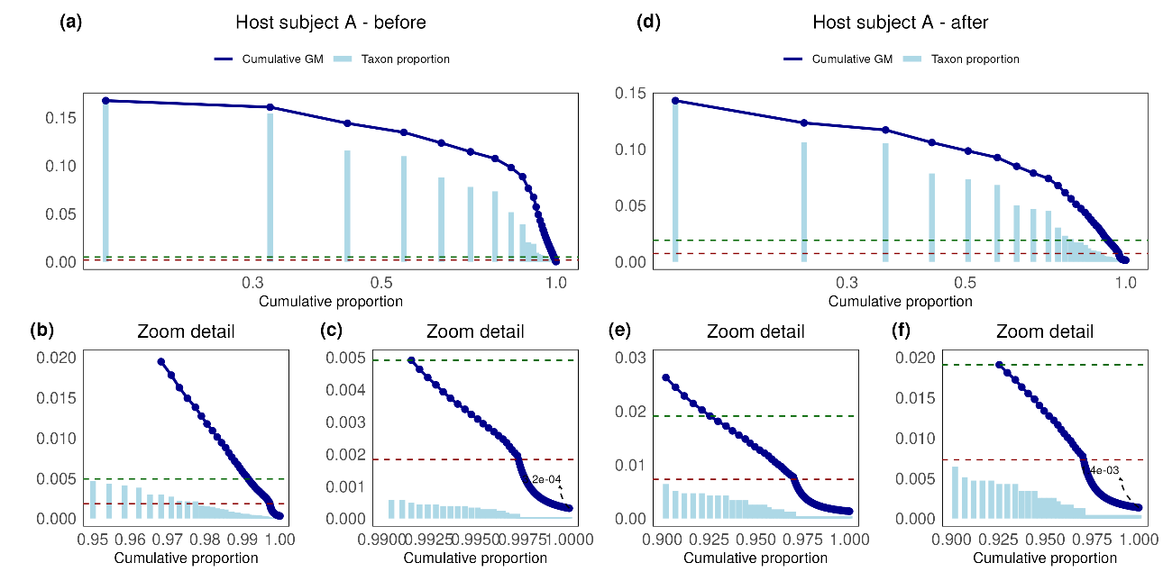
Figure 5. Saliva experiment: comparison of the microbiome of subject A before and after toothbrushing. Missing features reduce the value of the WS-GM to quantities that are increasingly negligible the greater the number of missing genera. Light-blue barplots represent genera proportions ordered in descending order vs the corresponding cumulative proportion. Blue line plots the cumulative WS-GM evaluated up to each feature indicated by the corresponding blue dot vs the cumulative proportions. Horizontal green and red dashed-lines marks features with counts equal to 10 and 1, respectively. Counts of feature between the green and the red line are between 1 and 10 (rares). Features below the red line are missing in the sample while present in at least one of samples included in the experiment and are revealed by the ‘1’ pseudocount needed for evaluating GM.
An in-depth study is appropriate to better understand how the WS-GM modulates the composition of the sample within an experiment such as that of saliva and why it becomes the common reference for all the samples involved if the microbiome of the experiment is sufficiently rich. For this purpose, the genus-level microbiome of subject A from the saliva experiment was analyzed as it has the greatest difference in sequencing depth between before ($20 533$) and after ($2 219$) brushing. Figure 5 shows the WS-GM (blue line) of each sample proportions toghether to the proportions (light-blue bar plot) ordered in descending order vs cumulative proportions value. The a-c and e-f panels refers to the before and to the after brushing state, respectively, and the two bottom subpanels are zoom details of the top panel on rare microbes. Rares features in each samples are those between the green and the red dashed-line that marks features with 10 and 1 counts, respectively. Thus, the red line higlight the WS-GM evaluated on features present in the sample. Genera below the red line are missing in the considered sample and are present in the analyzed microbiome since each of them is present in at least one of saliva experiment. The pseudocount ‘1’ is used to evaluate WS-GM and therefore a count 1 is assigned to each missing feature which is the minimum value that allows to indicate the possible presence of this genus in the sample and the need for greater sequencing depth for quantitative evaluations. The missing features reduce the value of the WS-GM to quantities that are increasingly negligible the greater the number of missing genera. The WS-GM of the before sample converge to $3.2⋅{10}^{-4}$ while the after sample converge to $1.4⋅{10}^{-3}$. These values are negligible with respect to most abundant proportion values for both samples and thus the two WS-GMs become a unique reference frame valid for both sample. It follows that clr effectively evaluate differential abundance of most abundant features.

5 Discussion
In order to compare groups of samples described by relative abundance of features, composition is the benchmark commonly used to infer a signature based on average abundance values. An abundance benchmark is needed to discriminate signatures associated to different samples and, being NGS data of each sample compositional, it is common to choose the most appropriate normalization factor in order to refer data to a known within-sample reference thus having relative abundance values possibly transformed by some suitable functions. Since the scope of a benchmarking is to obtain a single value representative of the composition of the group of samples, thus the normalized quantities of each group are usually averaged across-samples of the group (14) .
In the context of NGS data, the GM is of particular interest since it is the only averaging tool that respects the multiplicative property thus making the GM the only correct averaging operator across samples that are presented as ratios to some reference values. Therefore, AS-GM defines a feature ranking of the average compositional counts regardless of data normalization and can be used for determining NGS microbial and genetic signatures. Moreover, WS-GM contextualized within the NuRo dynamic multinomial modelling of NGS counts overcomes sparsity of the matrix when comparing groups of samples.
Indeed, sparsity of NGS data is known to be critical issue for managing benchmarking tools. The sparsity is due, however, to the attribution of ‘0’ pseudocount to the features missing in the sample but present in other samples of the experiment. In fact, if a single sample is sequenced, thus all features counts are non-null. If more than one sample is considered in a feature table, thus some characteristics may be only in a sample while missing in at least one of the others. Each sample contributes to the ecosystem composition with its own features and the union of samples defines the entire set of features used for benchmarking. When target sequencing is used, the feature set is the microbiome, when RNA-seq is used the feature set are genes.
When evaluating changes of abundance between samples, rarefaction is desirable in order to ensure a comparable prior probability distribution of features detected in each sample (see sec. 6.2). The rarefaction value should be as high as possible because it fixes both the precision of the proportion estimates based on Fig. 9a and the number of features revealed in each sample. Samples with sequencing depth that cannot guarantee the target relative standard deviation of the proportion estimates,$RSD^{*}$, ususally fixed to $0.1$, should be excluded from the analysis (see sec. 6.3). Moreover, particular attention must be paid to further counts normalization or transform and to the management of missing data. If no rarefaction is applied, differential abundance due to the different library size is revealed.
After the possible rarefaction process, the proportions or relative counts can be equivalently used to compare samples abundances. The comparison highlights the missing featuresthat are usually replaced with the ‘0’ pseudocount so that sample proportions are not affected. While a differential test could be carried out when only two samples are involved for inferring a feature proportion change, attention must be paid when comparing two groups of samples. In fact, feature abundance is usually averaged across each group and then tests are performed to compare the mean values of the groups. However, since NGS data are intrinsically compositional, the averaging operator across samples cares since arithmetic mean on proportions or relative counts, although rarefied, is meaningless (see sec. 6.1). Indeed, being the geometric mean the only correct average operator for compositional data, log transformed data and WS-clr are the most appropriate form of abundance for carrying out analyses since the per group arithmetic mean on log-data corresponds to the logarithm of the per group geometric mean of proportions or counts.
The WS-clr has been applied to the saliva experiment and it has been shown that clr-based assays integrated into the context of the NuRo dynamic binomial model of NGS data are not affected by microbial load and provide interpretations identical to those obtained from flow cytometric measurements. This result is valid also when rarefaction is applied although interpretation of the outcome should applied to proportions and not to counts, and a large number of reads is desirable in order to improve both precision and accuracy of relative abundances of most abundant features and to create a common reference frame for samples involved in the experiment. All in all, WS-clr can be applied to rarefied or non-rarefied data depending on whether the interest is in relative or absolute differential comparisons, respectively, and interpreted as if absolute abundance were available.

6 Methods

6.1 Geometric mean is the most appropriate average metric for features ranking
NGS data are compositional and thus the choice of the WS normalization factor plays an important role for samples comparison to be substantial and appropriate. To prove this, we adapt and extend the toy examples shown in (10) to cases of NGS feature abundance and recall that the following three rules must be observed.

6.1.1 Rule 1. Do Not Use the Arithmetic Mean to Average Normalized Numbers
To illustrate problems arising from using arithmetic mean, consider the simple example illustrated in Figure 6 already analyzed in the scientific literature (10) but here adapted to represent a feature table of sequenced samples. In particular, the panel 6a shows relative counts of a feature table (the yellow one) describing the composition of three features $F_{1}$, $F_{2}$, and $F_{3}$ in two samples, $S_{1}$ and $S_{2}$. The three white and gray tables associated with it are the within-sample (WS) marginal (below), the across-samples (AS) marginal (right), and the whole-table (WT) marginal (diagonal) tables. Each marginal reports the most used summary stas: total sum (Sum), the total arithmetic (AM) and geometric (GM) mean.
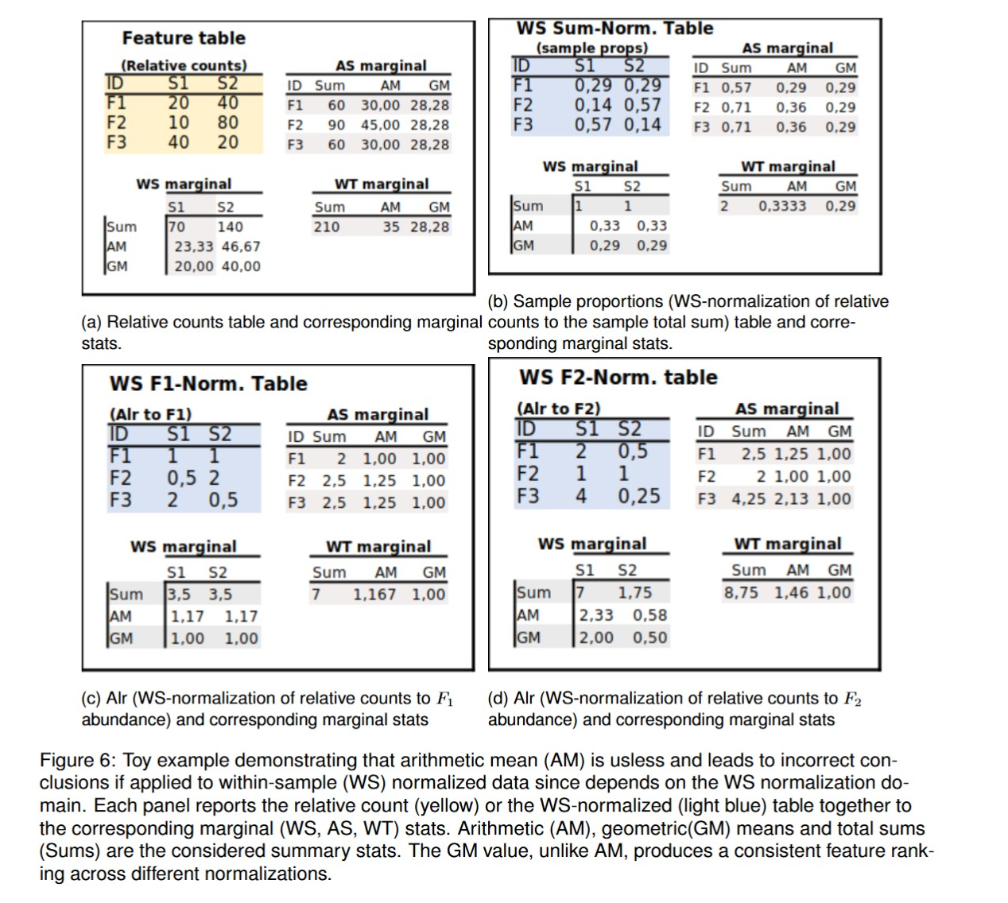
The counts of the F1 feature compared to those of F2 in the S1 sample are half, while in the S2 sample they are double. Furthermore, the abundance of $F_{3}$ relative to $F_{1}$ is double in $S_{1}$, but is half as much in $S_{2}$. Supposedly, these three features contributes to the same compositional diversity degree: each feature has a lower abundance than one of the others in one of the samples, but greater than the same ratio in the other sample. However, if we choose $F_{1}$ as the baseline feature, normalize each sample count to the corresponding abundance of $F_{1}$ (WS- F_1) normalized blue table in the 6c panel), and use the arithmetic mean (AM) as the across-sample summary statistic (AS marginal), we find that the abundance of both $F_{2}$ and $F_{3}$ is 25% larger than that of $F_{1}$.
The situation gets even worse if we take the taxon $F_{2}$ as reference (WS-F_2 normalized blue table in the 6d panel) and calculate the corresponding AS-AM marginal. Indeed, it turns out that the abundance of $F_{2}$ is now 25% lower than $F_{1}$ and more than twice lower than $F_{3}$ despite the fact that the total abundance of $F_{1}$ and $F_{3}$ was lower than that of $F_{2}$. It is therefore clear that in this context the arithmetic mean is not only useless but leads to completely incorrect considerations even if we consider ratios of taxa expressed as alr since results are affected by the feature used for data normalization. Similar considerations apply to the total sum since it is proportional to the arithmetic mean.

6.1.2 Rule 2. Use the Geometric Mean to Average Normalized Numbers
If the AS-GM is used as summary statistic, the interpretation is consistent with the composition indicated by the counts. In the example of figure 6, AS–GMs of features were practically equal on both relative counts and ratios of features independently on the chosen normalization feature. This is an important property of the geometric mean that can be exploited to compare AS means regardless the used normalization. Another toy example adapted from (10) is discussed in order to clarify this concept (see figure 7).
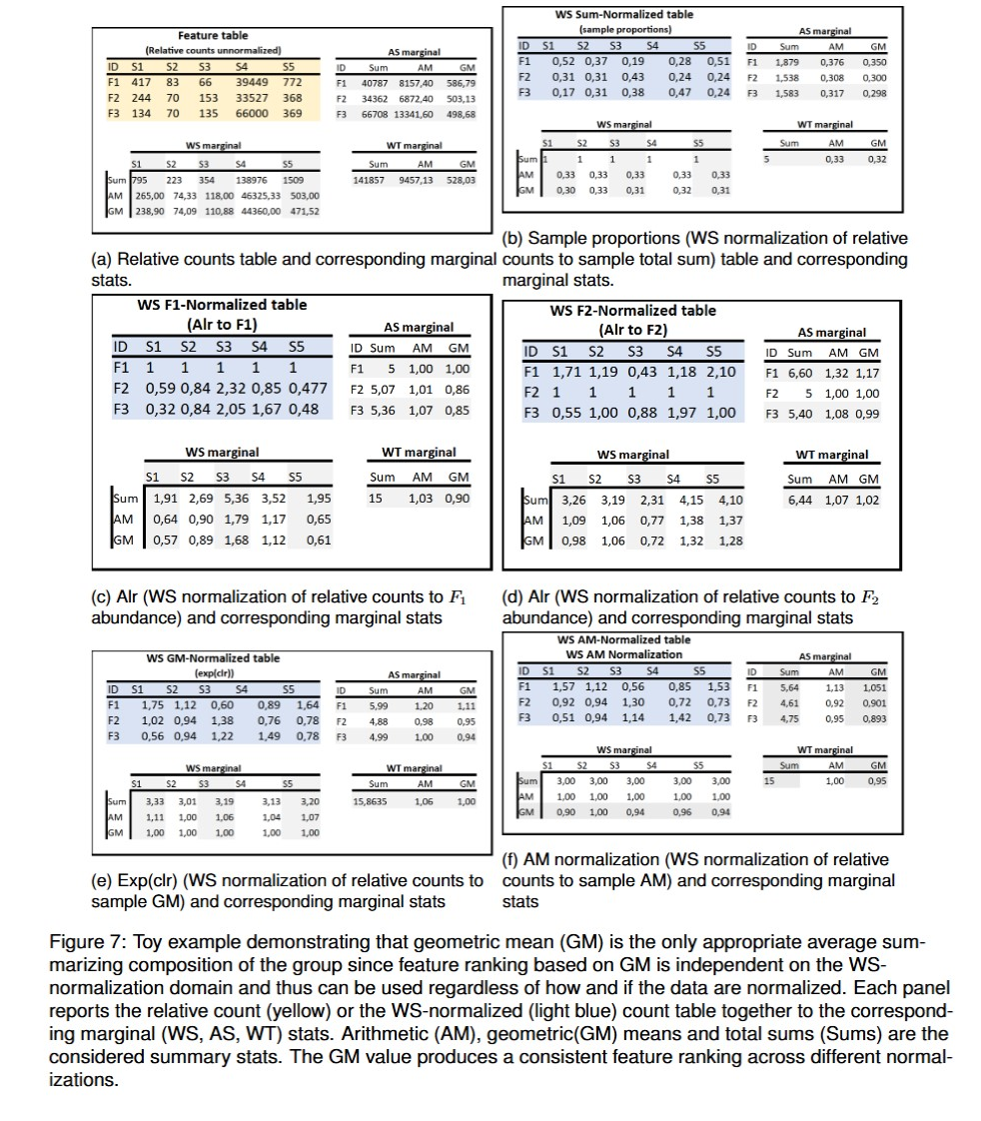
The yellow feature table in the 7a panel describes the composition of 3 features $F_{1}$, $F_{2}$ and $F_{3}$, in 5 samples, $S_{1}$, …, $S_{5}$.
Considering ratios of features to taxon $F_{1}$ (WS-F_1) normalized blue table in the 7c panel) and the arithmetic mean summary statistic of each feature across samples (AS-AM), it could be deduced that the abundance of $F_{2}$ and $F_{3}$ are 1% and 7% higher, respectively, than $F_{1}$. On the other hand, arithmetic means evaluated on ratios to $F_{2}$ (WS-F_2) normalized 7d panel) indicate that $F1$ abundance is now 32% larger than $F_{2}$. This two results are distant and confirm that the arithmetic mean is not the appropriate tool for comparing average relative abundances. The geometric mean leads to more coherent conclusions: considering ratios to $F_{1}$ results that $F_{2}$ is 14% lower than $F_{1}$, and $F_{3}$ is 15% lower. The same results are derived by using ratios to $F_{2}$: in fact $1.17=1/0.86$. Moreover, comparing $F_{2}$ and $F_{3}$ without explicitely normalizing to $F_{3}$ we can argue that $F_{2}$ is 1% larger than $F_{3}$ since $0.86/0.85=1.01$ as already indicated by geometric mean on data normalized to $F_{2}$. Even considering sample proportions, i.e. WS Sum-normalized table shown in figure 7b accompanied by the corresponding marginal statistics, the ranking of feature ratio based on geometric mean does not change with WS normalization factor since $0.86=0.300/0.350=503.13/586.79$ or $0.85=0.298/0.350=498.68/586.79$. The same considerations apply when relative count are normalized to the WS-GM (Figure 7e) or WS-AM (Figure 7f) mean.
Furthermore, the geometric mean can be used even if the numbers are not normalized. In fact, due to the multiplicative property of the geometric mean, which allows the geometric mean of the ratios to be evaluated as the ratios of the geometric means, normalization of means resulting from unnormalized data are equivalent to means of normalized data. This fundamental property makes the geometric mean the only correct averaging operator for data presented as ratios to reference values and which results in feature ranking based on the average abundance. Thus, this example shows that the geometric mean can be used to rank features based on the averaged relative abundance regardless of how and whether the data are presented as ratios to reference values since the geometric mean can be used even if the numbers are not normalized (10).
In conclusion, due to the multiplicative property of the geometric mean, ranking of features AS-averaged does not change with the chosen WS-normalization factor as well as the ratio between AS-average features.

6.1.3 Rule 3. Use the Sum (or arithmetic mean) of raw, unnormalized results whenever This “Total” Has Some Meaning
The total sum of feature abundances across samples is used to classify features based on their abundance relative to the group rather than a single sample. Since the arithmetic mean, or equivalently the sum, does not provide useful results on normalized data (see methods 6.1.1), it is important that the sum is calculated using raw, non-normalized data and that the relative rankings are then evaluated from the corresponding ratios. In figure 7a, total sum of $F_{2}$ is 16% smaller than $F_{1}$ while $F_{3}$ is 63% larger. Analogous considerations can be applied to the total sum of feature abundance within sample that is used to classify samples based on the number of reads. In previous example $S_{2}$ is 82% smaller than $S_{1}$ while $S_{5}$ is 90% larger.

6.2 NuRo: Dynamic Multinomial model for NGS data
Let us consider a vector of abundances $a=\left[a_{1},a_{2},...,a_{i},...,a_{\hat{F}}\right]$ with $i=1,...,\hat{F}$ that represents the outcome of the sequencing of a single sample $S$ with a number of features equal to $\hat{F}$. The element $a_{i}$ is the abundance of the $i$–th feature, $F_{i}$, and the sum of all features abundance is $R$ is the total library size, i.e. $R=\sum_{i=1}^{\hat{F}}{a_{i}}$. This value depends on the assay settings and not on the input material thus is an arbitrary value characterizing the sequencing process and related to the sample richness (19). In particular, the greater the value of R, the greater the coverage of less abundant features and therefore the greater the number of observed features, $\hat{F}$, which better approximates the actual number of features, $F$, present in the biological sample. The arbitrariness of $R$ means that counts of NGS data are not absolute but compositional and that can be modeled using the discrete Dirichlet-Multinomial distribution $a∼\text{DirMult}\left(R,α\right)$ with parameter $α=\{α_{1},α_{2},....,α_{\hat{F}}\}>0$ and $α_{0}=\sum_{k=1}^{\hat{F}}{α_{k}}$. Within this model, $a_{i}$ is the number of times a read was successfully recognized as a feature $F_{i}$ among the available $R$ reads when the probability of success is $p_{i}$. Therefore, the observations come from a multinomial distribution with number of trials $R$ and with corresponding probability vector $p=\{p_{1},p_{2},...,p_{i},...p_{\hat{F}}\}$ obtained from a Dirichlet distribution parameterized in $α$, with $p_{i}=\frac{α_{k}}{α_{0}}$ whose sum is 1 (20).
The proportion of successes of each observed feature, ${\hat{p}}_{i}=\frac{a_{i}}{R}$, is an estimate of the corresponding binomial probability with variance and covariance equal to $Var\{{\hat{p}}_{i}\}=\frac{p_{i}\left(1-p_{i}\right)}{R}$ and $Cov\{{\hat{p}}_{i},{\hat{p}}_{j}\}=-\frac{p_{i}p_{j}}{R}$ when $i≠j$, respectively , thus library size affects precision of the relative abundance estimate: the higher the $R$, the better the precision since the variance is reduced. Being the proportion estimator unbiased, efficient and consistent, also accuracy improves as precision improves because ${\hat{p}}_{i}$ becomes more consistently close to the parameter $p_{i}$. Figure 8 shows consistency of the binomial proportions estimate that provides increasingly accurate values as $R$ grows.
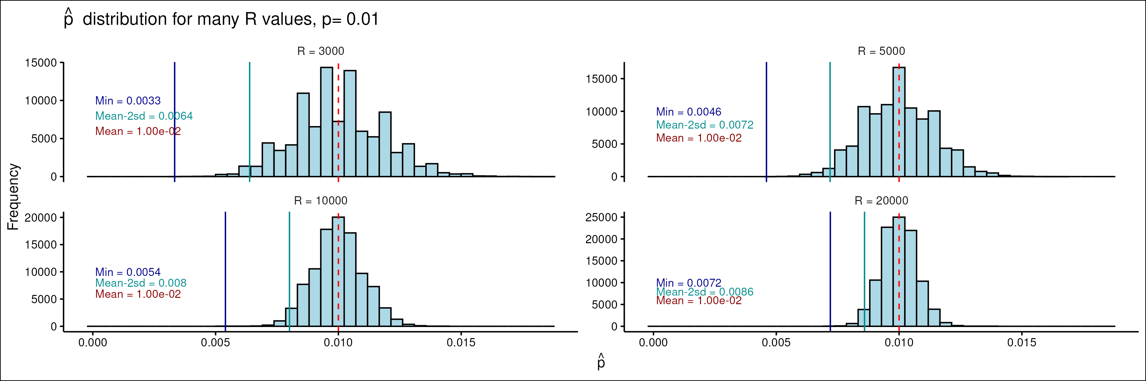
Figure 8. Consistency of the proportion estimator of a binomial model. Figures show the distribution of proportions of ${10}^{5}$ realizations of binomial random variables with parameters $p=0.01$ and four different $R$ values ($3 000,5 000,10 000,20 000$). Vertical lines represent the minimum $\hat{p}$ (blue, solid), the mean value of proportions minus 2$⋅$SD (light-blue, solid) and the a-priori probability value $p=0.01$ (red, dashed). Consistency of the model is that the higher $R$ the better the estimates since both the mean and the minimum observed proportion and the SD reduce, i.e. the better the accuracy as well as precision.
This classic asymptotic analysis of the binomial variable is performed by assuming the theoretical value of the proportion $p_{i}$ constant and therefore the statistical characteristics of the estimator improve as the number of samples increases. We will refer to this model as the static model. Special attention should be given to modeling the counts of the sequencing process using binomial variables. Indeed, the greater the sequencing depth, $R$, the greater the number of observed features, $\hat{F}$, due to the increase in the number of rare types that are observed, i.e. with a non-null abundance count. Since the condition $\sum_{i=1}^{\hat{F}}{p_{i}}=1$ must hold for any value of the sample sequencing depth, when a new feature is revealed thus the values of the proportional abundances are redistributed by lowering the $p_{i}$ values of the previously recorded features according to the constraint. Therefore, NGS counts are best described by a dynamic multinomial model (NuRo from the authors) that considers the compositionality of data by taking into account the relationship between the number of sequences, $R$, and the number of observed independent events (i.e. the number of observed features, $\hat{F}$). Since the composition of the features is peculiar to each sample, which means a uniqueness of the a-priori probability distributions of the features, the number and type of features, together to a given value $R$, marks each sequenced sample.
Note that when $R→∞$ the number of observed features, $\hat{F}$, increases converging to the theoretical sample richness, $F$, and therefore the dynamic model tends towards the static one. Therefore, unless $\hat{F}$ is already at $F$, both the number of observed features and their corresponding $p_{i}$ values depend on the sequencing depth, $R$, as well as the accuracy and precision of sample proportions (20).
Using the NuRo model helps define the context of differential abundance or gene expression analyses between samples. Since $R$ affects the number of observed feature types and therefore the corresponding a-priori probability values, comparison of feature abundance between samples having different sequencing depths is meaningless since the differential outcome from observed proportions reflects differences in the a-priori probabilities due to the non equal sampling depth that differentiates the feature set (i.e. the microbiome or the genes set). For example, consider two biological replicates, one with a sequencing depth 1000 times the other and the most abundant feature, $F_{1}$, which is definitely present in both sequences. The prior probability of $F_{1}$ is much lower in the sample with the largest number of reads due to the larger number of rare features captured by the instrument. It follows that comparing the abundance of $F_{1}$ between two sequencing is meaningless if samples present large differences in the sequencing depth, while it still makes sense to evaluate the differences between the feature ratios for those features that are detected in both sequencing and are not missing in one of the two files. Thus, rarefaction is highly recommended with differential analyses.
Although arbitrary, after sequencing the number of reads per sample, $R$, becomes a parameter of the process. The resulting finite number of $R$ affects precision of proportions of detected features, with particular concern to the rares.
Another distinguishing factor of the NuRo binomial model describing NGS sequencing is that features with null-probability or with zero-counts can never be present in the sequencing result of a single sample. In fact, $p_{i}=0$ means that the feature is definitely absent from the sample and therefore will never be sequenced. On the other hand, since the instrument can only reveal observed characteristics, modeling $a_{i}=0$ with a non-zero $p_{i}$ implies some a priori knowledge about the quantitative composition of the biological sample, but this never happens in reality and therefore $a_{i}>0$ is always true. This means that a single sample sequencing can be modeled as a Dirichlet-Categorical-Multinomial distribution and thus the support of each count is the set $\{1,...,R\}$ which exclude the zero count.
Missing features counts occur only when at least two samples are analyzed simultaneously as some features may be unobserved in one of the sequenced samples. In this case, a priori knowledge is needed to determine whether the corresponding missing count is due to the null-probability value of the feature in the sample or to the small number of sequenced reads that fail to ensure a reliable estimate of the binomial proportion. Missing counts must be properly managed based on the required analysis.

6.3 Characterization of the logarithm of binomial random variables
Let $x$ be a binomial random variable with probability of success $p_{x}$ in $R_{x}$ independent trials, i.e. 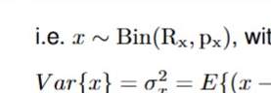, with support $1,...,R_{x}$. The first two moments of $x$ are $E\{x\}=μ_{x}=p_{x}R_{x}$, $Var\{x\}=σ_{x}^{2}=E\{{\left(x-μ_{x}\right)}^{2}\}=R_{x}p_{x}\left(1-p_{x}\right)$, with $E\{⋅\}$ being the expected value operator.
Sample proportion, ${\hat{p}}_{x}=\frac{x}{R_{x}}$ is an efficient consistent unbiased estimator of $p_{x}$ (see figure 8) and thus its variance is the lowest possible and equals the Cramer-Rao lower bound, $Var\{{\hat{p}}_{x}\}=CRLB=\frac{p_{x}\left(1-p_{x}\right)}{R_{x}}$. The relative variance
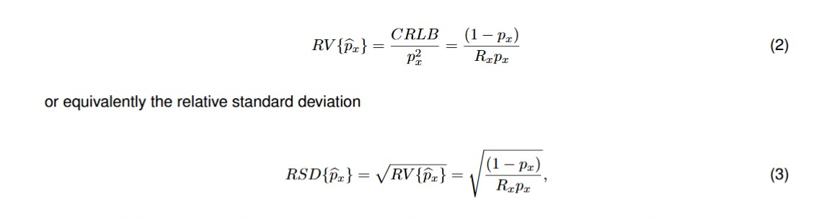
are normalized metrics useful for comparing the performance of the estimator across different values of $p_{x}$ and $R_{x}$. Both are related to the the dispersion of ${\hat{p}}_{x}$ and inversely related to the precision of the sample proportion ${\hat{p}}_{x}$: lower $RSD$ indicates higher precision and this happens when $R_{x}$ is large or when $p_{x}$ is not too close to 0 or 1. Figure 9a shows the behavior of the RSD vs $p_{x}$ for some $R_{x}$ values as indicated by the color legend. The horizontal dashed line marks the target $RSD^{*}$ value equal to $0.1$ which indicates a standard deviation of the sample proportion equal to the 10% of the sample proportion itself and thus is the RSD level that guarantees that the first non-zero decimal digit of the calculated proportion is the most significant. As an example, if ${\hat{p}}_{x}=0.30$ if its standard deviation is $0.03$, i.e. is 10% of its value, this indicates that the second decimal place varies about $±3$ and thus proportion varies within one SD between 0.27 and 0.33. Thus the first decimal digit, which is the first non-zero digit, is also the most significant digit. The figure highlights that if the goal is to estimate a proportion of approximately 0.01 with an RSD of at least 0.1 then at least $10 000$ readings are needed (the blue line). Lower proportion values require a greater number of reads to respect the RSD=0.1 constraint, otherwise the variance of the estimate increases.
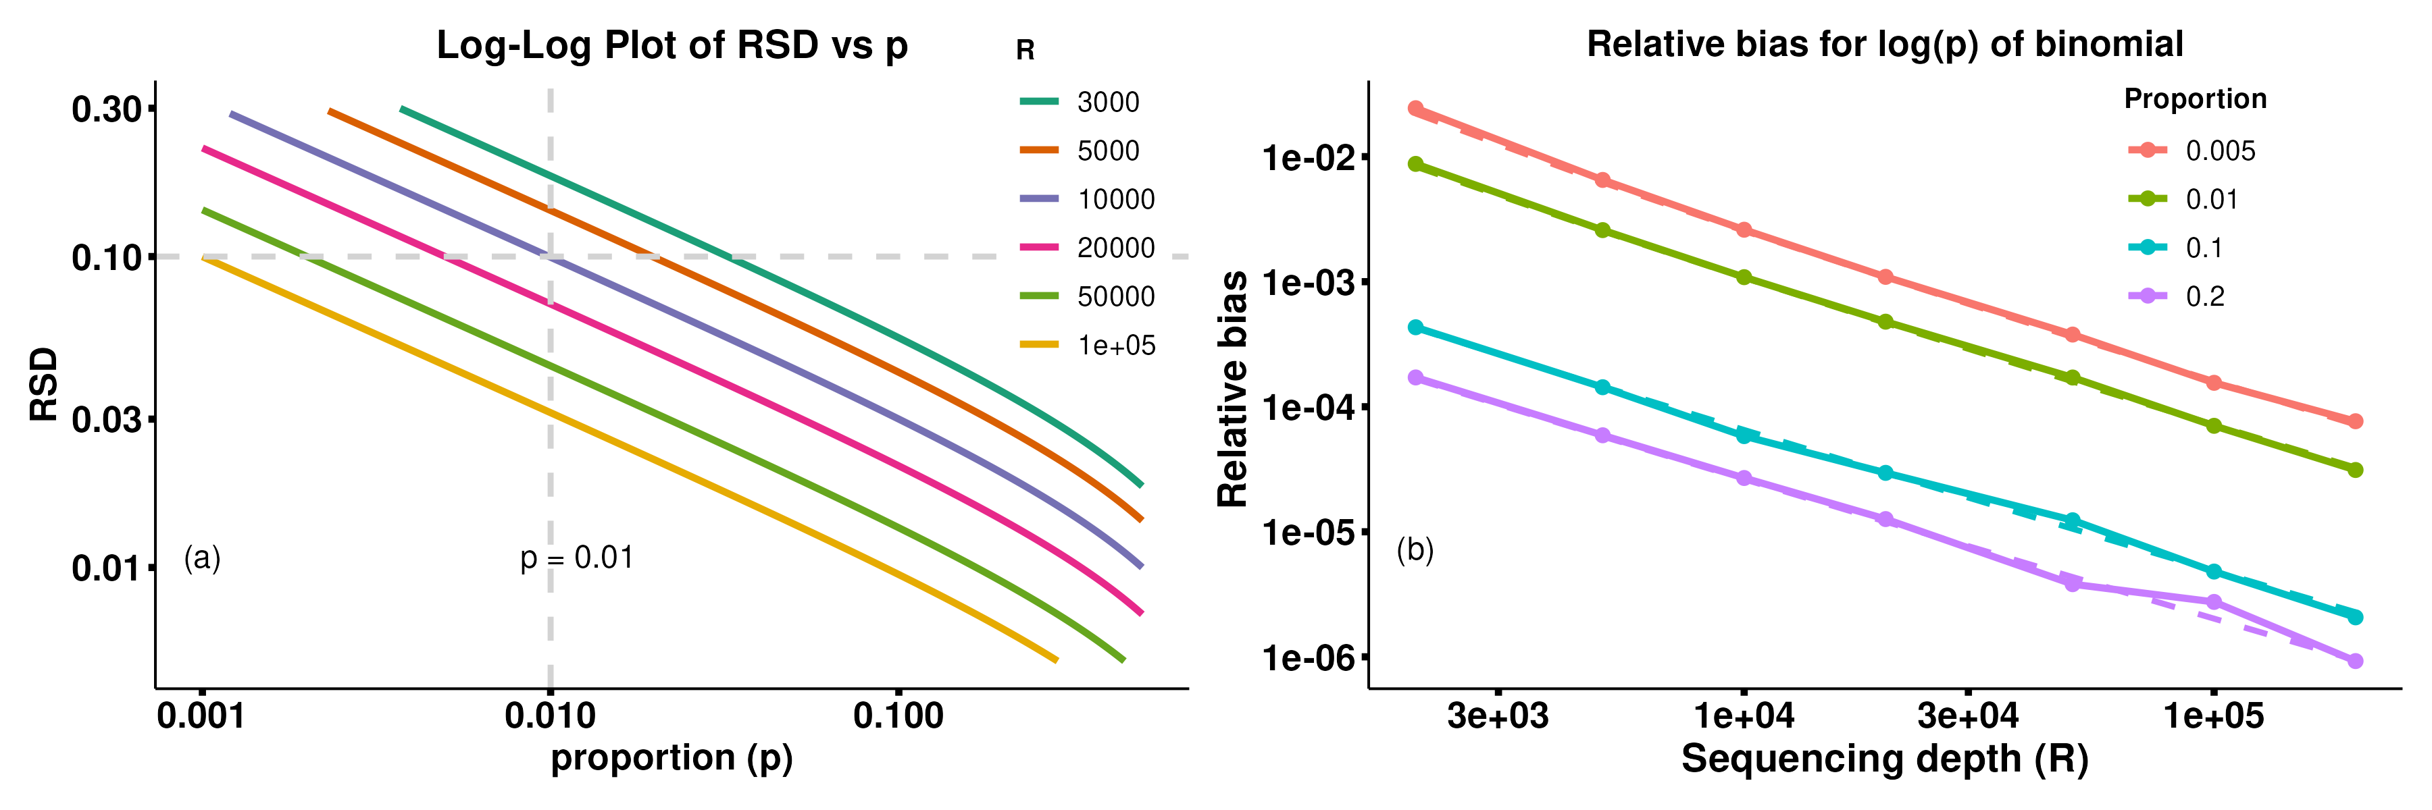
Figure 9. Statistical characterization of the logarithm of binomial proportions. (a): Relative standard deviation, RSD, of sample proportion ${\hat{p}}_{x}$ vs theoric probability, $p_{x}$, for different sequencing depth, $R$, values. Horizontal dashed gray line marks RSD=10%. Vertical gray dashed line marks the proportion value 0.01. (b): Logarithm of a binomial variable, $log\left(x\right)$, is asymptothycally unbiased. Plot shows relative bias $\left(E\{log\left(x\right)\}-log\left(x\right)\right)/log\left(x\right)$ vs sequencing depth, $R$, for some probability values of a positive binomial random varible. Solid lines refer to results over 1 million synthesized data, dashed lines refer to the error $\left(1-p_{x}\right)/\left(R_{x}p_{x}\right)$.
In order to evaluate the expected value of $log\left(x\right)$, the Taylor expansion about the expected value of $x$ up to the second order is used thus obtaining:
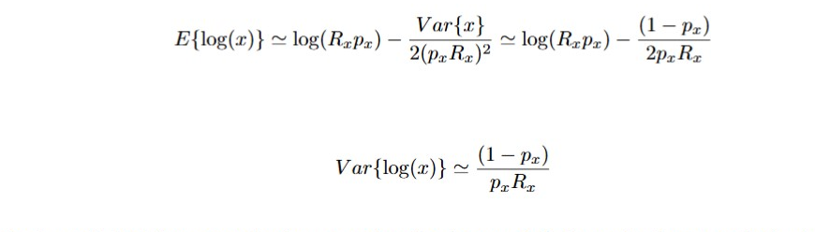
In order to verify that the second order approximation is enough is for evaluating expected value for large $R_{x}$, simulated data over 1 million synthesized data are presented in figure b with solid lines vs $R_{x}$ for many $p$ parameters. Simulated and theoretical results are almost overlapping. The bias $\left|\frac{\left(1-p_{x}\right)}{2p_{x}R_{x}}\right|$ depends on the sequencing depth and confirm that logarithm of a binomial abundance is asymptotically unbiased (dashed line in figure 9b).
–>

6.4 Geometric mean of mutinomial data
Geometric mean of multinomial proportions as modeled in sec. 6.2 is:
$$G\left(p\right)=exp\left(\sum_{i=1}^{\hat{F}}{logp_{i}^{1/\hat{F}}}\right)$$
and goes to zero if a large number of rares is included, i.e. a large sequencing depth is used, due to their small proportion value. In order to appreciate this behavior and to relate it to the increasing $\hat{F}$ due to revealed rares, data counts of a single sample synthesized according to a multinomial Dirichlet distribution under three different conditions are shown in figure 10. In particular, count data of one biological sample sequenced with different levels of sequencing depth ($R$ equal to $2 000$, $5 000$, $10 000$) and that reveals different number of features ($\hat{F}$ equal to 42, 64, and 106, respectively) are simulated as potential use cases for microbiome studies (simulating species abundance distributions at different sequencing depths), RNA-seq data (modeling gene expression variability between samples), or ecological studies (simulation of species abundance distributions in different environments). This is a paradigmatic example to emphasize the effects of sequencing depth on GM values both when considering a unique biological sample for which 3 successive phases of a single sequencing are reported, and when considering the sequencing of 3 different biological samples each with its own sequencing depth.
In particular, relative counts of features ordered by abundance are represented in figure 10a vs the feature index, k, for each sequenced depth according to the color legend and shows that number of counts of each feature increases with $\hat{R}$. For each feature and for each dataset, the corresponding a-priori probability and estimated sample proportions are shown in figure 10b with solid and dashed line, respectively. The most abundant features present a proportion value that decreases with $R$ due to the sum to 1 constraint to which proportions are subjected. On the other hand, rares presents proportion values that increase with $R$. When we need to evaluate differential abundance among the three samples, the union of the features revealed in each sample is considered and thus, for this simulated dataset, is the set of features of the red data. Due to the different sequencing depth, blue and green data have missing features with respect to the red one and thus a pseudocount is needed for each feature in each samples involved in the comparison. When log-based data transform as the GM are used, a ‘1’ pseudocount is usually added to each feature and thus counts are modified as shown by the gray tiles on the top of the count barplots shown in figure 10c. The cumulative geometric mean evaluated over proportions in each dataset (according to colors as in as in figure 10a) up to each feature after their decreasing abundance sorting, is plotted in figure 10d vs the cumulative sample proportion. Light colored lines refer to cumulative GM evaluated on each sample feature set without any pseudocunt, dark colored lines refer to GM evaluated after adding a ‘1’ pseudocount to each feature. The light gray dots emphasize the features missing in the corresponding sample whose abundance was set equal to 1 count for comparison purposes, implicitly indicating that the feature is missing because it is rarer than those already detected in the sample. The cumulative GM represent, at each feature index k, the GM evaluated on the k most abundant features and is equal to the sample GM when the cumulative proportion saturates. The effects of pseudocounting reduce on GM as $R$ increases, and regardless of sequencing depth, GM decreases with the number of rares included in the sample.
In particular, when the abundance of missing features are replaced by the pseudocount to compare all samples on the same set of characteristics, even the GM of the blue sample, which has the lowest number of reads, converges towards zero. Furthermore, the largest the number of missing feature the lowest the GM. It follows that if the sequenced samples contain a large number of rares, the GMs of each sample are similar to each other and close to zero and therefore the GM, in addition to being a reference for each individual sample, is a good candidate also as the reference for log-abundance of all samples. Therefore, if samples have a high number of rares, clrs can be used to compare feature abundances between samples since they are related to reference frame values that are very close to each other.
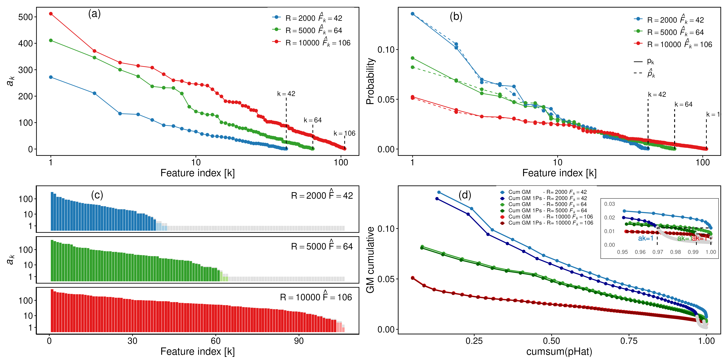
Figure 10. Multinomial Dirichlet counts synthesized under three different sequencing depths $R$ ($2 000$ (blue), $5 000$ (green), $10 000$ (red)) each with its number of features $F_{k}$ ($42$, $64$, and $106$, respectively) as potential use cases for microbiome studies, RNA-seq data or ecological studies. The features are ordered from most abundant to rarest. a: Scatter plot of relative counts vs index of ordered features. Black dashed line is at $a_{k}=3$. b: Scatter plot of relative proportions and probabilities of features vs index of ordered features. c: Barplot of relative counts without and with (gray box) ‘1’ pseudocount vs index of ordered features. d: Scatter plot of cumulative GM of relative proportions of features evaluated without (light color) and with ‘1’ pseudocount (dark color) vs the cumuative sample proportion. The small box shows detailes for rares with grey dots emphasizing contribution of the ‘1’ pseudocount.
It follows that metrics that uses GM as the abundance reference level, reduces the dependency from the number of reads if a sufficiently large sampling depth is used.

6.5 CLR
Clr is an abundance normalization method that uses the geometric mean as a scaling factor and then applies logarithmic transformation to the resulting ratio. In particular, the estimated WS-clr of multinomial counts as modeled in sec. 6.2 is evaluated as:

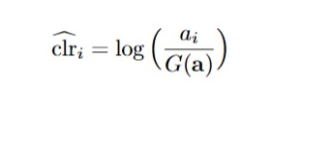
where the WS-GM is $G\left(a\right)={\left(\prod_{i=1}^{\hat{F}}{a_{i}}\right)}^{\frac{1}{\hat{F}}}$ and it represents an estimate of the average concentration of features present in the sample and reduces the weight of the most abundant characteristics.
An important property of the clr is the scale invariance which allows the evaluation of the clr using either absolute abundances or relative proportions (16). Focusing attention on the WS-clr, it is straightforward to show the invariance of clr with respect to the sample sequencing depth, i.e. 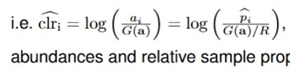 and therefore the WS-clr can be assessed by using both absolute abundances and relative sample proportions.
Another important attribute of clr is that it asymptotically estimates feature abundance. In fact, let us examine the within–sample clr of the $i$–th feature abundance. Recalling the binomial model for the feature count (see sec. 6.2) and substituting each log-term by the Taylor series expansion about the expected value (see sec. 6.3), thus expected values of the feature abundance, of its logarithm and of the logarithm of the geometric mean can be approximated as follows:

$$E\{a_{i}\}=p_{i}R$$
$$E\{log\left(a_{i}\right)\}≃log\left(p_{i}R\right)-\frac{\left(1-p_{i}\right)}{2p_{i}R}$$
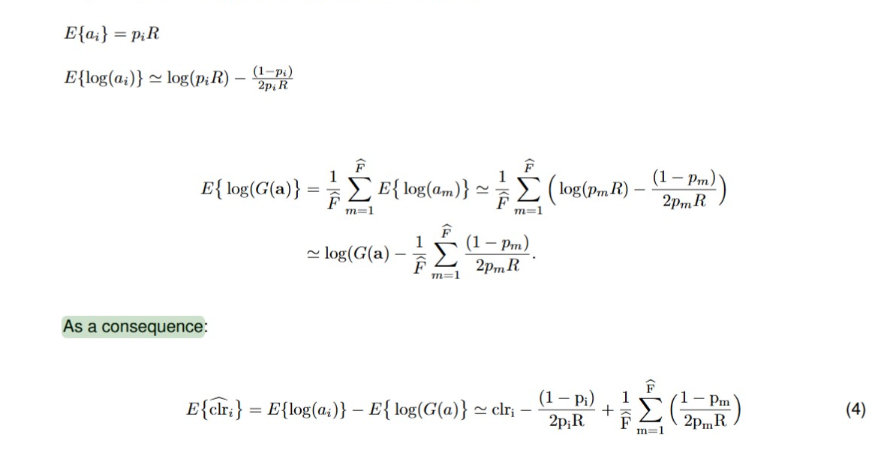
Equation (4) shows that clr is an asymptotic estimator of feature abundance since the last terms goes toward zero as the sample sequencing depth increases.
It follows that, if $R$ is sufficiently large, although the number of observed features lays below the sample richness, $F$, clr is an unbiased sample abundance estimator.

6.6 Math Notation.
A column vector with $N$ elements is denoted by boldface letters as $x={\left[x\left[1\right],x\left[2\right],...x\left[i\right],...,x\left[N\right]\right]}^{T}$ where $x\left[i\right]$ is the $i$-th element of the vector and the operator ${\left[⋅\right]}^{T}$ is the transpose vector.
$\hat{θ}$ is the estimate of the parameter $θ$.

7 Generative AI section
Practical examples on how to query AI tools for evaluating accuracy and precision of sample proportion estimate or reproduce data of the saliva experiment shown in this paper are reported in the supplementary materials AI_prompt.docx.
The same prompt has been given to chatgpt, DeepSeek and Claude and the corresponding outcomes have been recorded.
The list of queries:
- By considering the formula of the relative standard deviation of a proportion value estimated over $R$ counts, $RSD=\sqrt{\left(1-p\right)/\left(pR\right)}$, give the lowest proportion value that can be evaluated with a target $RSD^{*}$ no larger than 0.10 when $R=10 000$ and when $R=100 000$. Round the outcome to the first significant digit according the $RSD$.
- By considering the formula of the relative standard deviation of a proportion value estimated over $R$ counts, $RSD=\sqrt{\left(1-p\right)/\left(pR\right)}$, give the minimum number of reads needed for estimating proportions about $0.001$ with target $RSD^{*}$ no larger than $10\%$.

References
1. Schloss PD. 2024. Waste not, want not: Revisiting the analysis that called into question the practice of rarefaction. Msphere 9:e00355–23.
2. Greenacre M, Grunsky E, Bacon-Shone J, Erb I, Quinn T. 2023. Aitchison’s compositional data analysis 40 years on: A reappraisal. Statistical Science 38:386–410.
3. Wang B, Sun F, Luan Y. 2024. Comparison of the effectiveness of different normalization methods for metagenomic cross-study phenotype prediction under heterogeneity. Scientific Reports 14:7024.
4. Calle ML, Pujolassos M, Susin A. 2023. coda4microbiome: Compositional data analysis for microbiome cross-sectional and longitudinal studies. BMC bioinformatics 24:82.
5. Lin H, Peddada SD. 2020. Analysis of compositions of microbiomes with bias correction. Nature communications 11:3514.
6. Lin H, Peddada SD. 2020. Analysis of microbial compositions: A review of normalization and differential abundance analysis. NPJ biofilms and microbiomes 6:1–13.
7. Swift D, Cresswell K, Johnson R, Stilianoudakis S, Wei X. 2023. A review of normalization and differential abundance methods for microbiome counts data. Wiley Interdisciplinary Reviews: Computational Statistics 15:e1586.
8. Morton JT, Marotz C, Washburne A, Silverman J, Zaramela LS, Edlund A, Zengler K, Knight R. 2019. Establishing microbial composition measurement standards with reference frames. Nature communications 10:1–11.
9. Hu Y, Satten GA, Hu Y-J. 2022. LOCOM: A logistic regression model for testing differential abundance in compositional microbiome data with false discovery rate control. Proceedings of the National Academy of Sciences 119:e2122788119.
10. Fleming PJ, Wallace JJ. 1986. How not to lie with statistics: The correct way to summarize benchmark results. Communications of the ACM 29:218–221.
11. Lin H, Peddada SD. 2024. Multigroup analysis of compositions of microbiomes with covariate adjustments and repeated measures. Nature Methods 21:83–91.
12. Kurtz ZD, Müller CL, Miraldi ER, Littman DR, Blaser MJ, Bonneau RA. 2015. Sparse and compositionally robust inference of microbial ecological networks. PLoS computational biology 11:e1004226.
13. Shaffer M, Thurimella K, Sterrett JD, Lozupone CA. 2023. SCNIC: Sparse correlation network investigation for compositional data. Molecular Ecology Resources 23:312–325.
14. Fernandes AD, Reid JN, Macklaim JM, McMurrough TA, Edgell DR, Gloor GB. 2014. Unifying the analysis of high-throughput sequencing datasets: Characterizing RNA-seq, 16S rRNA gene sequencing and selective growth experiments by compositional data analysis. Microbiome 2:1–13.
15. Calle ML. 2019. Statistical analysis of metagenomics data. Genomics & informatics 17.
16. Egozcue JJ, Pawlowsky-Glahn V. 2019. Compositional data: The sample space and its structure. Test 28:599–638.
17. Pan AY. 2021. Statistical analysis of microbiome data: The challenge of sparsity. Current Opinion in Endocrine and Metabolic Research 19:35–40.
18. Fang Y, Subedi S. 2023. Clustering microbiome data using mixtures of logistic normal multinomial models. Scientific Reports 13:14758.
19. Quinn TP, Erb I, Richardson MF, Crowley TM. 2018. Understanding sequencing data as compositions: An outlook and review. Bioinformatics 34:2870–2878.
20. Fernandes AD, Macklaim JM, Linn TG, Reid G, Gloor GB. 2013. ANOVA-like differential expression (ALDEx) analysis for mixed population RNA-seq. PloS one 8:e67019.
21. Aitchison J. 1982. The statistical analysis of compositional data. Journal of the Royal Statistical Society: Series B (Methodological) 44:139–160.

