## \label{...} 应该紧跟在 \caption{...} 后面.

## [latex处理表格 [转]](http://www.cnblogs.com/longdouhzt/archive/2012/05/29/2524510.html)

论文写作中，有时候会遇到某一个表格水平跨度太长，但是latex不能根据页面的宽度自动断开单元格内的内容，会出现表格内容跨出文档水平长度无法显示。这里提供四种解决方案：

第一，最简单也是最初级的方法，就是缩小表格里面的内容显示字体。这种处理往往不能很好的满足一些期刊要求。

第二，使用表格中的p{width}来限定某一列的长度，比如p{5cm}。

第三，换一种表格生成环境，换成tabular*环境或者tabularx环境。

第四，如果制作的表格水平跨度确实非常长，而且表格也很大，这时最好的处理方式是将表格旋转为纵向放置，使用rotating宏包。

## latex如何使得表格不同列的字体大小不一样

http://bbs.sciencenet.cn/home.php?mod=space&uid=111494&do=blog&id=436728

首先需要在preamble中使用\usepackage{array}宏包，然后在\begin{tabular}环境后定义不同列的字体。需要注意的是，此时需要在表格每个单元格内容对齐位置之前，使用>{decl}来定义每个单元格不同的字体大小。示例如下：

%%%%%%%%%%%how to change the font size of a table column?%%%%%

My living address in Canada is given in Table~\ref{address}.

\begin{table} [h]

\centering

\caption{This is my living address in Canada}

\label{address}

\begin{tabular}{|>{\small}c|>{\Huge}c|}

\hline

Barclay Street & Hamilton \\

\hline

Ontario & Canada \\

\hline

\end{tabular}

\end{table}

[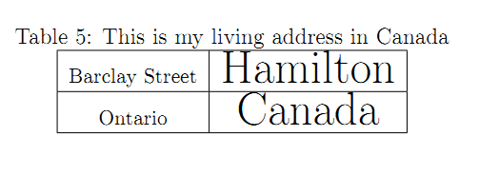](http://image.sciencenet.cn/home/233113voyvvc94c7cczvmj.png)

## latex中表格列宽控制命令p{width}使用举例

http://bbs.sciencenet.cn/home.php?mod=space&uid=111494&do=blog&id=434507

对于表格中水平方向的内容太长无法显示问题，在以前的博文提到可以使用p{width}来控制列宽予以解决，这里给出一个应用举例以及相应的做表代码。

%%%%%%%%%%%%%%%%%%%%%%%%%Without specifying width for last column%%%%%%%%%%%%%%%%%%%%%%%%%%%%

\begin{center}

\begin{tabular}{ | l | l | l | l | l |}

\hline

Item & Name & Gender & Habit & Self-introd tion \\ \hline

1 & Jimmy & Male & Badminton & Hi, everyone,my name is Jimmy. I come from Hamilton,

and it's my great honour to give this example. My topic is about how to use p{width} command \\ \hline

2 & Jimmy & Male & Badminton & Hi, everyone,my name is Jimmy. I come from Hamilton,

and it's my great honour to give this example. My topic is about how to use p{width} command \\ \hline

3 & Jimmy & Male & Badminton & Hi, everyone,my name is Jimmy. I come from Hamilton,

and it's my great honour to give this example. My topic is about how to use p{width} command \\

\hline

\end{tabular}

\end{center}

[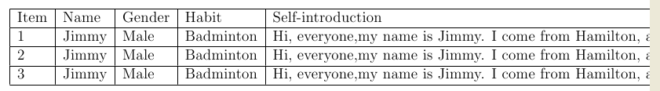](http://image.sciencenet.cn/home/215702uzp8vbqf5w9tv8hl.png)

%%%%%%%%%%%%%%%%%%%%%%%%%%%%%%%%%%%%%With width specified for the last column%%%%%%%%%%%%%%%%%%%%%%%%%%%

\begin{center}

\begin{tabular}{ | l | l | l | l | p{5cm}|}

\hline

Item & Name & Gender & Habit & Self-introd tion \\ \hline

1 & Jimmy & Male & Badminton & Hi, everyone,my name is Jimmy. I come from Hamilton,

and it's my great honour to give this example. My topic is about how to use p{width} command \\ \hline

2 & Jimmy & Male & Badminton & Hi, everyone,my name is Jimmy. I come from Hamilton,

and it's my great honour to give this example. My topic is about how to use p{width} command \\ \hline

3 & Jimmy & Male & Badminton & Hi, everyone,my name is Jimmy. I come from Hamilton,

and it's my great honour to give this example. My topic is about how to use p{width} command \\

\hline

\end{tabular}

\end{center}

[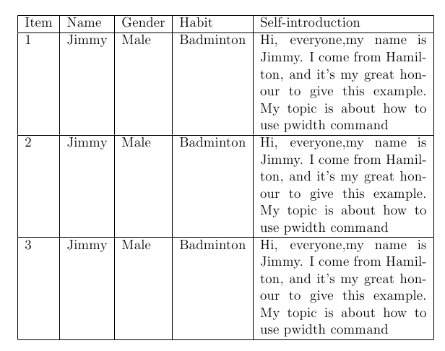](http://image.sciencenet.cn/home/215733hto02oh0kmtibhzo.png)

## latex之表格水平位置转换垂直位置

http://bbs.sciencenet.cn/home.php?mod=space&uid=111494&do=blog&id=434772

将表格在页面布局位置旋转，需要在preamble部分加上\usepackage{rotating} 宏包，然后使用环境sidewaystable.

示例如下：

%%%方法四：将表格页面位置旋转为纵向排列%%%%%%%%

\begin{sidewaystable}

\centering

\begin{tabular}{lllll}

\hline

Item 1 & Item 2 &Item 3 &Item 4 &Item 5 \\

\hline

\multicolumn{5}{l}{\bf S item 1}\\

a & b & c &d &e\\

a & b & c &d &e\\

a & b & c &d &e\\

a & b & c &d &e\\

a & b & c &d &e\\

&&&&\\

\multicolumn{5}{l}{\bf S item 2}\\

a & b & c &d &e\\

a & b & c &d &e\\

a & b & c &d &e\\

a & b & c &d &e\\

a & b & c &d &e\\

\hline

\end{tabular}

\caption{This is an example of rotate table layout}\label{rotatetable}

\end{sidewaystable}

## latex制作复杂表格之multirow，multicolum和cline综合使用简介

http://bbs.sciencenet.cn/home.php?mod=space&uid=111494&do=blog&id=445494

在复杂表格制作中，有时候会遇到一列横跨多行，或者一行横跨多列的情况，那么这个时候就要分别用到\multirow，\multicolum的命令，标准语法如下：

\multicolumn{num_cols}{alignment}{contents}.  %%%%%%%%%%%% num_cols is the number of s seqnt columns to merge; alignment is, either l, c, r or to have text wrapping specifiy a width p{5.0cm} . And contents is simply the act l data you want to be contained within that cell.%%%%%%%%%%%%%%%%

\multirow{num_rows}{width}{contents}. %%%%%%%%%%%%%%%%The arguments are pretty simple to ded e (* for the width means the content's natural width).%%%%%%%%%%%%%%

（需要注意的是：这个命令需要在preamble中添加宏包\usepackage{multirow}）

另外，在复杂表格中，需要从某个某列开始画线，那么需要使用\cline命令，标准语法为：

\cline{i-j}    %%%%%%%%%%% partial horizontal line beginning in column i and ending in column j %%%%%%%%%%%%%

关于\multicolum和\multirow在做表时的一些细节问题表述，可以参考latex文档中的Table部分。

这里，本博文给出一个更加复杂的表格制作，那就是表格中同时存在横跨多行和多列的情况，这个时候会出现\multicolum和\multirow混合使用的情况。（需要注意的是：这种情况下需要使用\multicolumn{1}{|c|}{...}来画单元格的左右边界线）。

例子一：

\usepackage{multirow}

..................

\begin{tabular}{c|c|c|c}  
\hline  
\multicolumn{1}{c|}{\multirow {2}{*}{Canada}}&\multicolumn{1}{|c|}{\multirow {2}{*}{Ontario}}& \multicolumn{2}{|c}{Hamilton}\\\cline{3-4}  
\multicolumn{1}{c|}{}&\multicolumn{1}{|c}{}&  
\multicolumn{1}{|c|}{Barclay Street} & Emerson Street\\  
\hline  
\end{tabular}

例子二：

\usepackage{multirow}

..................

\begin{tabular}{cc|c|c|c|c|l}  
\cline{3-6}  
& & \multicolumn{4}{|c|}{Jimmy} \\ \cline{3-6}  
& & Canada & China & Ontario & Hamilton \\ \cline{1-6}  
\multicolumn{1}{|c|}{\multirow{2}{*}{McMaster}} &  
\multicolumn{1}{|c|}{MS} & Mon & T & Wed & Thu & DeGroote School of Business\\ \cline{2-6}  
\multicolumn{1}{|c|}{}                          &  
\multicolumn{1}{|c|}{IS} & Jan & Feb & Mar & Apr & DeGroote School of Business \\ \cline{1-6}  
\end{tabular}

[转] <http://blog.163.com/heyanqiner@126/blog/static/173423558201152454357190/>

-------

## multirow 设定宽度，换行

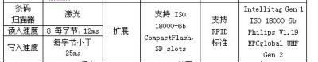

如表格第4列， 首先合并三行，然后分4行写入内容，如何实现这个单元格内容的换行呢？

[复制代码](javascript:void(0);)

\begin{tabular}{p{2em}c}

\hline%

a \newline b& \multirow{3}**{8em}**{soppurt ISO\\18000-6b\\Compactflash,\\SD slots}\\

b & \\

c& \\

\hline

\end{tabular}