CHAPTER 1

1.0 Introduction
Planning a trip requires more than choosing attractive places to visit. Travellers must coordinate travel dates, budget, number of travellers, interests, and daily activities while searching across different digital sources. The growing use of Artificial Intelligence and Large Language Models (LLMs) creates an opportunity to make this process more personalised, but AI-generated travel plans can still contain unsupported recommendations or fail to satisfy practical constraints.
In response to this need, this project develops Nuogo: A Web-Based, LLM-Assisted System for Travel Itinerary and Budget Planning. Nuogo is designed as a controlled planning assistant rather than a general-purpose chatbot. The system uses OpenTripMap-supported attraction data, a selected Travel Style, LLM-assisted itinerary drafting, deterministic validation, and budget checking to produce one personalised itinerary for each generation request. Users may also enable a rainy-day backup option so that selected outdoor activities can be accompanied by grounded indoor or less weather-sensitive alternatives without requiring live weather monitoring.
This chapter establishes the project foundation. It first presents the focused background and three problem areas, followed by the Research Questions (RQs), Research Objectives (ROs), and project scope. The chapter then explains the benefits and significance, milestones and deliverables, constraints and limitations, and the boundary of the minimum viable product (MVP).

1.1 Background
Digital technologies have changed how travellers search for destinations, compare services, and organise trips. Tourism recommender systems can personalise individual tourism resources, while generative AI can support conversational recommendation and decision-making (Solano-Barliza et al., 2024; Dwivedi et al., 2024). However, the overall planning process can still be fragmented because travellers must combine dates, budget, attractions, transport considerations, and personal interests across several sources.
LLMs are attractive for itinerary planning because they can interpret natural-language requirements and organise them into coherent day-by-day plans. At the same time, research shows that fluent LLM output is not necessarily a feasible travel plan. Travel-planning agents can struggle with multiple constraints, and exploratory LLM use can introduce factual or location errors that affect later decisions (Xie et al., 2024; Ma et al., 2023). Therefore, itinerary generation requires explicit checking rather than direct acceptance of model output.
External information can reduce the model's dependence on unsupported internal knowledge. Tourism-oriented retrieval and API-grounded approaches use external data before generation to improve factual support and relevance (Qi et al., 2024; Banerjee, Satish, & Wörndl, 2025). This is particularly important because recommender systems based on LLMs may still hallucinate non-existent items (Jiang et al., 2025). For the Nuogo MVP, OpenTripMap is therefore used to provide destination-specific attraction identifiers, names, categories, coordinates, and descriptions where available.
Based on this literature, Nuogo focuses on three manageable contributions: personalised LLM-assisted itinerary generation, budget-aware deterministic validation, and grounded attraction support. The MVP is limited to Beijing, Shanghai, and Xi'an. Instead of generating three full itineraries at the same time, the traveller selects one Travel Style - Budget-Saving, Balanced, or Comfort-Focused - and Nuogo generates one itinerary for that request. An optional rainy-day backup feature can attach a grounded indoor or less weather-sensitive alternative to selected outdoor activities. Live weather forecasting, automatic weather-triggered itinerary switching, booking, payment, and route navigation remain outside the MVP scope.

1.2 Problem Statement
The development of Nuogo is organised around three connected problems: fragmented travel planning, unreliable constraint and budget satisfaction in LLM-generated itineraries, and unsupported attraction recommendations. These problems are deliberately kept narrow so that each can be addressed and evaluated within the FYP scope.

1.2.1 Fragmented and Time-Consuming Travel Planning
Travellers commonly need to combine information from several websites or applications when planning dates, budget, attractions, and daily activities. This fragmentation increases planning effort and makes it difficult to keep the final itinerary consistent with the traveller's requirements. Tourism recommender research also shows that many systems focus on recommending individual tourism resources rather than completing the entire constrained planning workflow (Solano-Barliza et al., 2024). Therefore, there is a need for a single web-based workflow that collects the essential travel requirements and supports itinerary management.

1.2.2 Inadequate Constraint and Budget Satisfaction in LLM-Generated Itineraries
LLMs can generate detailed itineraries, but they may overlook practical constraints even when the response appears fluent. Xie et al. (2024) showed that language agents can struggle with complex travel-planning constraints. In practice, a generated itinerary may exceed the user's budget, duplicate activities, ignore travel dates, or fail to reflect the selected Travel Style. Therefore, there is a need for an LLM-assisted system that generates one personalised itinerary from essential user requirements and checks core constraints before the itinerary is presented.

1.2.3 Unsupported Attraction Recommendations in LLM-Generated Itineraries
An LLM may recommend inaccurate, unsupported, or non-existent tourism items when it relies only on internal model knowledge. Jiang et al. (2025) reported hallucinated recommended items in LLM-based recommender settings, while retrieval-oriented tourism research supports the use of external information to improve factual support (Qi et al., 2024). Therefore, Nuogo requires externally supported attraction candidates and deterministic grounding checks before attraction recommendations are accepted.

1.3 Research Questions
The research questions are derived directly from the three problem areas and guide the design and evaluation of the simplified Nuogo MVP.
RQ1: How can Nuogo simplify travel planning by integrating essential travel requirements and itinerary management within a single web-based workflow?
RQ2: How can Nuogo use an LLM to generate and validate a personalised, budget-aware itinerary according to the traveller's selected Travel Style, while also providing optional rainy-day backup alternatives for weather-sensitive outdoor activities?
RQ3: How can OpenTripMap-supported attraction data and deterministic validation reduce reliance on unsupported LLM-generated tourism recommendations?
RQ1 focuses on planning integration, RQ2 focuses on personalised and budget-aware generation with contingency support, and RQ3 focuses on attraction grounding and reliability.

1.4 Research Objectives
The purpose of this project is to develop a manageable web-based travel-planning prototype in which the LLM assists itinerary drafting while grounded data, budget rules, and validation remain explicit system controls.
- RO1: To develop a secure web-based travel-planning workflow that collects essential user requirements, supports attraction discovery, and allows users to manage generated itineraries.
- RO2: To develop an LLM-assisted itinerary generation module that produces and validates one personalised, budget-aware itinerary according to the user's selected Travel Style and can provide optional rainy-day backup alternatives for selected outdoor activities.
- RO3: To integrate the OpenTripMap API to retrieve destination-specific attraction information and use validated attraction records to support grounded itinerary generation and reduce unsupported LLM-generated recommendations.
Table 1.1 Problem-Research Question-Research Objective Alignment
Problem Area | Research Question | Research Objective | Planned System Response
Fragmented travel planning | RQ1 | RO1 | One web-based workflow for essential preferences, attraction discovery, itinerary display and management.
Constraint and budget failures in LLM output | RQ2 | RO2 | Selected Travel Style, one itinerary per request, core validation, hard-budget checking and optional rainy-day backup.
Unsupported attraction recommendations | RQ3 | RO3 | OpenTripMap-supported attraction pool and deterministic grounding validation.
Table 1.1 shows the one-to-one traceability between the three problem areas, research questions, research objectives, and the core system response. This alignment is used again in Chapter 3 when requirements and evaluation criteria are defined.

1.5 Project Scope
The scope is deliberately limited to the functions required to answer the three research questions. The system keeps the main selling points - grounded attraction data, personalised LLM planning, budget control, validation, and rainy-day contingency support - while excluding real-time and commercial travel services that would make the FYP unnecessarily complex.
Table 1.2 Project Scope Boundary
Scope Area | Included in Core MVP | Excluded / Future Enhancement
Users | Traveller account, login, profile and itinerary management; authorised supporting maintenance of destinations, POIs, and cost-reference records. | Enterprise administration, advanced analytics, commercial partner roles.
Pilot destinations | Beijing, Shanghai and Xi'an. | Nationwide China coverage and destinations outside the three pilot cities.
Essential inputs | Destination, travel dates, total budget, traveller count, interests, preferred attractions and selected Travel Style. | Large sets of optional constraints that are not required for the core planning workflow.
Travel Style | User selects Budget-Saving, Balanced or Comfort-Focused before generation; one itinerary is generated per request. | Automatic generation and comparison of three complete itineraries at the same time.
Attraction grounding | OpenTripMap-supported attraction discovery and candidate validation. | Claiming that all attraction information is real-time or fully verified.
Itinerary generation | One structured LLM-assisted day-by-day itinerary using grounded candidates and user requirements. | Unrestricted autonomous agents or open-ended multi-agent planning.
Rainy-day contingency | Optional grounded indoor or less weather-sensitive alternative for selected outdoor activities. | Live weather API, forecast monitoring, automatic weather-triggered itinerary switching.
Budget | Estimated category-level budget using maintained reference data; total budget is a hard ceiling. | Guaranteed real-time prices, booking quotations, payment processing or currency trading.
Validation | Core checks for structure, attraction grounding, dates, duplicates, required fields and budget; one controlled repair/regeneration attempt. | Complex formal route optimisation or unlimited repair loops.
Map | Display supported attraction locations as map markers. | GPS navigation, turn-by-turn guidance and live traffic routing.
Itinerary management | View, edit, save, regenerate and delete generated itineraries. | Social travel community, collaborative trip editing and public sharing.
The minimum viable product therefore follows a short user journey: select a pilot city, explore grounded attractions, enter essential preferences, select a Travel Style, optionally enable rainy-day backup, generate one itinerary, validate the result, and review the budget, map and source information. This boundary is intentionally narrower than a commercial travel platform and is designed to remain feasible for a single FYP.

1.6 Benefits and Significance
Nuogo is expected to provide practical and academic value by demonstrating how LLM-assisted travel planning can be combined with external attraction data, validation controls, security mechanisms, budget estimation, and transparent information labels in one web-based system.

1.6.1 Benefits

Benefits to Travellers
The proposed system helps travellers simplify travel planning by collecting the main trip requirements in one workflow and generating a personalised itinerary based on the selected Travel Style. Users can explore grounded attractions, review the day-by-day plan, check estimated budget information, use optional rainy-day backup alternatives for selected outdoor activities, and manage the itinerary when requirements change. This provides more control than prompt-only travel planning without requiring three complete itineraries to be generated at the same time.

Benefits to the Tourism Industry
The proposed system demonstrates how LLM technology can be combined with externally sourced tourist-attraction data, itinerary-validation controls, estimated budget reference data, and transparent information labels within a travel-planning application. By distinguishing between API-sourced information, AI-generated suggestions, database-backed records, and system-generated estimates, Nuogo illustrates a more transparent and responsible approach to AI-assisted digital tourism. The project also demonstrates how a travel-planning platform can use external POI grounding and deterministic checks without expanding into booking, payment, or tour-guide services that are outside the current FYP scope.

Benefits to Society
The project supports the development of smart tourism by encouraging the use of Artificial Intelligence and modern web technologies to improve travel-planning efficiency and support more informed user decisions. Smart tourism is increasingly recognised as a technology-driven paradigm in which intelligent systems are used to enhance traveller experiences and support decision-making (Stankov & Gretzel, 2020). By integrating secure itinerary generation, OpenTripMap-supported attraction retrieval, information-source labelling, budget estimation, validation, and itinerary management in one web application, Nuogo promotes more organised and transparent travel planning. Evidence from the tourism sector also suggests that digital transformation can contribute to operational efficiency and service performance (Liu et al., 2024).

Benefits to Future Researchers and Students
The proposed project can serve as a practical reference for future students and researchers interested in Artificial Intelligence, Large Language Models, tourism recommender systems, API integration, databases, and web-based travel applications. It demonstrates how AI technologies, software-engineering practices, external data sources, validation mechanisms, and database-backed cost estimation can be integrated into a practical academic prototype. Future work may extend the system through additional destinations, more authoritative current information sources, multilingual tourism content, stronger route optimisation, or other advanced travel-planning functions.

Benefits to the Project Developer
From the developer's perspective, the project provides practical experience across the complete software development life cycle, including requirements analysis, software architecture, database design, web development, external API integration, LLM orchestration, validation, security, software testing, project management, and technical documentation. It also strengthens problem-solving, analytical thinking, independent learning, and communication skills that are relevant to future professional work in software engineering and AI-related fields.

1.6.2 Significance

Technological Significance
The project demonstrates the practical integration of Generative Artificial Intelligence, Large Language Models, OpenRouter, DeepSeek, OpenTripMap, a relational database, and modern web technologies. Its technological contribution is the design of a controlled itinerary-generation pipeline that combines validated user input, externally sourced attraction records, selected travel-style planning, structured JSON output, deterministic itinerary validation, budget reconciliation, source and verification labels, and safe failure handling within one web-based application.

Academic Significance
This project applies concepts learned throughout the Software Engineering programme, including software development methodologies, stakeholder requirement gathering, functional and non-functional requirements, database design, web programming, software architecture, API integration, security, validation, and software testing. It therefore bridges theoretical knowledge with practical implementation and demonstrates how software-engineering principles can be applied to a real-world AI-assisted planning problem.

Industrial Significance
The proposed system illustrates how Artificial Intelligence can be applied to improve digital tourism services. Generative AI tools have been reported to support personalised customer service, content generation, and decision-making across the hospitality and tourism sector (Dwivedi et al., 2024). Nuogo demonstrates a non-booking use case in which AI supports personalised planning while grounded travel data, budget rules, and validation mechanisms remain visible parts of the application workflow.

Social Significance
The project supports the advancement of smart tourism by making travel planning more accessible, efficient, organised, and personalised. It aims to reduce users' dependence on multiple planning platforms and encourages more transparent use of externally sourced and AI-generated information. By clearly labelling estimates and AI-generated content, the system also promotes better-informed use of digital travel recommendations.

Professional Significance
The successful completion of Nuogo demonstrates the developer's ability to design, develop, integrate, test, and document a complete software system independently. The experience gained throughout the project strengthens professional competencies in software engineering, Artificial Intelligence, project management, testing, and technical communication, providing a foundation for future career development and lifelong learning.

1.7 Milestones and Deliverables
The project milestones and deliverables define the major checkpoints and tangible outputs used to monitor the progress of Nuogo from initial planning through implementation, testing, deployment, and final submission. Detailed project scheduling, the Work Breakdown Structure, and the Gantt Chart are more appropriately presented in Chapter 3 under project planning and methodology.

1.7.1 Project Milestones
The major milestones are summarised in Table 1.3. They identify the expected completion points for FYP 1 and FYP 2 activities.
Table 1.3 Project Milestones
Phase | Week | Milestone | Description
FYP 1 | Week 1 | Project Topic Approval | The project topic is selected and approved by the supervisor.
FYP 1 | Week 5 | Proposal Defence | The project proposal, objectives, scope, and proposed methodology are presented for evaluation.
FYP 1 | Week 10 | Requirement Analysis Completed | Functional requirements, non-functional requirements, project scope, user inputs, API requirements, security requirements, and the stakeholder requirement-gathering plan are documented. The functional and non-functional requirements were reviewed and refined based on the stakeholder questionnaire findings.
FYP 1 | Week 15 | System Design and Prototype Completed | The system architecture, database design, interface design, system modules, and initial prototype are completed.
FYP 2 | Week 20 | Sprint 1 Completed | User interface, registration, login, authentication, profile management, and input validation are implemented and reviewed.
FYP 2 | Week 25 | Sprint 2 Completed | Essential travel preferences, DeepSeek V3.1 integration, selected travel-style itinerary generation, budget estimation, and core output validation are implemented.
FYP 2 | Week 29 | Sprint 3 Completed | OpenTripMap grounding, attraction discovery, optional rainy-day backup, map display, itinerary management, and integration refinements are implemented.
FYP 2 | Week 33 | Integration and Testing Completed | All modules are integrated, and functional testing, API and failure testing, security testing, usability testing, response-time testing, budget evaluation, LLM output-quality evaluation, and bug fixing are completed.
FYP 2 | Week 34 | Deployment and Documentation Completed | The system is deployed for demonstration, and the final report and presentation materials are completed.
FYP 2 | Week 35 | Final Demonstration and Submission | The completed Nuogo system, final report, presentation slides, and supporting documents are submitted.

1.7.2 Project Deliverables
The project deliverables are the main tangible outputs produced throughout the development process. They ensure that each major project phase produces a clear result that can be reviewed and evaluated.
Table 1.4 Project Deliverables
Project Phase | Deliverable | Description
Project Planning | Approved Project Proposal | The project topic, problem statements, objectives, scope, methodology, and development schedule are reviewed and approved.
Requirement Analysis | Software Requirements Specification | The functional requirements, non-functional requirements, stakeholder requirement-gathering method and findings, user inputs, security requirements, API requirements, and system scope are documented.
System Design | System Design Documents and Initial Prototype | The system architecture, database design, system workflow, modules, user interface design, and initial website prototype are completed.
Agile Sprint 1 | Core System Prototype | User registration, login, authentication, profile management, user interface, and input validation functions are developed.
Agile Sprint 2 | LLM-Assisted Travel Planning Prototype | Travel preference collection, OpenRouter/DeepSeek integration, selected travel-style itinerary generation, estimated budget calculation, and structured output validation are developed.
Agile Sprint 3 | Travel Information and Integrated System Prototype | OpenTripMap attraction grounding, destination discovery, optional rainy-day backup alternatives, map display, itinerary management, and final integration are developed.
Integration and Testing | Integrated Nuogo System and Testing Report | All system modules are integrated, and functional testing, integration testing, user acceptance testing, security testing, and bug fixing are documented.
Deployment | Deployed Web Application | The completed Nuogo web application is deployed for system demonstration and evaluation.
Documentation | Final Project Report and Presentation Slides | The final report, testing results, system limitations, presentation slides, and supporting documents are completed.
Final Submission | Completed FYP Deliverables | The completed system, source code, final report, presentation slides, and required supporting materials are submitted for assessment.

1.8 Constraints and Limitations
The project is developed within the time, resource, data, and technical boundaries of a single Final Year Project. These constraints influence the size of the MVP and the external services that can be integrated. The limitations describe functions and information that the current system cannot guarantee or provide.

1.8.1 Constraints
The development of Nuogo is constrained by the time and resources available for a single Final Year Project. The project therefore prioritises a short core workflow: authentication, essential travel-preference collection, OpenTripMap attraction grounding, selected travel-style itinerary generation, core validation, budget estimation, optional rainy-day backup, and itinerary management. Advanced commercial and real-time travel functions are intentionally excluded.
The quality of generated itineraries depends partly on the completeness and correctness of the travel information provided by the user. Inaccurate or incomplete information about destination, budget, dates, duration, travellers, or interests may reduce the relevance of the generated recommendations.
The quality and completeness of API-supported attraction information depend on OpenTripMap coverage and availability. API-sourced records are treated as supporting information and are not assumed to be guaranteed real-time facts.
The budget module uses authorised-maintainer reference values rather than real-time booking prices. The estimated amounts therefore support preliminary planning but cannot guarantee the user's actual expenditure.
The MVP is limited to Beijing, Shanghai, and Xi’an in order to keep attraction-data preparation, cost-reference maintenance, validation, and evaluation manageable.

1.8.2 Limitations
- Online booking of hotels, flights, transportation, and tourist attractions. Nuogo does not support direct booking. Users must complete bookings through external service providers.
- Online payment processing. The system does not process payments for accommodation, transport, attractions, or other travel services.
- Real-time GPS navigation. Nuogo provides map-based travel-planning support but does not provide real-time GPS navigation or turn-by-turn route guidance.
- Real-time availability and prices. The system is not connected to commercial booking platforms for real-time hotel availability, flight schedules, ticket prices, or restaurant prices. Cost information is presented as planning estimates.
- Real-time weather and traffic. Live weather forecasting and traffic monitoring are outside the MVP. The rainy-day feature is a pre-generated contingency option and does not claim to detect current or future rain automatically.
- Nationwide destination coverage. The MVP supports Beijing, Shanghai, and Xi’an only. Other destinations are outside the current implementation scope.
- Social-media sharing and community functions. The system does not include social-media sharing or travel-community features so that the project can remain focused on its core travel-planning objectives.
External data coverage and freshness are also limitations. OpenTripMap is used as the required grounding source for the MVP, but the availability of names, categories, descriptions, and coordinates may differ between attractions. A matched OpenTripMap record is therefore labelled as API-sourced rather than automatically described as currently verified.
Budget values are planning estimates rather than booking quotations. Accommodation, food, transport, attraction, entertainment, and miscellaneous reference values are maintained for planning purposes and may differ from actual market prices because of season, availability, promotions, personal choices, and other factors. The system therefore cannot guarantee the user's final expenditure.
LLM-generated content remains probabilistic even when the input and candidate attractions are controlled. Validation and repair mechanisms can reduce unsupported or infeasible output, but they cannot guarantee that every natural-language explanation will be optimal or that every traveller will prefer the generated sequence. Human usefulness is therefore included as part of system evaluation.

1.9 Conclusion
This chapter has established the focused foundation of the Nuogo project. It identified three main problems: fragmented travel planning, weak constraint and budget satisfaction in LLM-generated itineraries, and unsupported attraction recommendations. The chapter then defined three corresponding research questions and research objectives and established a deliberately limited project scope.
The simplified MVP keeps Nuogo's main contribution clear: grounded attraction support, personalised LLM-assisted itinerary generation, deterministic validation, budget checking, and optional rainy-day contingency alternatives. The next chapter reviews the technologies, tools, similar systems, and research gap that justify this design.

CHAPTER 2

2.1 Introduction
This chapter reviews the literature, technologies, development tools, and existing travel-planning systems relevant to the simplified Nuogo MVP. The review focuses on tourism recommender systems, LLM-based itinerary generation, API-grounded generation, and deterministic validation. It then explains the selected tools and compares similar systems before identifying the focused research gap addressed by Nuogo.

2.2 Review on Relevant Technologies
Intelligent travel planning can be implemented through several technology approaches. No single approach fully addresses personalisation, factual support, multi-constraint planning, transparency, and itinerary management. Therefore, this section reviews five approaches that are particularly relevant to Nuogo and compares their strengths, limitations, and suitability for the proposed system.

2.2.1 Traditional Tourism Recommender Systems
Tourism recommender systems are designed to suggest destinations, points of interest, hotels, restaurants, or other tourism resources according to user preferences and available data. Traditional approaches commonly include content-based filtering, collaborative filtering, knowledge-based recommendation, and hybrid techniques. Solano-Barliza et al. (2024) found that tourism recommender systems increasingly combine multiple data sources, machine learning, deep learning, and optimisation methods to improve recommendation accuracy and personalisation. These systems are useful for ranking individual tourism items, but they do not automatically solve the complete itinerary-planning problem because a full itinerary must also consider dates, daily schedules, travel time, budget, route continuity, and multiple user constraints.

2.2.2 LLM-Based Travel Planning
Large Language Models provide a more flexible interface for travel planning because users can describe their requirements in natural language and receive a complete day-by-day itinerary. LLMs can combine information about destinations, interests, dates, traveller characteristics, and Travel Style into coherent explanations and recommendations. However, the flexibility of LLMs also introduces reliability risks. Xie et al. (2024) evaluated language agents using the TravelPlanner benchmark and reported that GPT-4 achieved only a 0.6% success rate on complex planning tasks, showing that language models may fail to track multiple constraints even when they produce fluent answers. This finding is directly relevant to Nuogo because the system must not assume that an LLM-generated itinerary is valid merely because it is detailed or well written.

2.2.3 Retrieval-Augmented and API-Grounded Generation
Retrieval-Augmented Generation (RAG) and API-grounded generation reduce an LLM's dependence on its internal knowledge by retrieving external information before generation. Qi et al. (2024) demonstrated that RAG can improve the accuracy and relevance of tourism-oriented LLM output by retrieving tourism information from an external database before generation. Banerjee, Satish, and Wörndl (2025) also explored retrieval-augmented generation in tourism recommender systems for city-trip recommendations. The main advantage of retrieval is that the model can work with externally supplied facts rather than relying only on memorised knowledge. Nevertheless, retrieved data may still be incomplete, outdated, ambiguous, or incorrectly matched, so the source and verification status of the retrieved information must remain visible.
Nuogo does not currently implement a full vector-database RAG pipeline. Instead, it uses an API-grounded approach in which OpenTripMap records are retrieved, normalised, and used as the allowed attraction pool for itinerary generation and attraction matching. This approach is narrower than general RAG but is suitable for the current MVP because RO3 specifically focuses on destination-specific attraction and point-of-interest data from OpenTripMap.

2.2.4 Deterministic Constraint Validation and Controlled Planning
A travel itinerary is a constrained plan rather than only a text-generation task. It must satisfy requirements such as trip dates, arrival and departure times, duration, budget, attraction availability in the supported data set, duplicate prevention, daily activity density, and route plausibility. Research on rigorous planning shows the value of separating natural-language planning from deterministic or formal constraint checking. Hao et al. (2024) showed that LLM-based planning can be strengthened by translating planning constraints into a form that can be checked by formal verification tools, substantially improving feasible-plan success in complex planning tasks. Nuogo does not implement the same formal solver used in that research; instead, it adopts the underlying design principle that the LLM should not be the final authority for feasibility. Deterministic server-side services are therefore used to check structure, grounding, schedule, budget, and other mandatory constraints.

2.2.5 Scope Decision: Controlled LLM Planning
Advanced agentic approaches can repeatedly call tools, revise plans, and continue reasoning across multiple steps, but this flexibility also increases latency, cost, implementation effort, and verification difficulty. Because the teacher feedback emphasises a manageable FYP scope, Nuogo does not implement an unrestricted autonomous agent. The MVP uses a controlled sequence: retrieve grounded data, generate one structured itinerary, run deterministic checks, allow one controlled repair/regeneration attempt, and then either display the valid result or return a safe failure message.

2.2.6 Comparison of Relevant Technologies
Table 2.1 compares the five reviewed technology approaches and identifies how each approach influences the design of Nuogo.
Table 2.1 Comparison of Relevant Technologies for Intelligent Travel Planning
Technology / Approach | Main Strengths | Main Limitations | Use in Nuogo
Traditional tourism recommender systems | Personalised ranking of destinations, attractions, hotels, or other items; mature recommendation techniques. | Often focuses on individual recommendations; may require historical user/item data; does not inherently build a feasible multi-day plan. | Supports preference modelling and POI ranking concepts.
LLM-based itinerary generation | Natural-language interaction; flexible personalisation; can generate complete day-by-day plans and explanations. | May hallucinate facts, miss constraints, repeat activities, or exceed time/budget requirements. | Used for structured itinerary drafting, sequencing, themes, and personalised explanations.
RAG / API-grounded generation | Uses external data to reduce unsupported model knowledge and improve factual support. | Quality depends on retrieval coverage, matching, freshness, and source reliability. | Nuogo uses OpenTripMap API grounding rather than full vector-store RAG.
Deterministic constraint validation | Explicitly checks hard rules such as budget, dates, grounding, duplicates, duration, and schedule feasibility. | Requires clearly defined rules and reliable reference data; less flexible than free-form generation. | Used as the authoritative validation and repair boundary after LLM drafting.
Controlled LLM workflow | Simple and testable generation path with explicit validation and failure handling. | Less autonomous than open-ended agents, but easier to evaluate and maintain. | Nuogo uses grounded retrieval -> one LLM draft -> core validation -> one controlled repair/regeneration attempt.
The comparison indicates that Nuogo is best treated as a controlled LLM-assisted planning system rather than a pure chatbot or an autonomous agent. Recommendation concepts support preference-aware attraction choice, OpenTripMap supplies grounded attraction records, the LLM organises the selected information into one itinerary, and deterministic checks protect core constraints such as dates, duplicates and budget. The three Travel Styles are retained as user-selectable planning modes rather than three full itineraries generated simultaneously.

2.3 Review on Selected Tools and Platforms
The implementation of Nuogo requires technologies for the user interface, server-side processing, data storage, LLM access, attraction retrieval, validation, mapping, testing, and secure configuration. The selected stack is intentionally conventional and modular so that the project remains maintainable within an undergraduate FYP.

2.3.1 Frontend Development Technologies
React is selected as the main frontend library because Nuogo contains interactive views for authentication, destination discovery, travel-preference collection, the generated itinerary, map display, budget summaries, and itinerary management. Vite supports a fast development and build process, while Tailwind CSS provides consistent responsive styling.

2.3.2 Backend and Database Technologies
Node.js and Express.js are selected for the backend because they use the same JavaScript ecosystem as the frontend and are suitable for RESTful APIs. The backend is responsible for authentication, input processing, OpenTripMap retrieval, LLM orchestration, core validation, rainy-day contingency logic, budget calculation, persistence, and supporting maintenance functions. MySQL Community Edition stores user accounts, preferences, itineraries, cost-reference records, and source metadata.

2.3.3 AI and Travel-Information Platforms
OpenRouter is used as the API platform for accessing the selected DeepSeek V3.1 model. The use of an API routing platform provides a single integration boundary for the selected model and supports provider routing. OpenTripMap is selected as the external tourism-information API because it provides attraction and point-of-interest records with unique identifiers, categories, coordinates, and optional descriptions. In Nuogo, OpenTripMap records support attraction discovery, attraction matching, grounded candidate selection, map display, unsupported-location handling, and information-source labelling. API-sourced information is not automatically treated as current or completely verified.

2.3.4 Validation, Security, Mapping, and Testing Tools
Zod is used for shared application and request-schema validation, while Ajv is used to validate structured LLM JSON output against the required itinerary schema. JWT, bcrypt, and Helmet support authenticated sessions, password hashing, and HTTP security headers. Leaflet and OpenStreetMap are used for interactive map presentation. Vitest, Supertest, and Playwright support unit/component testing, backend API testing, and end-to-end browser workflow testing. Git and GitHub are used for version control, project history, and backup.

2.3.5 Selected Tools and Platforms Summary
Table 2.2 Selected Tools and Platforms for Nuogo
Tool / Platform | Role | Reason for Selection | Official Website
Visual Studio Code | Development environment | Primary IDE for frontend, backend, database, testing, debugging, and Git workflows. | https://code.visualstudio.com/
React | Frontend library | Reusable component-based SPA interface for planning, discovery, travel-style selection, maps, budget review, and itinerary management. | https://react.dev/
Vite | Frontend build tool | Fast local development server and optimized frontend production build. | https://vite.dev/
Tailwind CSS | UI styling | Responsive utility-first styling and consistent visual design. | https://tailwindcss.com/
Node.js + Express.js | Backend runtime/framework | REST APIs, business logic, authentication, travel-data processing, LLM orchestration, validation, and persistence. | https://nodejs.org/ / https://expressjs.com/
MySQL Community Edition | Database | Persistent storage for accounts, preferences, itineraries, cost references, and related system records. | https://www.mysql.com/products/community/
OpenTripMap API | Tourism-information API | Grounded attraction/POI identifiers, categories, coordinates, and optional descriptions. | https://dev.opentripmap.org/
OpenRouter + DeepSeek V3.1 | LLM platform/model | Structured personalised itinerary drafting and natural-language explanations through a server-side API boundary. | https://openrouter.ai/
Zod + Ajv | Validation | Shared/request schema validation and JSON Schema validation of structured LLM output. | https://zod.dev/ / https://ajv.js.org/
JWT + bcrypt + Helmet | Security | Authentication tokens, password hashing, and HTTP security headers. | https://jwt.io/ / https://github.com/kelektiv/node.bcrypt.js / https://helmetjs.github.io/
Leaflet + OpenStreetMap | Map display | Interactive display of supported destinations, attractions, and itinerary locations. | https://leafletjs.com/ / https://www.openstreetmap.org/
Vitest + Supertest + Playwright | Software testing | Unit/component tests, REST API tests, and end-to-end browser workflow tests. | https://vitest.dev/ / https://github.com/ladjs/supertest / https://playwright.dev/
Git + GitHub | Version control | Change tracking, project history, backup, and source-code management. | https://git-scm.com/ / https://github.com/

2.3.6 Selected LLM Configuration
OpenRouter is used as the API platform for accessing DeepSeek V3.1 in the Nuogo MVP. The selected model identifier is deepseek/deepseek-chat-v3.1. As verified on 28 August 2026, OpenRouter reports a 163,840-token context window for this model and lists reference pricing of approximately US$0.25 per one million input tokens and US$0.95 per one million output tokens. Because the same model can be served by different infrastructure providers, actual provider pricing, latency, throughput, and temporary availability may vary. These values are therefore treated as verified configuration references rather than guaranteed fixed conditions for every request.
OpenRouter does not publish one fixed model-specific requests-per-minute value for DeepSeek V3.1 on the model page. Nuogo therefore treats HTTP 429 responses, provider timeouts, and temporary provider failures as external-service failure conditions. OpenRouter may route the same DeepSeek V3.1 model through another eligible provider when the initially selected provider is unavailable or rate-limited. This provider-layer routing does not switch Nuogo to a different LLM model.
The MVP retains DeepSeek V3.1 as its only LLM model so that generation behaviour remains consistent during testing and evaluation. No automatic secondary-model fallback is used. If all eligible providers for DeepSeek V3.1 fail, the generation request terminates with a controlled user-facing failure response. Partial, malformed, or unvalidated LLM output is not presented as a successful itinerary.
For data privacy, Nuogo requests eligible Zero Data Retention (ZDR) and no-data-collection routing for LLM requests. Only the minimum travel information required for itinerary generation is transmitted; passwords, authentication tokens, API keys, and unrelated account information are excluded. Account-level logging and other platform settings remain deployment controls that must be verified in the actual OpenRouter account before live deployment. OpenRouter may still retain non-content request metadata, such as token counts and latency, for operational reporting.
Because model pricing, provider availability, routing conditions, and provider data policies may change, the selected OpenRouter configuration is rechecked before final deployment and formal evaluation.
Table 2.3 Selected OpenRouter LLM Configuration (Verified 28 August 2026)
Item | Configuration
API Platform | OpenRouter
Primary Model | DeepSeek V3.1
Model ID | deepseek/deepseek-chat-v3.1
Context Window | 163,840 tokens
Reference Input Price | Approximately US$0.25 / 1M tokens; provider pricing may vary
Reference Output Price | Approximately US$0.95 / 1M tokens; provider pricing may vary
Rate-Limit Condition | No fixed model-specific RPM value is stated on the model page; HTTP 429 and capacity limits are handled as external-service failures
Availability | Multiple OpenRouter providers may serve the same model; temporary provider availability varies
Provider Failure Handling | OpenRouter may route the same DeepSeek V3.1 model through another eligible provider; no secondary-model fallback is used.
Secondary LLM Model | None in the MVP
Final Failure Strategy | Controlled user-facing failure if no eligible DeepSeek V3.1 provider succeeds; unvalidated output is not shown
OpenRouter Prompt Logging | Per-request no-data-collection routing is requested; account-level logging remains a deployment setting requiring verification.
Data-Retention Control | Eligible Zero Data Retention routing is requested; operational metadata may still be retained by OpenRouter.
External Data Minimisation | Only travel-planning information required for generation is sent; credentials and unrelated account data are excluded
Use in Nuogo | Structured itinerary drafting, sequencing, personalisation, and natural-language explanations after server-side grounding
Source note: OpenRouter DeepSeek V3.1 model page and provider pricing, OpenRouter reliability/provider-failover documentation, OpenRouter Data Collection documentation, and Zero Data Retention documentation; verified 28 August 2026.

2.4 Review on Similar Systems
Real-world travel platforms already provide different combinations of AI-assisted planning, recommendations, maps, booking, budgeting, collaboration, and itinerary organisation. The purpose of this comparison is not to claim that the reviewed systems lack AI capabilities. Instead, it identifies which functions are explicitly documented by their official product information and compares those functions with the control-oriented workflow proposed for Nuogo.

2.4.1 Comparison Method
The comparison uses publicly available official product pages, help centres, and company announcements reviewed on 26 August 2026. A function is treated as available only when the reviewed official source clearly documents it. The term "Not documented" means that the function was not identified in the reviewed official sources; it does not prove that the system cannot perform the function. This conservative approach avoids making unsupported claims about commercial systems.

2.4.2 Profiles of Existing Travel-Planning Systems
Table 2.4 Profiles of Existing Travel-Planning Systems
Platform | Profile | Official Source
Wanderlog | Itinerary planning with maps, route optimisation, AI assistance, reservations, collaboration, recommendations, and budget/expense tools. | https://wanderlog.com/
Tripadvisor | AI-generated personalised day-by-day itineraries supported by large-scale traveller reviews; trips can be saved, edited, and shared. | https://www.tripadvisor.com/Trips
Google Travel / AI Mode Canvas | AI Mode Canvas can build customised travel plans using flights, hotels, restaurants, attractions, and Search information. | https://blog.google/products-and-platforms/products/search/tips-prompts-ai-mode-canvas-travel-planning/
Booking.com AI Trip Planner | Conversational AI planning for destinations, accommodation recommendations, and itineraries, integrated with Booking.com booking information. | https://news.booking.com/bookingcom-launches-new-ai-trip-planner-to-enhance-travel-planning-experience/
Agoda | Booking-focused platform for hotels, flights, and activities with AI tools and personalised AI vacation-planning initiatives. | https://www.agoda.com/press/
Wanderlog provides one of the broadest itinerary-management feature sets among the reviewed platforms. Its official product pages document itinerary planning, route optimisation, map views, recommendations, reservation organisation, AI assistance, budgeting, and expense tracking. Tripadvisor provides AI-generated personalised itineraries and integrates its large collection of traveller reviews and business information into trip planning. Google has introduced AI Mode Canvas for customised travel itineraries using information from Search. Booking.com provides an AI Trip Planner that combines conversational itinerary support with its accommodation and booking ecosystem. Agoda has expanded the use of AI for booking support and travel-planning experiences, but its officially documented core product remains strongly oriented toward travel search and booking.

2.4.3 Functional Comparison
Table 2.5 compares the main functions that are relevant to the Nuogo research scope. The comparison focuses on planning and transparency rather than on commercial booking breadth.
Table 2.5 Functional Comparison of Existing Travel Platforms and Nuogo
System | AI & Personalisation | Budget Support | Map / Route | Booking / Reservations | Grounding, Validation & Source Transparency | Relevance to Nuogo
Wanderlog | Available: AI Assistant and itinerary-building tools. | Available: set budgets, track expenses, category/day breakdowns. | Available: map, distance/time, route optimisation. | Available: reservation import and lodging tools. | Not clearly documented as validating generated POIs against a dedicated retrieved candidate pool or exposing user/API/AI/estimate provenance labels. | Strong itinerary-management benchmark; Nuogo differs by hard-budget generation, grounded attraction validation, and provenance labels.
Tripadvisor | Available: personalised AI day-by-day itinerary generation. | Not documented as a hard itinerary-generation budget constraint. | Trip-planning and place discovery are available; route optimisation is not the main documented function. | Links planning to experiences and travel content; booking support exists on the wider platform. | Uses structured traveller content and reviews, but Nuogo-style attraction-grounding validation and provenance categories are not documented. | Strong traveller-content and AI recommendation benchmark.
Google Travel / AI Mode Canvas | Available: customised AI travel plans using flights, hotels, restaurants, attractions, and Search information. | Budget can be expressed in prompts, but a Nuogo-style deterministic hard-budget validator is not documented. | Strong integration with Google travel/search/map information. | Supports travel search and booking pathways. | Source information is surfaced through Google Search, but Nuogo-style item-level provenance categories and validation pipeline are not documented. | Strong information breadth; Nuogo focuses on a smaller controlled MVP and explicit validation.
Booking.com AI Trip Planner | Available: conversational recommendations and itinerary creation. | Not documented as enforcing a deterministic total-budget ceiling for generated itineraries. | Travel options are linked to Booking.com content; route planning is not the primary documented feature. | Strong integration with accommodation search, pricing, and booking. | No documented Nuogo-style validation of generated attractions against a dedicated POI pool or item-level provenance taxonomy. | Strong commercial planning/booking benchmark; Nuogo is non-booking and validation-focused.
Agoda | Partial: AI tools and personalised vacation-planning initiatives are documented, but a full persistent itinerary workflow is less clearly documented. | Travel deals and booking prices are central; Nuogo-style hard budget planning is not documented. | Travel discovery/booking tools exist; itinerary route optimisation is not the core documented function. | Strong multi-product booking for hotels, flights, and activities. | No documented Nuogo-style OpenTripMap grounding, deterministic itinerary validation, or provenance labels. | Useful booking/Asia-market benchmark; Nuogo focuses on controlled planning rather than booking.
Nuogo (proposed) | User selects Budget-Saving, Balanced, or Comfort-Focused before generation; one personalised itinerary is generated per request. | Hard total-budget ceiling with estimated category-level breakdowns calculated from maintained reference data. | Interactive Leaflet/OpenStreetMap display of supported attraction markers; live navigation and advanced route optimisation are outside the MVP. | Booking and payment are intentionally out of scope. | OpenTripMap-grounded attraction IDs, structured output validation, source/verification labels, and one controlled repair attempt before display. | Academic prototype emphasising transparent, grounded, budget-aware, constraint-validated LLM planning within three pilot cities.

2.4.4 Discussion of the Identified Gap
The reviewed systems show that AI-assisted travel planning, maps, booking, recommendations, and budget tools already exist in commercial products. Nuogo should therefore not be presented as the first AI travel planner. Its research value lies in a smaller and more controlled combination that can be implemented and evaluated within an FYP.
Three gaps are most relevant to the project. First, prompt-based travel planning can remain fragmented because user requirements, attraction evidence, and budget control are not always handled within one explicit workflow. Second, LLM-generated itineraries may violate constraints even when the response is fluent. Third, attraction recommendations may rely on unsupported model knowledge unless external grounding is applied. These gaps are supported by the literature on tourism recommenders, LLM travel planning, retrieval-augmented tourism systems, and LLM hallucination discussed earlier in this chapter.
Nuogo responds to these gaps through a deliberately focused design: one web-based planning workflow, user-selected Travel Style, OpenTripMap-grounded attraction candidates, one LLM-assisted itinerary per request, deterministic validation, hard-budget checking, and optional rainy-day backup alternatives for selected outdoor activities. The rainy-day feature is a contingency aid rather than a weather-forecasting subsystem, so the project does not require a live weather API.

2.4.5 Proposed Conceptual Framework
Figure 2.1 summarises the simplified conceptual logic of Nuogo. The framework separates user requirements, grounded attraction data, LLM drafting, deterministic control, and final presentation so that the LLM is not treated as the sole source of facts or budget decisions.
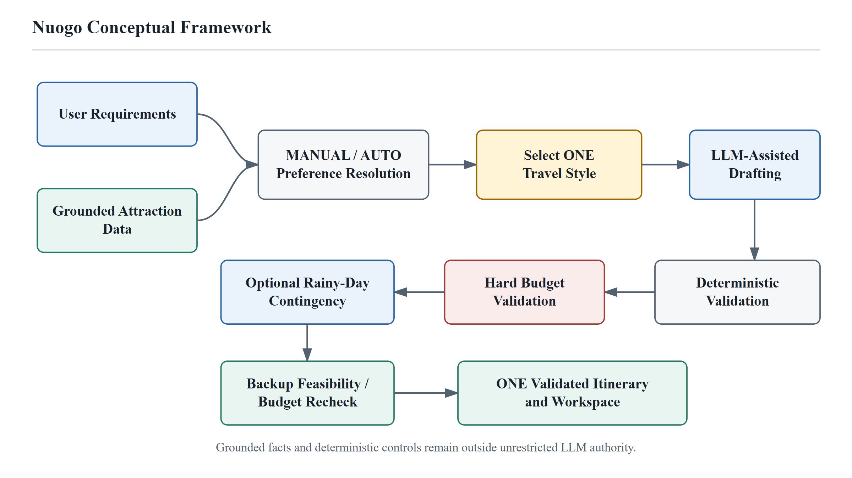
Figure 2.1 Proposed Conceptual Framework of Nuogo
Source: Developed by the author.

2.5 Conclusion
This chapter reviewed the literature and technologies that justify the simplified Nuogo design. Tourism recommender systems support preference-aware recommendations, LLMs provide flexible itinerary drafting, external retrieval improves factual support, and deterministic validation provides a practical control boundary for hard constraints.
The comparison with existing travel platforms confirms that Nuogo does not need to compete with commercial systems on booking breadth, real-time data, or route optimisation. Its focused contribution is the combination of grounded attraction support, user-selected Travel Style, one validated LLM-assisted itinerary, budget control, transparent source information, and optional rainy-day contingency planning for the three pilot cities.
CHAPTER 3
RESEARCH METHODOLOGY

3.1 Introduction
This chapter explains the research and system-development methodology used to design and implement Nuogo. It begins by linking the research questions and research objectives defined in Chapter 1, followed by the quantitative descriptive research approach, target population and sampling, Google Forms data collection, descriptive data-analysis procedure, stakeholder survey findings, and the validity, reliability, and ethics of the requirement study. It then presents the Hybrid Agile-Waterfall development process, planning, system requirements, system design, budget-reference approach, user interface, and evaluation strategy.

3.2 Methodology
Nuogo uses an applied system-development methodology supported by a quantitative descriptive requirement-gathering study. The questionnaire component is used to identify and prioritise stakeholder needs, while the Hybrid Agile-Waterfall approach guides the design, implementation, testing, and refinement of the software system. Treating these as connected but distinct methodological components allows the project to explain both how user evidence was collected and how the resulting requirements were translated into a working LLM-assisted travel-planning application.
The quantitative component is descriptive rather than hypothesis-testing: frequencies and percentages are used to summarise questionnaire responses and relate them to the research objectives and system requirements. The development component combines structured early-stage planning with iterative Agile implementation. Yahya and Maidin (2022) describe hybrid software development as the combination of traditional plan-driven and Agile practices, while Mishra and Alzoubi (2023) discuss the practical value of selecting structured and iterative practices according to project needs. Figure 3.1 summarises the Hybrid Agile-Waterfall process used for Nuogo.
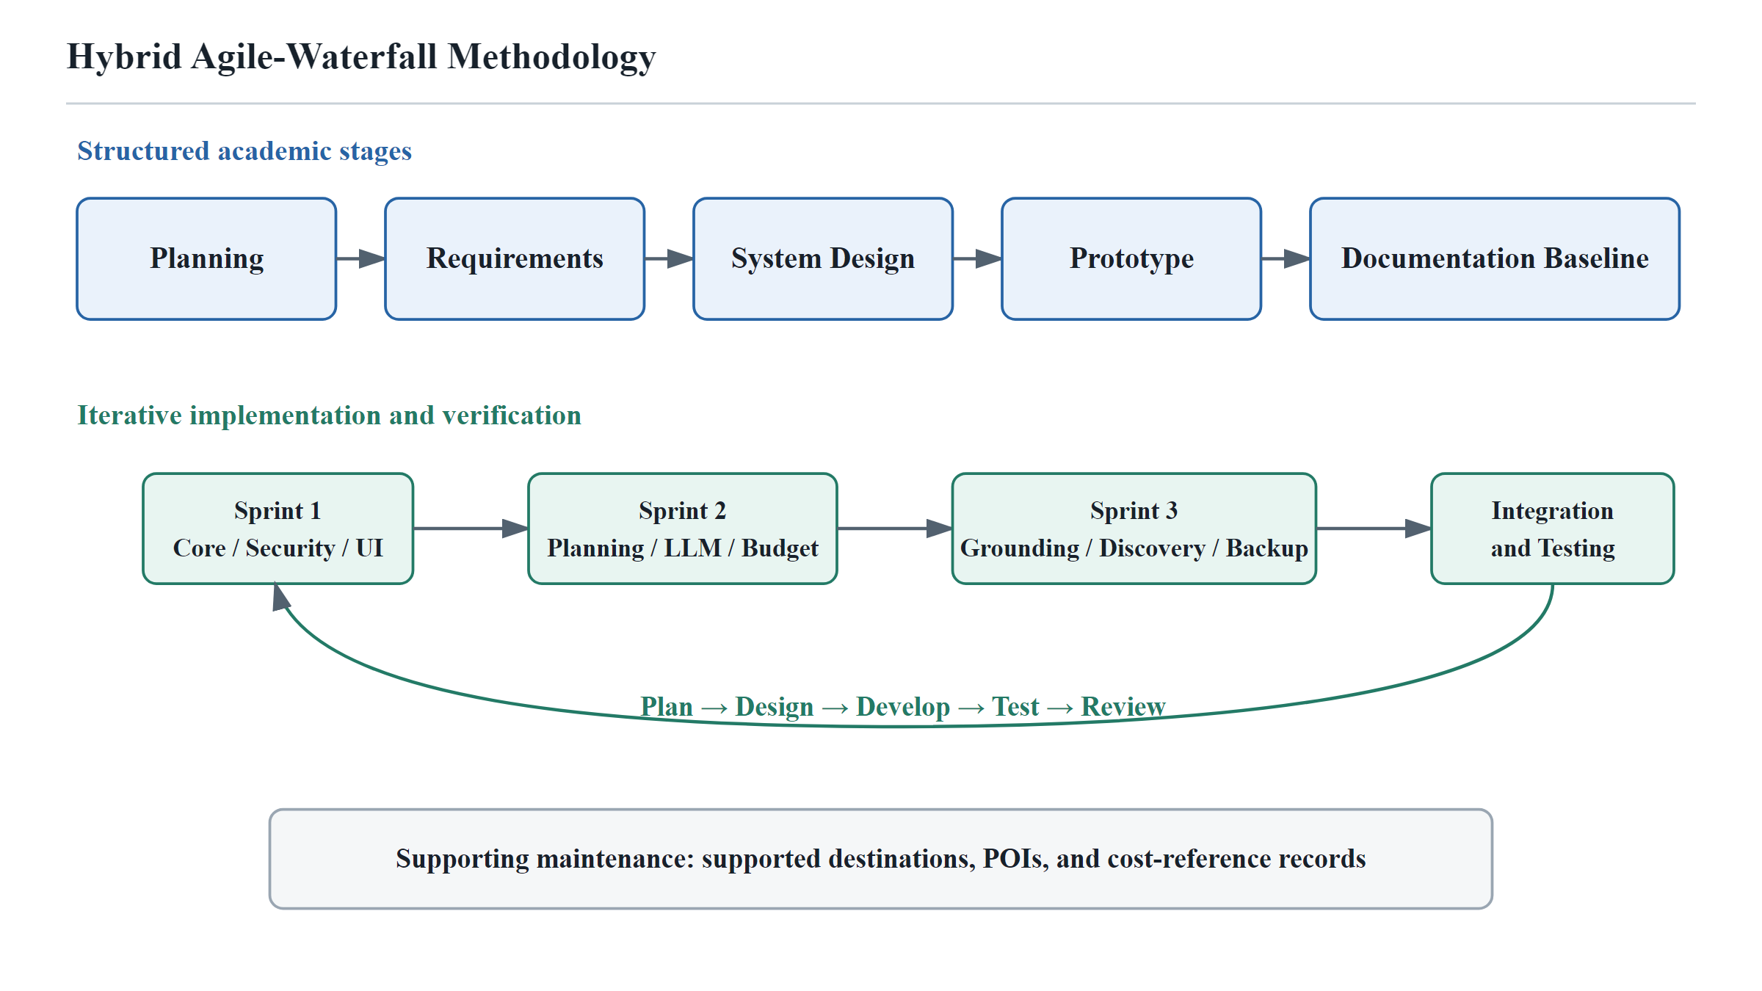
Figure 3.1 Hybrid Agile-Waterfall Methodology for Nuogo
Source: Developed by the author.

3.2.1 Alignment of Research Questions and Research Objectives
The research questions and objectives are defined in Sections 1.3 and 1.4. Their one-to-one alignment keeps the methodology, software requirements, system design, and evaluation focused on the three core project problems.
RQ1 aligns with RO1 by addressing the need for a single web-based workflow that collects essential travel requirements, supports attraction discovery, and allows users to manage generated itineraries.
RQ2 aligns with RO2 by addressing personalised, budget-aware LLM itinerary generation according to a selected Travel Style, together with optional rainy-day backup alternatives and deterministic validation.
RQ3 aligns with RO3 by addressing OpenTripMap-supported attraction grounding so that the LLM does not act as the sole source of attraction information.
This alignment is used as the basis for requirement traceability and the fixed-scenario evaluation described later in this chapter.

3.2.2 Research Approach and Design
The stakeholder requirement study adopts a quantitative descriptive approach. A structured questionnaire is used to collect numerical responses about travel-planning difficulties and desired system functions. The purpose of the survey is exploratory requirement elicitation rather than causal inference or hypothesis testing. Therefore, the analysis focuses on frequencies, percentages, and patterns of agreement rather than t-tests, ANOVA, chi-square tests, regression, or other inferential techniques.
The software-development component is an applied design-and-development activity guided by the Hybrid Agile-Waterfall methodology. The Waterfall-oriented activities provide documented planning, requirements, architecture, and prototype preparation, while Agile iterations are used to implement, test, review, and refine the system. This design is appropriate for an FYP because it combines evidence-based requirement identification with the controlled construction and evaluation of a working software artefact.

3.2.3 Population and Sampling
The target population for the questionnaire consists of potential users of web-based travel-planning systems, including students, employed adults, self-employed respondents, and other travellers who may need assistance when organising a trip. The study did not use a probability sampling frame for the wider traveller population; the collected respondents are therefore treated as a non-probability convenience sample for exploratory FYP requirement gathering.
Part A obtained up to 35 demographic responses, while the number of valid responses for individual Part B statements ranged from 28 to 30 because not every respondent answered every item. The sample is sufficient for identifying indicative stakeholder preferences for the prototype, but it is not used to claim statistical representativeness of all travellers. This limitation is particularly important because the respondents were geographically concentrated in Malaysia.

3.2.4 Data Collection Methods
Primary data were collected using a structured Google Forms questionnaire. Part A gathered demographic information, while Part B used ten five-point Likert-scale statements to measure respondents' views on travel-planning difficulty, integrated planning, personalised itinerary generation, budget control, three itinerary alternatives, cost breakdowns, externally supported attraction information, information-source transparency, itinerary management, and security/privacy. Supporting system requirements were also informed by the literature review, official platform and API documentation, and the comparison of existing travel-planning systems presented in Chapter 2.

3.2.4.1 Stakeholder Requirement Questionnaire
A stakeholder requirement-gathering questionnaire was conducted using Google Forms to obtain feedback from potential users before finalising the main functional and non-functional requirements of Nuogo. The questionnaire contained two parts. Part A collected demographic information, including age, gender, education, occupation, monthly personal income, country of residence, and current area of residence. Part B contained ten requirement statements rated using a five-point Likert scale, where 1 represented Strongly Disagree and 5 represented Strongly Agree. The requirement statements focused on travel-planning effort, integrated planning, personalised itinerary generation, budget control, three itinerary alternatives, estimated cost breakdowns, externally supported attraction information, source labels, itinerary management, and protection of personal and travel data.
The questionnaire received up to 35 responses in Part A, while the number of valid responses for individual Part B statements ranged from 28 to 30 because several respondents did not answer every item. The analysis therefore uses the valid response count shown by Google Forms for each question. Part A is used to describe the respondent profile, while Part B is analysed according to the findings that are most important to the design requirements and objectives of Nuogo.

3.2.5 Data Analysis Procedure
The Google Forms responses were reviewed in spreadsheet form before interpretation. The analysis followed a descriptive procedure because the questionnaire was designed to support requirement elicitation rather than statistical hypothesis testing.
First, the valid response count for each item was identified so that missing responses were not incorrectly treated as negative answers. Second, frequencies and percentages were used to summarise demographic categories and the five Likert response options. Third, Agree and Strongly Agree responses were combined when reporting the proportion of respondents who positively supported a proposed requirement. Fourth, the most important findings were grouped into four themes: integrated travel planning; personalised itineraries and budget support; external information and source transparency; and itinerary management, security, and privacy. Finally, these findings were mapped back to Objectives 1, 2, and 3 and to the functional and non-functional requirements in Section 3.5.
Inferential techniques such as t-tests, ANOVA, chi-square tests, correlation, and regression were not applied. The questionnaire used a small non-probability sample and was not designed to compare population groups or test causal relationships. Descriptive statistics are therefore more appropriate for summarising what the collected stakeholder data show.

3.2.6 Stakeholder Survey Findings and Requirement Analysis

3.2.6.1 Respondent Profile
Table 3.1 Respondent Demographic Profile
Variable | Valid n | Summary of Responses
Age group | 35 | 18-24: 25.7%; 25-34: 20.0%; 35-44: 25.7%; 45-54: 17.1%; 55+: 8.6%; below 18: 2.9%
Gender | 34 | Male: 52.9%; Female: 47.1%
Highest education | 35 | Bachelor's degree: 48.6%; Diploma/Foundation: 20.0%; Master's degree: 20.0%; Secondary or below: 8.6%; Doctoral degree: 2.9%
Occupation | 34 | Student: 38.2%; Employed: 32.4%; Self-employed: 23.5%; Unemployed: 2.9%; Retired: 2.9%
Monthly personal income | 35 | RM3,000-RM4,999: 31.4%; No personal income: 14.3%; Below RM1,500: 11.4%; RM1,500-RM2,999: 11.4%; RM5,000-RM7,999: 11.4%; RM8,000+: 8.6%; Prefer not to say: 11.4%
Country of residence | 35 | Malaysia: 77.1%; Singapore: 17.1%; China: 2.9%; Korea: 2.9%
Area of residence | 34 | Urban: 58.8%; Suburban: 26.5%; Rural: 8.8%; Prefer not to say: 5.9%
The demographic findings are used mainly to describe the respondent background rather than to justify individual system functions. Respondents aged 18-44 formed the largest combined age group at 71.4% of the 35 age responses. Gender was almost evenly distributed among the 34 valid responses, with 52.9% male and 47.1% female. Nearly half of the respondents held a Bachelor's Degree (48.6%), while the largest occupation groups were students (38.2%) and employed respondents (32.4%). These figures show that the questionnaire included respondents with different educational and working backgrounds.
The geographical profile is important when interpreting the findings. Malaysia accounted for 77.1% of the 35 country-of-residence responses, while 58.8% of respondents lived in urban areas and 26.5% in suburban areas. Therefore, the questionnaire is useful for validating the proposed Nuogo requirements, but it should not be treated as statistically representative of all travellers in China or the global travel population.

3.2.6.2 Requirement Survey Findings and Analysis
The following analysis does not treat every questionnaire statement as equally important. Instead, it focuses on the findings that are most closely related to Nuogo's problem statements, objectives, and core system requirements. The percentages are calculated from the valid responses shown in Google Forms for each item.

3.2.6.2.1 Travel-Planning Difficulty and Need for an Integrated System
The first two statements establish the practical need for Nuogo. For Question 1, 90.0% of the 30 respondents selected Agree or Strongly Agree that searching for travel information across different websites or applications is time-consuming. Question 2 produced the same 90.0% combined agreement for the usefulness of one system to organise different parts of travel planning. These findings support the core problem addressed by Nuogo: travel planning can become fragmented when users need to search, compare, and organise information across several sources.
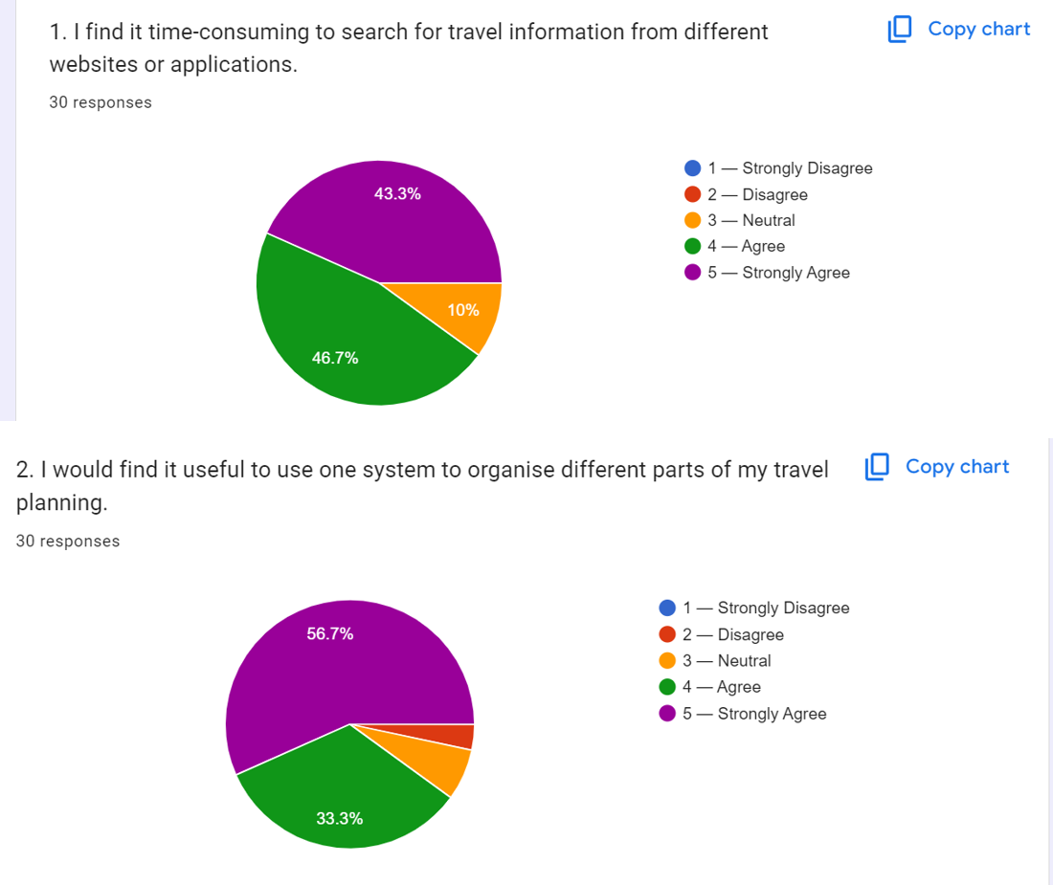
Figure 3.2 Google Forms Results on Travel-Planning Difficulty and Integrated Planning
Source: Google Forms stakeholder questionnaire.

3.2.6.2.2 Personalised Itinerary, Budget Control, and Travel-Style Choice
The findings most directly related to RO2 are especially strong. Question 3 showed that 96.7% of respondents agreed or strongly agreed that the system should generate an itinerary based on destination, travel dates, and trip duration. Question 4 showed 90.0% agreement that the generated itinerary should remain within the user's total travel budget. Question 6 also supported clear travel-cost breakdowns. These findings justify personalised itinerary generation with explicit budget control.
Question 5 showed that 93.1% of the 29 valid respondents supported having Budget-Saving, Balanced, and Comfort-Focused options. To retain this stakeholder preference while responding to supervisor feedback that the system should be simpler, Nuogo keeps the three options as selectable Travel Styles. The user chooses one style before generation, and the system produces one itinerary for that request instead of generating and comparing three complete itineraries at the same time. This preserves personalisation while reducing generation, validation, interface, and evaluation complexity.
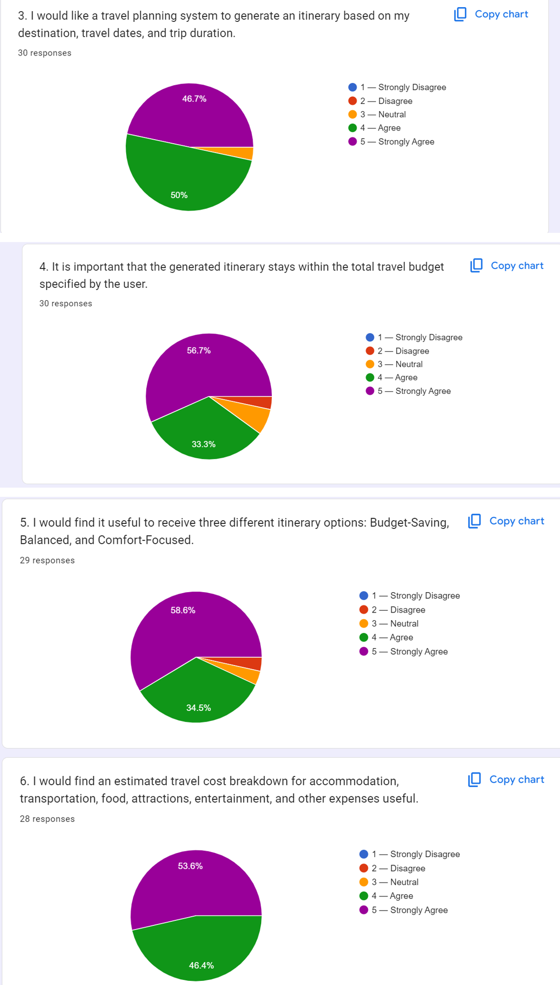
Figure 3.3 Google Forms Results on Personalised Itineraries, Budget Control, and Travel-Cost Support
Source: Google Forms stakeholder questionnaire.

3.2.6.2.3 External Travel Information and Source Transparency
The responses also strongly support RO3. For Question 7, 96.7% of respondents agreed or strongly agreed that tourist attractions recommended by an AI travel-planning system should be supported by information from an external travel-information source. This result supports the use of OpenTripMap to provide destination-specific attraction and point-of-interest data before itinerary generation.
Question 8 showed 93.3% positive agreement that the system should clearly show whether information is externally sourced, AI-generated, or estimated. This finding supports Nuogo's verified-information boundary and the decision to display source and verification labels instead of presenting OpenTripMap data, AI-generated explanations, database-backed records, and system-generated estimates as if they have the same verification status.
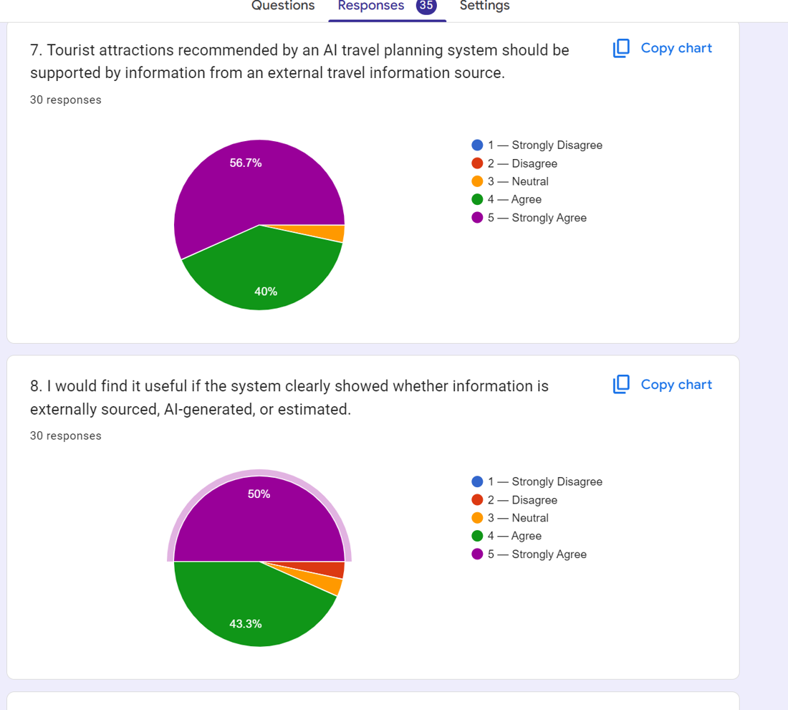
Figure 3.4 Google Forms Results on External Information Support and Source Transparency
Source: Google Forms stakeholder questionnaire.

3.2.6.2.4 Itinerary Management, Security, and Privacy
Question 9 received 100% positive agreement from 30 respondents for the ability to edit, save, and regenerate generated itineraries when travel preferences change. This shows that users do not only value itinerary generation; they also expect continued control over the generated plan. The result supports the itinerary-management functions included in Nuogo.
Question 10 showed that 96.7% of respondents agreed or strongly agreed that an LLM-assisted travel-planning system should protect users' personal information and travel data. This is one of the most important findings for RO1 because it supports the inclusion of authentication, access control, input validation, API-key protection, privacy controls, secure logging, data deletion, and prompt-injection protection.
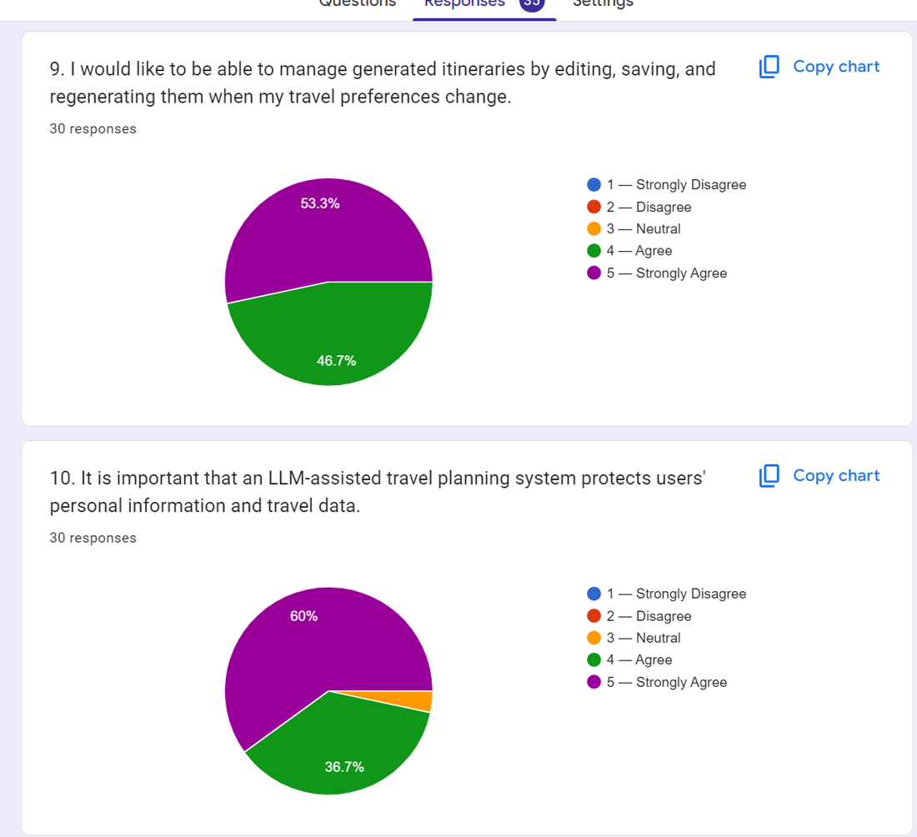
Figure 3.5 Google Forms Results on Itinerary Management, Security, and Privacy
Source: Google Forms stakeholder questionnaire.
Overall, the questionnaire supports the simplified Nuogo design. The responses support an integrated planning workflow, personalised itinerary generation, budget control, the availability of three Travel Styles, externally supported attraction information, source transparency, itinerary management, and protection of user data. The final MVP retains these needs but narrows how they are implemented so that the project remains feasible and explainable.

3.2.7 Validity, Reliability and Ethics

3.2.7.1 Validity
Content validity is supported by aligning the questionnaire items with the project problems, RQs, ROs, and proposed requirements. The Part B items cover planning effort, integrated planning, personalisation, budget compliance, three user-selectable Travel Styles, cost transparency, external attraction support, source transparency, itinerary management, and protection of user data. The revised system design interprets the three-option item as a travel-style choice rather than a requirement to generate three full itineraries simultaneously.

3.2.7.2 Reliability
Procedural consistency is supported by using the same structured Google Forms questionnaire and the same five-point Likert response scale for all respondents. However, the questionnaire is not treated as a single psychometric scale because the ten statements measure different system requirements rather than one underlying construct. Accordingly, the report does not claim internal-consistency reliability through Cronbach's alpha or similar coefficients. The results are used as indicative requirement evidence and are interpreted together with the project scope and literature review.

3.2.7.3 Research Ethics
The questionnaire is used only for academic requirement gathering, and the report presents aggregated results rather than publishing individual response rows or participant names. Participation is treated as voluntary, and respondents were able to leave some items unanswered, as reflected by the different valid response counts. The analysis avoids fabricating, altering, or removing data merely to improve the appearance of the findings. Confidentiality, honest reporting, and minimisation of unnecessary personal information are maintained throughout the reporting process.
Any AI-assisted research or writing tool used during project preparation should support rather than replace the researcher's judgement. Facts, quotations, and citations must be independently checked, and any required university disclosure or AI-use policy must be followed before final submission.

3.2.8 System Development Methodology
The system-development methodology uses a Hybrid Agile-Waterfall model. Structured planning, requirement analysis, system design, and prototype preparation are completed before the major implementation work, while Agile iterations are used to develop, test, review, and refine the software. This approach was selected because the FYP requires stable academic documentation and milestones while the LLM integration, OpenTripMap grounding, budget logic, validation pipeline, localisation, and user interface benefit from repeated implementation and testing.

3.2.8.1 Agile Iterative Cycle
Each Agile development sprint follows five repeated activities: Plan, Design, Develop, Test, and Review. Planning identifies the functions to be completed in the sprint. Design prepares the relevant interface, data, API, and validation logic. Development implements the planned functions. Testing verifies both expected behavior and failure conditions. Review evaluates the sprint result and identifies improvements before the next iteration. This cycle is particularly important for Nuogo because LLM-assisted planning, external API integration, budget validation, and information-source labelling require repeated testing rather than a single implementation pass.
Table 3.2 Agile Iterative Cycle Used in Nuogo
Step | Application in Nuogo
Plan | Identify sprint objectives, features, risks, acceptance criteria, and test cases.
Design | Prepare interface flow, service boundaries, schemas, database interactions, validation rules, and API contracts.
Develop | Implement the planned React, Node.js/Express, MySQL, OpenTripMap, OpenRouter, and validation functions.
Test | Run unit, API, integration, security, budget, localization, and browser workflow tests as applicable.
Review | Inspect test results and user experience, correct defects, and refine the next iteration.

3.2.8.2 System Design and Prototype Preparation
After the initial requirements are identified, the System Design phase defines the technical structure and operation of Nuogo. The design covers the system architecture, database structure, user interface, major modules, system workflow, security boundaries, external API interactions, LLM-generation process, validation pipeline, and information-provenance rules. Preparing these design components before full implementation helps ensure that the research objectives, stakeholder requirements, and MVP boundaries are translated into a consistent technical plan.
Prototype preparation is carried out alongside system design to provide an early representation of the intended user experience. The prototype demonstrates the main planning flow, including authentication, destination and attraction discovery, travel-preference input, travel-style selection, presentation of the generated itinerary, budget information, map interaction, optional rainy-day backup, and itinerary-management actions. The prototype is used to identify interface and workflow issues before the implementation is finalised during FYP 2.

3.2.8.3 Agile Iterative Development
During FYP 2, Nuogo is implemented through an Agile iterative development approach consisting of three main development sprints. Each sprint develops a related group of functions and repeats the Plan, Design, Develop, Test, and Review cycle. This approach allows security controls, LLM integration, selected travel-style itinerary generation, OpenTripMap grounding, budget logic, localisation, and itinerary validation to be progressively implemented and refined rather than being integrated only at the end of the project.

3.2.8.3.1 Sprint 1: Core System Setup
Sprint 1 establishes the core web application and security foundation. The sprint focuses on the frontend application structure, user registration and login, authentication, profile management, protected routes, client-side and server-side input validation, server-side API-key handling, basic security configuration, and the initial user-interface components. Completing these functions first provides the authenticated application framework required by later travel-planning modules.

3.2.8.3.2 Sprint 2: Intelligent Travel Planning
Sprint 2 focuses on the core intelligent planning workflow. The main activities are essential preference collection, travel-style selection, OpenRouter/DeepSeek integration, generation of one structured itinerary, budget estimation, and core output validation. This sprint deliberately avoids simultaneous three-itinerary generation so that the LLM workflow remains testable and manageable.

3.2.8.3.3 Sprint 3: Grounded Travel Information and Integration
Sprint 3 integrates OpenTripMap attraction grounding, destination discovery, manual or automatic attraction selection, map presentation, optional rainy-day backup alternatives, itinerary management, and final end-to-end integration. Rainy-day alternatives use grounded attraction candidates and do not require a live weather API.

3.2.8.4 Integration and System Testing
After the three development sprints are completed, the modules are integrated and evaluated as a complete Nuogo system. Integration testing verifies authentication, essential preference collection, OpenTripMap retrieval, travel-style selection, OpenRouter generation, core validation, budget calculation, source labelling, optional rainy-day backup, map display, and itinerary management.
Testing and evaluation cover both conventional software quality and the quality of the LLM-assisted travel-planning process. Testing is performed during Agile iterations and again after integration so that defects in authentication, APIs, budgeting, grounding, localisation, itinerary generation, validation, and browser workflows can be identified before final evaluation.

3.2.8.4.1 Functional Testing
Functional testing verifies the major user workflow: registration/login, destination discovery, preference submission, manual or automatic attraction selection, travel-style selection, optional rainy-day backup, one-itinerary generation, validation, budget calculation, map display, source labels, and itinerary-management actions.

3.2.8.4.2 API and Failure Testing
API testing evaluates communication with OpenTripMap and OpenRouter. Test cases include successful responses, malformed or invalid responses, unavailable services, request timeouts, empty attraction data, unsupported destinations, zero validated candidate pools, and malformed LLM output. The system should provide controlled failure or repair behaviour instead of displaying incomplete or unvalidated results. Mock/demo verification and genuine live integration verification are reported separately.

3.2.8.4.3 Security Testing
Security testing evaluates authentication, JWT/session expiry handling, role-based access control, cross-user data-access prevention, client-side and server-side input validation, API-key protection, prompt-injection handling, secure logging, and data deletion. Test cases include invalid login attempts, expired authentication, unauthorised protected-route access, attempts to access another user's itinerary, malformed user inputs, and prompt-injection attempts.

3.2.8.4.4 Usability Testing
User Acceptance Testing and usability evaluation assess interface clarity, ease of destination discovery and preference entry, clarity of the selected Travel Style, readability of the generated itinerary, usefulness of budget information, understandability of source labels, usefulness of rainy-day backup options, map interaction, and itinerary-management actions.

3.2.8.4.5 Performance and Response-Time Testing
Response time is measured for major interactive operations, particularly attraction retrieval and validated itinerary generation. Fixed scenarios record the time from submission of requirements until one validated itinerary or a controlled failure result is returned.

3.2.8.4.6 Budget Evaluation
Nine fixed travel scenarios are used for budget evaluation: three pilot cities multiplied by the three selectable Travel Styles. Each scenario uses a predefined hard budget, and the generated itinerary must not exceed it. At least one scenario per city enables rainy-day backup so that contingency choices can also be checked without adding their unused alternative cost to the main itinerary total.

3.2.8.4.7 LLM Output-Quality Evaluation
Table 3.3 LLM Output Evaluation Metrics and Acceptance Criteria
Metric | Measurement | Acceptance
Constraint Satisfaction Rate | Satisfied mandatory constraints / total mandatory constraints x 100% | >= 95%
Completeness Rate | Populated required itinerary fields / total required itinerary fields x 100% | 100%
Factual Support Rate | OpenTripMap-supported attraction activities / total attraction activities requiring grounding x 100% | 100%
Duplication Rate | Repeated attractions / total attractions x 100% | 0%
Budget Compliance Rate | Generated itineraries within the hard user budget / total generated itineraries x 100% | 100%
Schedule Feasibility Rate | Valid itinerary days / total itinerary days x 100% | 100%
Preference and Travel-Style Alignment | Satisfied applicable preferences and selected-style criteria / total applicable criteria x 100% | >= 80%
Rainy-Day Backup Validity | Valid displayed rainy-day backups / total displayed rainy-day backups x 100% | 100% when backup is enabled
Human Usefulness | Average participant rating using a 5-point usefulness scale | >= 4.0 / 5
The LLM-assisted itinerary process is evaluated using nine fixed scenarios: Beijing, Shanghai, and Xi'an are each tested once with Budget-Saving, Balanced, and Comfort-Focused Travel Styles. The scenarios vary duration, budget, travellers, interests, and preferred attractions. The LLM is evaluated as a drafting component, while grounding and budget validity are checked deterministically.
The evaluation measures constraint satisfaction, completeness, factual support, duplication, budget compliance, schedule feasibility, preference/travel-style alignment, rainy-day backup validity, and human-rated usefulness. A generated result is counted as successful only after the required deterministic checks pass.

3.2.8.4.8 Travel-Style, Rainy-Day Backup, and Localization Testing
Travel-style testing verifies that the selected Budget-Saving, Balanced, or Comfort-Focused mode influences the planning choices without violating the hard total budget. The system is not required to generate three plans simultaneously. Rainy-day backup testing verifies that any displayed contingency attraction is grounded, in the same pilot city, not duplicated in the main itinerary, suitable as an indoor or less weather-sensitive alternative where category information permits, and not double-counted in the main budget total. Chinese and English presentation are tested separately so that user-facing labels remain consistent.

3.2.8.5 Deployment
After integration and the required system testing, Nuogo is prepared for deployment and demonstration. The frontend, backend, MySQL database, OpenTripMap connection, OpenRouter connection, environment configuration, security settings, and required runtime services are checked to ensure that the major components operate correctly in the deployment environment. Live external-service verification is reported separately from mock or demo verification so that unavailable credentials or unexecuted checks are not incorrectly reported as successful live integrations.

3.2.8.6 Documentation and Final Submission
The documentation activity records the implemented system functions, architecture, database design, user interface, methodology, technologies, testing and evaluation results, operating procedures, and system limitations. Traveller and authorised-maintainer guidance is prepared where required. The final submission then brings together the completed Nuogo system, source code, final report, presentation slides, demonstration materials, and other required supporting artefacts for project assessment.

3.2.9 Research and Development Tools
Several tools support the research, documentation, and development activities described in this chapter. Google Forms is used to distribute the stakeholder questionnaire and collect responses. Google Sheets or Excel is used to review response data and calculate descriptive frequencies and percentages for the small dataset. Draw.io is used to prepare system diagrams such as the methodology diagram, WBS, use case diagram, workflow, and final ERD where applicable. Visual Studio Code is used for software implementation, while Git and GitHub support version control, change tracking, and project backup. Microsoft Word is used to prepare and organise the final report and its tables, figures, and references.
These tools support the research and engineering process but do not replace methodological judgement. Survey results are interpreted according to the research objectives and limitations, diagrams must reflect the implemented system, and external facts or citations must be verified against appropriate sources before final submission.

3.3 Planning
The Planning phase defines the development activities, sequence, timeline, and work packages required to complete Nuogo. It ensures that the project remains aligned with the FYP schedule and that the security, LLM integration, travel-information grounding, budget logic, validation pipeline, user interface, and testing tasks are completed in a controlled order. The detailed milestones and deliverables are presented in Chapter 1, while this section focuses on the Work Breakdown Structure, project schedule, and Gantt Chart used to manage implementation.

3.3.1 Work Breakdown Structure (WBS)
The Work Breakdown Structure is simplified to match the revised MVP. The development work focuses on research and scope definition, requirements, system design, the core grounded LLM-planning workflow, testing/evaluation, and documentation. Advanced real-time travel services and simultaneous three-itinerary generation are not included as separate work packages.
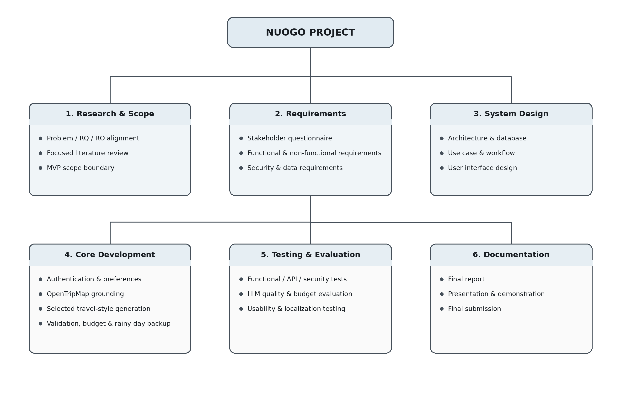
Figure 3.6 Nuogo Work Breakdown Structure
Source: Developed by the author.

3.3.2 Project Schedule
The Nuogo project is scheduled from 6 July 2026 to 5 March 2027. FYP 1 focuses on project planning, requirement analysis, literature review, system design, stakeholder requirement gathering, and prototype preparation. FYP 2 focuses on implementation through three main Agile sprints: Core System Setup, Intelligent Travel Planning, and Grounded Travel Information and Integration. The later stages integrate all modules, perform system and user testing, prepare deployment, complete documentation, and prepare the final demonstration and submission.
The schedule also reflects dependencies between tasks. Authentication and input validation are completed before advanced itinerary generation. Travel preference collection and LLM integration are developed before full OpenTripMap grounding and itinerary validation. Integration and testing are performed after the main modules are connected so that security, API failure handling, budget compliance, factual support, schedule feasibility, localization, and itinerary-management workflows can be evaluated together.

3.3.3 Gantt Chart
The Gantt Chart provides a time-based view of the major project activities and their planned sequence across FYP 1 and FYP 2.
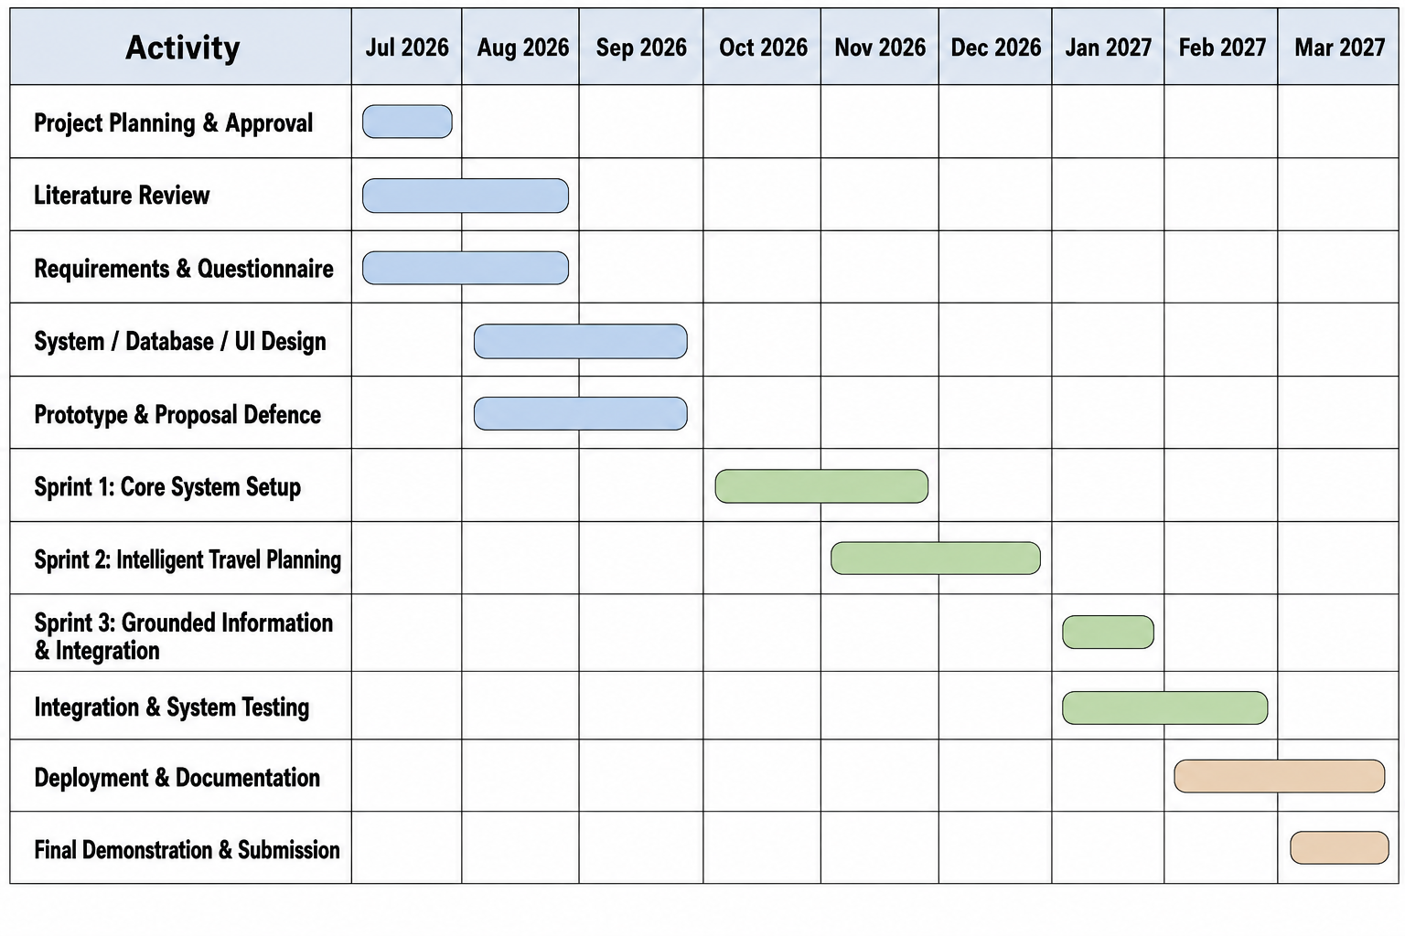
Figure 3.7 Project Gantt Chart
Source: Developed by the author.

3.4 Hardware Requirement
Nuogo is a web-based application and does not require specialised user hardware. A standard desktop computer, laptop, tablet, or smartphone with an Internet connection and a modern web browser can be used to access the system. Development and local testing require a computer capable of running the React/Vite frontend, Node.js/Express backend, MySQL database, browser-based testing tools, and the selected development environment. External LLM and OpenTripMap processing is accessed through APIs, so no dedicated local GPU is required for the minimum viable product.
Table 3.4 Hardware Requirements
Hardware item | Requirement
End-user device | Desktop, laptop, tablet or smartphone capable of running a modern web browser.
Network | Stable Internet connection for the web application and external API communication.
Development computer | Computer capable of running VS Code, Node.js, React/Vite, MySQL, browser tools, and automated tests.
Specialised AI hardware | Not required for the MVP because DeepSeek V3.1 is accessed through OpenRouter rather than executed locally.

3.5 Software Requirement
The software requirements define what Nuogo must do and the quality conditions under which the system should operate. The requirements are derived from the research objectives, scope, literature review, stakeholder survey, and system design. Functional requirements describe the services provided to travellers and authorised maintainers, while non-functional requirements define security, reliability, usability, performance, maintainability, transparency, and compatibility expectations.

3.5.1 Functional Requirement
Table 3.5 Functional Requirements of Nuogo
ID | Requirement | Description
FR1 | User account and authentication | The system shall support registration, login, logout, profile management, and authenticated access to protected functions.
FR2 | Essential travel preference collection | The system shall collect destination, travel dates, total budget, traveller count, interests, preferred attractions, selected Travel Style, and the optional rainy-day backup choice.
FR3 | Destination discovery | The system shall retrieve and display OpenTripMap-supported attractions for Beijing, Shanghai, and Xi'an.
FR4 | Attraction selection | The system shall support manual preferred-attraction selection and automatic recommendation from the grounded candidate pool.
FR5 | Input and prompt-injection validation | The system shall validate malformed or unsafe user input before protected processing or LLM submission.
FR6 | Travel-style selection | The user shall select Budget-Saving, Balanced, or Comfort-Focused before generation; one itinerary shall be generated per request.
FR7 | LLM-assisted itinerary generation | The system shall use OpenRouter/DeepSeek V3.1 to produce one structured day-by-day itinerary using validated requirements and allowed attraction candidates.
FR8 | Rainy-day backup | When enabled, the system shall provide grounded indoor or less weather-sensitive alternatives for selected outdoor activities without using live weather monitoring.
FR9 | Itinerary validation and controlled repair | The system shall check required structure, attraction grounding, dates, duplicates, required fields, and budget, and shall allow one controlled repair/regeneration attempt before failure.
FR10 | Budget estimation | The system shall calculate planning estimates from maintained reference data and display total cost, category breakdowns, remaining budget, and CNY values.
FR11 | Source and estimate labels | The system shall distinguish user input, OpenTripMap-supported attraction data, AI-generated itinerary content, and estimated costs.
FR12 | Map display | The system shall display supported attraction locations as map markers; live navigation is not provided.
FR13 | Itinerary management | The system shall allow users to view, edit, save, regenerate, and delete itineraries.
FR14 | Supporting maintenance | Authorised maintenance functions shall support updates to supported destinations, POIs, and cost-reference records without making administration a core research contribution.

3.5.2 Non-Functional Requirement
Table 3.6 Non-Functional Requirements of Nuogo
ID | Quality area | Requirement
NFR1 | Security | Passwords shall be hashed; protected routes shall require authenticated access; role-based authorization shall prevent cross-user and unauthorized administrator access; API keys shall remain server-side.
NFR2 | Privacy | Only necessary travel-planning data shall be sent to the LLM; users shall be informed about stored data and shall be able to delete relevant account/itinerary data.
NFR3 | Reliability | Invalid LLM output, API failures, unsupported attractions, or failed constraints shall result in one controlled repair/regeneration attempt or a user-facing failure message rather than an unvalidated itinerary.
NFR4 | Data transparency | Displayed facts, estimates, and AI-generated content shall carry source/verification labels and OpenTripMap matching shall not be described as guaranteed real-time verification.
NFR5 | Usability | The interface shall support clear preference entry, attraction discovery, travel-style selection, optional rainy-day backup, readable itinerary details, budget information, source labels, and map interaction.
NFR6 | Performance | The system should return API data and generated itineraries within a practical response time for interactive web use; response time shall be measured during evaluation.
NFR7 | Maintainability | Frontend, backend, provider, validation, budgeting, and persistence responsibilities shall remain modular enough to test and modify independently.
NFR8 | Compatibility | The web application shall operate in modern desktop and mobile browsers with responsive presentation.
NFR9 | Localization | Chinese shall be supported as the default user-facing language and raw internal enum/developer labels shall not appear in the interface; English mode shall remain consistently English.
NFR10 | Budget correctness | Every generated itinerary shall satisfy estimatedTotalCost <= userTotalBudget. Travel-style targets are guidance for planning behaviour and do not override the hard budget ceiling.
Table 3.7 Requirement-to-Design Traceability Matrix
RQ / RO | Main Requirements | Design / Evidence
RQ1 / RO1 | FR1-FR5, FR13; NFR1-NFR5 | Authentication, preference interface, destination discovery, itinerary workspace, usability testing.
RQ2 / RO2 | FR6-FR10, FR13; NFR3, NFR5, NFR10 | Travel-style selection, LLM generation, rainy-day backup, validation/budget services, fixed-scenario evaluation.
RQ3 / RO3 | FR3, FR4, FR7, FR9, FR11; NFR4 | OpenTripMap grounding, source labels, grounded attraction checks, API/failure testing.
Supporting scope | FR12, FR14; NFR6-NFR9 | Map markers, maintenance utility, performance, maintainability, browser compatibility and localization testing.
The traceability matrix makes the simplified system easier to evaluate because each research question is connected to a small set of requirements and design evidence rather than to a large number of unrelated features.

3.6 System Design
The system design translates the validated requirements into a technical structure. Nuogo uses a layered web architecture that separates the presentation interface, application and security logic, tourism-information retrieval, LLM-assisted generation, validation and guardrails, and persistent data. The design also maintains an explicit information-provenance boundary so that externally sourced data, database-backed records, system estimates, and AI-generated content are not presented as equivalent forms of evidence.

3.6.1 Framework
Nuogo follows a simple controlled planning framework: Ground -> Select Travel Style -> Generate One Itinerary -> Validate -> Add Rainy-Day Backup if enabled -> Recheck Budget -> Display and Save. OpenTripMap provides the attraction candidate pool, the LLM assists with sequencing and personalised explanations, and deterministic services remain responsible for core validity and budget compliance. This shorter framework replaces the earlier multi-profile pre-planning and unrestricted repair concepts.

3.6.2 System Architecture
The simplified architecture keeps a conventional web structure. The traveller interacts with a React/Vite presentation layer. Node.js and Express coordinate authentication, essential preference processing, OpenTripMap grounding, LLM generation, validation, budget calculation, and rainy-day contingency logic. MySQL stores persistent application records and reference data. OpenTripMap and OpenRouter/DeepSeek V3.1 remain external services. Authorised maintenance of supported destinations, point-of-interest records, and cost-reference data is supporting functionality rather than a separate research module.
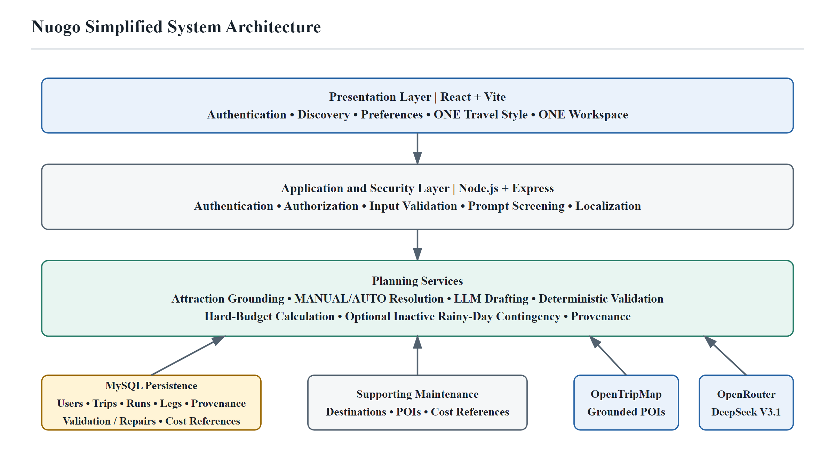
Figure 3.8 Nuogo Simplified System Architecture
Source: Developed by the author.

3.6.2.1 Presentation Layer
The Presentation Layer provides the traveller-facing web interface for authentication, destination discovery, essential preference entry, travel-style selection, optional rainy-day backup, itinerary presentation, budget summaries, map markers, and itinerary management. Protected supporting views allow authorised maintainers to update supported destinations, POIs, and cost-reference records.

3.6.2.2 Application and Security Layer
The Application and Security Layer handles authentication, authorisation, input validation, prompt-injection screening, secure API-key boundaries, preference processing, LLM orchestration, core validation, and controlled failure handling. The user-facing workflow is intentionally short so that these controls remain testable.

3.6.2.3 Supporting Service Layer
The Supporting Service Layer contains the main planning services: OpenTripMap attraction normalization and grounding, selected travel-style logic, budget estimation, rainy-day alternative selection, map/location preparation, itinerary persistence, and source-label preparation.

3.6.2.4 Data Layer
The Data Layer uses MySQL to store user accounts, essential travel preferences, generated and saved itineraries, cost-reference data, source metadata, and operational records required by the implemented system. The MVP generates one itinerary for each travel-style request, although multiple saved generation records may exist for the same user over time.

3.6.2.5 External Service Layer
The External Service Layer contains services that are outside the Nuogo application boundary. OpenTripMap provides the required destination-specific attraction and POI records for RO3, while OpenRouter provides controlled access to the selected DeepSeek model. Because these services can fail, time out, change, or return incomplete data, Nuogo includes explicit error handling and does not treat successful communication with an external service as proof that all returned content is current or complete.

3.6.2.6 Source, Provenance, and Verification Boundary
Nuogo distinguishes information according to both source and verification status. User-provided information includes the destination, dates, budget, number of travellers, selected attractions, and other preferences entered by the user. OpenTripMap API-sourced information includes attraction identifiers, names, categories, coordinates, and descriptions where available. Database-backed information includes saved records and authorised-maintainer reference values. AI-generated information includes itinerary sequencing, personalised explanations, and recommendation reasons. System-generated estimates include calculated travel costs and other values derived from predefined rules and reference data.
Table 3.8 Information Sources and Verification Meanings
Information category | Example | Meaning in Nuogo
User input | Dates, budget, traveller count, interests, selected Travel Style | Validated for format and required ranges, but not independently verified as real-world facts.
OpenTripMap-supported | Attraction ID, name, category and coordinates | Matched to an external OpenTripMap record; used as the grounding evidence for attraction selection.
AI-generated | Activity sequencing, itinerary explanations and recommendation reasons | Produced by the LLM and accepted only after the required deterministic checks.
Estimated cost | Accommodation, food, transport, attraction and other planning estimates | Calculated from maintained reference values and clearly presented as planning estimates rather than booking quotations.
Stored application record | Saved itinerary, user profile, cost-reference metadata | Persisted by Nuogo for application use; database storage does not itself make the content externally verified.
Currently verified, when available | Suitable current authoritative information | Used only when a current authoritative source genuinely supports the claim; not assumed for all OpenTripMap or cost-reference data.
User-provided information includes the destination, travel dates, budget, number of travellers, selected attractions, interests, arrival and departure information, and other preferences entered by the traveller. These inputs are validated for structure, range, and completeness where appropriate, but the system does not independently prove that every user-entered preference or travel fact is true.
API-sourced information includes OpenTripMap attraction identifiers, names, categories, coordinates, and descriptions where available. A successful match indicates that the attraction is supported by an external OpenTripMap record. This status does not guarantee that operating hours, prices, temporary closures, or availability are current.
Database-backed information includes stored user profiles, preferences, saved itinerary records, and authorised-maintainer cost-reference values. The database records provide persistence and traceability, while the collection date and last-updated date of cost references help users and authorised maintainers understand the age of the planning data.
AI-generated information includes activity sequencing, itinerary themes, recommendation explanations, and other natural-language content produced by the LLM. These items are labelled as AI-generated and are subject to the system validation boundary. System-generated estimates, including travel-cost calculations, are labelled as estimates rather than verified prices.
Only information obtained from a suitable current and authoritative source at the time of use may be described as currently verified. The current MVP therefore does not claim real-time verification of market prices, opening hours, live traffic, booking availability, or weather conditions.

3.6.3 System Modules and Functionalities
The simplified Nuogo MVP is explained through five core functional modules. This structure keeps the system understandable for implementation, testing, and presentation. Maintenance of supported destinations, POIs, and cost-reference data remains a supporting function and is not treated as a separate research contribution.
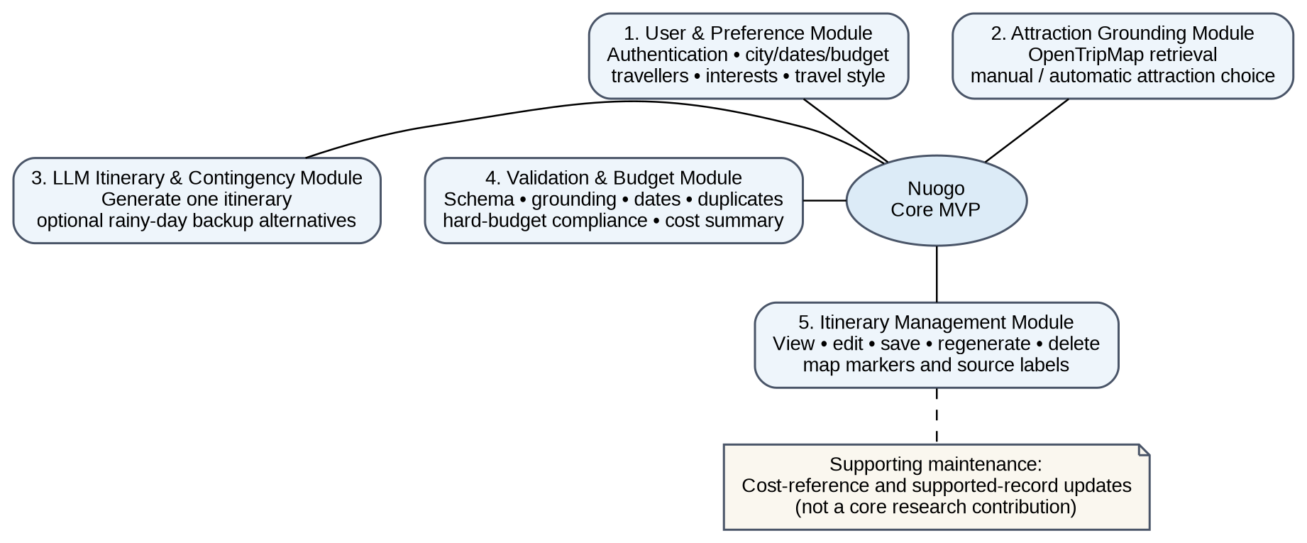
Figure 3.9 Simplified Nuogo System Modules and Functions
Source: Developed by the author.

3.6.3.1 User and Preference Module
The User and Preference Module combines the basic account and planning-input functions needed for the main user journey. It supports registration, login, profile handling, essential travel requirements, travel-style selection, optional rainy-day backup selection, and pre-generation input validation. Security controls such as password hashing, authenticated access, server-side API-key protection, and prompt-injection screening remain supporting requirements rather than separate user-facing features.
Table 3.9 Security, Privacy, and Data-Governance Controls
Requirement | Implementation in Nuogo
Password Protection | User passwords are hashed using bcrypt before storage. Plaintext passwords are not stored.
Authentication | JWT-based authentication protects authenticated functions. The Nuogo MVP does not use refresh tokens. When a JWT expires, the user must authenticate again through the normal login process before protected functions can be accessed.
Access Control | Authenticated access prevents cross-user access to protected itinerary data. Authorised maintenance access is limited to the supporting records required by the MVP.
API Key Protection | OpenRouter and OpenTripMap credentials are stored in server-side environment/configuration boundaries and are not exposed to client-side code.
Input Validation | Client-side and server-side validation reject malformed, incomplete, or invalid travel inputs before protected processing.
Prompt-Injection Protection | User-provided free text is treated as untrusted input, screened for suspicious prompt-injection patterns, and separated from system instructions.
Secure Logging | Application and security errors are recorded without intentionally logging passwords, API keys, authentication tokens, or LLM prompt/response content. Operational log retention is controlled by deployment policy; automated retention-period enforcement is outside the current MVP. A deployment may adopt a maximum 90-day policy subject to institutional requirements and configuration.
Data Deletion and Retention | User account, profile, travel-preference, and saved-itinerary data are retained while the corresponding account or record remains active and is required for the requested functions. Users can delete saved itineraries and account-related data through supported deletion workflows; associated records are removed according to the implemented database relationships and deletion procedures.
Privacy and Consent | Users are informed about profile and travel information stored or processed by Nuogo through the system privacy/consent mechanism.
External AI Data Minimisation | Only information required for itinerary generation is sent to the external LLM. Passwords, API keys, authentication tokens, and unrelated account information are excluded.
External LLM Data Retention | Nuogo requests eligible Zero Data Retention and no-data-collection routing for LLM requests. Account-level logging and platform configuration remain deployment settings that must be verified before live deployment; OpenRouter may still retain non-content operational metadata.

3.6.3.2 Attraction Grounding Module
The Attraction Grounding Module communicates with OpenTripMap to retrieve and normalise destination-specific attraction records for Beijing, Shanghai, and Xi'an. Users may select preferred attractions manually or allow automatic recommendation from the grounded candidate pool. The module records provider identifiers and supports map markers and attraction validation.

3.6.3.3 LLM Itinerary and Rainy-Day Contingency Module
The LLM Itinerary and Rainy-Day Contingency Module prepares a grounded prompt from the user's essential requirements, selected Travel Style, and allowed attraction candidates. DeepSeek V3.1 generates one structured day-by-day itinerary per request. When the rainy-day option is enabled, the module may attach a grounded indoor or less weather-sensitive alternative to selected outdoor activities. The feature does not query or monitor live weather.

3.6.3.4 Validation and Budget Module
The Validation and Budget Module is the control boundary after LLM drafting. It checks the required JSON/schema structure, attraction grounding, dates, duplicates, required fields, basic schedule consistency, and hard-budget compliance. If the draft fails, one controlled repair or regeneration attempt is allowed. A second failure produces a controlled user-facing error rather than an unvalidated itinerary. Budget estimates are calculated from maintained reference data and are not invented by the LLM.

3.6.3.5 Itinerary Management Module
The Itinerary Management Module presents the validated day-by-day plan, budget summary, source labels, and attraction map markers. Users can view, edit, save, regenerate, and delete itineraries. If a rainy-day alternative is displayed, its cost is not added to the main itinerary total unless the traveller actually replaces the original activity.

3.6.3.6 Supporting Maintenance Function
Authorised maintainers can manage supported destinations, point-of-interest records, and cost-reference data used by the planning system. This remains supporting application maintenance rather than a main research module. Advanced user administration, analytics, guide or agency management, booking, payments, and enterprise monitoring remain outside the core project contribution.

3.6.4 Database Design
The Nuogo database supports persistent user accounts, essential travel preferences, generated and saved itineraries, OpenTripMap-related attraction records, cost-reference data, and source metadata. The logical model may retain multiple saved generation records, but each generation request produces only one selected travel-style itinerary. Supporting maintenance records are stored only where required by the implemented MVP.
Figure 3.10 presents a logical Entity Relationship Diagram aligned with the frozen MVP persistence model. USER, TRIP, SUPPORTED_DESTINATION, CANONICAL_POI, COST_REFERENCE, ITINERARY_RUN, TRIP_LEG, and traceability records represent meaningful persistent data groups. Current travel preferences and nested itinerary days, activities, meals, transport details, and optional inactive Rainy-Day Backup information are persisted within JSON payloads where implemented rather than being presented as separate physical tables.

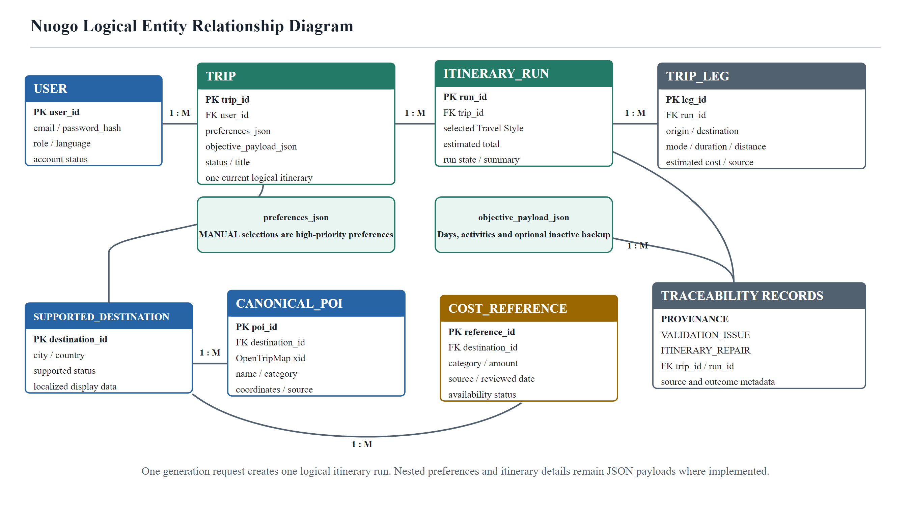
Figure 3.10 Entity Relationship Diagram (ERD) of Nuogo
Source: Developed by the author.
The ERD is a logical design model: primary keys identify records, foreign keys connect related entities, and the 1/M labels indicate one-to-many relationships. MANUAL attraction selections are high-priority preference inputs that remain subject to grounding, schedule, density, duplication, and hard-budget validation; Nuogo does not implement a mandatory Must Visit field. One generation request creates one logical itinerary run, while provenance, validation, and repair records support traceability.

Table 3.10 Logical Database Data Groups
Data group | Purpose and content
User and authentication data | User account, role/profile and authentication-related records required by the implemented security model.
Travel preferences | Destination, dates, budget, travellers, interests, high-priority preferred attractions, selected Travel Style, and Rainy-Day Backup preference stored within the trip preference payload where implemented.
Itineraries | One logical itinerary run per generation request, with nested day/activity details and optional inactive backup information stored in the objective payload where implemented; route legs are persisted separately where supported.
POI / attraction support data | OpenTripMap identifiers and normalized/cached attraction data used for grounding, display and map markers.
Cost reference data | City, category, planning value/range, currency, source, collection date and review date used for estimates.
System / API records | Provenance, validation outcomes, repair records, and operational/API metadata required for traceability and controlled failure handling without storing credentials or unnecessary prompt content.
The exact physical table and field definitions should remain aligned with the implemented MySQL schema. This report describes the logical data groups required by the system without claiming that every conceptual data group must correspond to exactly one database table.

3.6.4.1 Budget Estimate Data Sources and Reliability
The Nuogo MVP provides estimated travel costs for Beijing, Shanghai, and Xi'an. It does not retrieve guaranteed real-time accommodation, transportation, food, attraction, entertainment, or booking prices. Table 3.11 presents a prepared reference dataset used to define controlled planning values and support evaluation. The implemented architecture supports persistence and authorised maintenance of cost-reference records; however, the final live verification did not establish that every value listed in Table 3.11 had been imported into a disposable MySQL integration database.
Each reference record identifies the supported city or route, cost category, reference value or range, currency, named information source, collection date, and last-reviewed date. All MVP values are maintained in Chinese Yuan (CNY). The values remain planning estimates rather than booking quotations because actual expenditure can change according to travel dates, season, promotions, availability, and traveller choices.
Accommodation anchors are based on named Trip.com public hotel listings sampled for late-August 2026 travel dates. Local-transport references use published fare policies from Beijing, Shanghai, and Xi'an transport authorities. Intercity railway references use route-specific second-class fare ranges cross-checked against current published China rail fare tables, with China Railway 12306 retained as the primary operational reference for manual verification.
Food planning ranges are derived from named 2026 restaurant and food-price samples rather than an unsupported generic daily amount. Attraction-ticket references use named official museum, attraction, or government tourism sources. Entertainment references use named venue or government-published ticket information. Miscellaneous cost is treated as a Nuogo system-defined planning reserve and is labelled as a system estimate rather than an externally verified market price.
The prepared reference dataset should be reviewed at least once every three months or earlier when a source changes materially. A record whose source can no longer be traced or whose review period has expired may be marked as outdated or unavailable. During formal evaluation, system-estimated costs can be compared with the prepared reference dataset for fixed scenarios in Beijing, Shanghai, and Xi'an. Category totals remain subject to double-counting checks and every generated itinerary must remain within the user's hard total-budget ceiling. All displayed amounts remain planning estimates rather than guaranteed current prices.
Table 3.11 Prepared Budget Reference Dataset for the Nuogo MVP (Collected 28 August 2026)
City / Category | Named Traceable Source | Reference Value / Range Used | Collection / Review
Beijing - Accommodation | Trip.com public listings: HanTing Hotel (Beijing Wangfujing) and The Peninsula Beijing (Trip.com, n.d.-a, n.d.-e). | Nuogo-prepared indicative anchors: approximately CNY 140 / 600 / 2,344 per room-night for budget, mid-range, and premium planning; these are not live quotations. | Public listings accessed 31 August 2026; dynamic prices must be refreshed before scenario use.
Shanghai - Accommodation | Trip.com public listings: Metropolo Xin Cheng Hotel and Regent Shanghai on the Bund (Trip.com, n.d.-b, n.d.-d). | Nuogo-prepared indicative anchors: approximately CNY 288 / 800 / 2,668 per room-night for budget, mid-range, and premium planning; these are not live quotations. | Public listings accessed 31 August 2026; dynamic prices must be refreshed before scenario use.
Xi'an - Accommodation | Trip.com public listing: New Sanjiangyuan Hotel (Trip.com, n.d.-c); additional tier values are Nuogo planning anchors. | Nuogo-prepared indicative anchors: approximately CNY 148 / 364 / 544 per room-night for budget, mid-range, and premium planning; these are not live quotations. | Public listing accessed 31 August 2026; dynamic prices must be refreshed before scenario use.
Beijing - Local transportation | Beijing Municipal People's Government / Beijing Subway (2025). | Published standard fare reference: CNY 3 up to 6 km; CNY 4 for 6-12 km; CNY 5 for 12-22 km; CNY 6 for 22-32 km; then CNY 1 per additional 20 km. | Official source accessed 31 August 2026; recheck before use.
Shanghai - Local transportation | Shanghai Municipal People's Government (2026a). | Published city-metro fare reference: CNY 3 up to 6 km, then CNY 1 per additional 10 km; suburban lines may use separate fare mechanisms. | Official source accessed 31 August 2026; recheck before use.
Xi'an - Local transportation | Shaanxi Rail Transit Group / Xi'an Metro (2024). | Published fare reference: CNY 2 for 0-6 km; CNY 3 for 6-10 km; CNY 4 for 10-14 km; CNY 5 for 14-20 km; CNY 6 for 20-26 km; then CNY 1 per additional 8 km. | Official operator source accessed 31 August 2026; recheck before use.
Beijing-Shanghai - Intercity railway | China Railway 12306 official fare-query service (n.d.). | Prepared indicative second-class planning range: approximately CNY 576-697. This is not a live fare; the actual route and travel-date fare must be queried on 12306. | Official query accessed 31 August 2026; query the actual travel date.
Beijing-Xi'an - Intercity railway | China Railway 12306 official fare-query service (n.d.). | Prepared indicative second-class planning range: approximately CNY 480-593. This is not a live fare; the actual route and travel-date fare must be queried on 12306. | Official query accessed 31 August 2026; query the actual travel date.
Shanghai-Xi'an - Intercity railway | China Railway 12306 official fare-query service (n.d.). | Prepared indicative second-class planning range: approximately CNY 652-795. This is not a live fare; the actual route and travel-date fare must be queried on 12306. | Official query accessed 31 August 2026; query the actual travel date.
Beijing - Food | Trip.com Beijing Duck guide and named sample restaurants (Robin, 2026). | Nuogo-prepared indicative daily tiers: CNY 80-150 / 150-300 / 300-450 per traveller-day, informed by varied sample meal prices rather than a guaranteed daily spend. | Guide accessed 31 August 2026; indicative only; review within three months.
Shanghai - Food | Trip.com Shanghai Food Guide and named sample restaurants (Leona, 2026a). | Nuogo-prepared indicative daily tiers: CNY 60-120 / 120-220 / 220-350 per traveller-day, informed by varied sample meal prices rather than a guaranteed daily spend. | Guide accessed 31 August 2026; indicative only; review within three months.
Xi'an - Food | Trip.com Xi'an Food Guide and named sample restaurants (Leona, 2026b). | Nuogo-prepared indicative daily tiers: CNY 50-100 / 100-180 / 180-260 per traveller-day, informed by varied sample meal prices rather than a guaranteed daily spend. | Guide accessed 31 August 2026; indicative only; review within three months.
Beijing - Attraction tickets | The Palace Museum official visitor information (n.d.). | Published general-admission reference: CNY 60 in peak season and CNY 40 in low season; Treasure Gallery and Clock and Watch Gallery are CNY 10 each. Reservation and eligibility rules must be checked. | Official source accessed 31 August 2026; recheck before visiting.
Shanghai - Attraction tickets | Shanghai Municipal People's Government, Shanghai Tower tourism notice (2026b). | Published regular-admission reference: CNY 180 for a standard adult ticket. Concessions and promotional prices may vary. | Official government source accessed 31 August 2026; recheck before visiting.
Xi'an - Attraction tickets | Emperor Qinshihuang's Mausoleum Site Museum official ticket information (n.d.). | Published admission reference: CNY 120 for an adult and CNY 60 for eligible students; reservation, concession, and free-admission rules apply. | Official attraction source accessed 31 August 2026; recheck before visiting.
Beijing - Entertainment | Universal Beijing Resort official Tickets & Offers page (n.d.). | A dated one-day ticket is advertised from CNY 350. Prices depend on the selected date and must be checked in the official price calendar. | Official venue source accessed 31 August 2026; recheck for the selected date.
Shanghai - Entertainment | Shanghai Municipal People's Government tourism-festival notice (2025). | Published regular adult reference: CNY 260 for Shanghai Happy Valley. Promotional and date-specific prices may vary. | Official government source accessed 31 August 2026; recheck before visiting.
Xi'an - Entertainment | Tang Paradise official visitor channel (n.d.) and Air China partner offer (2026). | Indicative adult gate-price reference: CNY 120. Shows are separate and variable; confirm the current price through the official venue channel. | Official venue and partner sources accessed 31 August 2026; recheck before visiting.
All cities - Miscellaneous reserve | Nuogo system-defined planning reserve; no external market-price citation is claimed. | CNY 30-100 per traveller-day, applied only as an estimated planning reserve. | Defined for the prepared evaluation dataset; review when the planning policy changes.
Source note: Table 3.11 contains maintained planning references rather than live quotations. Accommodation and food figures are indicative tier anchors informed by named public samples; transport, attraction, and entertainment figures use the cited published sources. Market values and rules may change, so sources should be rechecked before use. Full source details appear in the reference list below.
Different travel-cost categories use different reference methods. Accommodation and food use tiered planning anchors derived from named samples, while transportation, railway, attraction, and entertainment categories use source-specific published fares or ticket references. Miscellaneous cost remains a clearly labelled system-defined planning reserve. The source, collection date, and last-reviewed date are preserved so that planning estimates can be distinguished from verified current booking information.

References for Table 3.11
Air China. (2026, April 15). [Fly to Xi'an] Exclusive Tang Paradise attraction and performance offers for Air China passengers. https://webresource.airchina.com.cn/zh-CN/content/c/2026-04-15/29047.shtml
Beijing Municipal People's Government. (2025, April 23). About subway fares. https://english.beijing.gov.cn/specials/beijinglifeonthesubway/noticeforpassengers/202504/t20250423_4072294.html
China Railway 12306. (n.d.). Ticket fare query. Retrieved August 31, 2026, from https://kyfw.12306.cn/otn/leftTicketPrice/init
Emperor Qinshihuang's Mausoleum Site Museum. (n.d.). Tickets. Retrieved August 31, 2026, from https://www.bmy.com.cn/jingtai/bmyweb/ticketing.html
Leona. (2026a, June 8). Shanghai food guide 2026: What to eat in Shanghai. Trip.com. https://sg.trip.com/guide/food/what-to-eat-in-shanghai.html
Leona. (2026b, January 16). Xi'an food guide 2026: What to eat in Xi'an. Trip.com. https://sg.trip.com/guide/food/what-to-eat-in-xian.html
Robin. (2026, August 7). Beijing Duck (2026): Best Peking Duck restaurants in Beijing. Trip.com. https://www.trip.com/guide/food/beijing-duck.html
Shaanxi Rail Transit Group. (2024, October 29). How are fares calculated using the Xi'an Metro app ride code? https://shxgdjt.com/news/info/120
Shanghai Municipal People's Government. (2025, September 11). Shanghai Tourism Festival: Discounts and free entry to attractions! https://english.shanghai.gov.cn/en-FestivalsCelebrations/20250911/9502fe309abc41a9a2f61966e5725b6a.html
Shanghai Municipal People's Government. (2026a, August 13). How to take metro in Shanghai. https://english.shanghai.gov.cn/en-Individuals-Transportation-Metro/20260813/f257d5c373db4da3a8bde717b9f46b27.html
Shanghai Municipal People's Government. (2026b, May 15). Shanghai at half price: China Tourism Day deals you can't miss. https://english.shanghai.gov.cn/en-FestivalsCelebrations/20260515/ee03e0a7bc6e4d87acc0a1cbe5d8ca49.html
Tang Paradise. (n.d.). Tang Paradise official visitor channel. Retrieved August 31, 2026, from https://www.tangparadise.cn/
The Palace Museum. (n.d.). Visit. Retrieved August 31, 2026, from https://intl.dpm.org.cn/visit.html?_wap=1
Trip.com. (n.d.-a). HanTing Hotel (Beijing Wangfujing). Retrieved August 31, 2026, from https://www.trip.com/hotels/beijing-hotel-detail-1193485/hanting-hotel/
Trip.com. (n.d.-b). Metropolo Xin Cheng Hotel, the Bund Shanghai. Retrieved August 31, 2026, from https://www.trip.com/hotels/shanghai-hotel-detail-536088/metropolo-xin-cheng-hotel-the-bund-shanghai/
Trip.com. (n.d.-c). New Sanjiangyuan Hotel. Retrieved August 31, 2026, from https://www.trip.com/hotels/xi-an-hotel-detail-104448598/new-sanjiangyuan-hotel/
Trip.com. (n.d.-d). Regent Shanghai on the Bund. Retrieved August 31, 2026, from https://www.trip.com/hotels/shanghai-north-bund-tourist-resort-hotel-detail-115585710/regent-shanghai-on-the-bund/
Trip.com. (n.d.-e). The Peninsula Beijing. Retrieved August 31, 2026, from https://www.trip.com/hotels/beijing-hotel-detail-374792/the-peninsula-beijing/
Universal Beijing Resort. (n.d.). Tickets & offers. Retrieved August 31, 2026, from https://www.universalbeijingresort.com/en/tickets-offers

3.6.5 Use Case Diagram
The simplified use case model has two human actors: the Traveller and an Authorised Maintainer. OpenTripMap and OpenRouter/DeepSeek V3.1 are supporting external systems rather than human actors. The traveller can register, log in or continue as a guest, manage a profile, discover attractions, choose MANUAL or AUTO attraction preferences, enter essential preferences, select one Travel Style, optionally enable Rainy-Day Backup, generate and manage one itinerary workspace, and review budget, map, and provenance information. The authorised maintainer supports destinations, POIs, and cost-reference records.
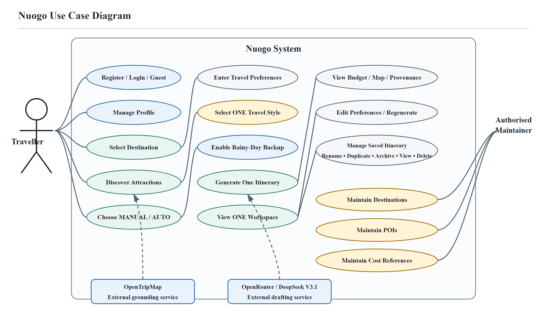
Figure 3.11 Simplified Use Case Diagram of Nuogo
Source: Developed by the author.

3.6.6 System Flow
The Nuogo workflow begins when a traveller logs in and selects Beijing, Shanghai, or Xi'an. OpenTripMap-supported attractions are retrieved for discovery and manual or automatic attraction choice. The traveller then enters essential preferences, selects one Travel Style, and decides whether rainy-day backup should be included.
The validated input and grounded attraction candidates are sent to DeepSeek V3.1 to generate one structured itinerary draft. The backend checks schema completeness, attraction grounding, dates, duplicates, and hard-budget compliance. If the draft fails, one controlled repair/regeneration attempt is allowed; otherwise the request ends with a controlled failure message. If the Rainy-Day Backup option is enabled, a grounded indoor or less weather-sensitive alternative may be attached to a suitable outdoor activity without querying live weather. The contingency remains inactive, and its feasibility and estimated cost are checked without adding the unused alternative to the main active itinerary total. The validated itinerary is then saved and displayed with budget information, map markers, source labels, and management actions.
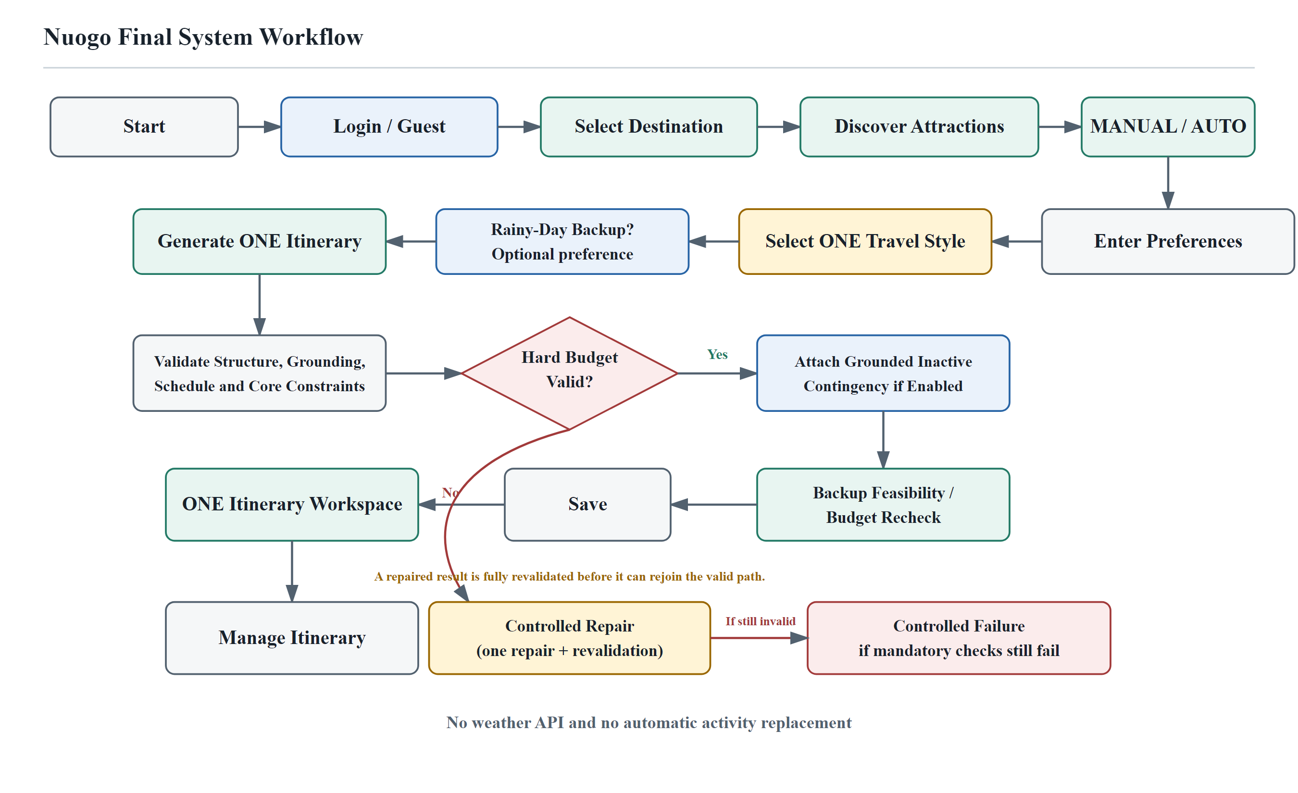
Figure 3.12 Simplified System Workflow of Nuogo
Source: Developed by the author.

3.7 User Interface
The Nuogo user interface is designed as a short responsive workflow from authentication to attraction discovery, essential preference entry, travel-style selection, optional rainy-day backup, itinerary generation, and itinerary management. Complex internal validation is hidden behind clear user-facing status, budget, map, and source information.
Figure 3.13 shows the frozen Nuogo landing interface and the entry points to authentication and itinerary planning.
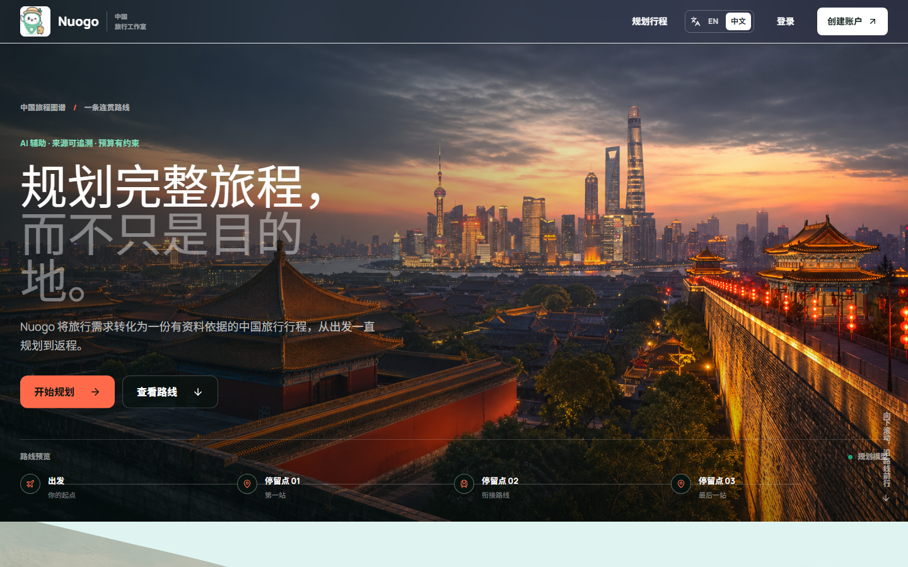
Figure 3.13 Nuogo Landing and Authentication Entry Interface
Source: Developed by the author.

3.7.1 Registration and Login Interface
The authentication interface allows new users to create an account and existing users to log in. Input fields are validated before submission, and protected functions require a valid authenticated session. Security-related implementation details such as password hashing, token validation, and server-side access control are handled by the backend and are not exposed as editable client-side logic.

3.7.2 Destination Discovery and Travel Preference Interface
The planning interface first allows the traveller to choose a supported destination. Destination discovery presents OpenTripMap-supported attractions, categories, available descriptions, and map locations. The preference form then collects essential dates, budget, traveller count, interests, preferred attractions, the selected Travel Style, and the optional rainy-day backup choice.

3.7.3 Generated Itinerary and Rainy-Day Backup Interface
After successful generation and validation, Nuogo presents one itinerary corresponding to the selected Budget-Saving, Balanced, or Comfort-Focused style. The interface shows the day-by-day plan, estimated total cost, remaining budget, key source labels, and map markers. If rainy-day backup was enabled, eligible outdoor activities can also display a separate grounded contingency alternative. Backup costs are shown separately and are not automatically double-counted in the main itinerary total.

3.7.4 Itinerary Workspace
The itinerary workspace displays the selected plan in day-by-day form. Activity entries may include localized attraction names, time, estimated duration, category, available description, personalised recommendation reason, estimated cost, source label, and verification status. Transport segments show the origin, destination, transport mode, estimated distance, time, and cost where supported by the current calculation model. Daily summaries combine activities, meals, transport, and estimated spending information to make the itinerary practical for trip preparation.
Figure 3.14 shows the frozen one-itinerary workspace with the inactive Rainy-Day Backup, grounded source label, map, itinerary details, and estimated budget presentation.
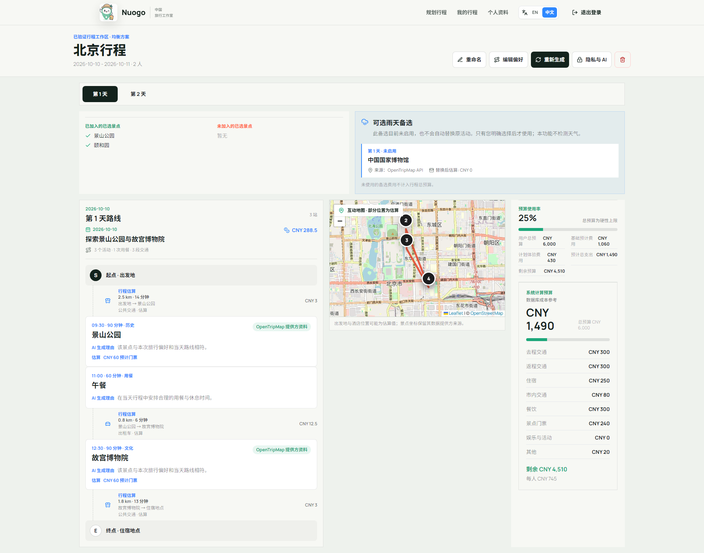
Figure 3.14 Generated One-Itinerary Workspace
Source: Developed by the author.
Figure 3.15 documents the destination-discovery stage with Beijing selected. It presents the localized destination introduction, categorized grounded-attraction cards, OpenTripMap source labels, and corresponding map markers so that travellers can inspect supported choices before configuring an itinerary.
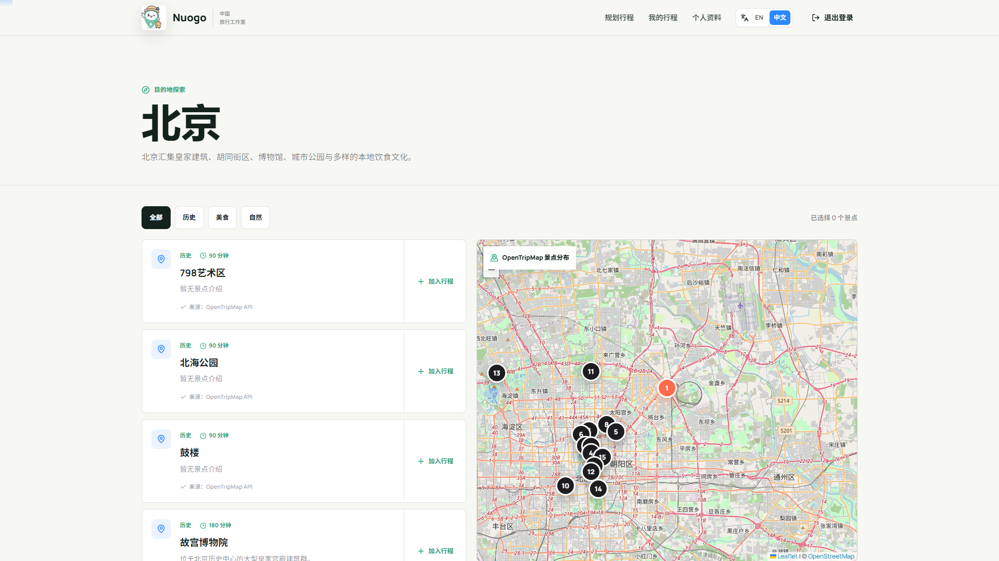
Figure 3.15 Nuogo Destination Discovery and Attraction Map Interface
Source: Developed by the author.
Figure 3.16 records the pre-generation preference workflow. Panel A shows the origin, destination, travel dates and times, traveller count, and hard total budget. Panel B shows a MANUAL set of high-priority grounded-attraction preferences, one selected Travel Style, and the optional Rainy-Day Backup control; the backup remains an inactive contingency unless the traveller chooses to use it.
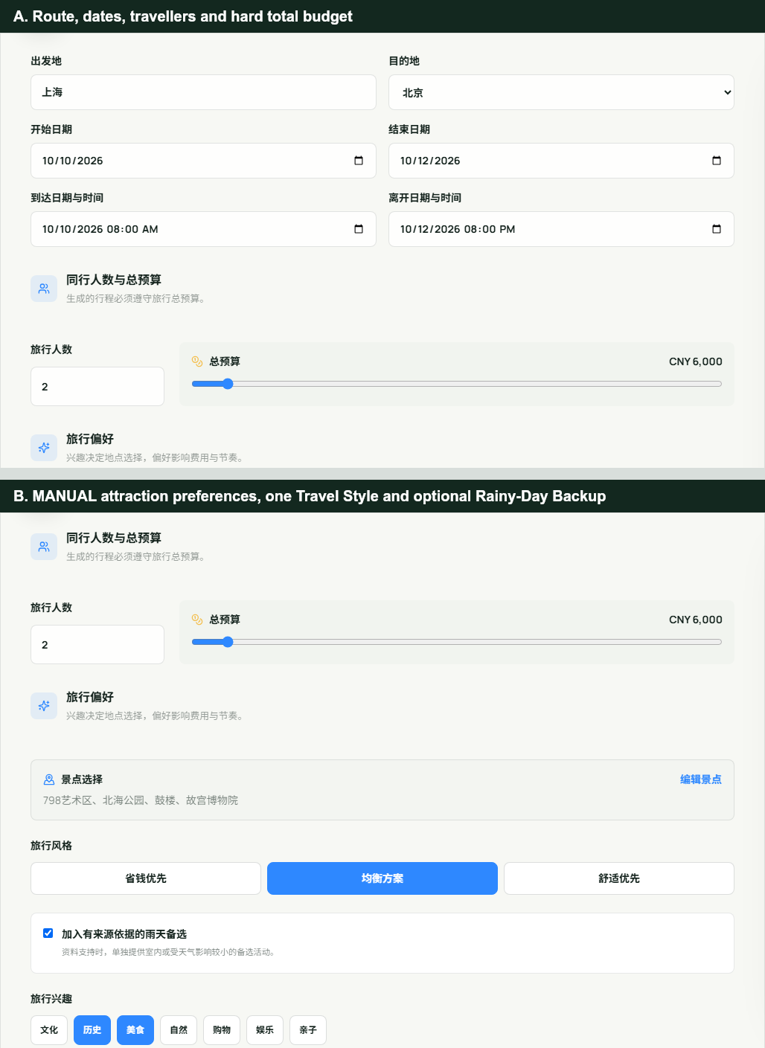
Figure 3.16 Nuogo Travel Preference and Travel Style Configuration Interface
Source: Developed by the author.

3.7.5 Supporting Maintenance Interface
A protected supporting interface allows authorised maintainers to update supported destinations, POIs, and cost-reference records required by the MVP. It is not presented as a major traveller-facing function or research contribution. The main evaluation remains focused on the traveller workflow and the three research objectives.
Figure 3.17 demonstrates the role-protected supporting maintenance surface and its destination, POI, and cost-reference sections. The visible cost-reference records are explicitly labelled as deterministic demonstration fixtures rather than live evidence. The maintenance interface is supporting functionality for destinations, POIs, and cost-reference data rather than a primary research contribution.
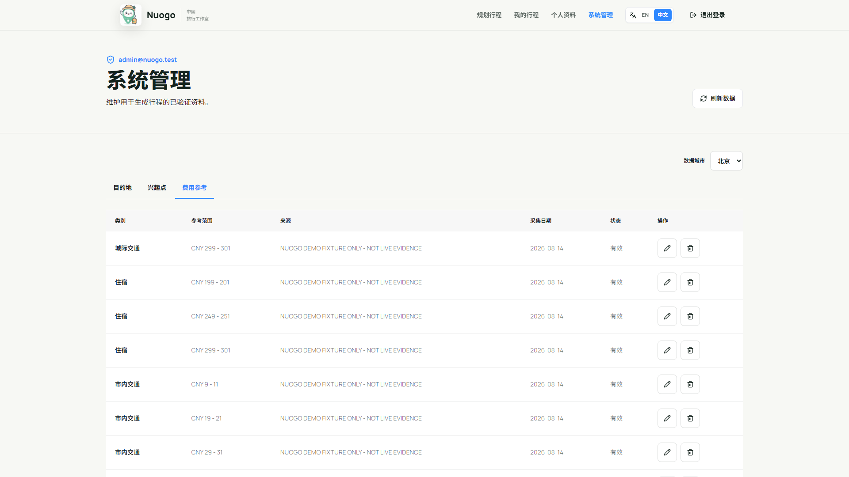
Figure 3.17 Nuogo Authorised Maintenance Interface
Source: Developed by the author.
Figure 3.18 provides interface-level evidence of English localization after an explicit language change and refresh. Navigation, preference labels, Travel Style choices, source-aware backup wording, and form controls are presented in English without exposing internal enum values.
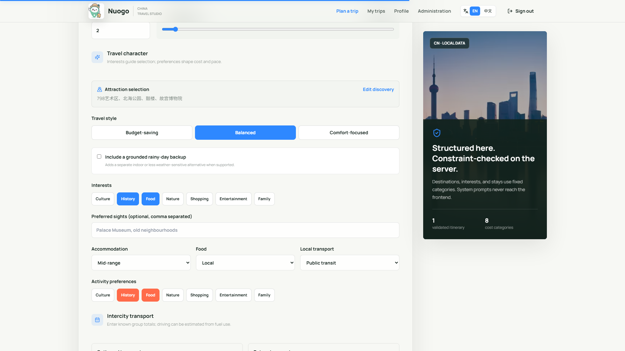
Figure 3.18 Nuogo English Localization Interface
Source: Developed by the author.
The interface evidence in Figures 3.15 to 3.18 was captured from the frozen application in its controlled deterministic demonstration environment. The screenshots demonstrate the implemented workflow and presentation behaviour; they are not represented as live OpenTripMap, OpenRouter, or MySQL responses.

3.8 Conclusion
This chapter described the research methodology, stakeholder requirement study, simplified development plan, requirements, architecture, system design, interfaces, and evaluation approach used for Nuogo. The revised design keeps the stakeholder-supported Travel Styles but changes them into a pre-generation choice, generates one itinerary per request, and adds optional rainy-day contingency support without live weather monitoring.
The chapter also established traceability from RQs and ROs to requirements and design evidence. OpenTripMap grounding, LLM-assisted drafting, deterministic validation, budget control, source transparency, and itinerary management remain the core technical contributions, while advanced commercial, real-time, and autonomous-agent functions remain outside the MVP.

