# Centos 7安装步骤

## 1. 创建新的虚拟机

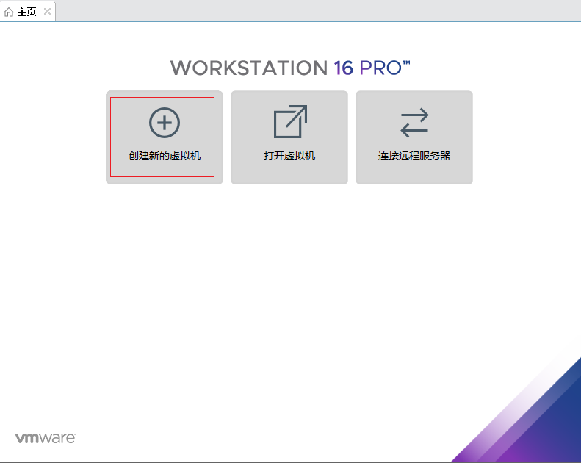

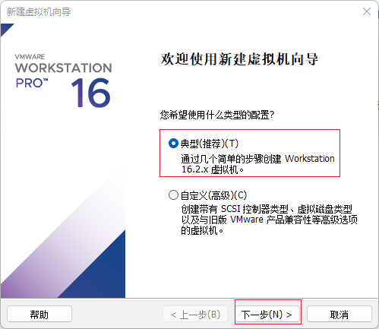

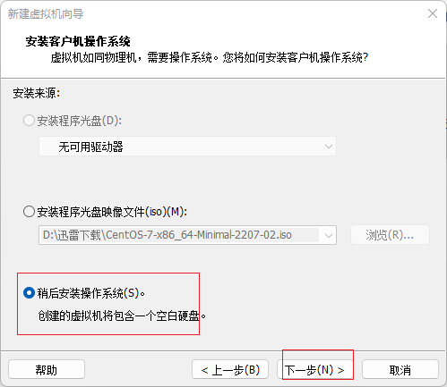

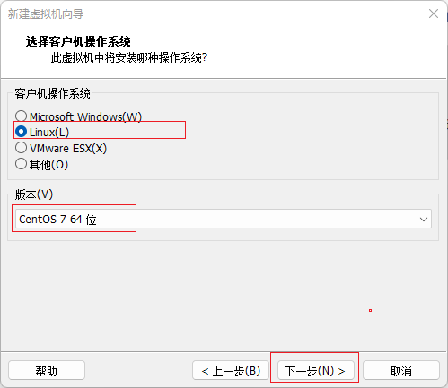

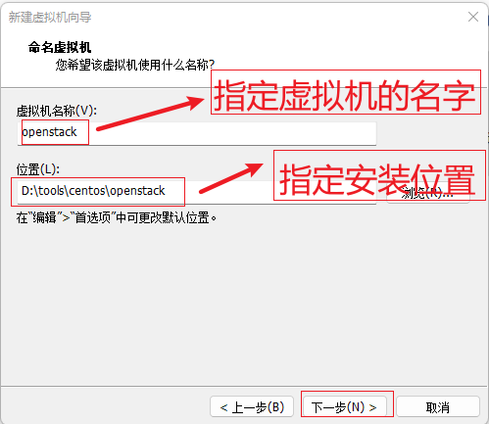

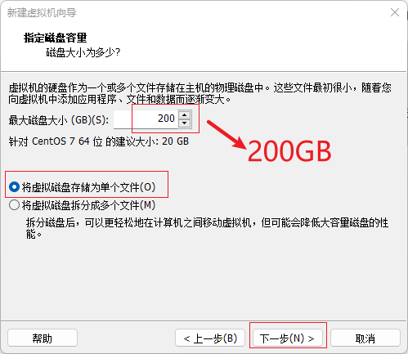

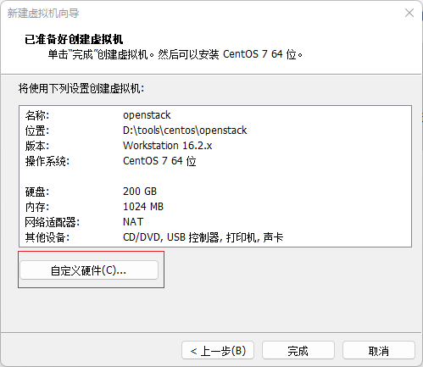

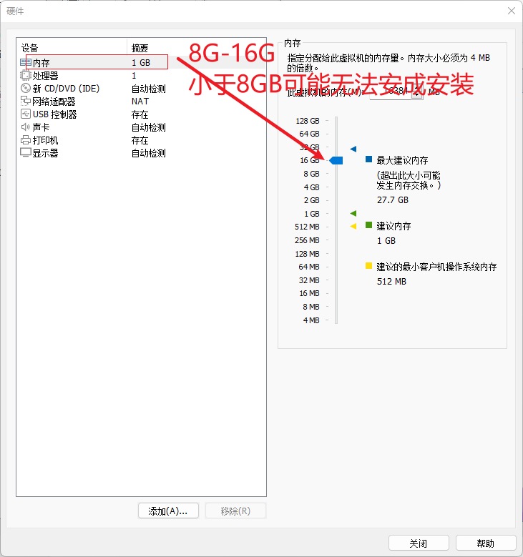

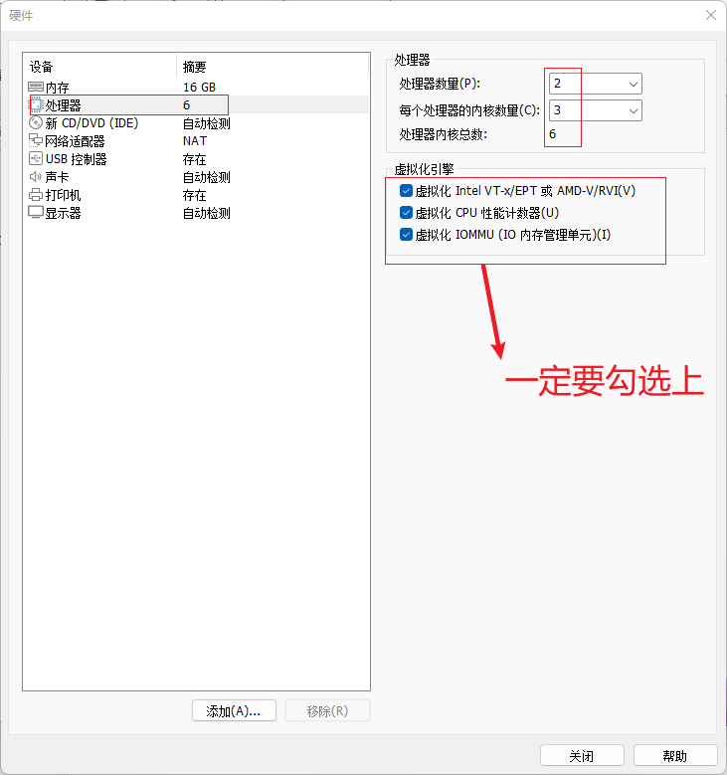

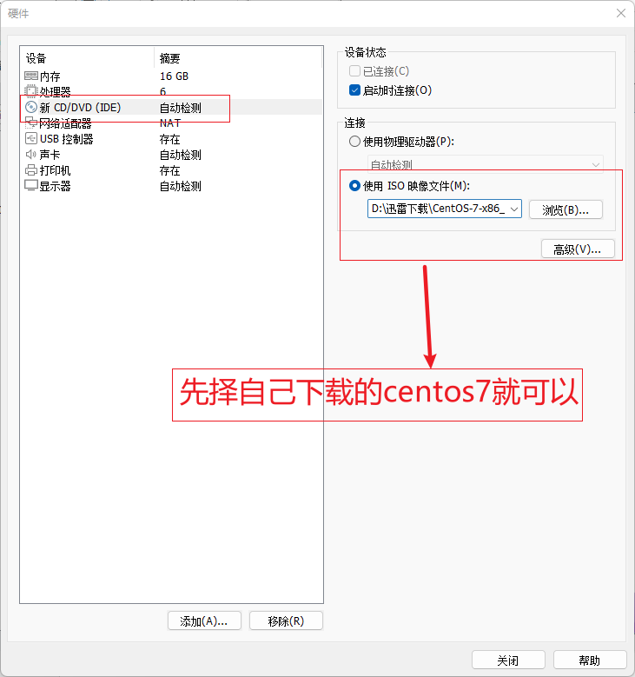

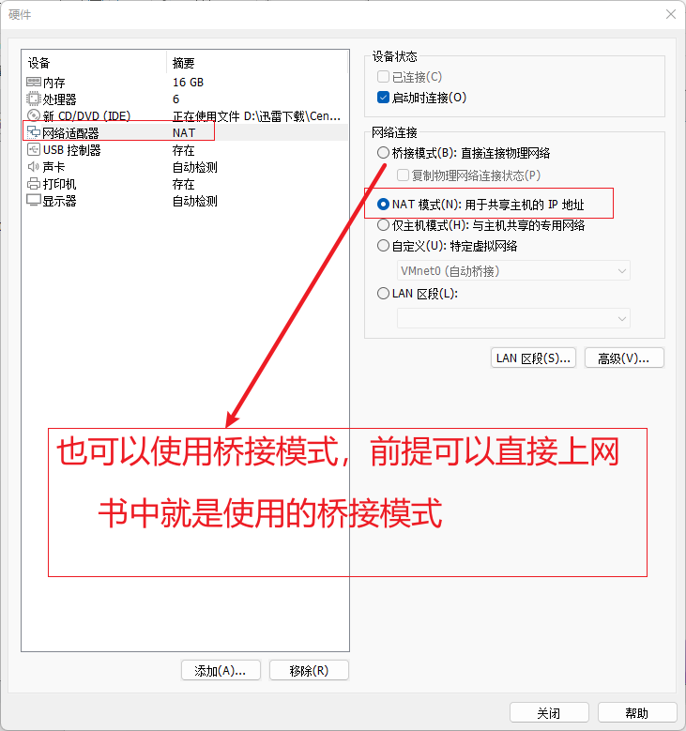

点击关闭

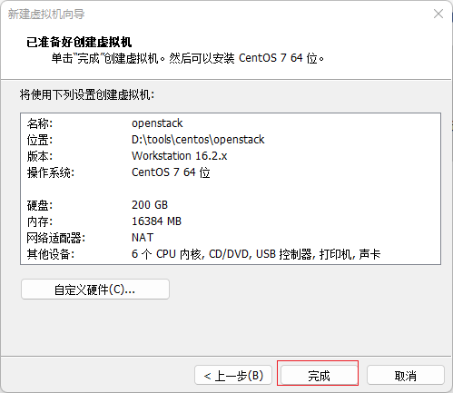

点击完成

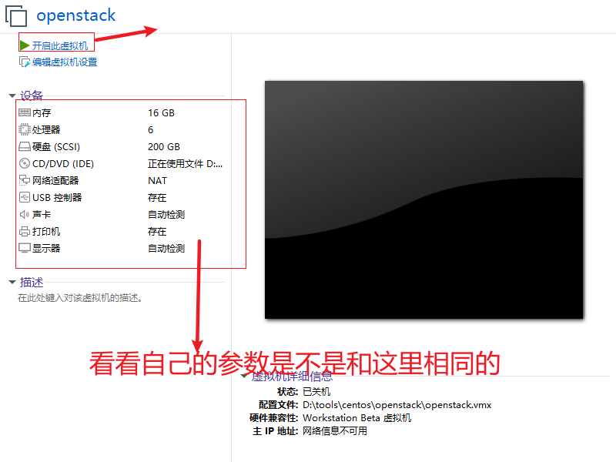

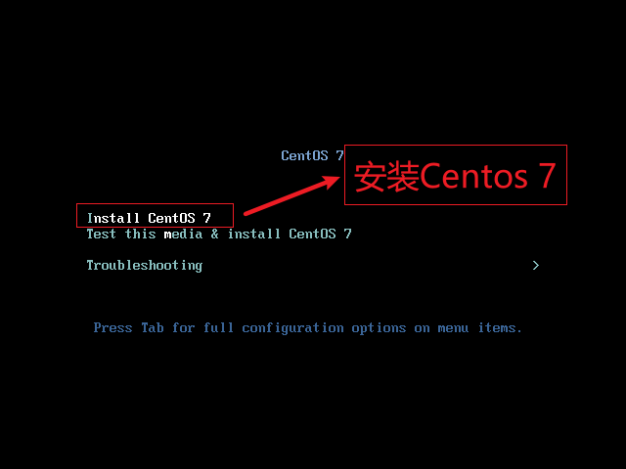

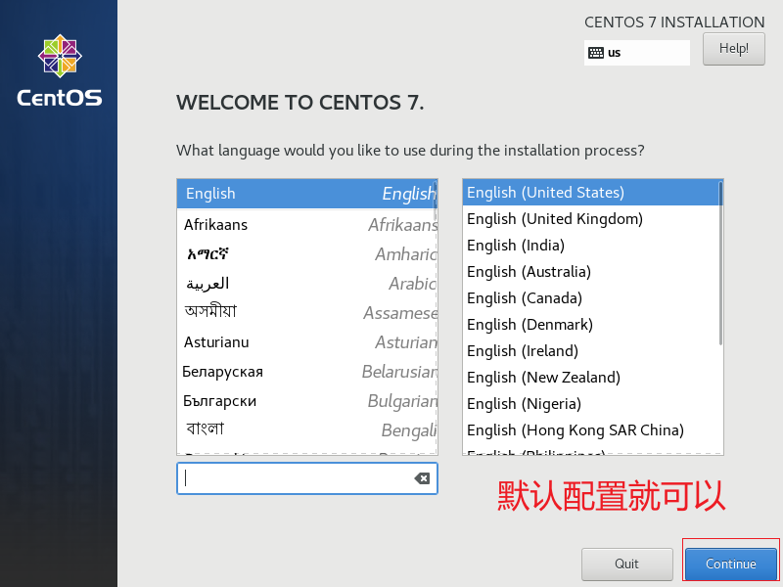

设置时间与时区

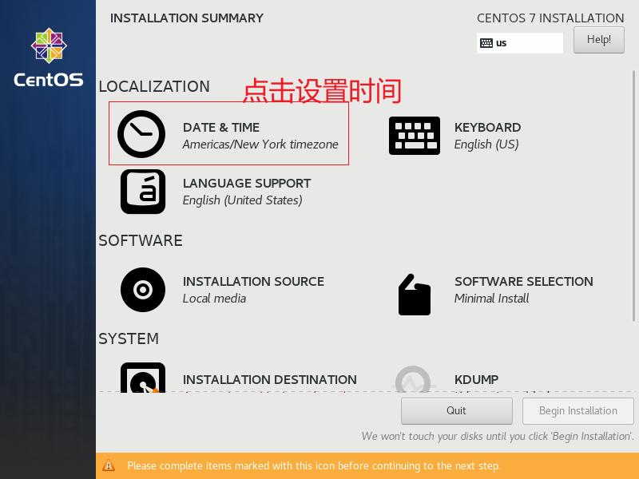

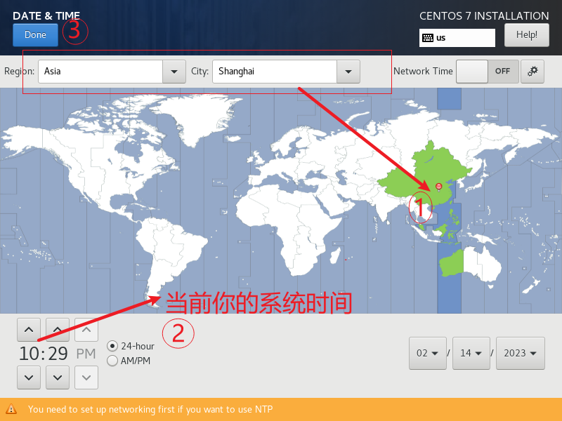

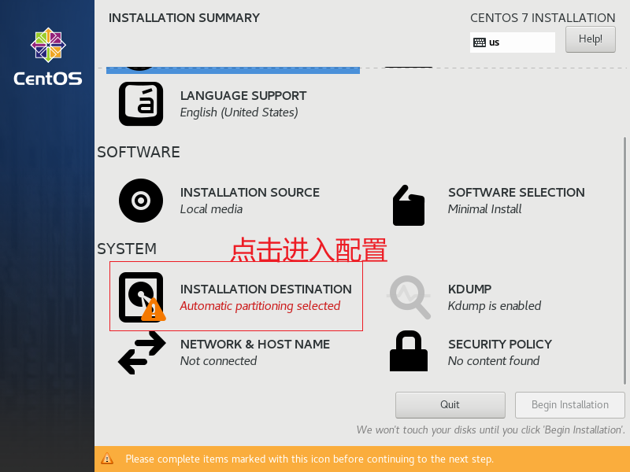‘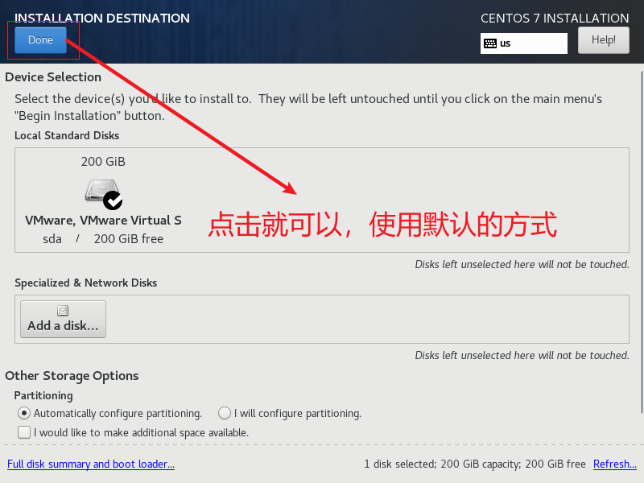

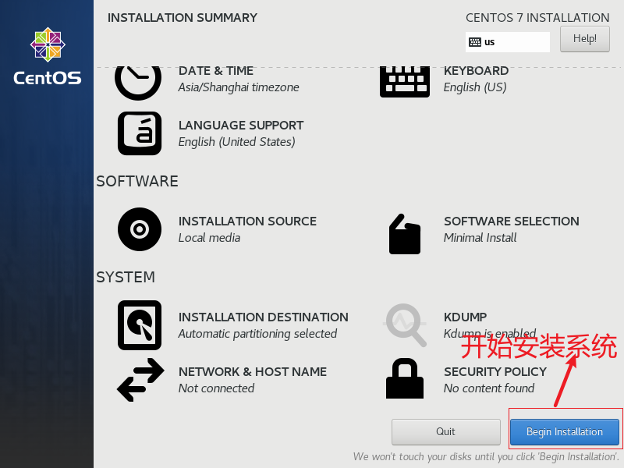

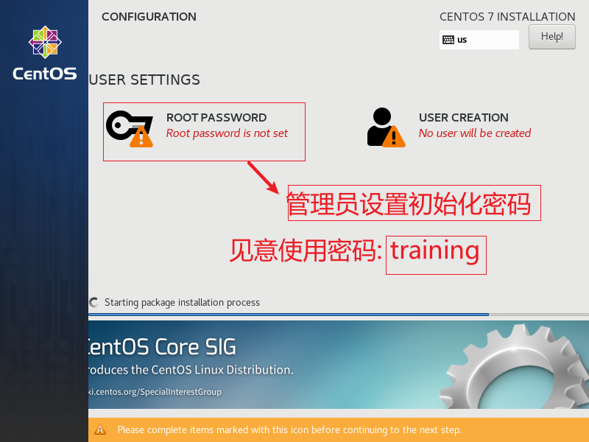

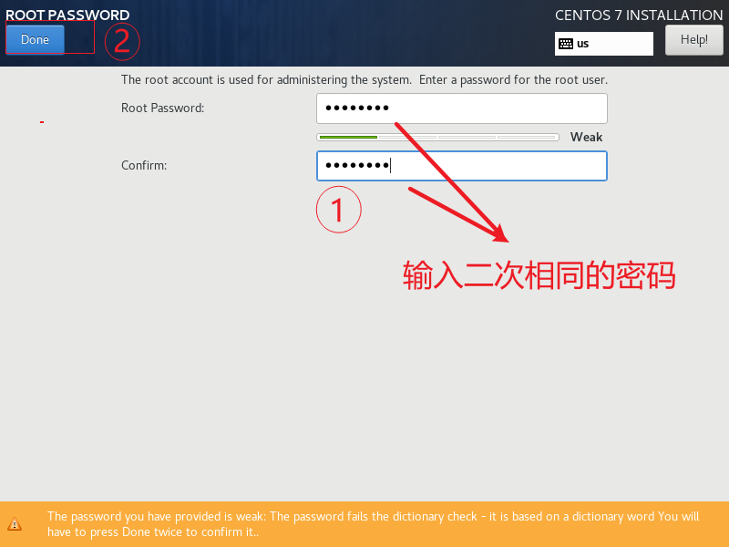

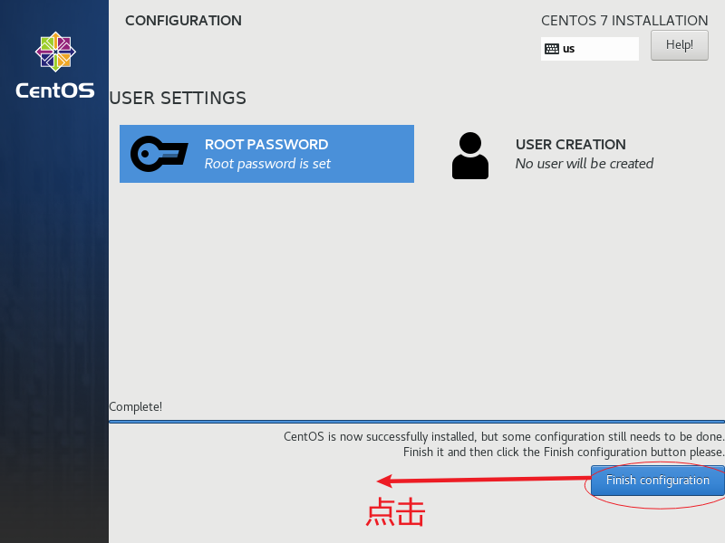

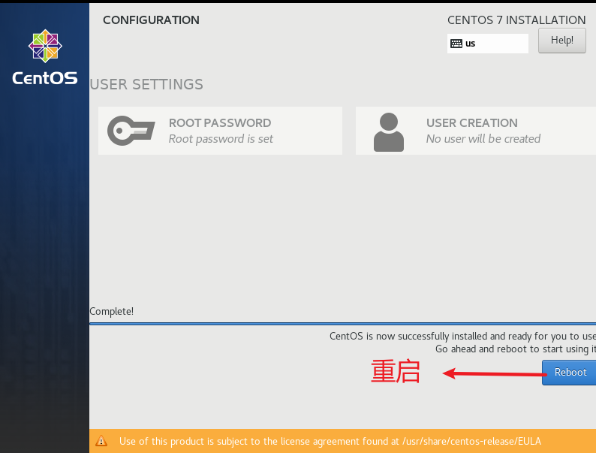

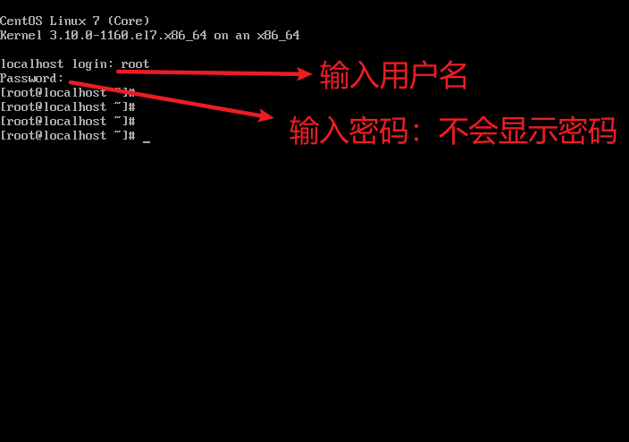

## 2.生成动态IP地址

|  |
| --- |
| [root@localhost ~] dhclient |



## 3.查看生成的IP地址

|  |
| --- |
| [root@localhost ~] ip addr |

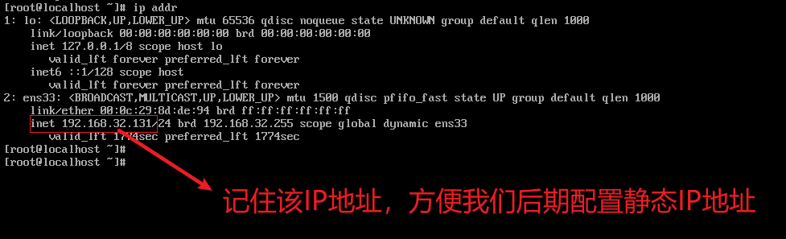

## 4. 修改网络

|  |
| --- |
| 进入到指定的目录  [root@localhost ~]# cd /etc/sysconfig/network-scripts/  [root@localhost network-scripts]# ls  [root@localhost network-scripts]# vi ifcfg-ens33 |

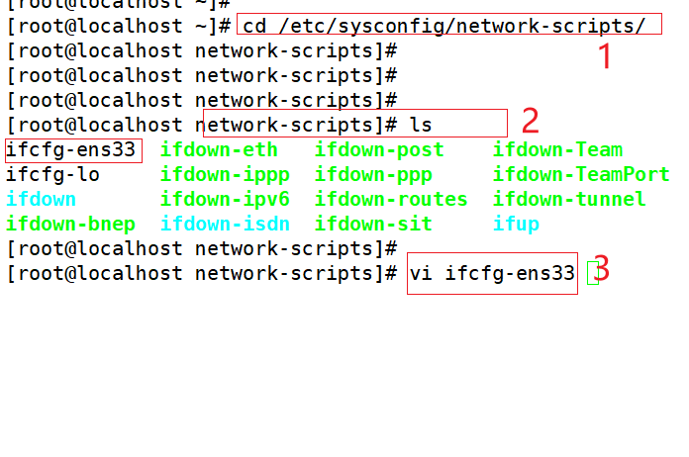

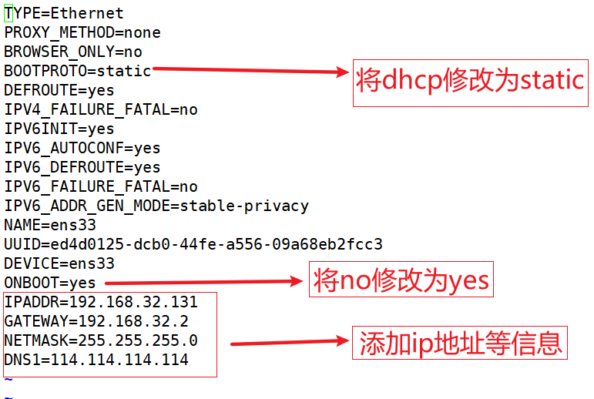

修改完成后，退出保存就可以

## 5. 重启网卡

|  |
| --- |
| [root@localhost network-scripts]# systemctl restart network  #测试网络是否能连通  [root@localhost network-scripts]# ping www.baidu.com |

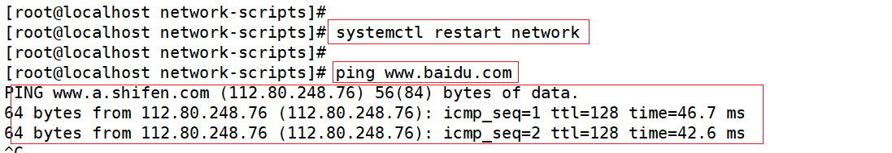

## 6. 禁止防火墙开机启动

|  |
| --- |
| [root@localhost network-scripts]# systemctl disable firewalld |



## 7. 禁止SELinux

|  |
| --- |
| [root@localhost network-scripts]# vi /etc/selinux/config |

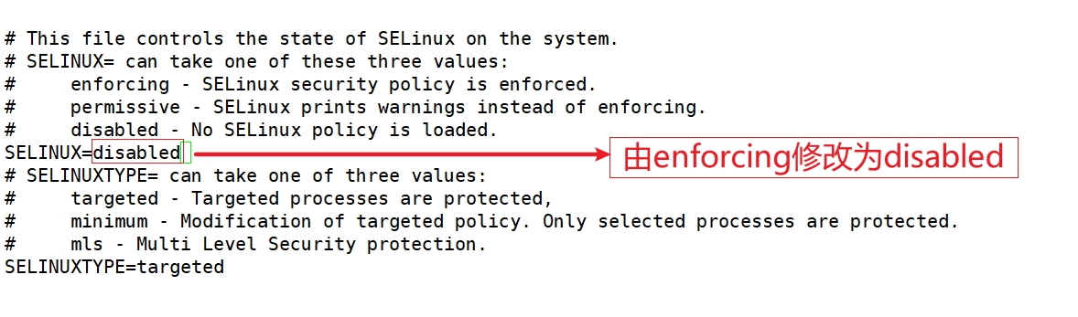

重启系统

## 8. 停用NetWorkManager服务

|  |
| --- |
| [root@localhost ~]# systemctl disable NetworkManager  Removed symlink /etc/systemd/system/multi-user.target.wants/NetworkManager.service.  Removed symlink /etc/systemd/system/dbus-org.freedesktop.nm-dispatcher.service.  Removed symlink /etc/systemd/system/network-online.target.wants/NetworkManager-wait-online.service.  [root@localhost ~]#  [root@localhost ~]# systemctl stop NetworkManager  [root@localhost ~]# systemctl enable network  network.service is not a native service, redirecting to /sbin/chkconfig.  Executing /sbin/chkconfig network on  [root@localhost ~]# systemctl start network |

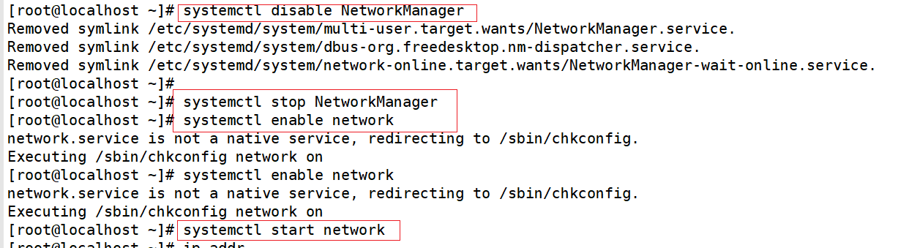

## 9. 修改主机名以及映射

|  |
| --- |
| [root@localhost ~]# hostnamectl set-hostname node-a  [root@localhost ~]#  [root@localhost ~]# vi /etc/hosts  [root@localhost ~]#  [root@localhost ~]# |

在文件结尾添加如下内容

|  |
| --- |
| 192.168.32.131 node-a node-a.localdomain  Linux系统安装好后,都会有默认的主机名,这里以CentOS系统为例,默认的主机名为localhost.localdomain,为了便于使用,我们常常需要修改主机名,下面演示的是永久更改主机名的方法. 步骤: 1.以根用户登录,或者登录后切换到根用户,然后在提示符下输入hostname命令,可以看出当前系统的主机名为localhost.localdomain |

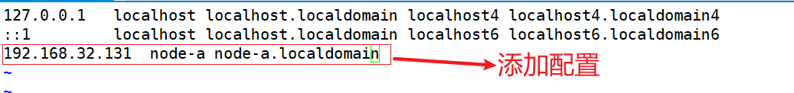

使用ping命令测试

|  |
| --- |
| [root@localhost ~]# ping node-a  PING node-a (192.168.32.131) 56(84) bytes of data.  64 bytes from node-a (192.168.32.131): icmp_seq=1 ttl=64 time=0.011 ms  64 bytes from node-a (192.168.32.131): icmp_seq=2 ttl=64 time=0.023 ms |

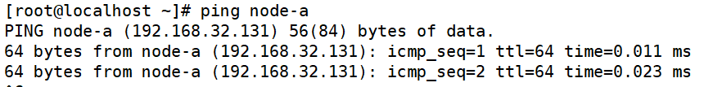

## 10. 安装时间同步软件

|  |
| --- |
| [root@localhost ~]#centos7支持chrony时间同步配置，ntp在centos8上已经不再支持；  Chrony相比ntp时间同步配置更简单更高效，它是一个开源的软件能保持系统始终与服务器时间同步：  yum install -y chrony |

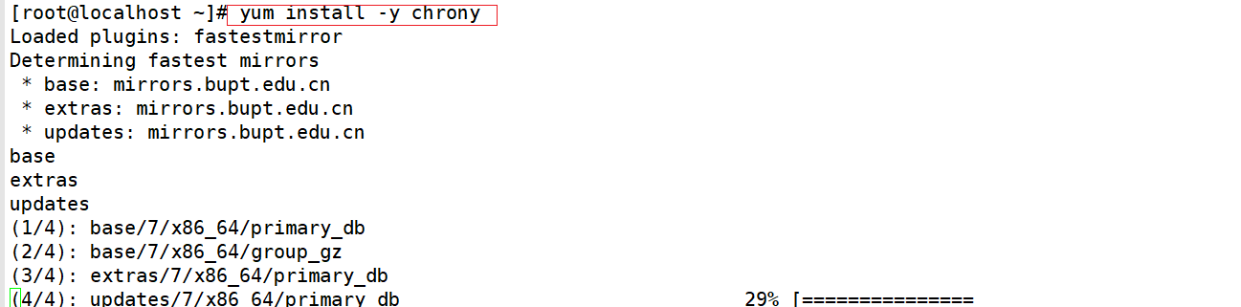

## 11. 添加NTP服务地址

|  |
| --- |
| [root@localhost ~]# vi /etc/chrony.conf |

添加如下内容

|  |
| --- |
| server ntp1.aliyun.com iburst ：把阿里云作为时间源 |

## 12. 准备所需的软件库

|  |
| --- |
| [root@localhost ~]# yum -y update |

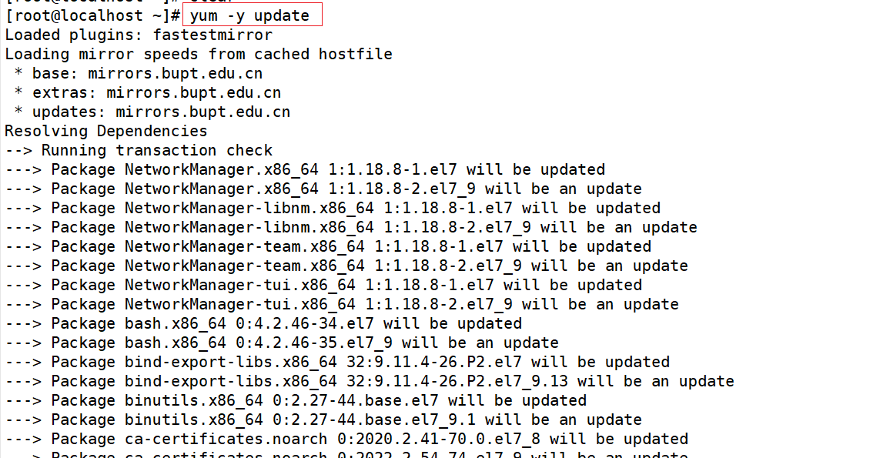

|  |
| --- |
| [root@localhost ~]# yum -y install centos-release-openstack-train  安装仓库 |

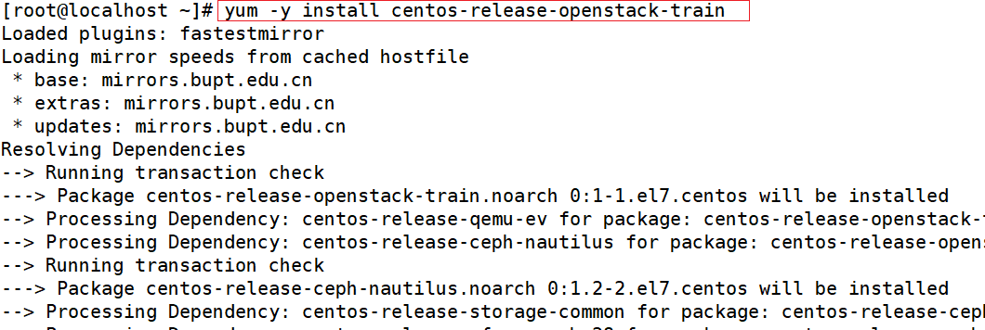

## 13. 安装packstack安装器

|  |
| --- |
| [root@localhost ~]# yum -y update |

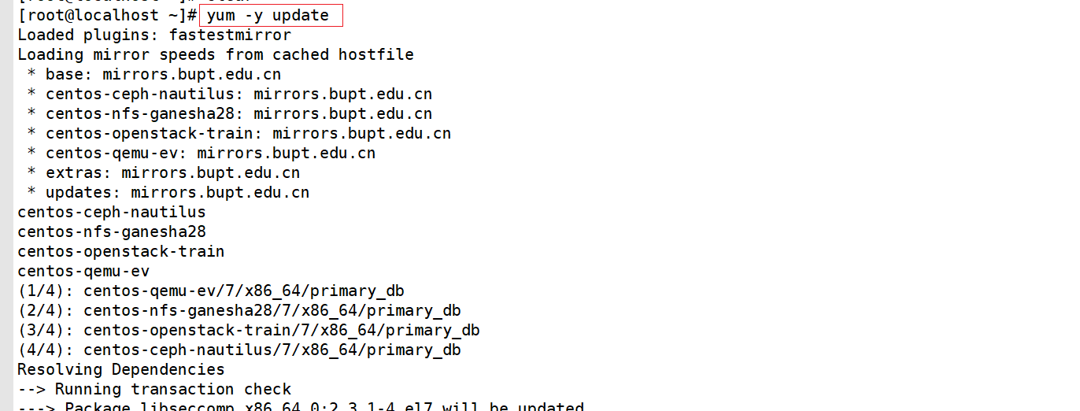

|  |
| --- |
| [root@localhost ~]# yum -y install openstack-packstack  安装packstack安装器 |

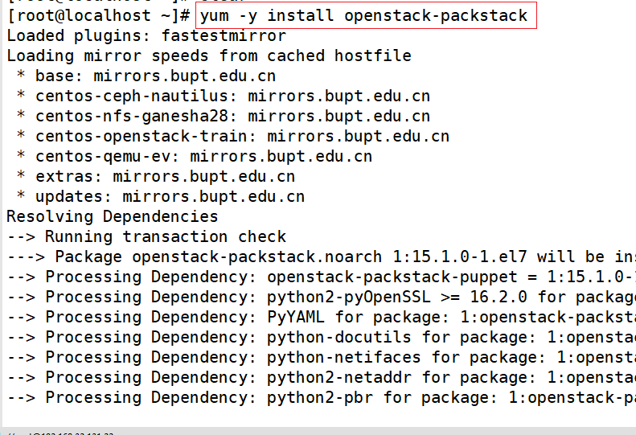

## 14. 运行packstack安装OpenStack

|  |
| --- |
| [root@localhost ~]# packstack –allinone  运行它 |

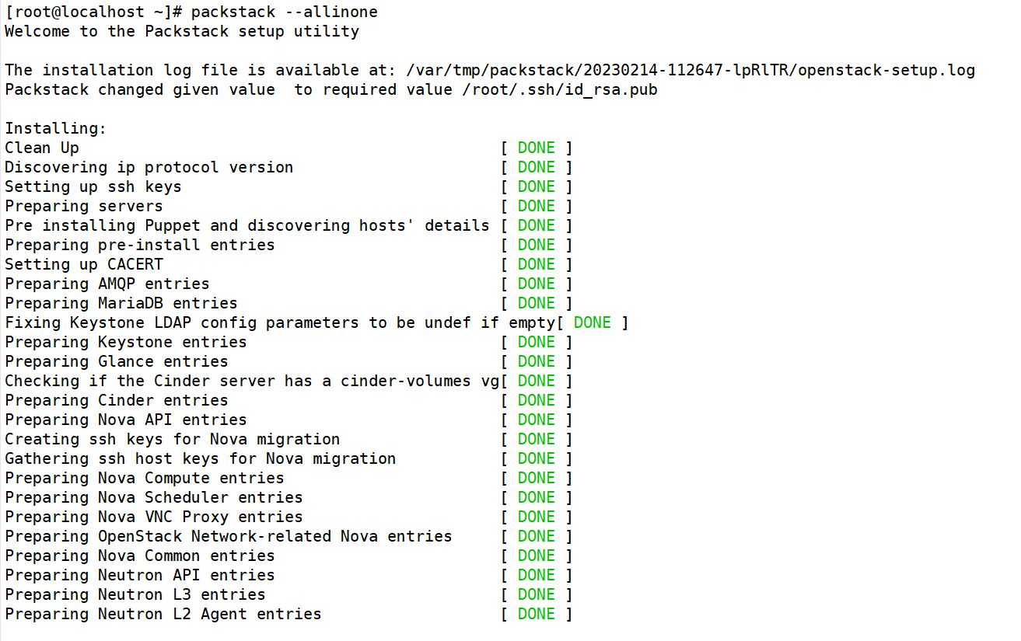

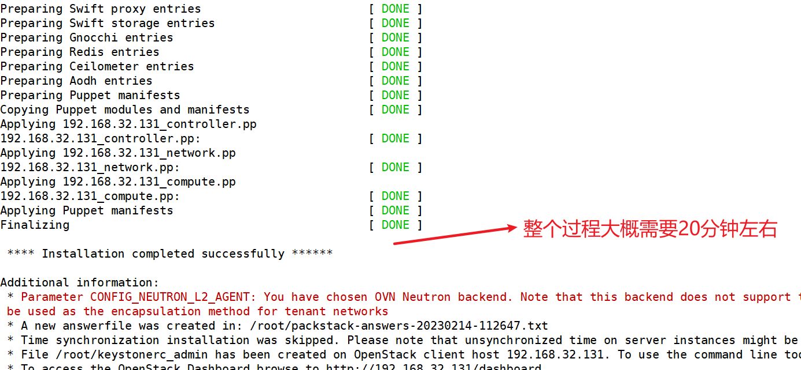

查看当前安装版本

|  |
| --- |
| [root@localhost ~]# nova-manage --version  20.6.0 |

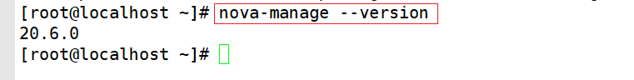

整个安装过程完成。