1.pwd

pwd command is going to return the “present working directory”.

Explanation: pwd command is going to return the “present working directory”.

>pwd

Output: 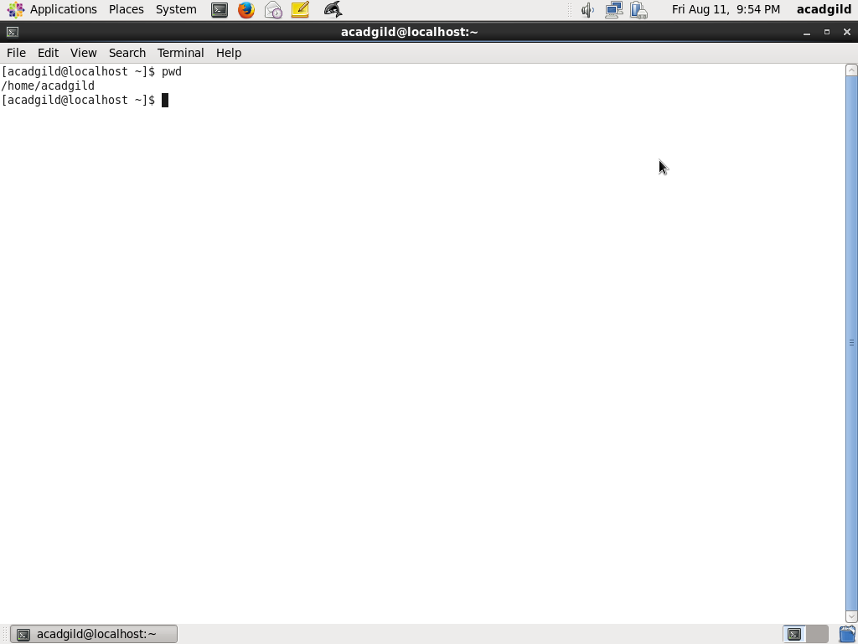

2.vi

Explanation: vi is a visual text editor similar to notepad in windows.

>vi:

Output:

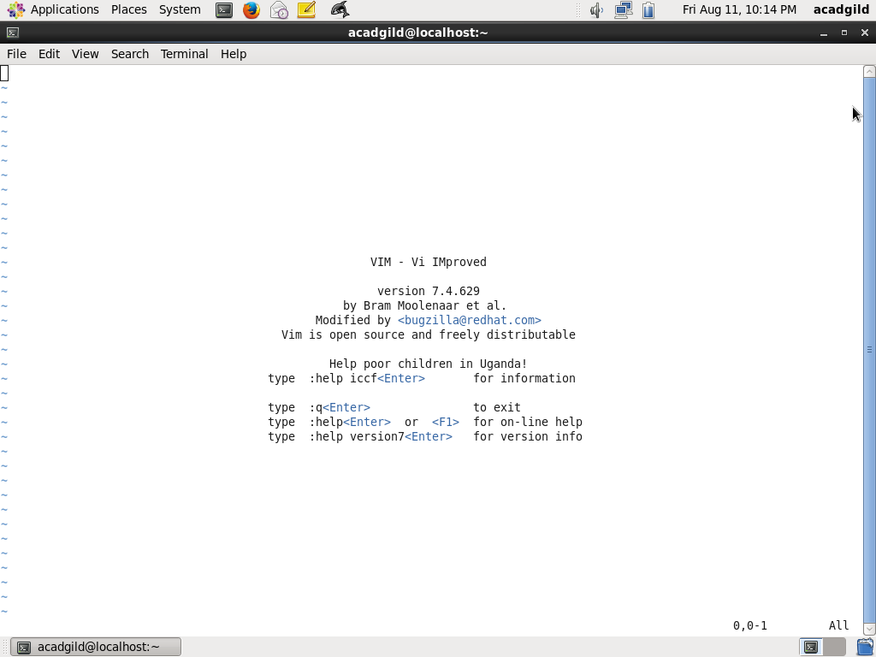

**3.touch**

**Explanation**:

If file.txt exists, touch updates its access and modification times to the current time. If file.txt doesn't exist, it is created as a new, empty file.

>touch anup.txt

Output:

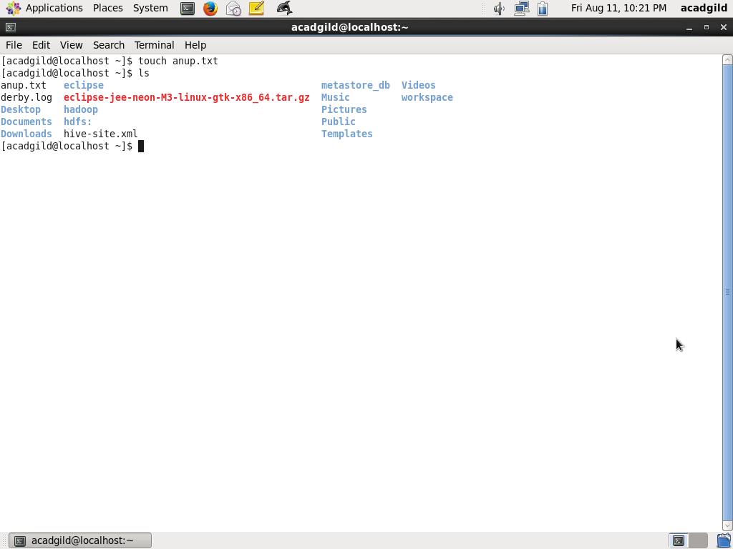

4.mkdir:

It is used to create [directories](https://www.computerhope.com/jargon/d/director.htm) on a [file system](https://www.computerhope.com/jargon/f/filesyst.htm).

Example:

Creates a new directory called mydir whose parent is the current directory.

Mkdir mydir

>mkdir

Output:

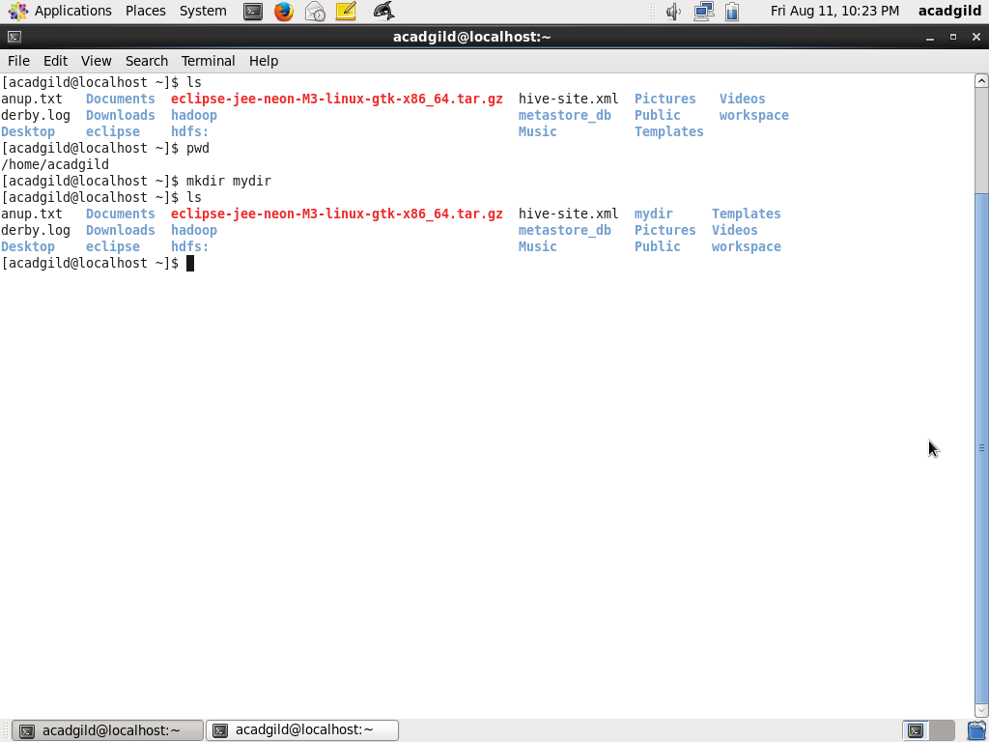

5.rm

The rm command removes ([deletes](https://www.computerhope.com/jargon/d/delete.htm)) [files](https://www.computerhope.com/jargon/f/file.htm) or [directories](https://www.computerhope.com/jargon/d/director.htm).

Example:

If there is a file in your current directory named "-anup.txt", you can delete it with the command

>rm --force anup.txt

Output:

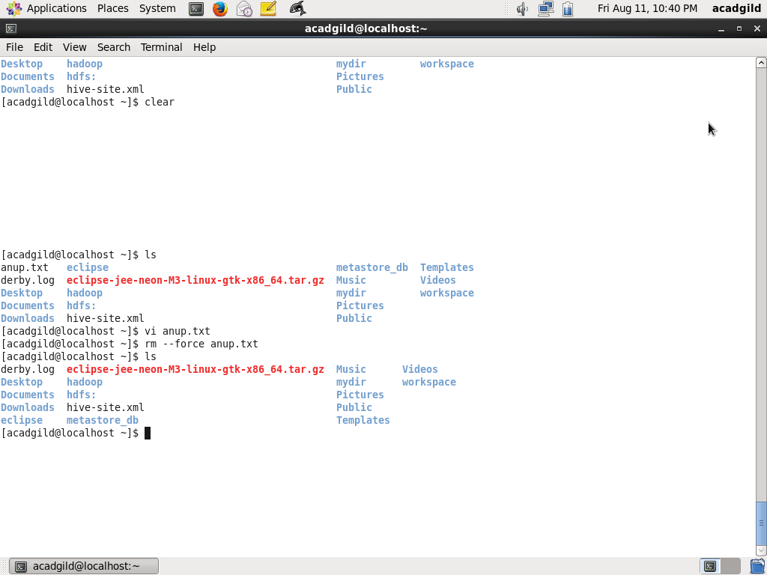

6.ls

Lists the contents of a [directory](https://www.computerhope.com/jargon/d/director.htm).

Example:

Lists the total files in the directory and subdirectories, the names of the files in the current directory, their permissions, the number of subdirectories in directories listed, the size of the file, and the date of last modification.

>ls

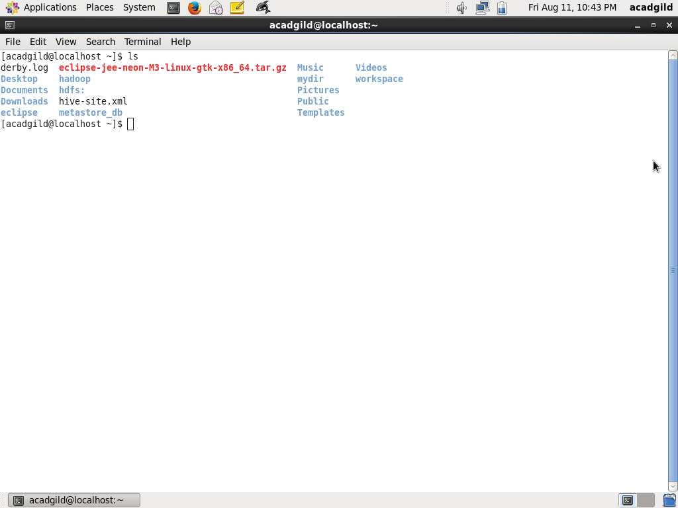

7.echo

echo displays a line of text.

Explanation:

It displays a line of text.

>echo Hello,World!

Output:

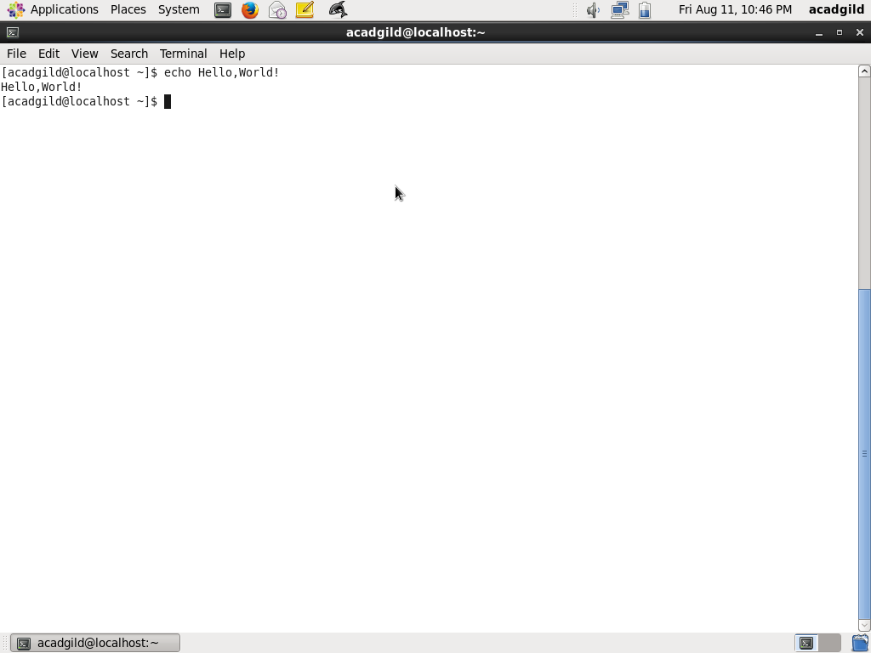

8.cat

It reads [data](https://www.computerhope.com/jargon/d/data.htm) from [files](https://www.computerhope.com/jargon/f/file.htm), and outputs their contents. It is the simplest way to display the contents of a file at the [command line](https://www.computerhope.com/jargon/c/commandi.htm).

Explanation:

It reads the content of the file and show it on the command line

>cat anup.txt

Output:

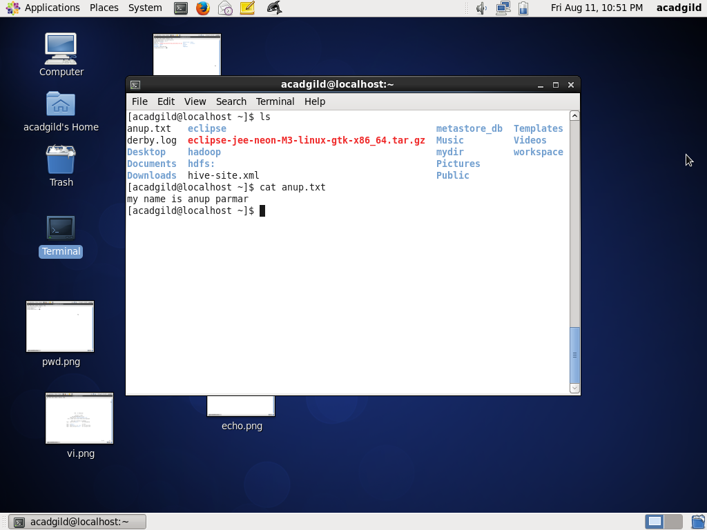

9.who

Who command prints information about all users who are currently logged in.

Explanation:

Displays the username, line, and time of all currently logged-in sessions.

>Who

Output:

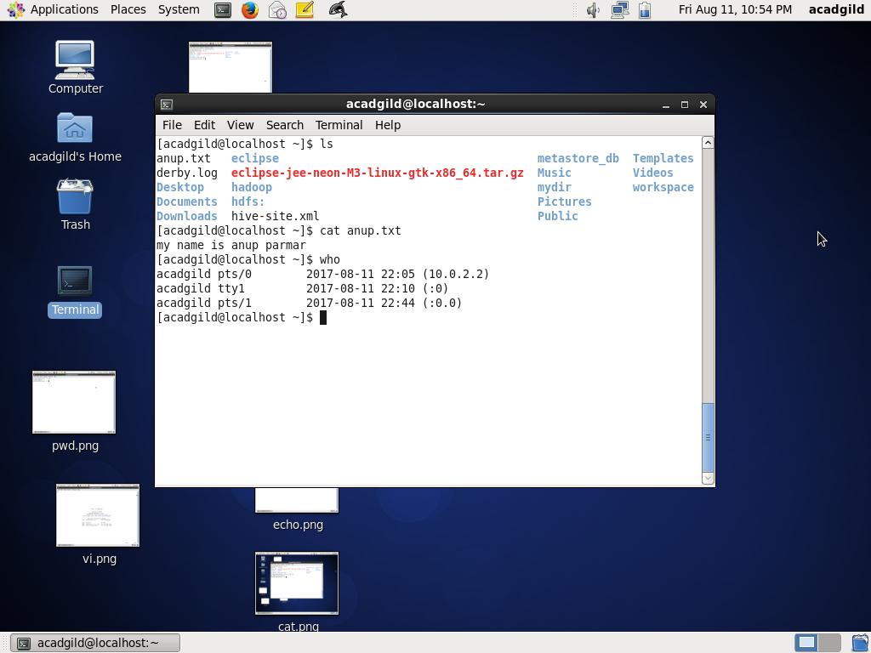

10. cd

The cd command, which stands for "change directory", changes the [shell](https://www.computerhope.com/jargon/s/shell.htm)'s [current working directory](https://www.computerhope.com/jargon/c/currentd.htm).

Explanation:

It allows you to change your [working directory](https://www.computerhope.com/jargon/c/currentd.htm). You use it to move around within the [hierarchy](https://www.computerhope.com/jargon/h/hierfile.htm) of your [file system](https://www.computerhope.com/jargon/f/filesyst.htm).

>cd

Output

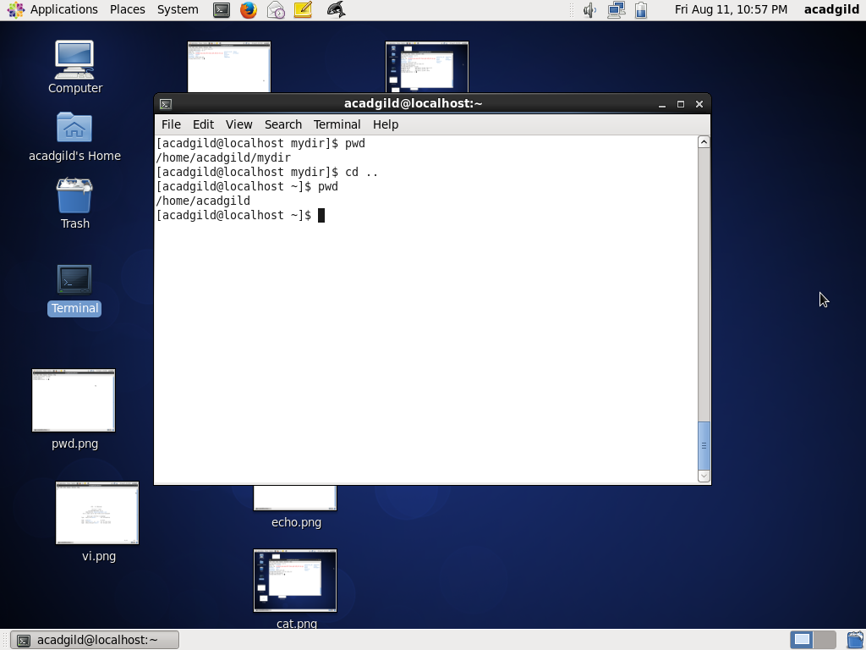

11.date

The date command is used to print out, or change the value of, the system's time and date information.

Explanation:

Running date with no options will output the system date and time

>date

Output:

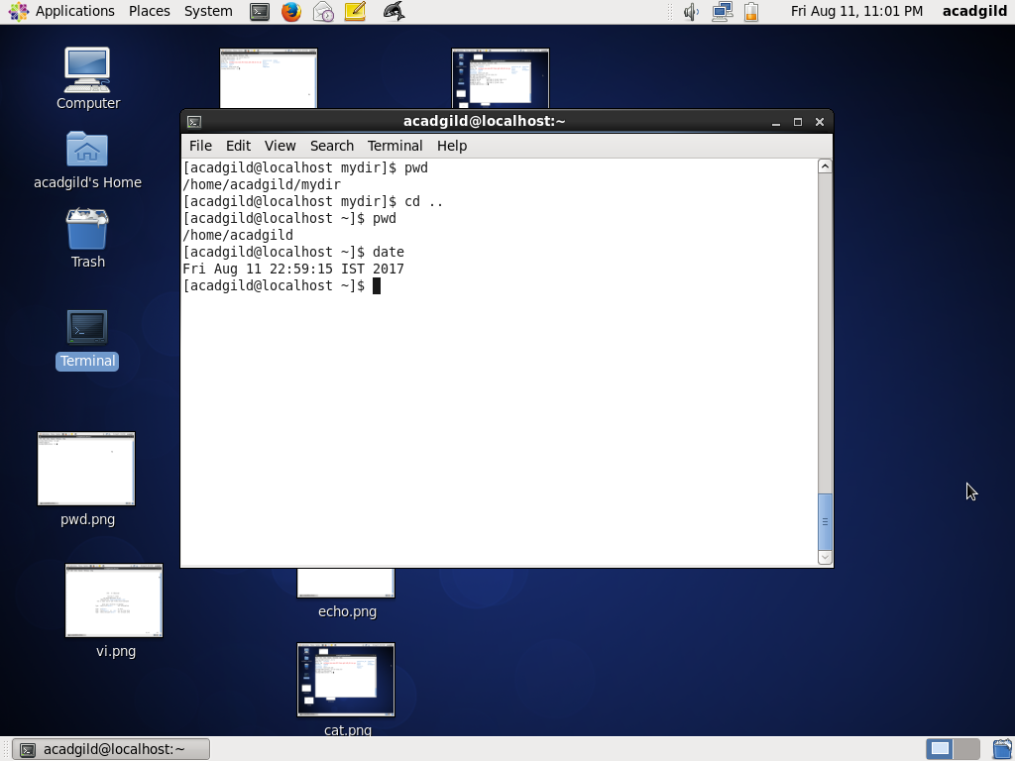

12.cal

Display a conveniently-formatted calendar from the command line.

Explanation:

Displays the calendar for this month.

>cal

Output:

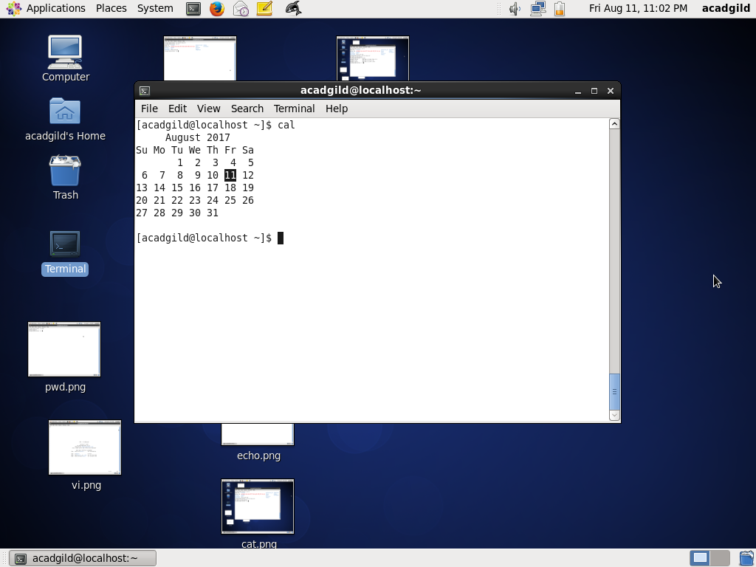

13.mv

The mv command is used to move or [rename](https://www.computerhope.com/jargon/r/rename.htm) files.

Explanation:

**mv** renames file SOURCE to DEST

>mv anup.txt /home/acadgild/anup.txt

Output:

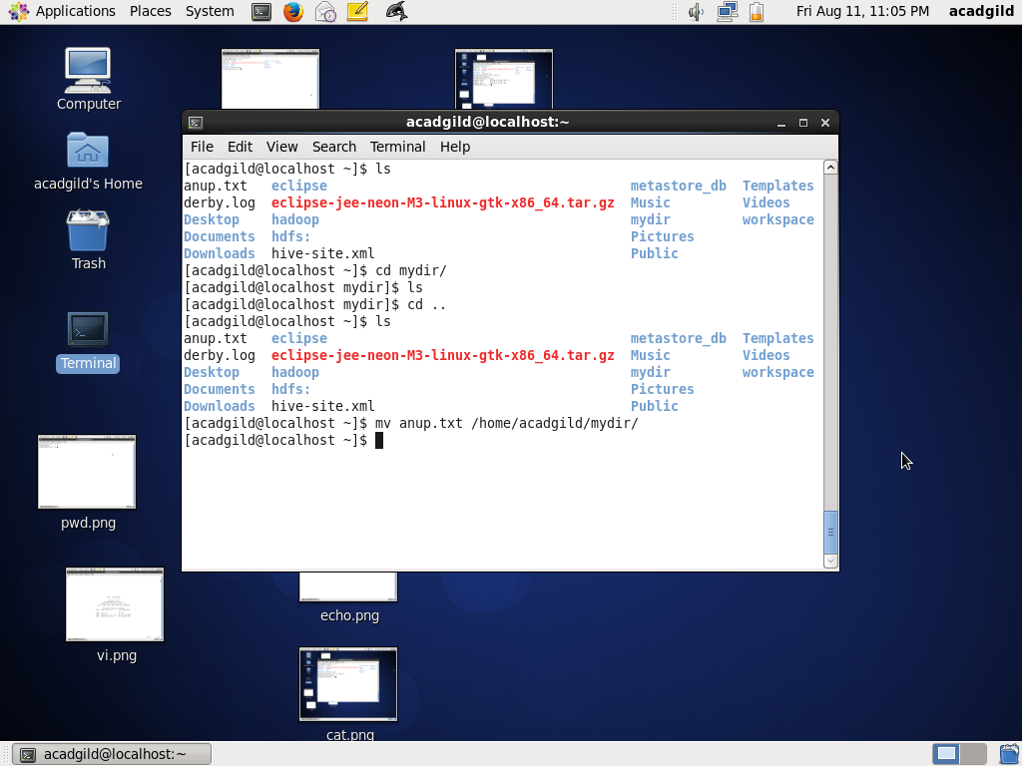

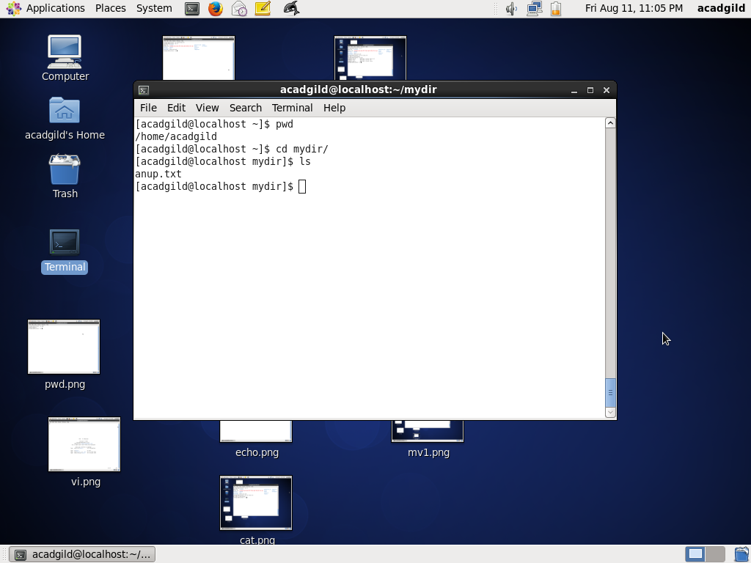

14.cp

The cp command is used to make copies of files and directories.

Explanation:Copy a same file into another directory

>cp anup.txt /home/acadgild

Output:

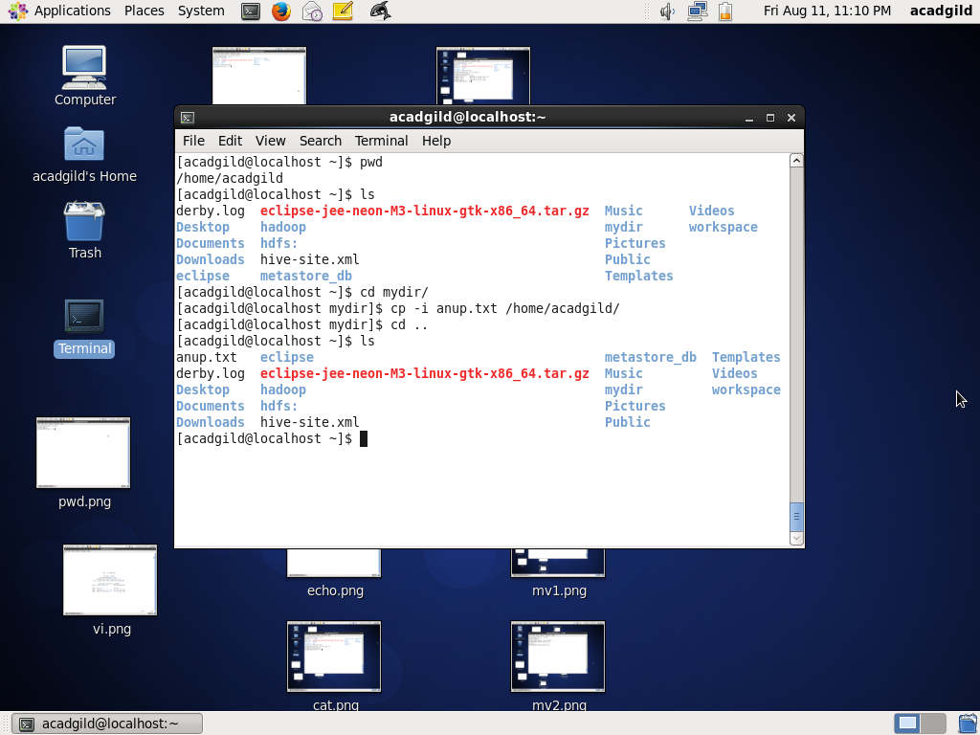

15.which:

Locate the [executable file](https://www.computerhope.com/jargon/e/execfile.htm) associated with a given [command](https://www.computerhope.com/jargon/c/command.htm).

Explanation:

which returns the [pathnames](https://www.computerhope.com/jargon/p/path.htm) of the [files](https://www.computerhope.com/jargon/f/file.htm) (or [links](https://www.computerhope.com/unix/link.htm)) which would be [executed](https://www.computerhope.com/jargon/e/execute.htm) in the current [environment](https://www.computerhope.com/jargon/e/environm.htm).

>which anup.txt

Output:

