Environment variables to be set

“secretKey” – jwt token encryption key

“dbusername” – database username

“dbpassword” – database password

“DEBUG” – (optional) ‘app:startup’ for start up info, ‘app:debug’ for debug info

End points-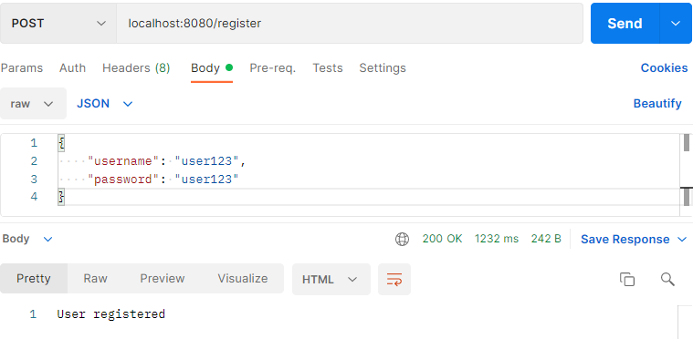: 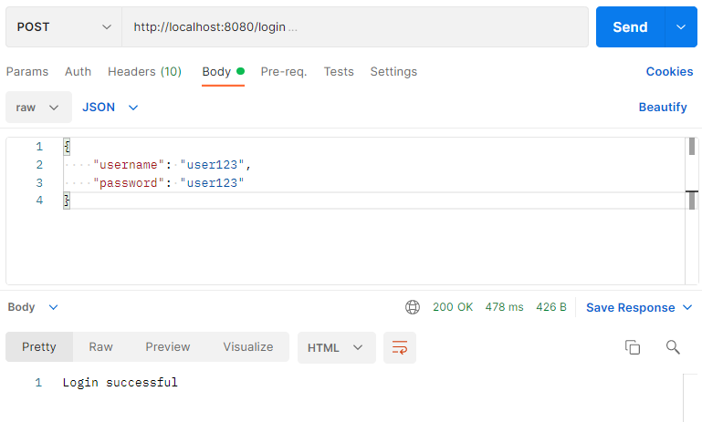

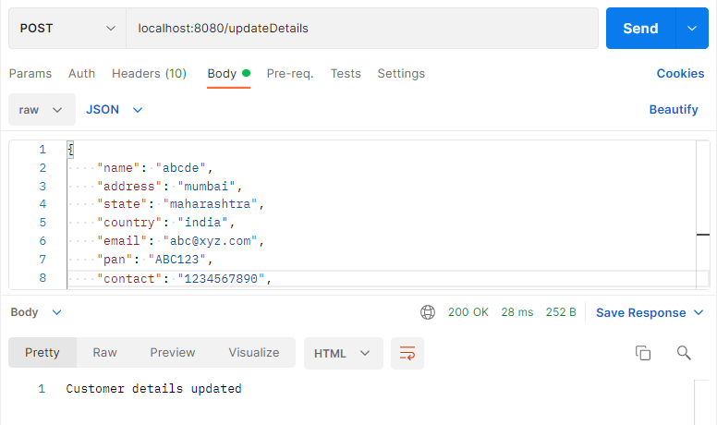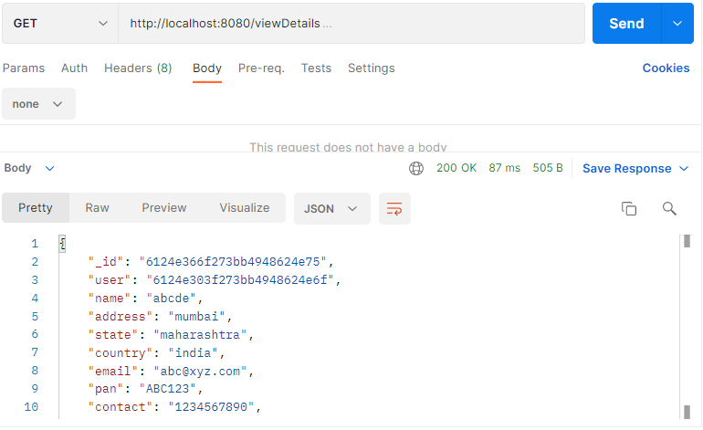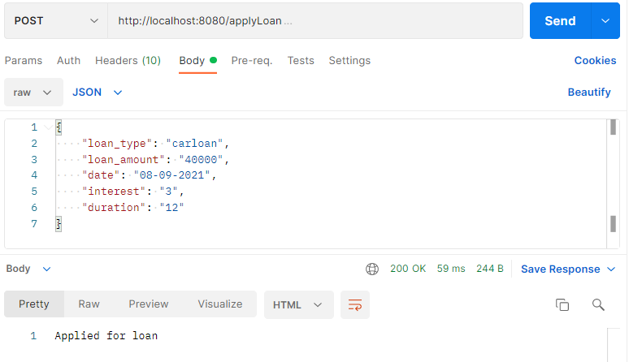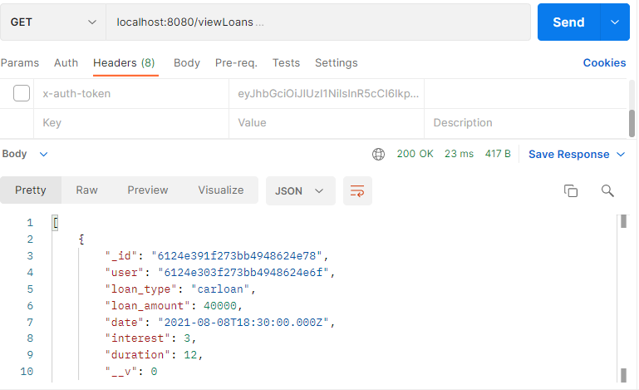

Code Coverage – 86.52%

